Removal of rhodamine 6G using nanofibres, track-etch membrane and nanofibre-track etch composite membranes
¹Bode-Aluko, C.A, MSc, ¹Petrik, L.F, PhD, ²Apel P.Y, DSc 1. Environmental and Nanosciences Research group (ENS), Chemistry department, University of the Western Cape, South Africa.
2. Flerov Laboratory of Nuclear Reactions, Joint Institute of Nuclear Research, Dubna, Russia.

Abstract
Statement of the problem: Dyes are organic environmental pollutants coming from the textile industries. Their presence in the aquatic environment poses a serious threat to both aquatic organisms and humans who depend on these water bodies for domestic use. To salvage this situation, several methods have been used to remove these dyes from water, some of which are cost effective but not readily available. This research focuses on the use of improved nano-filtration methods for the removal of rhodamine 6G (RD) in an emergency case. Methodology & Theoretical Orientation: The research is based on preparation of membranes comprising electrospun nanofibres and track-etched membrane for filtration/adsorption of RD in a continuous flow process. Polyacrylonitrile (PAN-nfs), polyamide 6 nanofibres (PA6-nfs) and Polyethylene terephthalate track etch membrane (PET-TM) were combined through an electrospinning process. Findings: PAN-nfs, PA6-nfs, PET-TM and their composite membranes (PET-TMPAN and PET-TMPA6) were used to adsorb RD from aqueous solution. The highlight of the results was that the composite membranes (PET-TMPAN and PET-TMPA6) gave better results when compared with the initial membranes (PAN-nfs, PA6-nfs and PET-TM). The uptake of RD by these membranes could be best achieved for 10 mg/L of RD when the initial pH was 10 and at a flow rate 1 mL/min using 0.0026 g of each membrane. PET-TMPAN adsorbed 91.27% of RD, PET-TMPA6, 70.66%, PAN-nfs, 61.97%, PA6-nfs, 36.80% and PET-TM 24.53%. The adsorption patterns of RD onto PET-TMPA6 and PET-TMPAN were well fitted to both the Langmuir and Freundlich isotherm models. Furthermore, all the membranes were regenerated to overcome fouling and were reused. Conclusion and significant: Electrospinning process was used to combine nanofibres and track-etch membrane for filtration of dyes. Recommendation: The use of electrospun composites for removal of pollutants offers an effective emergency water treatment option and its efficacy for other pollutants should be explored.

Image

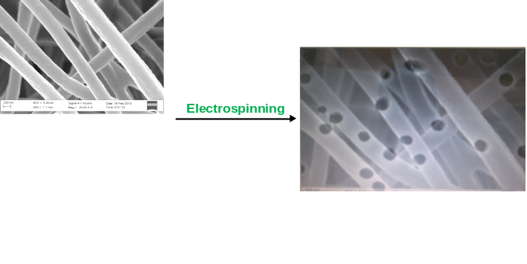
Figure 1: Fabrication of nanofibre-track etch composite membrane

Recent Publications
- Apel P (2013) Track-etching at Flerov Laboratory of Nuclear Reactions, Joint Institute for Nuclear Research, Moscow Region, Russia Encyclopedia of Membrane Science and Technology, Wiley & Sons Incorporation.
- Bhardwaj N, Kindu S (2010) Electrospinning: A fascinating fiber fabrication technique. Biotechnology Advances, 28:325-347.
- Bode-Aluko C, Pereao O, Fatoba O, Petrik L (2016) Surface-modified polyacrylonitrile nanofibres as supports. Polymer Bulletin 1-12.
- Pereao O, Bode-Aluko C, Ndayambaje G, Fatoba O, Petrik F (2016) Electrospinning: polymer nanofibres adsorbent applications for metal ion removal. Journal of Polymers and the Environment 1-15.
- Senturk H, Ozdes D, Duran C (2010) Biosorption of Rhodamine 6G from aqueous solutions onto almond shell (Prunis dulcis) as a low cost biosorbent. Desalination 252: 81-87.

Biography
Chris Ademola Bode-Aluko has his BSc (Hons) in Industrial Chemistry and MSc in Inorganic chemistry. He is rounding off his PhD research at the University of the Western Cape under the supervision of Professor Leslie Petrik. His PhD is focused on environmental remediation where he has been looking into removal of both organic and inorganic pollutant from solution. He research is based on the production of nanofibres via an electrospinning process. Polymers such as polyacrylonitrile PAN, polyethylene terephthalate PET, polystyrene PS, polyamide 6 PA6 etc. have been electrospun into nanofibres. Some of the nanofibres such as PAN have been functionalized by immobilizing ligands on them for removal of toxic metals from solution. Recently, he visited Joint Institute for Nuclear research JINR, Russia to gain more skills on track etched membrane fabrication. Currently, he is working on fabricating nanofibres track etched composite membrane through an electrospinning process for removal of dyes from solution. He has recent publications on removal of toxic metals using nanofibres.
Email: chrisbodealuko@gmail.com

