Effects of biologically active substances on the rabbit fertility
Lubomir Ondruska, PhD., Vladimir Parkanyi, PhD., Jan Rafay, PhD. National Agricultural and Food Centre - Research Institute for Animal Production Nitra, Hlohovecka 2, 951 41 Luzianky, Slovak Republic

Abstract
The aim of the study was in vivo and in vitro evaluation intravaginal application of biologically active substances included in the rabbit insemination dose on sperm-ovule interaction and selected reproduction parameters. This study was realized in two experiments – in vitro and in vivo. The adult female rabbits were divided into four groups. Group C (control) with intramuscular application of synthetic GnRH (gonadotropin releasing hormone) superanalogue – Lecirelin (2.5 µg per doe) immediately after the artificial insemination (A.I.). Two groups (H_{0.06} and H_{0.12}) with intravaginal application of heparin (0.06 µl; 0.12 µl per doe) and intramuscular application of GnRH (2.5 µg per doe) after A.I.. The last was group G only with intravaginal application of GnRH – Lecirelin (7.5 µg per doe). All females were artificially inseminated by fresh semen doses (0.5 ml per one female) and insemination doses (I.D.) were diluted by insemination extender for rabbit sperm (MiniTüb, Germany). Concentration of spermatozoa varied from 24.0 to 95.2 x 10⁶ per insemination dose. In an in vitro experiment we analyzed the influence of intravaginal application GnRH and two different level of heparin on total number of oocytes and zygotes, number of zygotes with two pronuclei and number of unfertilized oocytes. In an in vivo experiment we followed intravaginal application of GnRH and different level of heparin on selected reproductive parameters. Significance of differences among groups were determined by t-test and χ2 test. The highest kindling rate (89.29%) was obtained in group H_{0.06} and number of total born kits (10.88±2.63) in group H_{0.12}. Intravaginal application of GnRH and heparin positively influenced the number of zygotes with two pronuclei and decreased the number of unfertilized oocytes. However these differences were not significance compared with control group. This work was supported by the Slovak Research and Development Agency under the contract No. APVV-16-0067 and No. APVV-0044-12.

Image
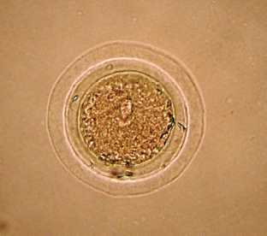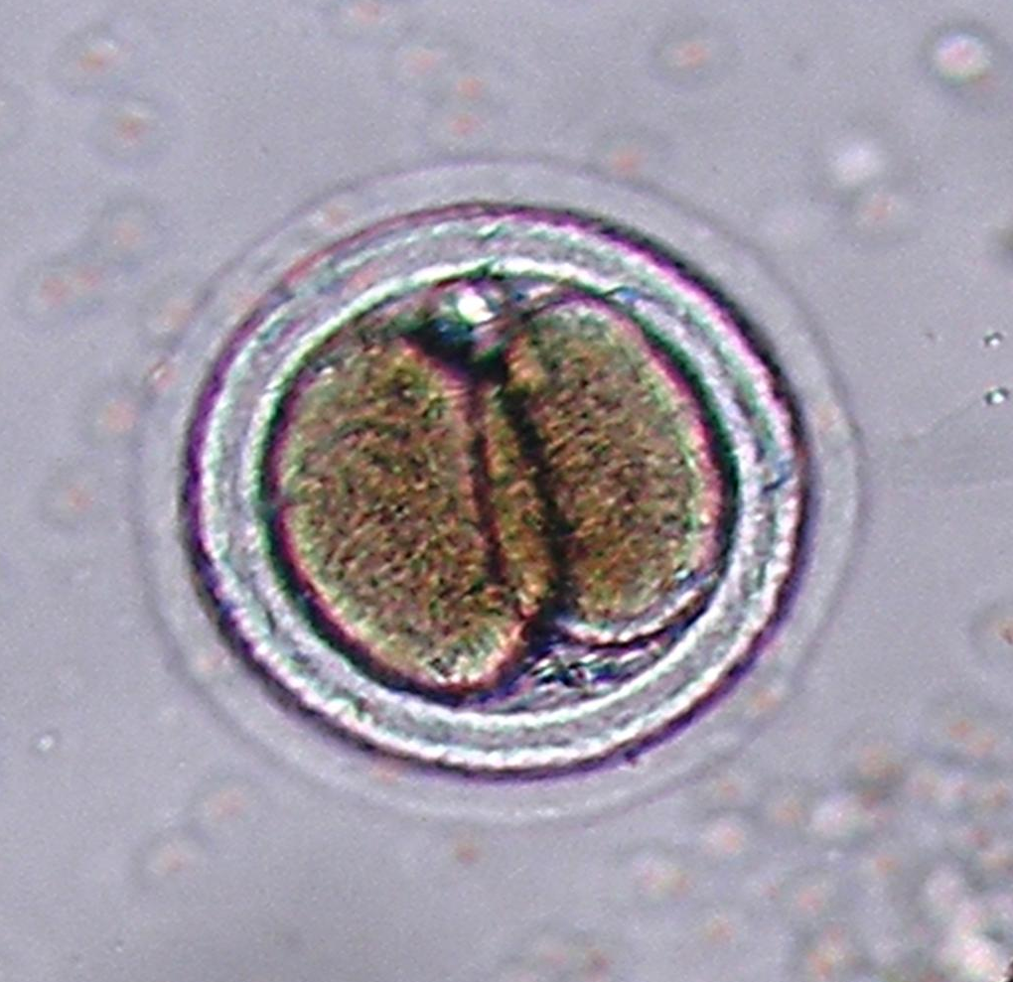
Figure 1: Rabbit zygote pronuclei Figure 2: Stage of two blastomeres
on 18-20 hour in group G
Recent Publications
- Chang MC (1951) Fertilizing capacity of spermatozoa deposited into the fallopian tubes. Nature 168: 697-698.
- Dal Bosco A, Rebollar PG, Boiti C, Zerani M, Castellini C (2011) Ovulation induction in rabbit does: current knowledge and perspectives. Animal reproduction science 129(3-4):106-117.
- Dal Bosco A, Cardinali R, Brecchia G, Rebollar PG, Fatnassi M, Millán P, Mattioli S, Castellini C (2014) Induction of ovulation in rabbits by adding Lecirelin to the seminal dose: In vitro and in vivo effects of different excipients. Anim. Reprod. Sci. 150(1-2): 44-49.
- Morales P, Pizarro E, Kong M, Kerr B, Ceric F, Vigil P (2000) Gonadotropin-Releasing Hormone-Stimulated Sperm Binding to the Human Zona Is Mediated by a Calcium Influx. Biology of Reproduction 63:635-642.
- Morales P (1998) Gonadotropin-Releasing Hormone Increases Ability of the Spermatozoa to Bild to the Human Pellucida. Biology of Reproduction 59:426-430.
- Quintela LA, Peňa AI, Vega MD, Gullón J, Prieto MC, Barrio M, Becerra JJ, Maseda F, Herradón PG (2004) Ovulation induction in rabbit does submitted to artificial insemination by adding buserelin to the seminal dose. Reprod.Nutr. Dev. 44:79-88.
- Rebollar PG, Dal Bosco A, Millán P, Cardinali R, Brecchia G, Sylla L, Lorenzo PL, Castellini C (2012) Ovulating induction methods in rabbit does: the pituitary and ovarian responses. Theriogenology 77(2):292-298.

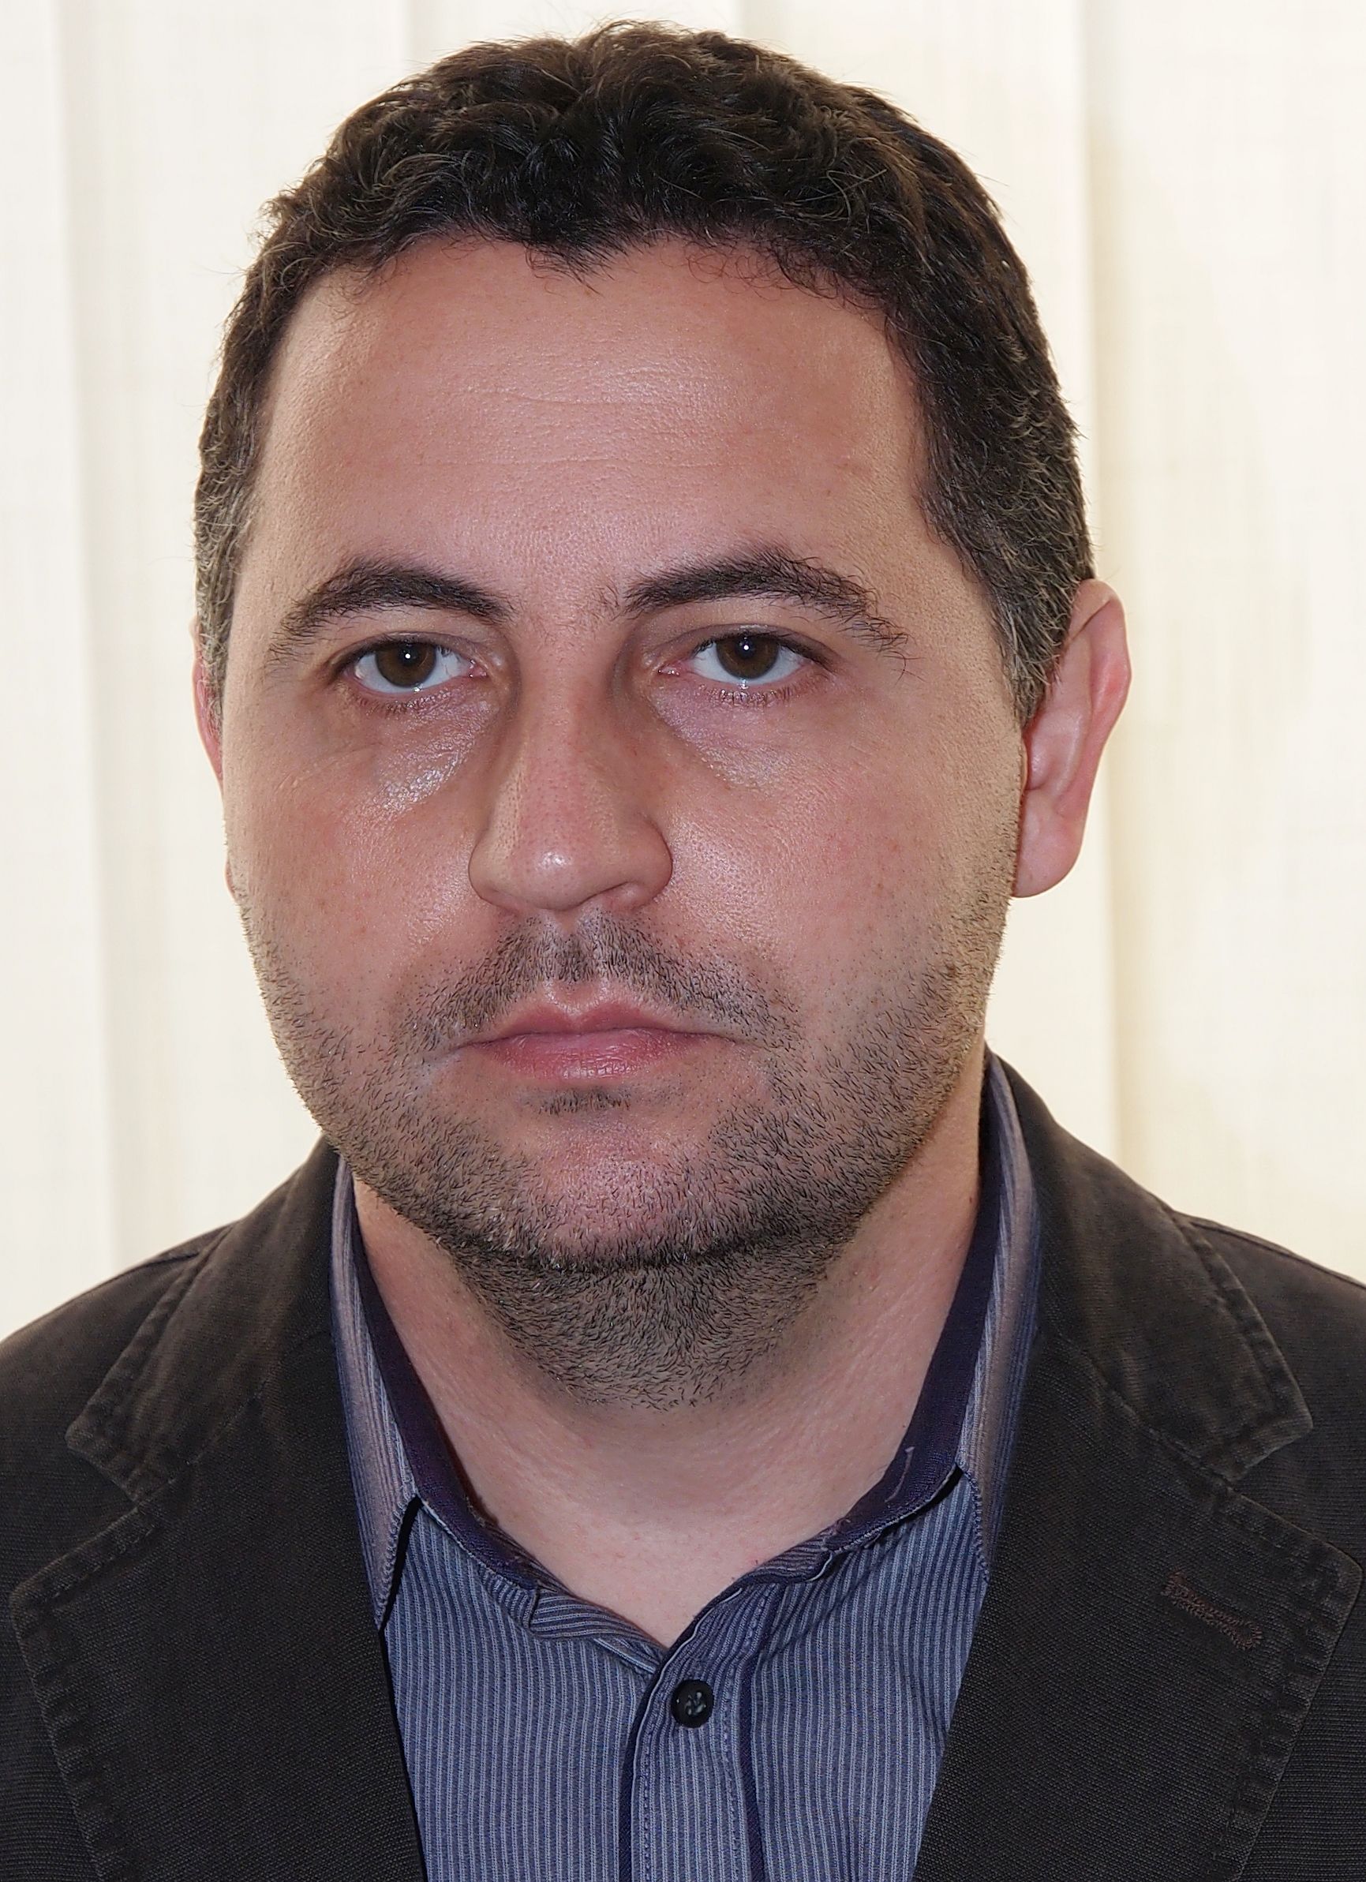 Biography
Dr. Lubomir Ondruska is a research scientist at the National Agricultural and Food Centre Nitra in Slovak Republic. He is interested in the area of animal genetics, animal breeding, molecular biology and reproduction physiology of farm animals (as an animal model uses rabbit, other farm animals and game). He is scientist strives for the application of modern methods and practices in basic and applied research as well as to the user community. His gained experience and education applies to the solution research projects and also on pedagogical activities in Slovak Agricultural University in Nitra, Slovakia.
Scientific research activities: Original scientific work: 52, Books in authorship: 2, Contributions in proceedings of scientific conferences and congresses: 155, Expert and popular articles: 53. Participation and coordination in the research project: Slovak Research and Development Agency: 7, EU operational programs: 2, Ministry of agriculture projects: 7.
Email: ondruska@vuzv.sk
- Full Name: Lubomir Ondruska
- Personal Email: ondruska.lubomir@gmail.com
- Mobile Number:+421903014291
- Session Name: Animal Biotechnology and Marine Biotechnology
- Category: Poster presentation
- Date of Birth: 1979 28th October
- Postal Address: National Agricultural and Food Centre, Hlohovecka 2, 951 41 Luzianky, Slovak Republic

