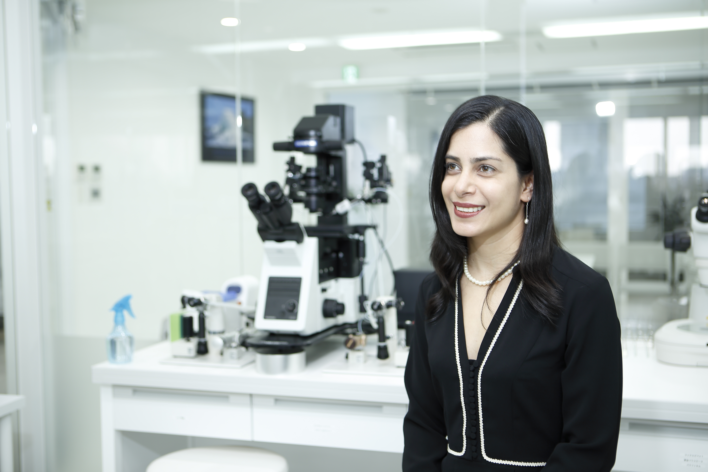

Easy and safe Vitrification of oocytes and blastocysts:
Outcome from the worldwide large scale clinical trials

Sofía Soto-Rodriguez and Masashige Kuwayama
Repro-Support Medical Research Centre, Tokyo, Japan

The demand of fertility preservation has been increasing for these 2 decades, due to either health conditions or maternity delay. For this reason, many techniques for preservation of oocytes and embryos have been developed along these years. Due to vast clinical results exceeding 2,000,000 cases in over 73 countries, the open system of vitrification has been able to make 90% of human oocytes and embryos survive after freezing. Despite the variety of techniques, many of them require very skilled manipulation and complicated protocol; besides, none of them had reached a high survival rate that would consider the fragility of the oocytes of cancer patients or women over 40 years old. The last remaining challenge was to rescue valuable oocytes and embryos that still had led to death, and create an improved noninvasive vitrification method that gives possibilities to women in true difficulty and pain. The aim of this work is to present the world wide results of a very successful vitrification method for all the developmental stages of oocytes and embryos. In this retrospective study, patients undergoing IVF cycles during 2015-2016 underwent IVF cycles with either oocyte or blastocyst vitrification in clinics worldwide.

During this session, we report the hidden improvements of the vitrification method in order to obtain the best survival rates for oocytes and blastocysts yielding to a higher pregnancy rate compared to fresh cycles. These results are an evidence of the safety and effectiveness of the method. With this high survival rate and excellent clinical results, ordinary methods are changing in advanced fertility facilities all around the world.

Biography
Sofia Soto-Rodríguez started as an embryologist in 2008 and was trained in vitrification directly by the hand of Dr. Masashige Kuwayama. In 2014 she became an official trainer of the Cryotech vitrificaton method in official Cryotech workshops in the most important meetings in the world. In 2015, she completed her PhD in Biomedical Sciences at Universidad de Guadalajara, and since then she became the Research director at Repro-Support Medical Research Center, supporter of Cryotech.

Presenting author details
Full name: Sofia Soto-Rodriguez
Contact number: +52 (998) 889-92-50, Ext. 46
Linked In account: https://www.linkedin.com/in/sofía-soto-rodríguez-6344295/
Session name/ number:
Category: Oral presentation

