Syringic acid, a phenolic compound attenuated arthritis by inhibition of Cytokines in Complete Freund’s Adjuvant induced arthritis in rats.
Archana R. Juvekar, Institute of Chemical Technology,Mumbai,India
Shilpee Chanda, Institute of Chemical Technology,Mumbai,India

Abstract
Aim and objective: To evaluate the anti-arthritic potential of Syringic acid in Freund ‘s complete adjuvant induced arthritis in rats and to study the underlying mechanism. Methods: Rheumatoid arthritis was induced in male Wistar rats by sub-plantar injection of 0.1ml of Complete Freund’s adjuvant into right hind paw on day 0. The treatment of Syringic acid (25,50 and 100mg/kg) and standard drug, Indomethacin (1mg/kg) was started from day 0 and continued up to day 21. The body weight, paw volume, paw thickness and arthritic index were determined on day 0,3,7,10,14,18 and 21. On day 22, rats were sacrificed and hematological, biochemical, anti-oxidant parameters, the thymus and spleen indices and cytokine level were estimated. Histopathological examination of the injected paw of the rat was performed. Results: Syringic acid showed significant(p<0.05) reduction in paw volumes at doses 50mg/kg and 100mg/kg. Syringic acid showed significant reduction in Tumor Necrosis Factor-α(TNF-α) and Interleukin-6(IL-6) levels in the serum, while increase in the anti-oxidant and biochemical parameter. The histopathology showed reduced cellular infiltration, synovial line thickening and joint erosion of cartilage. Conclusion: The restoration of the levels of TNF-α and IL-6 to normal may be contributing to the anti-arthritic potential of Syringic acid and could be a promising therapeutic alternative in the treatment of Rheumatoid arthritis.

Image
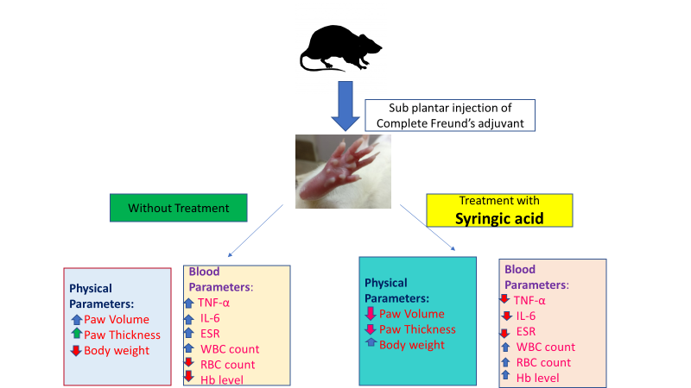
Figure 1: Syringic acid attenuates arthritis in Complete Freund’s adjuvant induced arthritis in rats
Recent Publications (minimum 5)
- Mestry, Snehal N., et al. "Punica granatum improves renal function in gentamicin-induced nephropathy in rats via attenuation of oxidative stress." Journal of Ayurveda and integrative medicine (2018).
- Chowdhury, Amrita A., et al. "In vitro antiglycating effect and in vivo neuroprotective activity of Trigonelline in d-galactose induced cognitive impairment." Pharmacological Reports (2017).
- Gawali, Nitin B., et al. "Agmatine attenuates chronic unpredictable mild stress-induced anxiety, depression-like behaviours and cognitive impairment by modulating nitrergic signalling pathway." Brain research 1663 (2017): 66-77.
- Thanekar, Deepavali, et al. "Evaluation of antitumor and anti-angiogenic activity of bioactive compounds from Cinnamomum tamala: In vitro, in vivo and in silico approach." South African Journal of Botany 104 (2016): 6-14.
- Gawali, Nitin B., et al. "Involvement of nitric oxide in anticompulsive-like effect of agmatine on marble-burying behaviour in mice." European journal of pharmacology 770 (2016): 165-171.
- Bulani, Vipin D., et al. "Inclusion complex of ellagic acid with β-cyclodextrin: Characterization and in vitro anti-inflammatory evaluation." Journal of Molecular Structure 1105 (2016): 308-315.
- Bulani, Vipin D., et al. "Characterisation and anti-inflammatory evaluation of the inclusion complex of ellagic acid with hydroxypropyl-β-cyclodextrin." Journal of Inclusion Phenomena and Macrocyclic Chemistry 82.3-4 (2015): 361-372.
- Kothavade, Pankaj S., et al. "Therapeutic effect of saponin rich fraction of Achyranthes aspera Linn. on adjuvant-induced arthritis in Sprague-Dawley rats." Autoimmune Diseases 2015 (2015)
- Kothavade, Pankaj S., et al. "The petroleum ether fraction of Celastrus paniculatus Willd. Seeds demonstrates anti-arthritic effect in adjuvant-induced arthritis in rats." Journal of Traditional Chinese Medical Sciences 2.3 (2015): 183-193.

Biography
Dr. Archana R. Juvekar is currently a professor in Pharmacology and Physiology at Institute of Chemical Technology,Mumbai,India. She has to her credit over 100 national and international publications in peer-reviewed journals and over 150 national and international conference proceedings. She has till date awarded 21 PhD degrees and guided more than 65 master students and is still actively involved in undergraduate, graduate teaching and research projects. She has received the best research paper award sponsored by the AI-Ameen College of Pharmacy Award for Best Paper published in UPER 2011 and best research paper award for paper at 34th Annual Conference on Indian Pharmacological Society 2002. Dr. Archana R Juvekar by her dedicated work skills and vast knowledge has been the backbone of success for many young research scientists and she would continue to do so for the years to come.
Email: shilpeechanda37@gmail.com

Notes/Comments:

The first author of the present work is Dr.Archana R Juvekar and the presenting author is Ms. Shilpee Chanda.

