The discourses about the pathogenesis of primary arterial hypertension: high blood pressure communication with circulation in the blood and tissues of HSV-1
Mirzoeva Tomiris, Educational and Clinical Center for Family Medicine of the Rudaki district, The Republic of Tajikistan.
Annotation
The purpose of the article is to study relationship between disease of arterial hypertension and herpes simplex virus first type (HSV-1), analysis of statistical data in Rudaki district on the prevalence this two diseases, communication of disturbance in biochemical structure of elastic fibers of a vascular wall and immunological response of the body against HSV – 1. In the article is considered the problem of nutrition of people with high blood pressure and the reason increased consumption of salt by these persons. The assimilation of amino acids lysine /arginine in persons with established arterial hypertension based on information on food intake data, during the week. The article analyzes the process of reducing the extensibility and elasticity arteries, the characteristic features in compensatory mechanisms of the cardiovascular system are distinguished and described in cases of violation of the morphological structure in the walls of blood vessels. Also establishing, the connection of abnormalities in the central nervous system, in the processes of excitation and inhibition of its structures, is arising from the circulation in the blood and tissues of HSV-1, mechanism of biochemical protection of brain structures, consisting in an increase in the blood circulation of cholesterol, LDL and glucose. Based on the analysis of people's way of life, as well as the involvement of a breath test, was established that, the most compensatory processes against HSV-1 and hypertension are carried out in the lung alveoli, where the pulmonary surfactant plays a key role. Surfactant protein A is the most abundant protein of the pulmonary surfactant. It has pronounced immunomodulatory properties. The functional differences between SP-A1 and SP-A2 include their ability to stimulate phagocytosis, inhibit the secretion of surfactant. In conclusion, the generalization of the treatment respiratory gymnastics is lowers blood pressure through destruction HSV-1 by the surfactant.
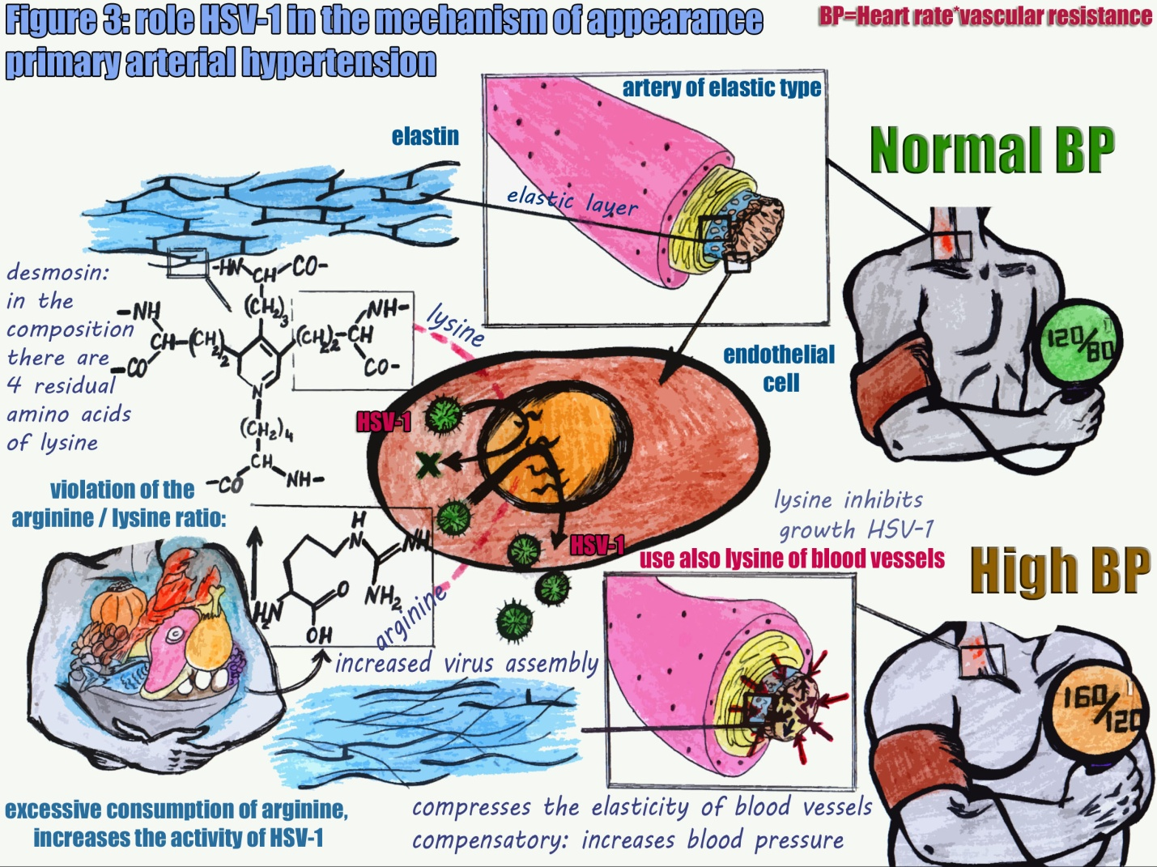
References
- WHO_DCO_WHD_2013.2 (2013) 1:8-13.
- http://www.who.int/mediacentre/factsheets/fs400/ru/ (2017).
- Березов Т. Т., Коровкин Б. Ф. (1998) Биологическая химия 21:664.
- Барановский А. Ю. (2012) Диетология руководство 5:145-149.
- Кисилев О.И., Жилинская И. Н. (2007) Вопросы общей вирусологии 3.5:95-104.
- http://www.beloveshkin.com/2016/04/balans-aminokislot-lizin-arginin-ot-gerpesa-do-alcgejmera.html (2016).
- Шмидт Е. В., Лунев Д. К., Верещагин Н. В. (1976) Сосудистые заболевания головного и спинного мозга 1:53-66.
- Чухловина М. Л. (2010) 1:3-8.
- Микеров А.Н. (2012) Роль сурфактантного белка А в иммунной защите легких // Фундаментальные исследования 2:204-207.
- Северин Е. С., Алейникова Т. Л., Осипов Е. В., Силаева С.А. (2008) Биологическая химия 8:149-158, 9:206-219,14:343-350.
- Быков В. Л., Юшканцева С. И. (2012) Гистология, цитология и эмбриология: атлас, органы сердечно-сосудистой системы 146-156.
- Шанин В. Ю. (1998) Клиническая патофизиология 21:328-336.
- Морман Д., Хеллер Л., (2000) Физиология сердечно-сосудистой системы 1:18-26.
- Кумар В. (2016) Основы патологии заболеваний по Роббинсу и Котрану 11:559-562.

Biography
Mirzoeva Tomiris Rakhimovna was born in 20 January 1994, in the Dushanbe city, the Republic of Tajikistan. From 2000 to 2011 she studied at secondary school No. 82 of the Dushanbe. In 2011 entered to the Faculty of General Medicine of the Avicenna Tajik State Medical University, which graduated in 2017. Now, she studied in the Institute of the postgraduate training of the Ministry of Health of the Republic of Tajikistan, by family medicine specialty, which sponsored by Swiss Tropical and Public Health Institute (Swiss TPH).

