Neurogenetics of Costello syndrome

Ramachandran Muthiah

Morning star hospital, Marthandam,
Kanyakumari District, India

Abstract

Costello syndrome is a rare RASopathy resulting from germline mutations of the protooncogene HRAS. Many of these mutations affect SHP2, SOS1, RAS, RAF and MEK proteins It was discovered by Dr. Jack Costello, a New Zealand paediatrician in 1977. Dr. White says. Costello syndrome is now known to be one of a group of related disorders,, caused by abnormal functioning of the Ras‐mitogen‐activated protein kinase (RAS/MapK) pathway. Ras/MAPK pathway is an essential signaling pathway that controls cell proliferation, differentiation, survival and its dysregulation causes clinically overlapping genetic disorders, called as ‘Rasopathies’. In this pathway, Ras, a GTPase, transmits extracellular signaling from receptor tyrosine kinases to two serine/threonine kinases (Raf and MEK) and, finally, to the activation of MAPKs. Costello syndrome is a severe developmental disorder characterised by postnatal growth retardation with delayed skeletal maturation, psychomotor retardation, cutis laxa, and acanthosis nigricans. Excessive mucopolysaccharides, which accumulate in cultured fibroblasts of patients with Costello syndrome (CS). Intracellular accumulation of chondroitin non-sulphate, as a cause of functional deficiency of the 67 kDa elastin binding protein, has been described in fibroblasts of patients with Costello syndrome.This gives support to the previous hypothesis of a defect in lysosomal degradation.

The Splicing Efficiency of Activating HRAS Mutations Can Determine Costello Syndrome Phenotype and Frequency in Cancer.This unravels a potential for development of new anti-cancer therapies based on SSO-mediated HRAS exon 2 skipping. Gene correction of these germline mutations to restore normal protein functions is anticipated as a new therapeutic option. This can be achieved through disruption of gain-of-function pathogenic mutation, restoration of loss-of-function mutation, addition of a transgene essential for cell function and single nucleotide changes. Development of genome editing tools comes in two waves. The first wave focuses on improving targeting specificity and editing efficiency of nucleases. The second wave of gene editing draws on innovative engineering of fusion proteins combining deactivated nucleases and other enzymes that are able to create limitless functional molecular tools.technology CRISPR (clustered regularly interspaced short palindromic repeat) has been nothing less than miraculous, at the cellular level to fix the genetic diseases by editing the double helix of the DNA. The tool acts as a pair of DNA scissors to modify the genes by replacing the defected ones. This technology has had a revolutionary impact on the life sciences, is contributing to new cancer therapies and may make the dream of curing inherited diseases come true.
Oxidative stress- play a role in cancer development and free radicals- determine non-neoplastic clinical features such as elastin anomalies, alteration of skin and appendages, developmental retardation and cardiac defects. PAR therapy (potassium ascorbate with ribose) a reduction in oxidative stress biomarkers in parallel with improvement of clinical features. It combines the antioxidant action of vitamin C with the stabilizing intracellular effects of potassium and causes improvement of skin and appendage lesions, better evolution of psychomotor development, no Progression of heart hypertrophy, nor tumor development. It is low cost, no side-effects, orally administered and useful for all genetic syndromes with cancer risk.

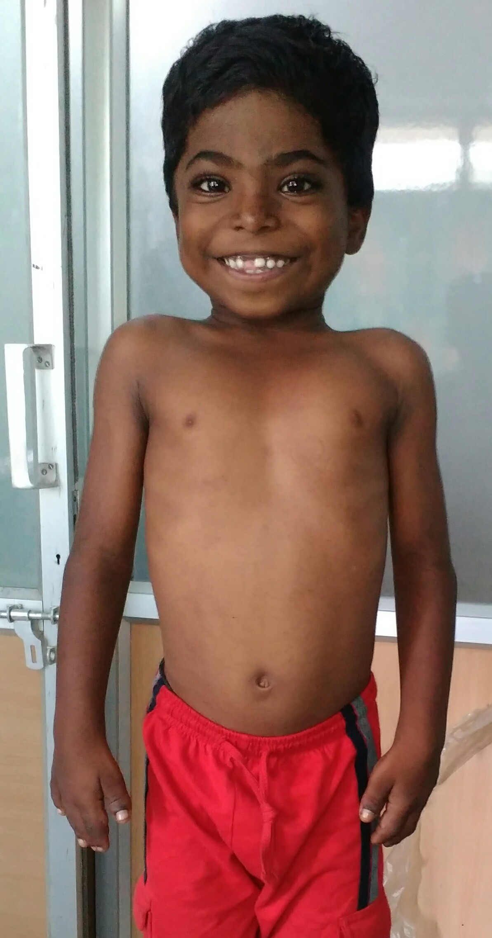

9 year old boy with radiant smile

Publications
- Muthiah, R. (2021) Isolated Acute Rheumatic Pancreatitis—A Case Report. Case Reports in Clinical Medicine, 10, 52-77
- Muthiah, R. (2019) Infective Endocarditis in Tetralogy of Fallot Complicating Brain Abscess—A Case Report. Case Reports in Clinical Medicine, 8, 105-126
- Muthiah, R. (2018) Native Aortic Valve Endocarditis—A Case Report. Case Reports in Clinical Medicine, 7, 483-504.
- Muthiah, R. (2018) Tropical Coronary Artery Disease and Arrhythmogenic Potentials—The Changing Pattern towards Endomyocardial Fibrosis—An Analysis. Case Reports in Clinical Medicine, 7, 397-429
- Muthiah, R. (2018) Isolated Patent Ductus Arteriosus in an Elderly Female, Aged 65 Years—A Case Report. Case Reports in Clinical Medicine, 7, 352-379.

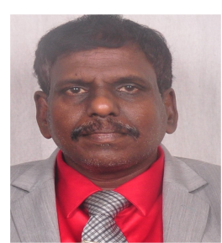

Biography
Ramachandran Muthiah, Consultant Physician & Cardiologist, Zion hospital, Azhagiamandapam and Morning star hospital, Marthandam, Kanyakumari District, India. Born on 10/5/1966.. Mother Swornam belongs to keezhkulam village and Father Muthiah belongs to Enayam thoppu and both were farmers. Published many papers in Cardiosource, American College of Cardiology Foundation, Case Reports in Clinical Medicine (SCIRP) and Journal of saudi heart assocoation.
Name/Address: Ramachandran Muthiah
Palaninta vilai, keezhkulam-629193, kanyakumari district, Tamil nadu state, India
(landline-+914651 203014,
mobile +91 7598755201)
Category: Oral
Passport No:P8925619

