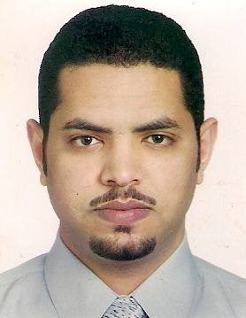

Title: A new evidence that the AEBP1 gene causes a rare form of EDS

Name: Fahad Hakami
Pathology & Laboratory Medicine, King Abdulaziz Medical City-WR, P.O.Box 9515, Jeddah 21423, Saudi Arabia

Ehlers Danlos syndrome (EDS) is a heterogeneous group of inherited collagen diseases caused by defects in collagenous and rarely noncollagenous protein-coding genes. There are numerous subtypes with diverse molecular etiologies: classical, hypermobility, vascular, and others. Common clinical features include hyperextensible skin and joints, skin fragility and reduced wound healing capability. In this study, we describe a girl presented with a unique constellation of clinical findings including joint hypermobility, ligamentous laxity, excessive femoral anteversion, redundant and hyperextensible skin, poor wound healing with abnormal scarring and easy bruising, generalized muscle weakness and abnormal muscle bulk. She also had abnormal wide gate due to her clubbed and flat feet as well as bilateral flexible pes palnus. Collectively, these features mimic those seen in individuals with EDS. No pathogenic variants in the known EDS genes were found through exome sequencing, however, a homozygous splice site variant (c.1630+1G>A) in the AEBP1 gene was identified. To date, only four patients have been previously reported to have compound or homozygous pathogenic variants in this gene with EDS-like clinical features similar to our patient. Our study expands the clinical spectrum of an extremely rare EDS subtype, suggest differential diagnosis approach, and support previous report suggested that bi-allelic pathogenic variants in AEBP1 are the cause of this autosomal-recessive EDS subtype. It also emphasizes the importance of molecular confirmation for the diagnosis of individuals with such rare condition.

Biography

Dr Fahad Hakami has completed his PhD at the age of 34 years followed by two-year clinical postdoctoral studies at Harvard University. He is an American board certified molecular geneticist. He is the head of Molecular Medicine Laboratories at King Abdulaziz Medical City, Jeddah, Saudi Arabia.

Presenting author details
Full name: Fahad Hakami
Contact number: +966555662828
Twitter account: fhdhkmi
Linked In account: Dr Fahad Hakami, PhD, DABMGG, FACMGG
Session name/ number:
Category: Poster presentation
Other authors:
Oday Al Qurashi, Yousef Al Ghamdi, Aiman Shawli

