Frequency of Rearrangements Versus Small Indels Mutations in BRCA1 and BRCA2 Genes in Turkish Patients with High Risk Breast and Ovarian Cancer

Hülya Yazıcı^{1,} PhD,Istanbul University,TR
Seda Kılıç¹, MS,Istanbul University,TR
Demet Akdeniz¹, PhD,Istanbul University,TR
Özge Şükrüoğlu¹, MS,Istanbul University,TR
Ş. Buğra Tunçer¹, PhD, MS,Istanbul University,TR
Mukaddes Avşar¹, MS,Istanbul University,TR
Gözde Kuru¹, MS,Istanbul University,TR
Betul Çelik¹,MS,Istanbul University,TR
Pınar Saip², MD,Istanbul University,TR

Abstract

Statement of the Problem The current rearrangement ratio of BRCA1 and BRCA2 genes is not known in the Turkish population. Rearrangements are not routinely investigated in many Turkish laboratories. This creates problems and contradictions between clinics. Therefore, the aim of this study was to evaluate the distribution and frequency of rearrangements in BRCA1 and BRCA2 genes in high-risk families and to clarify the limits of BRCA1 and BRCA2 testing in Turkey. Methodology: The study included 1809 patients at high risk of breast cancer or ovarian cancer. All patients were investigated for both small indels and rearrangements of BRCA genes using DNA sequencing and multiplex ligation-dependent probe amplification (MLPA) analysis. Findings: The overall frequency of rearrangements was 2% (25/1262). The frequency of rearrangements was 1.7% (18/1086) and 4% (9/206) in patients with breast cancer and ovarian cancer, respectively. The frequency of rearrangements was 3.7% (8/215) in patients with triple-negative breast cancer. The rearrangement rate was 7.7% (2/26) in patients with both breast and ovarian cancer. Conclusion & Significance: Rearrangements were found with high rates and were strongly associated with bilateral and triple-negative status of patients with breast cancer, which are signs of high risk for breast and ovarian cancer. Analysis of rearrangements should definitely be included in routine clinical practice in Turkey for high-risk families and also for improved cancer risk prediction for families.

Keywords: High-risk breast and ovarian carcinoma, BRCA1 and BRCA2 genes, rearrangements, Turkish population.

Image

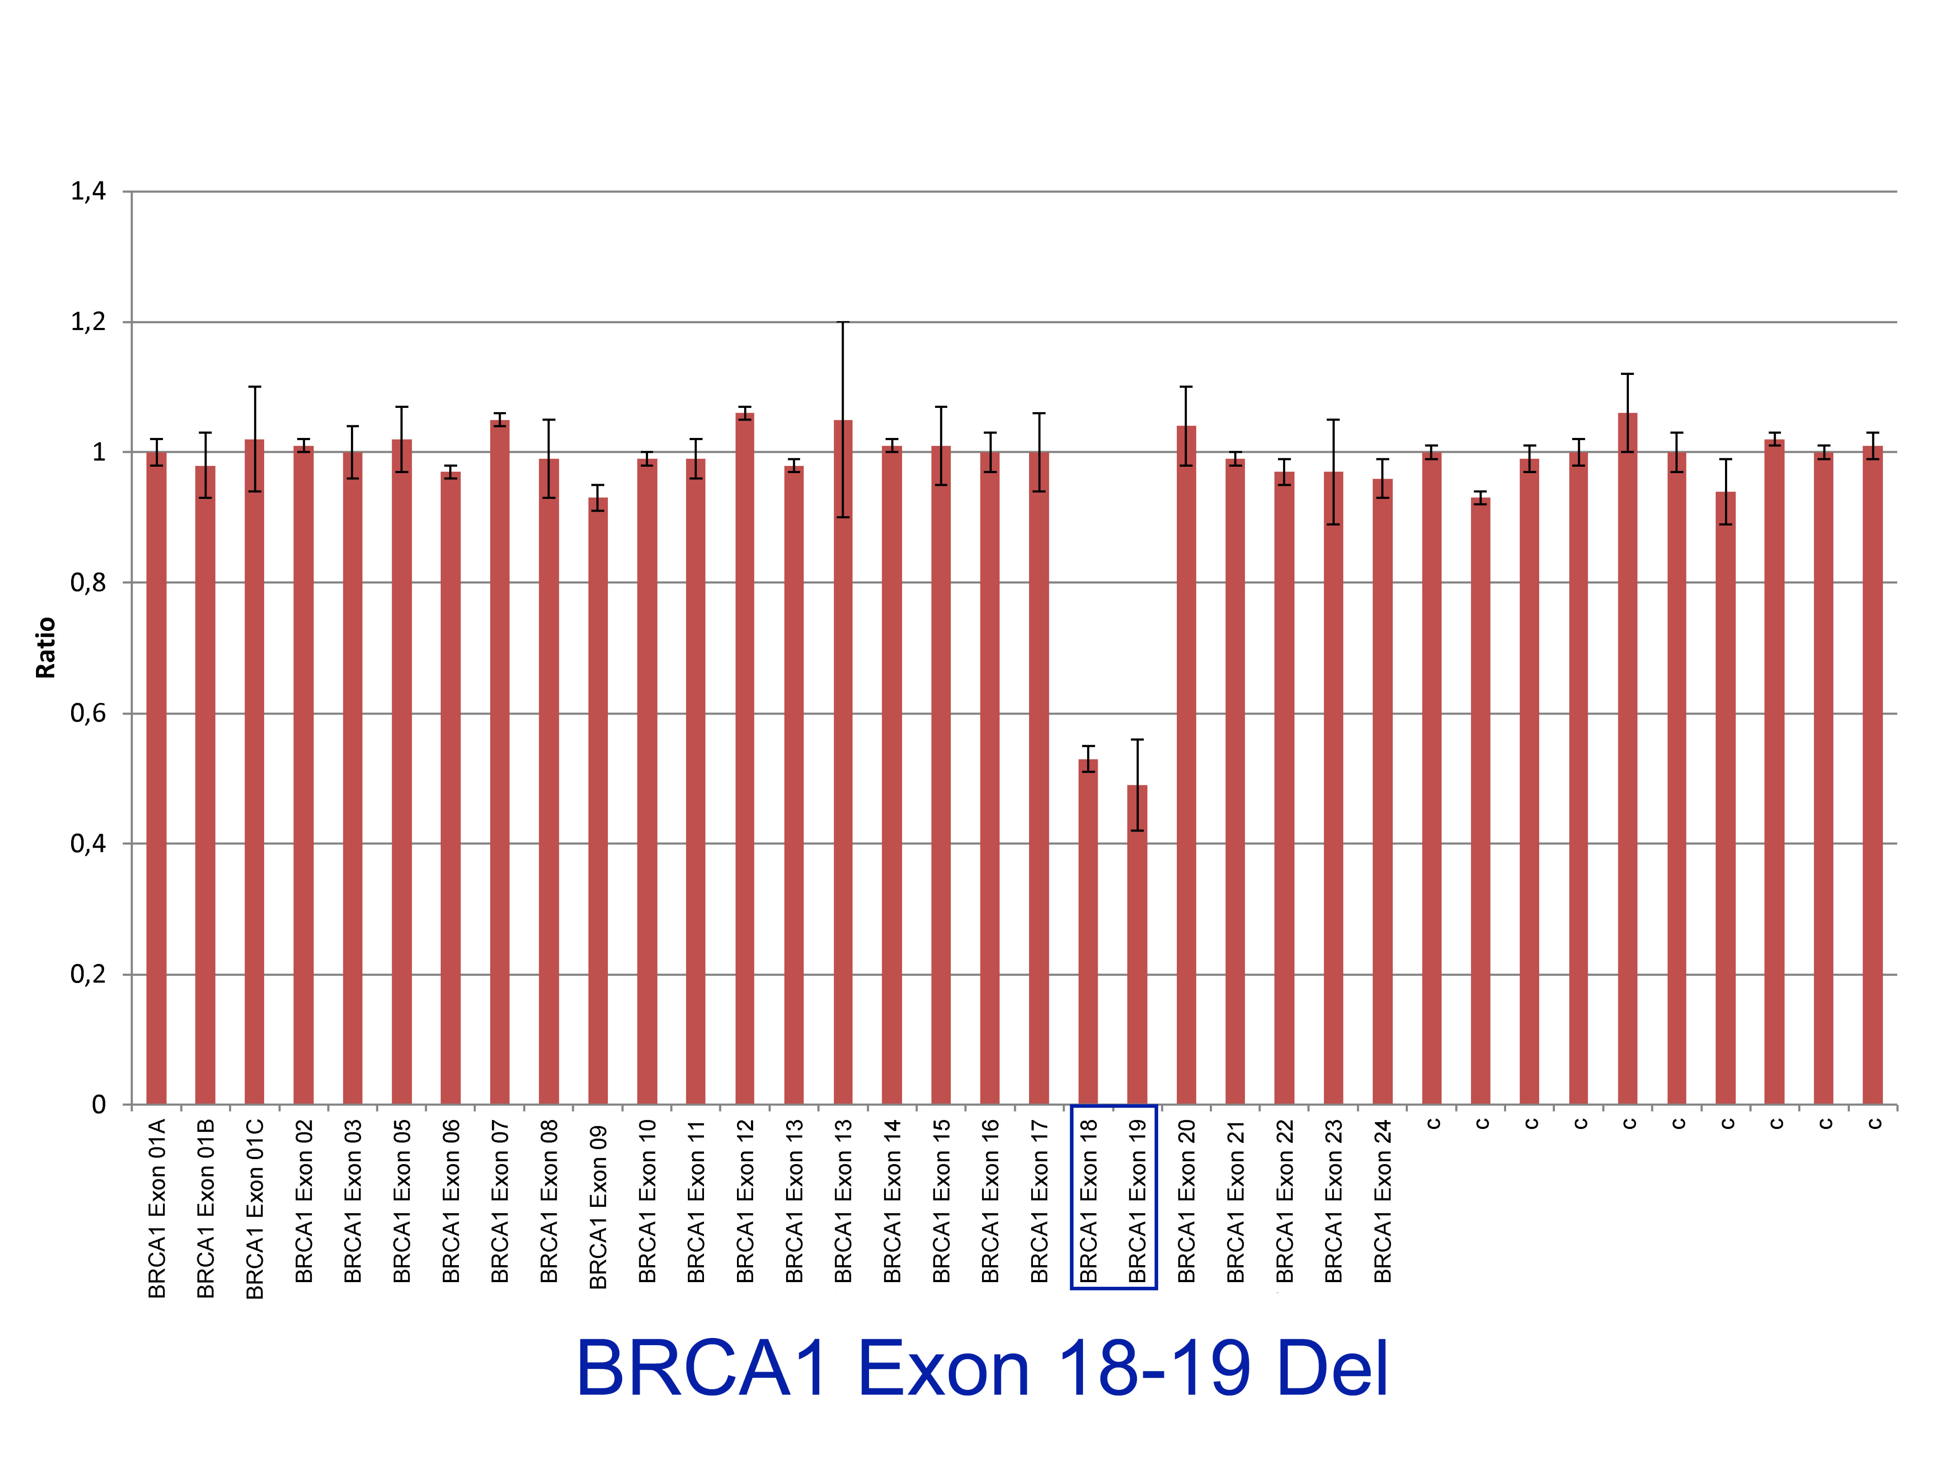

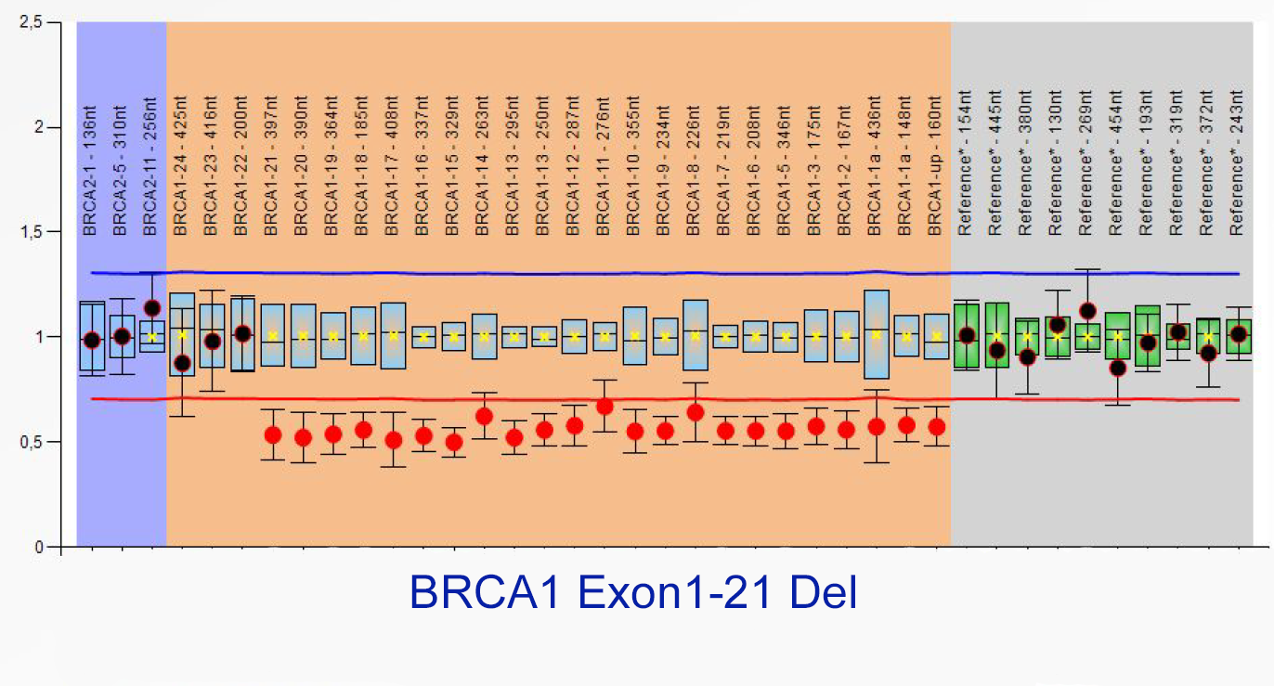
Figure 1: Results of MLPA analysis for BRCA1 gene. (Left Upper):
Patient DNA have a normal copy number of BRCA1 gene; (Righth
Upper): Patient DNA with the deletion of exon 1-21 region of
BRCA1gene; (Left Lower): Patient DNA with a normal copy number
of BRCA1 gene; (Rigth Lower): Patient DNA with the deletion of exon
18-19 region of BRCA1 gene.

Recent Publications
- Mehrgou A, Akouchekian M. Te importance of BRCA1 and BRCA2
genes mutations in breast cancer development. Med J Islam Repub Iran
2016; 30: 369. (PMID: 27493913)
- Judkins T, Rosenthal E, Arnell C, Burbidge LA, Geary W, Barrus T,
Schoenberger J, Trost J, Wenstrup RJ, Roa BB. Clinical signifcance of
large rearrangements in BRCA1 and BRCA2. Cancer 2012; 118: 5210-
5216. (PMID: 22544547)
- James PA, Sawyer S, Boyle S, Young MA, Kovalenko S, Doherty R,
McKinley J, Alsop K, Beshay V, Harris M, Fox S, Lindeman GJ, Mitchell
G. Large genomic rearrangements in the familial breast and ovarian cancer gene BRCA1 are associated with an increased frequency of high risk
features. Fam Cancer 2015; 14: 287-295. (PMID: 25678442)
- De Silva S, Tennekoon KH, Karunanayake EH, Amarasinghe I, Angunawela P. Analysis of BRCA1and BRCA2 large genomic rearrangements
in Sri Lankan familial breast cancer patients and at risk individuals. BMC
Res Notes 2014; 7: 344. (PMID: 24906410)
5. Kwong A, Chen J, Shin VY, Ho JC, Law FB, Au CH, Chan TL, Ma
ES, Ford JM. Te importance of analysis of long-range rearrangement of
BRCA1 and BRCA2 in genetic diagnosis of familial breast cancer. Cancer
Genet 2015; 208: 448-454. (PMID: 2627141
Biography
I love this work because it keeps me motivated intrinsically which is the utmost necessity for success. Research is an organized method that keeps all scientist dissatisfied with what you have discovered and this dissatisfaction is what drives more and more discovery. For so many years the question: ‘How to cure cancer?’, which has gone unanswered drives me so ambitious in order to find the answer. I believe that the work conducted our lab may help cancer patients always improve my motivation.
Email: celikbetul6@gmail.com

