Knowledge, Attitudes and Practices of Health Care Workers on the Management of Health Care Waste in four Health Care Facilities, Botswana

Bontle Mbongwe. (PhD) ¹*; Kealeboga Asele (BSc)¹; Roy Tapera (MPH)¹, Samuel Apua (MPH)²

¹Department of Environmental Health, University of Botswana, Gaborone, Botswana
²Boitekanelo College, Gaborone, Botswana

Statement of the Problem: Health-care waste poses a threat to health care workers, the public and the environment particularly in developing countries where adherence to prescribed World Health Organization and national protocols are not strictly followed. The purpose of this study is to identify gaps in knowledge, attitudes and practices among healthcare workers on the Management of Health Care waste in four hospitals in line with international and local standards

Methodology & Theoretical Orientation:: A descriptive cross-sectional study methodology was followed. Questionnaires were used to assess the knowledge, attitudes and practices of employees as well as management and administrative practices in the identified facilities. Ethical clearance was sort from the Ministry of health and the surveyed hospitals.

Findings: Questionnaires were administered in 323 health care workers across the four facilities comprising nurses (129, 39.9%), support staff (116, 36%) and medical doctors (33, 10.2%), pharmacy (14, 4.3%) laboratory scientists (14, 4.3%), radiologists (13, 4%) and managers (4, 1.2%). Over 60% of healthcare workers did not have training on health care waste management. However nurses (39.9%) were the most trained health care professionals. Whilst staff reported receiving training on policies and procedures on waste management, hospital managers reported not having such policies in their facilities. Eighty-two (25.4%) and 49 (15.2%) respondents reported having had at least one needle stick injury and cuts by sharp objects respectively. Poor segregation of healthcare waste was observed in all the surveyed hospitals.

Conclusion & Significance: The findings of this study suggest a need for healthcare workers training curricula to include health care waste management training. Health and safety procedures must be followed in managing sharps and other infectious materials.

Biography

Bontle Mbongwe is a Senior lecturer in the University of Botswana having previously worked for the Ministry of Health In Botswana, She is passionate about preventive health services with a focus to collaborate with researchers trained in disciplines related to, yet distinct from her own. These fields include medicine, chemistry, biology and behavioral sciences. Her passion for health care waste is motivated by her earlier involvement in a project known as Making Medical Injections Safer (MMIS) focusing on countries with high HIV prevalence. John Snow Inc, led the "Rapid Interventions to Decrease Unsafe Injections" in 11 countries which included Botswana. Bontle’s role was to train health care workers to administer only necessary injections safely, using appropriate safe injection devices, as well as to ensure that health care waste is efficiently managed using methods that are safe for the community and the environment. She continues to follow the facilities she trained.

Email: bontle.mbongwe@gmail.com

Image:
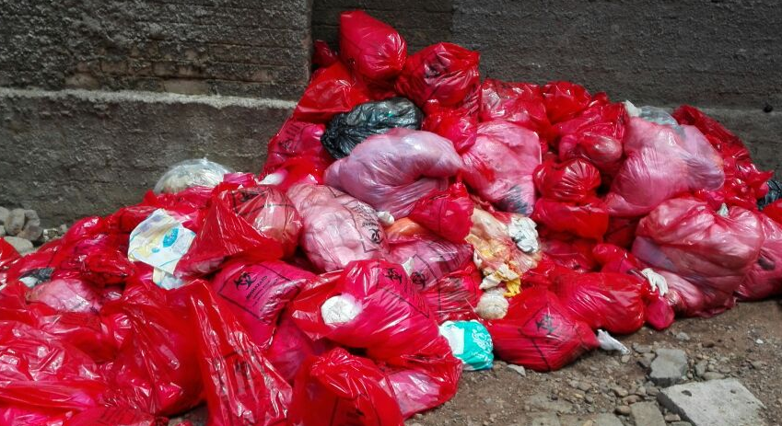
Figure 1: Evident poor segregation of waste in an open environment

Recent Publications:

(Aseweh Abor and Bouwer, 2008, Chartier, 2014, Mathur et al., 2011, Mbongwe et al., 2008, Nemathaga et al., 2008)ASEWEH ABOR, P. & BOUWER, A. 2008. Medical waste management practices in a Southern African hospital. International journal of health care quality assurance, 21, 356-364.
CHARTIER, Y. 2014. Safe management of wastes from health-care activities, World Health Organization.
MATHUR, V., DWIVEDI, S., HASSAN, M. & MISRA, R. 2011. Knowledge, attitude, and practices about biomedical waste management among healthcare personnel: A cross-sectional study. Indian journal of community medicine: official publication of Indian Association of Preventive & Social Medicine, 36, 143.
MBONGWE, B., MMEREKI, B. T. & MAGASHULA, A. 2008. Healthcare waste management: current practices in selected healthcare facilities, Botswana. Waste Management, 28, 226-233.
NEMATHAGA, F., MARINGA, S. & CHIMUKA, L. 2008. Hospital solid waste management practices in Limpopo Province, South Africa: A case study of two hospitals. Waste management, 28, 1236-1245.

