
SUMMER PROJECT REPORT
ON
SUPPORT SERVICES IN HOSPITAL
A STUDY IN SHARDA HOSPITAL

“MASTERS OF BUSINESS ADMINISTRATION”
2016-2018

SUBMITTED TO: SUBMITTED BY:
Dr. Nishtha Attri RAHUL KAUSHAL
MBA (HCHA) System Id: 2016012175

DECLARATION

I hereby declare that the Project Report entitled “SUPPORT SERVICES” submitted by me to the School Of Business Studies, Sharda University, Greater Noida, is a bonafide work carried out by me and is original and not submitted to any other University or Institution for the award of any Degree/Diploma/Certificate or published any time before.

PLACE: Greater Noida Signature:
DATE: Name: RAHUL KAUSHAL
System Id: 2016012175

CERTIFICATION

This is to certify that the Project Report entitled “SUPPORT SERVICES” submitted in partial fulfilment for the award of programme of Sharda University, Gr.Noida, was carried out by Mr. RAHUL KAUSHAL under my guidance. This has not been submitted to any other University or Institution for the award of any degree/ diploma/certificate.

Signature of the Internal Guide Signature of the Principal
Name: (with stamp)

ABSTRACT
Ensuring efficient and safe Support services through the hospital system is a consistent problem in healthcare settings. As demand and patient complexity increases small in efficiencies and errors in health care delivery can cause hospital overcrowdings and service delay. An inefficient layout may also create problem concerning patient supervision may increase the travel time and waiting time. This may give patients a poor overall impression of the setting. Reducing delays and making sure that patients receive the right care at right time will have a significant beneficial effect on the quality of care patients receive.
To accomplish the above criteria the objectives are set which include, to understand the problems which the outdoor patients encounter like long standing queues, improper maintenance of patient traffic at the out patient department section, to find the bottlenecks, reasons and solutions for the problems encountered. A random sampling technique is followed to collect the data. A sample of 50 patients is selected randomly from out patient department i.e., OP consultation patients, patients in causality or emergency department and from the diagnostics. The data is collected by observation method and by preparing a format in which time slots are given to each activity i.e., waiting time for op registration, waiting time for doctor consultation, waiting time for diagnostic billing, testing and dispatch of reports. Data is analysed by plotting graphs and histograms. The average time taken for OP registration is 5.5 minutes, waiting time for doctor consultation is 20.0 minutes, for diagnostic billing it is 5.0 minutes, for diagnostic procedures it is 14.1 minutes and for dispatch of reports it is63.1minutes. The inferences made from the above analysis are the waiting time is more for doctor consultation and dispatch of reports. As dispatch of reports is delayed, by the time the patient gets the report the doctors may not be available in OPD. This is due to improper scheduling of consultants and radiologist. So, some suggestions are recommended to improve the patient care delivery.
This project will help to optimise patient’s flow that is necessary to understand how the system is currently working by reviewing existing process and determining weak or broken links of the system.

Table of Contents
S.No Description Page No
Organization
Introduction of Sharda Hospital
Vision and Mission
Services
Leadership
Facilities
Location of different departments
Out Patient Department
Strength of hospital
History of Organization

Introduction To Topic
Support services
Housekeeping
Sanitation
- Components of housekeeping
- Services of hospital
- Outcome of housekeeping
- Structure
- Areas
- Cleaning agents
- Duties and responsibilities
- Recent trends in housekeeping
- Mechanical equipments
3. Bio-medical waste management
- Introduction
- Aim and objective
- Need for safety and treatment disposal
- Definition
- Major sources of medical waste
- Principle of waste management
- Categories of biomedical waste
- Demarcation of colours
- Colour coding for segregation of BMW
- New categories of biomedical waste as per BMW rule 2016
- Label for biomedical waste containers bags

4. Linen and laundry services
- Types of linen
- Major equipment needed
- Activities in laundry

5. Ambulance services
- Introduction
- Types of ambulance in Sharda hospital
- Basic life support(BLS)
- Advanced life support(ALS)
- Basic and advanced life support(cardio pulmonary resuscitation)
- Types of ambulance
- How it works
- Eligibility for use of transport ambulance
- Don’ts in use

6. Dietician
- Introduction
- Work in Sharda hospital
- OPD patients
- IPD patients
- Services for IPD patients
- Nutrionist rounds
- Critical IPD patients

7. Pharmacy department
- Introduction
- Need for the department
- Functions
- Physical structure

8. Security guard
9. Research Problem & Objective
Research problem of housekeeping
- Aim of housekeeping
- Objective of housekeeping

Research problem of biomedical waste management
- Aim and objective
- Need for safety and treatment disposal

10. Literature Review
Types of literature review
Literature review on support services

11. Research Methodology
Sample Design
Source of Information
Tools & Techniques used in Sampling
Structure of the Study

6. Data Analysis
7. Inferences 46

8. Summary and conclusions 47

9. Limitations and Recommendations
Limitations
Recommendations

10. Appendix 49
Bibliography
Questionnaire

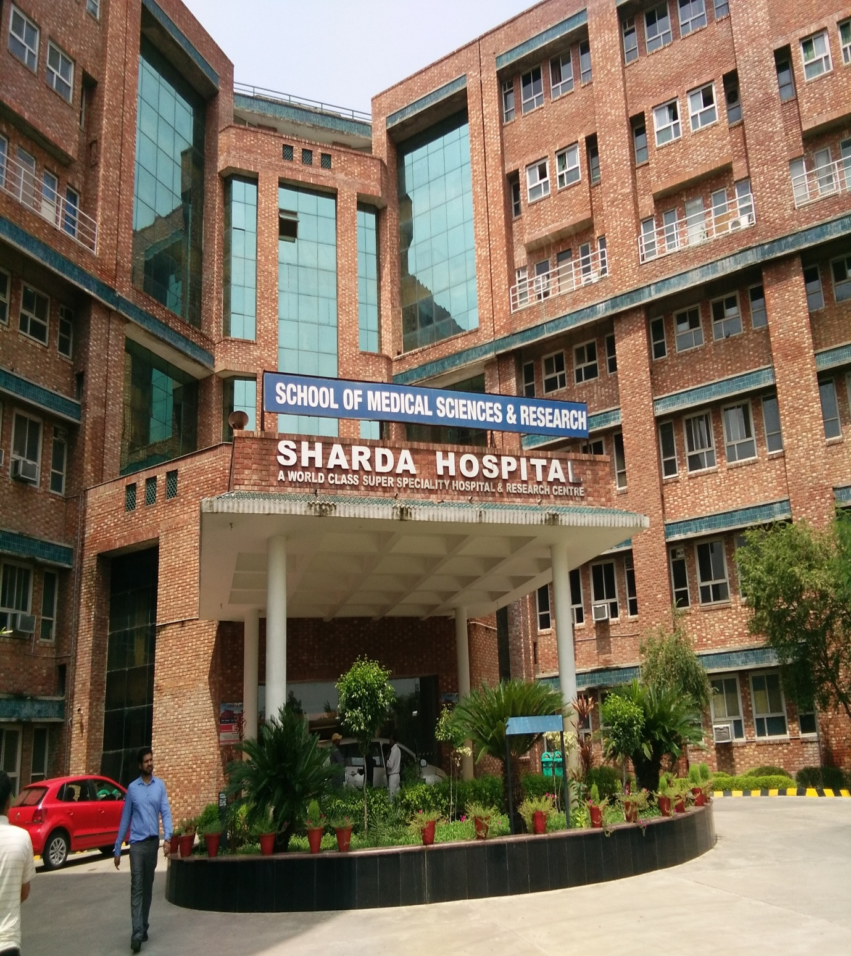

ACKNOWLEDGEMENT

I wish to express my sincere gratitude to Brig. Dalip Sir, HOD of operation department Sharda Hospitals, Gr.Noida, Uttar Pradesh for giving me the opportunity to do my Summer Internship at his highly esteemed Organization.

I am grateful to Meenakshee Dixit for their valuable guidance, advice, suggestion and encouragement rendered to me at every stage.

I am also extremely thankful to Mr. Parshant Sirvastav (Housekeeping Department), Mr. Pradeep (Pharmacy), and Mr. Parmod Marwah (Biomedical Engineering), Mr. Deepak gupta (Ambulance and Laundry Department) and Mr.Rajbir (SequrityDepartment) for giving me information and valuable guidance during the period of internship.

Without their encouragement and guidance this project would not have materialized.

The guidance and support received from all the members who contributed to this study was vital for the completion of this study. I am grateful to all of them for their constant support and guidance either directly or indirectly towards completion of my study.

PAGE LEFT BLANK
INTENTIONALLY
VISION AND MISSION
OF
SHARDA HOSPITAL

VISION:-
Sharda hospital aspires to be a top research driven, community serving, not for profit centre of excellence for healthcare services.

MISSION:-
To become a preferred healthcare services provider by continuously focusing on community development, and high end teaching and research.

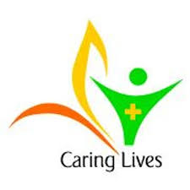

LOGO OF SHARDA HOSPITAL

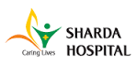

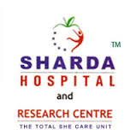

INTRODUCTION
Sharda hospital is a state of art multi super speciality hospital it offers medical care at par the global excellence.
It is equipped with all modern facilities and equipment.
Sharda hospital offer vide range of medical services from tertiary care, super specialities, general specialities, advanced diagnostic & radiology services to critical care.

It is also established a PANCHAKARMA centre at sharda hospital. Which provide therapies of high and positive prognostic value to the diseases that are considered to be medically un manageable.
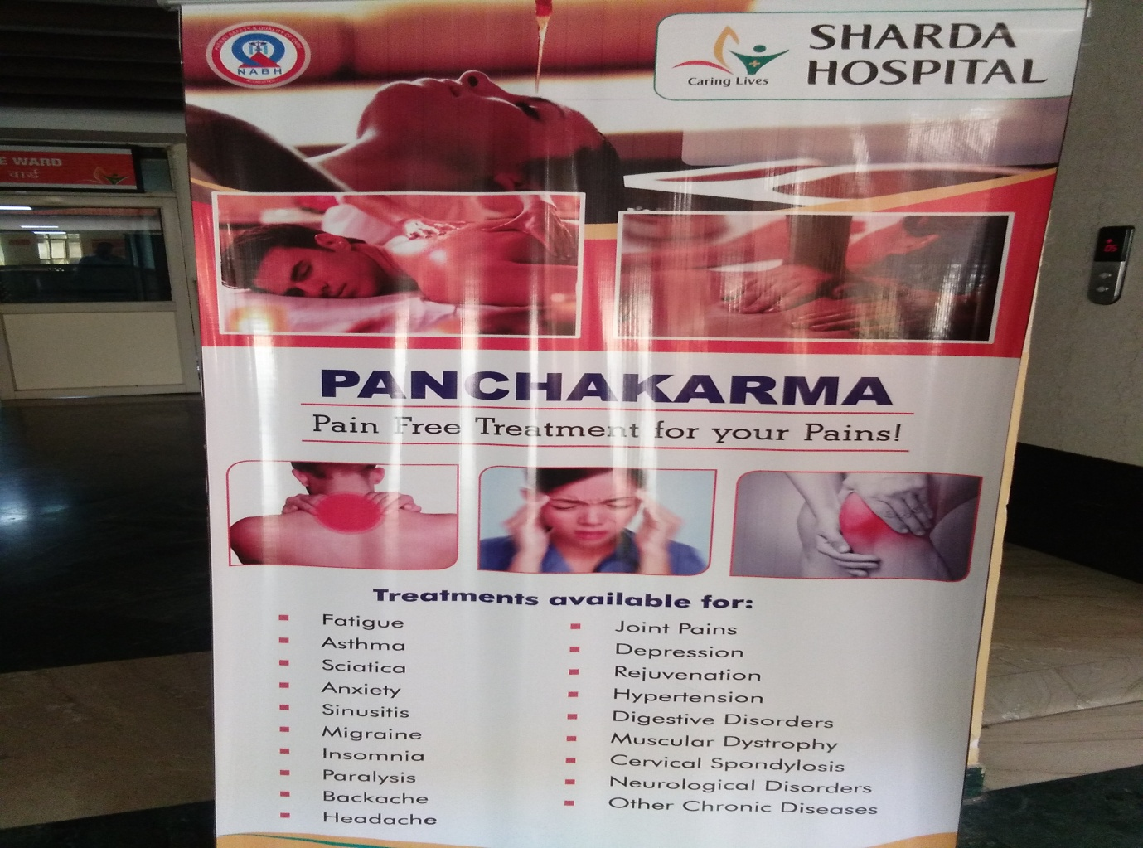

SERVICES given by hospital are:-
Ambulance Radiology Parking
Pharmacy Blood bank Wating lounge

It is associated with School of Medical Sciences and Research.
It also includes ±200 MBBS students.
It has 100+ beds in critical care in the fields of medicine, pulmonology, surgery, pediatric, neonatology, cardiology, cardiothoracic surgery and neurosciences.
It also provided medical facilities to all section of the society.
SHARDA HOSPITAL is a 900+ bedded hospital.
The capacity of the hospital is 1000+ bedded.
It included six blocks in every floor. (A,B,C,D,E,F)

It also provided medical services to the international patients; it gives packages services international patients.
The packages services will starts from Rs.2500 to Rs. 7500 in packages of 2500 Rs. They will limited services and the packages of Rs.7500 they give unlimited services to the internationals patients.
It also provided services to CGHS/ECHS patients and or other for government and corporate empanelment.
Likes ITBP, BSF, CRPF, Indian oil, Bruda Druck , BSNL, CISF, POWER SPACK and some others.
Sharda hospital is also associated with Insurance Company like Apollo Munich Health Insurance, Medicare, United Health care, Star Health insurance, focus TPA, Genius TPA.
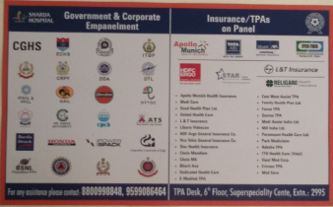
Every hospital consists of some emergency codes they are also available in the hospital mainly they are 7.
Which is shown in picture:-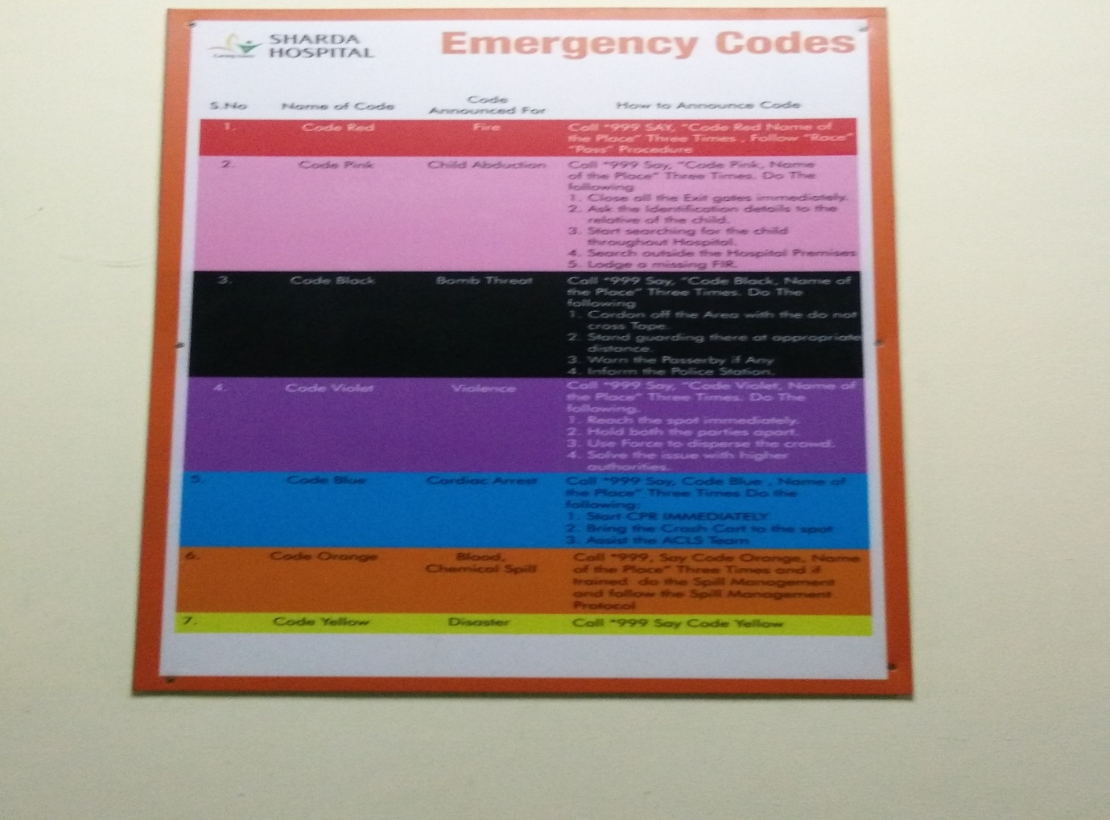
There are 4 gates are available in the hospital.
First gate are associated with Emergency department.
Second gate are associated with Reception.
Third gate are associated with OPDs.
And Fourth gate associated with Admission and Billings.
Sharda hospital is takes the accreditations from NABH & NABL.
Every Thursday Pulse Program has been organised by the Operation Department.

SERVICES FOR INTERNATIONAL PATIENTS
Sharda Hospital, a part of Sharda University is geared to welcome international patients. We offer the highest standards in cutting-edge technology led by a dedicated team of doctors. We ensure a hygienic environment and personalized care.
Our International Patient Services will organize your treatment packages, visa assistance, airport pick up, hotel reservations and any sightseeing trips you may want to add after your recovery. These services include coordinating scheduling of appointments, medical care and advice and ensuring your comfort and well being.
- Appointment scheduling
- Treatment packages in advance
- Visa assistance Airport pick-n-drop facility
- Hotel reservations, (if needed)
- Language interpreters
- Express check-in through our dedicated international patient’s lounge
- In-house business centre
- Choice of international cuisine
- International newspapers & internet access in the room
- The recliner’s lounge for your comfort
- Dedicated International executive during your entire stay with us at ‘Sharda Hospital’ for all your medical & non-medical needs
- Ambulance pick up if required
- Concierge services for dining & entertainment
- Follow up assistance for future appointment scheduling after discharge
HOSPITAL SERVICES:-
ADMN. SERVICES
ESSENTIAL SERVICES
- PERSONNEL MANAGEMENT
- FINACIAL MANAGEMENT
- HOUSEKEEPING
- MATERIAL MANAGEMENT
- OPD SERVICE
- IPD SERVICE
- EMERGENCEY AND CASUALTY SERVICE
- OPERATION THEATER

HOSPITAL
PATIENT
UTILITY SERVICES
SUPPORTIVE SERVICES
- HOSPITAL ENGINEERING
- TRANSPORT
- MEDICAL STORE
- PUBLIC RELATION
- COMMUNICATION
- FIRE AND SECURITY
- CANTEEN
- DHARAMSHALA
- DIETARY SERVICES
- RADIOLOGY SERVICES
- LABORATORY SERVICES
- CENT. STERILE SUPPLY SERVICES
- LAUNDARY SERVICES
- BLOOD BANK
- MORTUART
- MEDICAL RECORDS
- PHARMACY SERVICES

FACILITIES:
- Out Patient Department
- In Patient Department
- Emergency & Trauma services
- Intensive Care Unit
- Pathology Department
- Radiology Department
- Operation Theatre
KEY SPECIALITIES:
- Emergency medicine
- Surgery (minimal access surgeries)
- Orthopedics
- Obstetrics & Gynecology
- Medicine
- ENT
- Ophthalmology
- Pediatrics
- Radiology
- Laboratory
- Neurology & Neurosurgery
- Cardiac sciences
- Oncology
- Gastroenterology
- Plastic surgery
- Urology
- Dermatology
- Dentistry
- Physiotherapy
LOCATION OF DIFFERENT DEPARMENTS
A BLOCK
- GROUND FLOOR
- Radiology
- 1ST FLOOR
- Central Lab
- 2ND FLOOR
- Dept. Of Optho.
- Semi-private Ward
- 3RD FLOOR
- General Surgery Male Wards
- 4TH & 5TH FLOOR
- College admin
- College
B BLOCK
- GROUND FLOOR
- Emergency
- 1ST FLOOR
- Labour Ward
- 2ND FLOOR
- Burn Unit
ICCU, SICU, MICU, PICU
OT Complex
- 3RD FLOOR
- General Surgery Female Ward
- 4TH & 5TH FLOOR
- Dept. of anatomy
- Biochemistry
C BLOCK
- GROUND FLOOR
- OPD (Ped., Obs. & Gynae., Blood Bank)
- 1ST FLOOR
- Administration
- 2ND FLOOR
- Gynae/obs. Ward
- 3RD FLOOR
- General Medicine Female Ward
- 4TH & 5TH FLOOR
- Semi-private & Deluxe Ward
- Central library
D BLOCK
- GROUND FLOOR
- OPD (Ortho, Eye, Surgery & Neuro-surgery)
- TPA office
- 1ST FLOOR
- OPD (Medicine, ENT, Dental, Skin, ECG, Speech Therapy, Echo TMT)
- 2ND FLOOR
- Paed. & ENT Ward
- 3RD FLOOR
- General Medicine Male Ward
- 4TH & 5TH FLOOR
- Ortho. Ward
- College
F BLOCK
- GROUND FLOOR
- Chemist, cafeteria
- 1ST FLOOR
- Offices/ Stores
- 2ND FLOOR
- CSSD
- 3RD FLOOR
- MRD
- 4TH & 5TH FLOOR
- College
- College
EMERGENCY/ CASULTY:
- 25 Beds for Observation (PICU-5, ICU-10 & Ward-10)
- Triage Services/Hi-tech Resuscitation
- High speed evaluation
- Disaster Management
SURGERY (MINIMAL ACCESS SURGERY):
- Gall Bladder Stones
- Appendicitis
- Hernia
- Removal of Uterus
- Thyroid
- Breast
- Gastrointestinal Surgery
ORTHOPAEDICS:
- Knee & Hip Replacement
- Arthroscopic management of Knee, Shoulder & ankle problems
- Complex fracture Clinic
- Osteoporosis Clinic
- Spinal Surgery
- Trauma Center
OBSTETRICS & GYNAECOLOGY:
- Ante-natal screening
- Deliveries
- Post-natal Care
- Specialized treatment of infertility
- Laparoscopic Surgery
- Medicine
- Diabetic Clinic
- Asthma
- Hypertensive clinic
- Sleep Clinic
- Medical ICU
- ENT
- Audiometric
- Minimally invasive surgery
- Routine Surgery
- Ophthalmology
- Complete eye care facility
- Micro surgeries
- Glaucoma unit
- Phako-emulsification
PAEDIATRICS
- The complete child care approach
- Immunization
- Neonatology
- NICU
- PICU
RADIOLOGY
- CT scanner
- X-Ray with image intensifier
- Mobile X-ray Units
- Ultrasound with Color Doppler
- Round the Clock service

LABORATORY MEDICINE
- Complete range of laboratory investigations
- Hematology
- Biochemistry
- Microbiology
- Histopathology
- Serology
- Clinical Chemistry
- Blood Bank
NEURO SCIENCES
- Full time availability of Neurosurgeons
- Neuro Trauma
- Neuro Critical Care
- Minimally invasive Neuro-spinal surgery
- Spinal surgery
- Pain Clinic
CARDIAC SCIENCES
- Fully functional non-invasive cardiac Lab
- State-of-art Color Doppler
- Echo-Cardiograph
- Halter Monitoring
- TMT
- 6 bed Cardiac IC

ONCOLOGY
- Preventive oncology
- Complete diagnostic evaluation
- Chemotherapy
- Palliative care for advanced cancers
- Physiotherapy
PLASTIC SURGERY
- Peripheral nerve surgeries
- Transplantation
- Cosmetic surgeries
- Aesthetic surgeries
- Treatment of Burn injuries
NEPHROLOGY
- Kidney disease
- Dialysis centre 2 beds
- Round the clock emergency
- Full time Nephrologists available
UROLOGY
- Full time Urologist available
- Urology & Laparoscopic urology
- Operative Urology
- State-of-art operation theatre
- Lithotripsy

DERMATOLOGY
- Acne Management
- Psoriasis treatment
- Vitiligo Management
- Hair & Nail clinic
- Cosmetology
- STD
DENTISTRY
- Being a Dental College full range of services are available under one roof
- Orthodontist
- Oral & Maxillofacial surgeon
- Re-constructive Surgery
- Ultra modern equipments
- Community camps
- Special school dental health check-ups
PHYSIOTHERAPY
- Fitness & Health promotion
- Special care for senior citizen
- Burn & Plastic surgery Clinic
- Ortho & Trauma rehabilitation
- Anti-natal clinics

Sharda hospital beds:-
Specialty |  |  | Ward |  |  | Sub total |  |  | Total | G –Total
Medicine & allied specialties
General medicine |  | Male ward |  |  |  | 43 | 85 |  |  | 350
 |  | Female ward |  |  |  | 42 |  |  |  | 350
Pediatrics |  | Pediatric ward |  |  |  | 38 | 38 |  |  | 350
TB &chest |  | Male ward |  |  |  | 10 | 10 |  |  | 350
 |  | Female ward |  |  |  | 10 |  |  |  | 350
Skin & DVD |  | Male ward |  |  |  | 5 | 5 |  |  | 350
 |  | Female ward |  |  |  | 5 |  |  |  | 350
 |  | Male ward |  |  |  | 5 | 5 |  |  | 350
 |  | Female ward |  |  |  | 5 |  |  |  | 350
Surgery & allied specialties |  |  |  |  |  |  |  |  |  | 350
General surgery | Male ward |  |  |  | 48 |  |  |  | 90 | 350
General surgery | Female ward |  |  |  | 42 |  |  |  | 90 | 350
Orthopedics | Male ward |  |  |  | 22 |  |  |  | 38 | 350
Orthopedics | Female ward |  |  |  | 16 |  |  |  | 38 | 350
Ophthalmology | Male ward |  |  |  | 7 |  |  |  | 13 | 350
Ophthalmology | Female ward |  |  |  | 6 |  |  |  | 13 | 350
ENT | Male ward |  |  |  | 7 |  |  |  | 13 | 350
ENT | Female ward |  |  |  | 6 |  |  |  | 13 | 350
Obstetrics & gynecology |  |  |  |  |  |  |  |  |  | 350
Obstetrics &ANC | Obstetrics ward |  |  | 32 |  |  |  | 53 |  | 350
Gynecology | Gyane Ward |  |  | 21 |  |  |  |  |  | 350

Intensive care | No .beds | Private ward
Casualty | 10 | Suit | 4
Casualty ICU | 15 | Deluxe | 8
Resuscitation | 6 | Economy | 5
Pre and post operative bed | 39 | Private | 8
ICCU | 5 | Semiprivate | 8
MICU | 5 | Total | 33
SICU | 5
PICU | 5
NICU C | 3
NICU S | 3
Burn unit | 2
Eclampsia | 2
Labor room | 2
Antenatal care | 2
Total | 107

SUPPORT SERVICES:-
- Chemist Shop
- Pharmacy
- Laundry
- Kitchen
- Canteen/Cafeteria
- Medical Gases
- Sterile Supplies/ CSSD
- Blood Bank
- Mortuary/Postmortem
- Maintenance
- Bio medical engineering
- Transport and Ambulance
- Medical Records
ENGINEERING SERVICES:-
- Civil
- Electrical
- Plumbing and sanitation
- AC
- Fire
- Carpentry
- Paint etc
- Welding etc
AFFILIATIONS & APPROVALS:-
- BDS is approved by Dental Council of India. Paramedical Courses are recognized by the State Govt. (U.P. State Medical Faculty).
- Approval of MBBS by Medical Council of India and state approval.
- QCI-Quality council of India
- CGHS-central government health scheme
OTHER SERVICES:
- Free Parking:
- Transportation: Ambulance services (24 hours)
- Drug Store/Chemist Store: 24 Hour,
- Cafeteria/Restaurant: Within hospital campus

- HISTORY OF HOSPITAL:-
Sharda Hospital is an Institute of Medical Sciences & Research, Greater Noida. This hospital is established to offer medical facility to the needy patients in and around Greater Noida, India and abroad. Sharda is equipped with all modern facilities and sophisticated medical equipment, with the objective of providing comprehensive healthcare under one roof to all sections of the community. All departments are headed by highly qualified and experienced consultants; many of them are renowned doctors in their respective fields.
The Hospital has trained staff including nurses; full time doctors and support staff to provide round the clock personalized attention and care leading to faster recovery of patient.

Laboratory:-
Hi-tech laboratory with pneumatic systems to transfer samples and medicines;
Complete range of investigations in the areas of Haematology, Clinical Pathology, Biochemistry, Histopathology, Cytopathology, Microbiology and Immunology. Open 24 hours with a dedicated team.
Radio Diagnostics
The latest 128 slice cardiac CT and 1.5 Tesla MRI with Total Imaging Matrix, ultra sound,x-ray, Dark room.
Casualty and Emergency
A team of skilled and experienced paramedics, headed by an experienced doctor specializing in emergency and trauma care. A dedicated operating theatre is attached to the emergency unit with a spacious triage and recovery room functioning 24 hours.
Preventive Health Check
Various health check packages for different age group ranging from a newborn to 90 year olds. Patient Rooms Spacious and Comfortable rooms with television, internet and video conferencing facility. Spacious and comfortable Presidential Suites. Isolation wards for patients with infectious diseases.
Physiotherapy
The Physiotherapy Department provides post-operative care for patients and the Department of Yoga offers a therapeutic yoga certificate course.
Gr. Floor:-
Admission and billing counters, 24 hours Blood Bank, Dialysis Centre ,and OPDs.
OPD consultation rooms
Well-equipped OPD consulting rooms to avoid long waiting time and a spacious patient waiting lounge with comfortable seating and pleasant ambiance.

LEDERSHIP:-
S.No. | Composition | Name & Designation
1. | Medical Superintendent | Dr. ANUP RAJ
2. | Dean
3. | HOD- Ophthalmology | Dr. Yogeshwar Arora
4. | HOD- Dermatology | Dr. Amrinder Jit Kanwar
5. | HOD- ENT | Dr. Rohit Saxena
6. | HOD- General Medicine | Dr. Ashok Kumar Agarwal
7. | HOD- General Surgery | Dr. Ashutosh Niranjan
8. | HOD- Microbiology | Dr. Yogesh Chander
9. | HOD- Obstetrics & Gynaecology | Dr. Nimmi Chutani
10. | HOD- Orthopaedics | Dr. Sudhir Kumar
11. | HOD- Paediatrics | Dr. A.K. Gupta
12. | HOD- Pathology | Dr. Geeta Deshmukh
13. | HOD- Psychiatry | Dr. Ashutosh Tripathi
14. | HOD- Radio Diagnosis | Dr. Arti Tripathi
15. | HOD- T.B. & Chest | Dr. S.V. Gaur

HOUSEKEEPING

HOSPITAL HOUSE KEEPING SERVICES:-
It is said that first impression, prolongs till the end.
A patient entering first time to the hospital when welcomed by a neat and clean environment as well as aesthetic feelings, takes away half of his misery and increases his confidence on the hospital.
The hospital house keeping services comprises of activities related to cleanliness, maintenance of a healthy environment and good sanitation services, keeping the hospital premises free from pollution.
In short it is the service directed towards a clean, safe and mentally comfortable environment.
Is a place for every thing and every thing in its place.
Housekeeping means performing all the duties towards cleaning, maintaining orderliness, and running a house or a business property.
In case of hospital, the housekeeping duties involve maintaining the hospital to best possible state in terms of cleanliness, and keeping it at highly desirable ambience.
The housekeeping department, in any hospital business, contributes to major amounts of profit through its services.
Because a customer demands a clean, tidy, and pleasing ambience.
It generates the first impression on a customer mind. Housekeeping efforts shows how the hospital will take care of its guests.
Good housekeeping means having no unnecessary items about and keeping all necessary items in their proper places.

WHAT IS SANITATION
“It is the quality of living expressed in clean homes, clean farms, clean neighbourhood and clean community. Being a way of life, it must come from the people, nourished as it is by knowledge and grown as an obligation & ideal in human relations.
AIMS OF HOUSE KEEPING:-
To provide a Happy, Healthy, Safe and Pollution free environment built on a strong and sustainable programme to the customers who visits the hospital, specially the patients & their relatives.
OBJECTIVE OF HKS:-
General Sanitation, cleanliness and comfortable environment.
Developing courteous, reliable and congenial atmosphere.
Adequate support of motivated staff.
Good interdepartmental cordial relation.
Ensuring safety of staff, patient and relatives.
Quality control of sanitary equipments and cleaning agents.
Proper record keeping and feed back.
COMPONENTS OF HKS:-
GREENARY COMFORT
ADEQUATE WATER SUPPLY
CLEAN & APPEALING TOILETS
SANITATION & CLEANLINESS
PROPER DISPOSAL OF BMW
HOSPITAL INFECTION CONTROL
PEST & RODENT CONTROL
ODOR CONTROL
APPEALING INTERIOR (INDICATORS, LIGHTING, DESIGNING)
PROPER SWEARAGE DISPOSAL
HOUSEKEEPING PROVIDES SOME SERVICES:-
Pantry services:-
They provide high quality pantry service and every types of food.
Pest control:-
They are providing termite control and general pest control services for plant, offices campus and building with Guaranteed using standard quality and Govt. Approved germicides and client requirement and AMC.
Building management:-
The engineering division in our organisation is structured with experienced engineers and architects and skilled manpower to plan, design and execute the construction, interior decoration and all construction related activities.

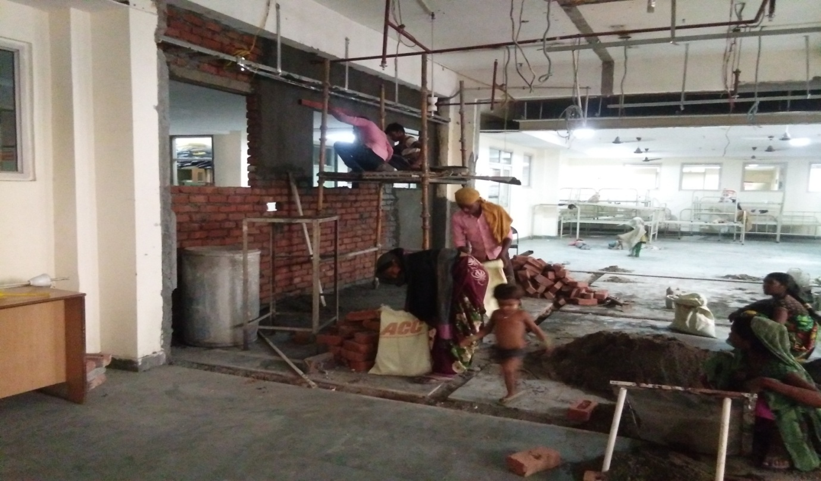

Waste management:-
They have waste disposal squad and machinery by which they can efficiently dispose waste..
OUT COME OF GOOD HKS:-
It eliminates the accident and fire causes.
It provides the best use of space.
It also helps control property damage.
Keeps inventory of material to a minimum.
Reduces the amount of cleanup.
GREAT PATIENT SATISFACTION
MORE VISITS OF PATIENTS
INCREASE POPULARITY
PREVENT & CONTROL INFECTION
ENHANCES PUBLIC RELATION
REDUCE AVERAGE LENGTH OF STAY
REDUCTION IN COST OF MEDICAL CARE
REDUCE PATIENT SUFFERING

GOOD HOUSEKEEPING PROVIDES:-
CLEAN ENVIORNMENT
PRODUCTIVITY
SAFETY
QUALITY

GOOD HOUSEKEEPING

STRUCTURE OF HOUSEKEEPING STAFF IN SHARDA HOSPITAL:-
Executive Housekeeper

Deputy Housekeeper

Assistant Housekeeper

Store Keeper
Linen room supervisor
Uniform room supervisor
Floor supervisor

Store attendants
Linen room attendants
Uniform room attendants
Room Attendants

SWOT ANALYSIS:-
STRENGTHS:-
High quality of equipments.
Large no. of housekeeper.
WEAKNESS:-
Lack of supervisors.
AREAS TO BE CLEANED:-
S.NO. AREA/ ITEM DISINFECTION METHOD FREQUENCY
1. Floor Cleanser 3 in each shift/ week
2. Walls Pesticide Spray once in two weeks
3. Fans Wet Mopping One in two weeks
4. AC Vacuum Cleaning Once a week
5. Refrigerator cleaning with soap once in two weeks
6. Sinks Clean so Daily Once
7. Buckets Soap Water Daily
8. Window pans Mopping Daily
9. Doors/ pale mates Mopping Daily
10. Toilets Mirror, Basin Pots Cleaning with detergent daily
11. Machine Cleaning Scrubbing Once Week

CLEANING AGENTS:-
WATER
CLEANSO/ PHENYLE
CARBON TETRACHLORIDE
SOAP
HCL
AMMONIA
METHYLATED SPIRIT
TURPENTINE
VINEGAR

DUTIES AND RESPONSIBILITY OF HOUSEKEEPING IN HOSPITAL:-
Clean hospital floors and surfaces using predefined cleaning methods and procedures
• Mix appropriate quantities of cleaning liquids and chemicals in accordance with state safety regulations
• Dust, mop and sweep patients’ room, nurses and surgical units and administrative offices
• Make beds using clean and disinfected linen and replenish supplies such as towels, blankets, soaps and shampoos
• Clean and disinfect patients bathroom and public restrooms
• Clean mirrors and windows along with polishing fittings and fixtures
• Collect dirty laundry from patients’ rooms and deliver them to washing areas
• Distribute clean linen and hospital / surgical gowns to appropriate floors
• Take and address patients’ complaints regarding housekeeping services
• Empty trash receptacles and ensure proper compaction of surgical waste according to hospital policies
• Create and maintain inventory of cleaning supplies and equipment
• Inform housekeeping supervisor of any cleaning equipment that may need repair or replacement
• Inform housekeeping supervisor about any building hazard and assist in addressing it
• Maintain a clean and organized storage area for cleaning equipment and supplies
• Iron, fold and store clean laundry after tagging it with room numbers
• Maintain adequate stock of cleaning supplies.

RECENT TREND IN HKS:-
MECHANIZED CLEANING
CLOSED, LEAK PROOF BMW TRANSPORT SYSTEM
ELIMINATION OF UNPLEASANT ODOUR
CONTROL OF NOISE
CONTROL OF INFECTION THROUGH CSSD
APPEALING COLOURS OF WALLS & CORRIDOORS
EVALUATION OF DETERGENTS FACILITY CONSULTANT

MECHANICAL EQUIPMENTS:-
VACCUM CLEANER
SCRUBBING AND POLISHING MACHINES
WET EXTRACTION SYSTEM
SCRUBBER DRIER SWEEPER
HIGH PRESSURE WASHERS
SCARIFYING MACHINES

BIO MEDICAL WASTE MANAGEMENT
The issue of biomedical waste management has assumed great significance in recent times particularly in view of the rapid upsurge of HIV infection. Government of India has made proper handling and disposal of this category of waste a statutory requirement with the publication of gazette notification no 460 dated 27 July 1998. The provisions are equally applicable to our service hospitals and hence there is a need for all the service medical, dental, nursing officers, other paramedical staff and safaiwalas to be well aware of the basic principles of handling, treatment and disposal of biomedical waste. The present article deals with such basic issues as definition, categories and principles of handling and disposal of biomedical waste.

INTRODUCTION
The subject of biomedical waste management and handling has been assuming increasing significance for the past few years. The responsibility of medical administrators as regards proper handling and disposal of this category of waste has now become a statutory requirement with the promulgation of Government of India (Min of Environment and Forests) gazette notification no. 460 dated 27 Jul 1998. The provisions of the gazette are also applicable to Armed Forces hospitals. The present system of biomedical waste disposal system in Armed Forces is far from satisfactory. It is therefore highly desirable that all service officers concerned with the administration of hospitals and other health care echelons take all steps to adhere to the laid down directives. It is equally important that all service medical, dental, nursing officers, other paramedical staff and waste handlers such as safaiwalas be well oriented to the basic requirements of handling and management of biomedical waste. It is with this objective of providing such basic information that the present article has been composed.
Bio medical waste, generated from a number of healthcare units, is imparted necessary treatment to reduce adverse effects that this waste may pose.
Installation of individual treatment facilities by small healthcare units requires comparatively high capital investment. In addition, it require separate manpower and infrastructure development for proper operation and maintenances of treatment system.
A common Bio medical waste treatment facility is used for treatment and disposal of BMW.
The concept of common Bio medical waste treatment facility not only addresses costs related problem but also prevents proliferation of treatment equipment in a city.
By running the treatment equipment to CBWTF its full capacity, the cost of treatment of per kilogram gets significantly reduced.
AIMS AND OBJECTIVES:-
To prevent the use of used products such as syringes which is a major cause to communicate any disease.
To cut down the risk of cutting and edging of waste handlers.
The objective of this study is to safeguard the lives of humans, animals or plants from any disease.
To find out the awareness of waste management amongst the hospital staff.
To find out how the waste is segregated at its generation point, how it is treated inside a hospital compound and how it is disposed.
To find out the linkages between the clean area and dirty area in the hospital.
To find out the types of wastes produced by the hospital and how much it is affecting the living animals i.e. humans or animals.
The basic aim is to protect the public and the environment from potentially infectious diseases caused due to lack of management of medical waste.

NEED FOR SAFETY TREATMENT AND DISPOSAL OF BMW:-
Due to increase the population the amount of biomedical waste generation also increased it requires attention.
Within the domain of municipal solid waste biomedical waste acquire a special dimension, since it is infectious and hazardous.
The amount of infectious waste is around 25% and non infectious wastes constitute nearly 75%. In the absence of proper segregation, the non infectious waste become infectious and poses environmental threat to the society.
An in appropriate treatment and disposal can spread infectious diseases like TB, hepatitis, enteric fever , HIV infection, or even AIDS.
DEFINATION
Biomedical waste is defined as any waste, which is generated during the diagnosis, treatment or immunisation of human beings or animals, or in research activities pertaining there to, or in the production or testing of biomedical.
MAJOR SOURCES OF MEDICAL WASTE:-
Nursing homes for the elderly.
Blood banks and collection services.
Animal research and testing laboratories.
Mortuary and autopsy centres.
Laboratories and research centres.
Hospitals and other health-care establishments.

PRINCIPLES OF WASTE MANAGEMENT
FOUR MAIN PRINCIPLES ARE:-
1 SORTING:-
Sorting is separating waste by type (e.g., infectious waste, pharmaceutical waste) into colour-coded bags at the place where it is generated.

2 HANDLING:-
Handling is collecting and transporting waste within the facility.
3 INTERIM:-
Interim storage is storing waste within the facility until it can be transported for final disposal.
4 DISPOSALS:-
Final disposal is the elimination of solid medical waste, liquid medical waste, sharps, and hazardous chemical waste from the health facility.

Categories of Biomedical Waste:-

There are ten defined categories:-

1. Human anatomical waste: (tissues, organs, body parts)

2. Animal waste: (including animals used in research and waste originating from veterinary hospitals and animal houses).

3.Microbiological and biotechnology waste: (including waste from lab cultures, stocks or specimens of microorganisms, live or attenuated vaccines, wastes from production of biological, etc.)

4. Waste sharps: (used/unused needles, syringes, lancets, scalpels, blades, glass etc.)

5. Discarded medicines and cytotoxic drugs.

6. Soiled wastes: (items contaminated with blood and body fluids, including cotton dressings, linen, plaster casts, bedding etc.)

7. Solid wastes: (wastes generated from disposable items other than waste sharps such as tubing, catheters, i.v. sets, etc.)

8. Liquid waste: (waste generated from washing, cleaning, house keeping and disinfection activities including these activities in labs).

9. Incineration ash: (from incineration of any biomedical waste)

10. Chemical waste: (chemicals used in production of biologicals and disinfection).

DEMARKATION OF COLORS:-
1. Black bag or bin
This is not biomedical waste.
Materials like paper, plastics, cardboard boxes, and other dry waste generated in hospital office or in the wards are disposed in this bag.
This bag is used for collecting dry waste material which is not infectious.

2. Yellow bag or bin
This bag is used for highly infectious items.
Like pathological waste, human anatomical waste such as body parts, amputated parts/organs, tumors, placentas, aborted or dead fetuses, blood soaked cotton bandages, animal tissues, organs, carcasses etc.

3 White and Blue bin
This bag is used for collecting the segregated metal sharps such as needles, blades, saws, scalpels and glass pieces.
A metal box or a plastic canister should be used for collecting the metal sharps.
It is strongly recommended that even metal sharps and broken glass articles should be segregated.
These bags must be puncture proof.
Broken glass sharps should be collected in blue/ white bags.
.
4 Red bag Figure
This bag is used for the disposal of plastics collected from Ot‟s, icu‟s and wards.

Colour Coding for segregation of BMW:-
COLOR CODING | TYPES OF CONTAINER | WASTE CATEGORY | TREATMENT OPTION
YELLOW | Plastic bag | Human anatomical/Animal waste(Tissues, organs ,body parts) | Incineration
RED | Disinfected container/ plastic bag | Microbiology and Biotechnology, soiled and solid waste | Autoclaving/Microwaving/Chemical Treatment
BLUE | Plastic bag/puncture proof container | Waste sharps, solid waste | Autoclaving/Microwaving/Chemical treatment and Shredding
BLACK | Plastic bag | Discarded medicines and cytotoxic drugs, Incineration ash, chemical waste | Disposable secured landfill

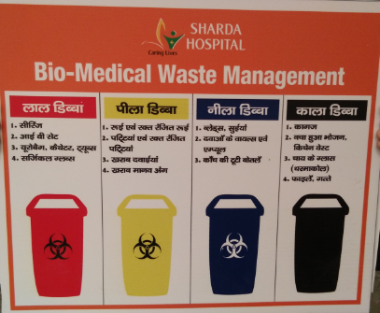

NEW CATEGORIES OF BIOMEDICAL WASTE AS PER BMW RULE 2016:-
Acc. To the BMW guidelines, Black box has been replaced by the white box.
White box is puncture proof, leak proof, tamper proof containers.
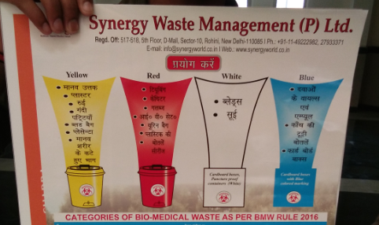
LABEL FOR BIOMEDICAL WASTE CONTAINERS/BAGS:-
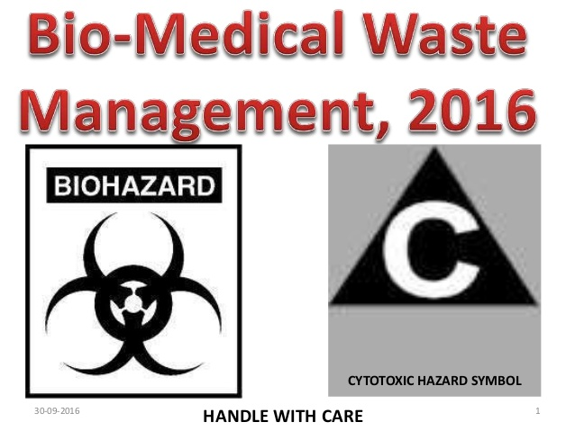

Linen and Laundry services:-
Linen and laundry services are responsible for providing safe clean adequate and timely supply linen to user unit of hospital at right, right price and right place.
Linen is generally used to denote clothing items. It includes the all textile used in hospital including Mattress, bed cover, pillow cover, bed sheet, towels, blankets, curtains, Dr.Coat, table cover and etc.
In this hospital there are two machines are used for clothing. One is used for infected clothes and other for non-infected.
Clothes are segregated by the ward boy.
Ward boy will drop the clothes to laundry and they also receive from laundry.
Hypo-chloride solution is used for infected clothes. And they wash these clothes for one hours in this machine.
50 kg machine require 300 gm of chemical which consists of 50 bed sheets.
Cotton is most preferred and frequently used material as it is cheaper and more comfortable.
Hospital laundry receives all the linen materials from different areas like ward, OT, OPD, and office area where they undergo process of shorting, washing, and extracting, drying, ironing, folding, mending, and delivering.
The OT linen materials need special care since it has to be washed and sterilized carefully. So if possible, the hospital can go for separate laundry process for OT linen materials alone
Total staff = 8
One incharge, one supervisor, six workers.

TYPES OF LINEN
Linen for housekeeping- this includes curtains, drapes, table cloths, etc.
Patient linen-Bed linen, Body linen, OT linen.
Staff linen-Doctors and medical staffs Apron, Gown etc.
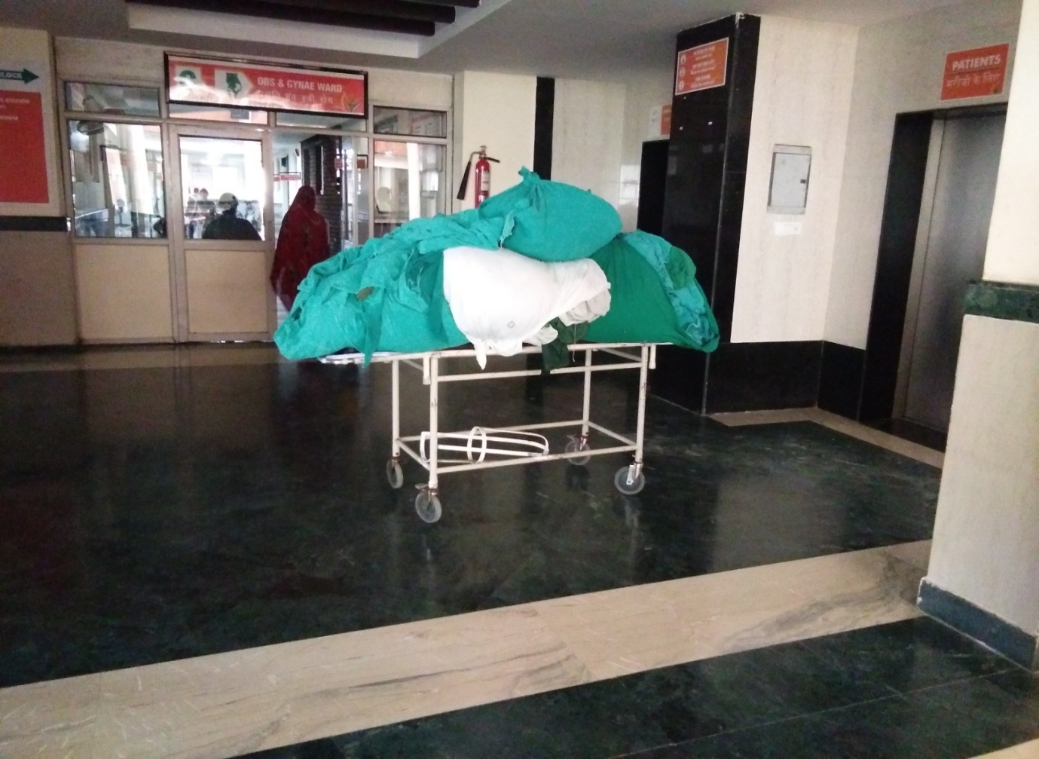

Objective of laundry services:-
To provide comfortable and pleasant environment to patient and visitors of hospital by supplying clean linen.
To control Hospital Infection.
To supply uninterrupted supply of linen to user department.
To improve image of hospital.

Major equipment needed is:-
Boilers
Washing machine
Hydro extraction machine
Drying tumblers
Calendaring machine
Steam bed press
Electric hand press
Sweing machine
Weighing scale
Fire extinguisher
Trolleys

Activities in laundry:-
Collecting and receiving dirty and soiled linen from wards and other dept.
Sorting of linen.
Removing of blood stains.
Disinfection.
Washing and drying.
Repairing/sewing.
Pressing/calendaring and folding.
Storage.
Issue of materials.

There are two types of machine is used :-
One is used for the infected linen. Means the clothes which is infected from the blood and it comes from the OT.
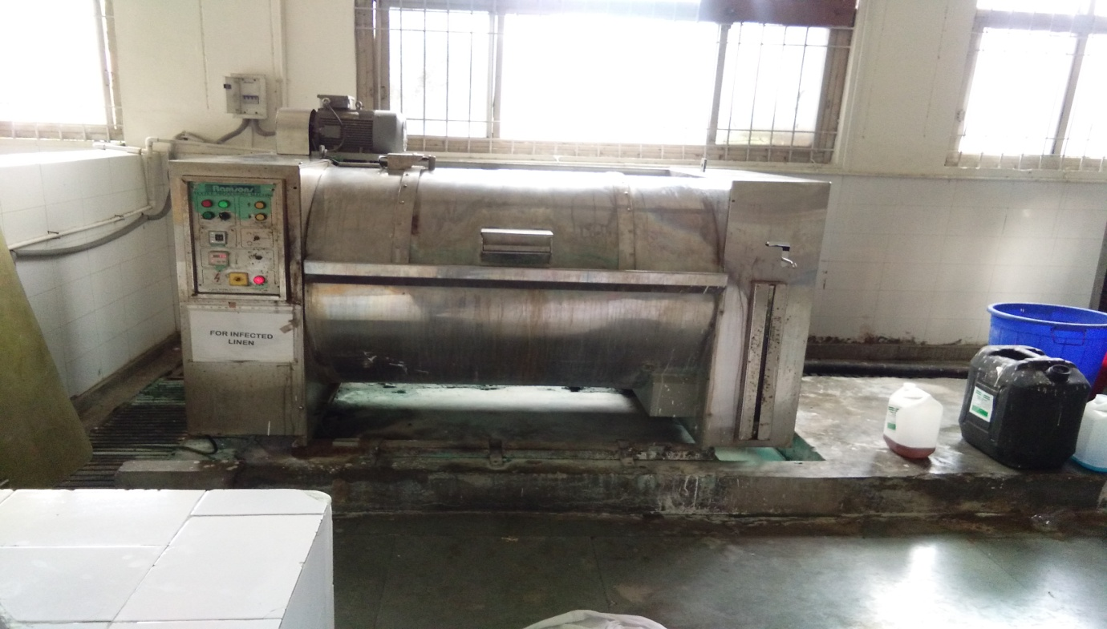

Second one is used for the non infected linen. Means the clothes does not have any linen most of the bed linen, medical staffs apron.
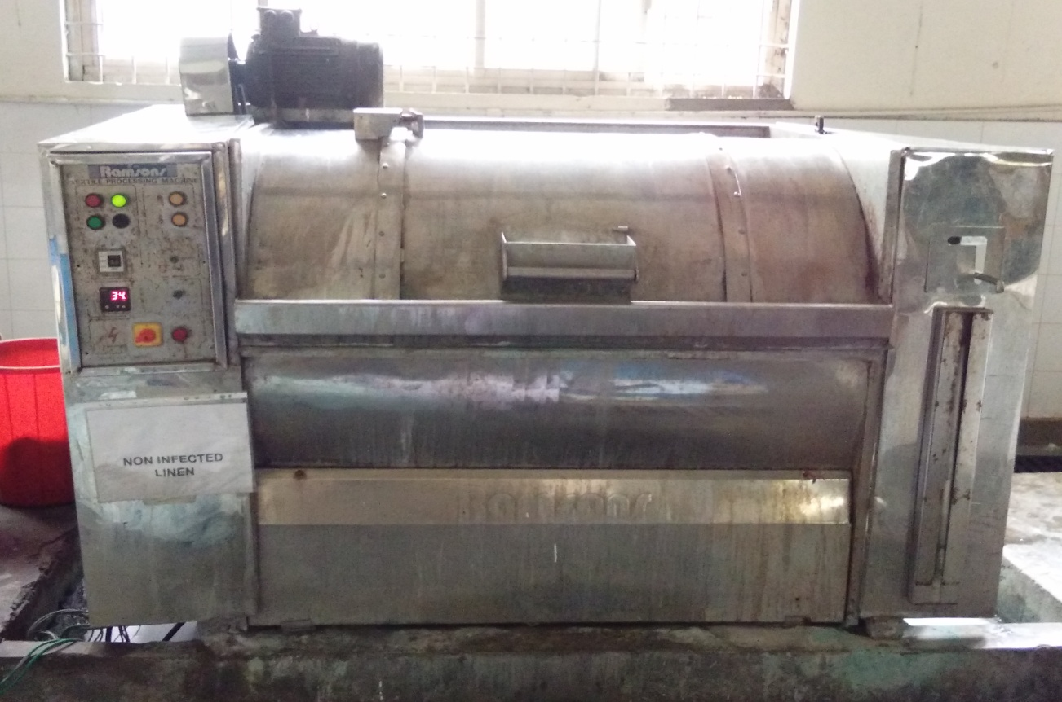

Washing machine
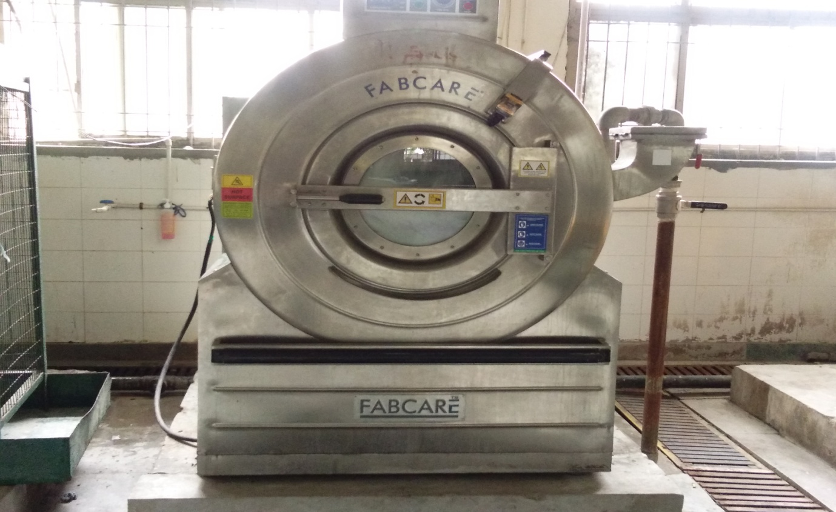

There are two type of washed linen tanks which is used one is used for washed linen and other is used for non washed linen.
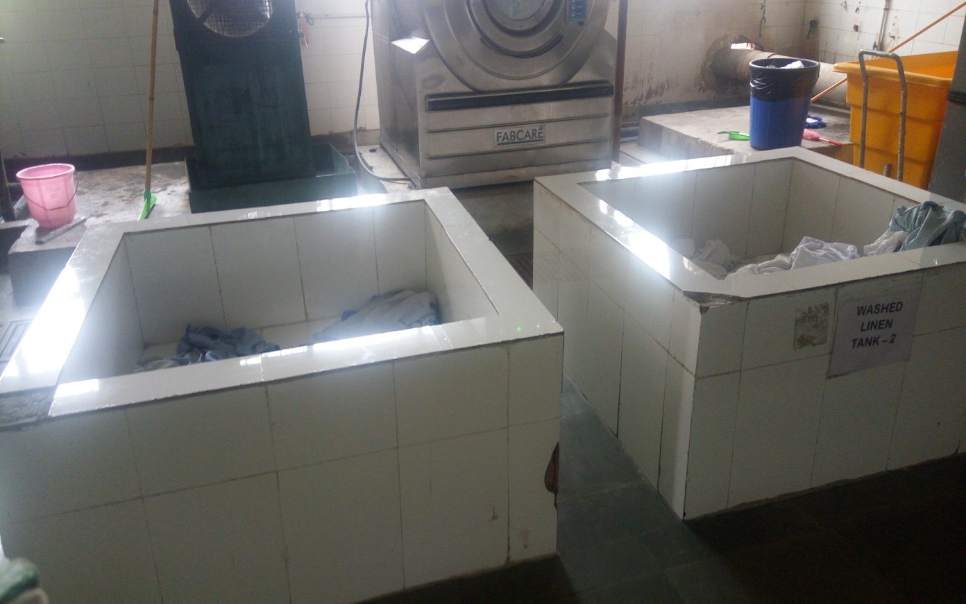

HYDRO EXTRACTOR:-
Hydro Systems’
Smart Dosing System is a total chemical management system that automatically ensures the proper amount of laundry chemicals are added tomatch the actual load size. Determines the linen weight and adds the correct amount of water necessary for the particular cleaning process. The Smart Dosing System then allows the washer and the detergent dispensers to communicate with each other and calculates the precise amount of detergent based on the linen weight and the selected wash program. And with customized options available for usage across various laundry segments, the results are considerable cost savings on water, energy and up to 20% savings on detergent.
Chemical is wasted, which is bad for the environment. Too much soap also leaves your laundry stiff and full of sticky soap residue. Textile strength is compromised and it can also lead to skin irritation.
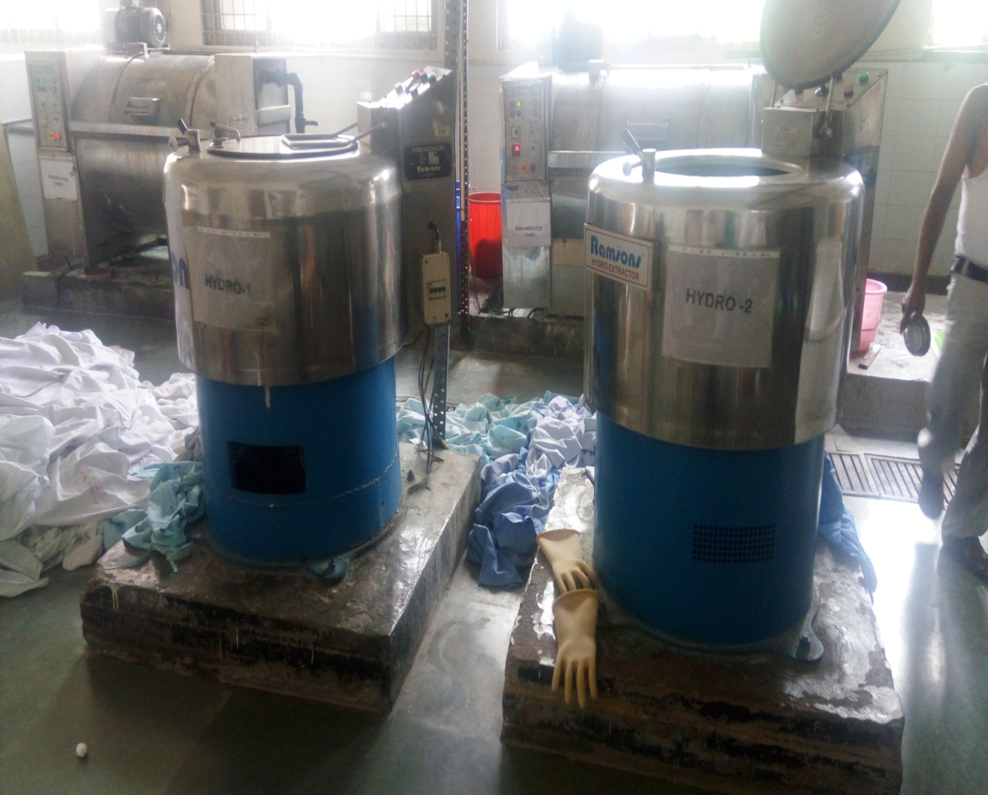
DRYER:-
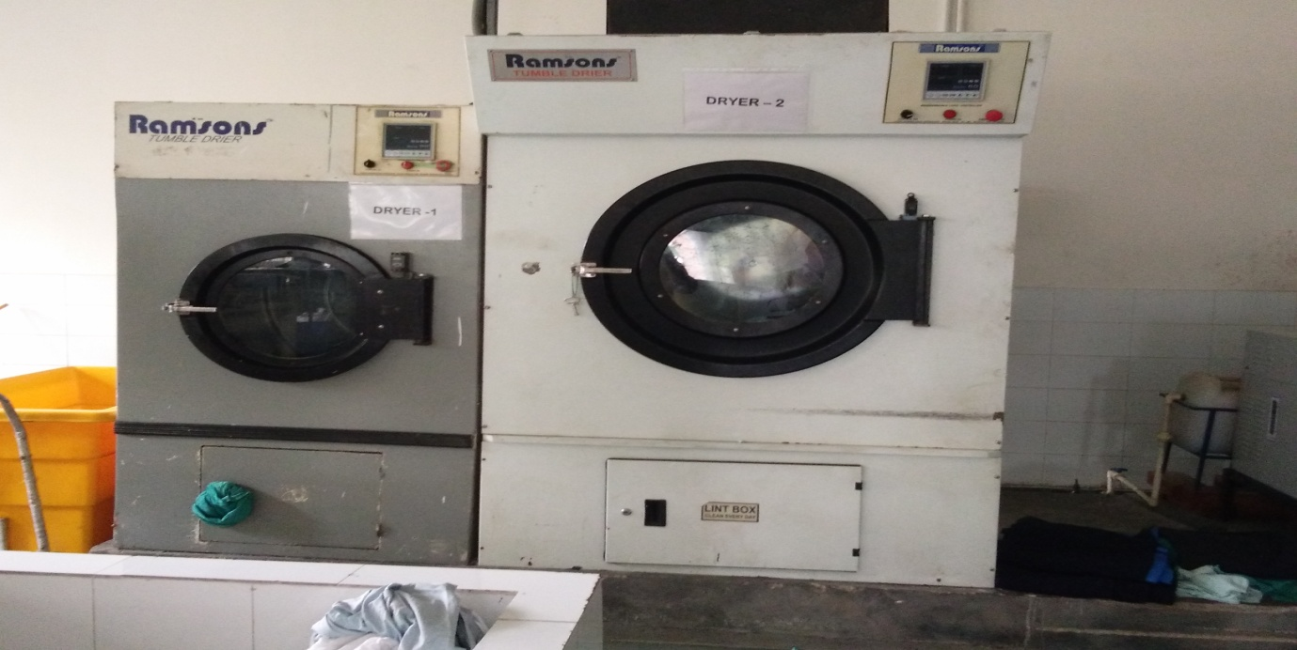

CALANDER MACHINE:-
Electrical Calendar Machine is designed for ironing single or multi-fold flat linen. The Laundry Calendar Machine comes handy where large quantities of flat linen are to be processed. This is a unique machine to dry and iron all at material such as Bed Sheets, Pillow covers, Table Cloth & Napkins directly after Hydro extraction to produce a quality finish.
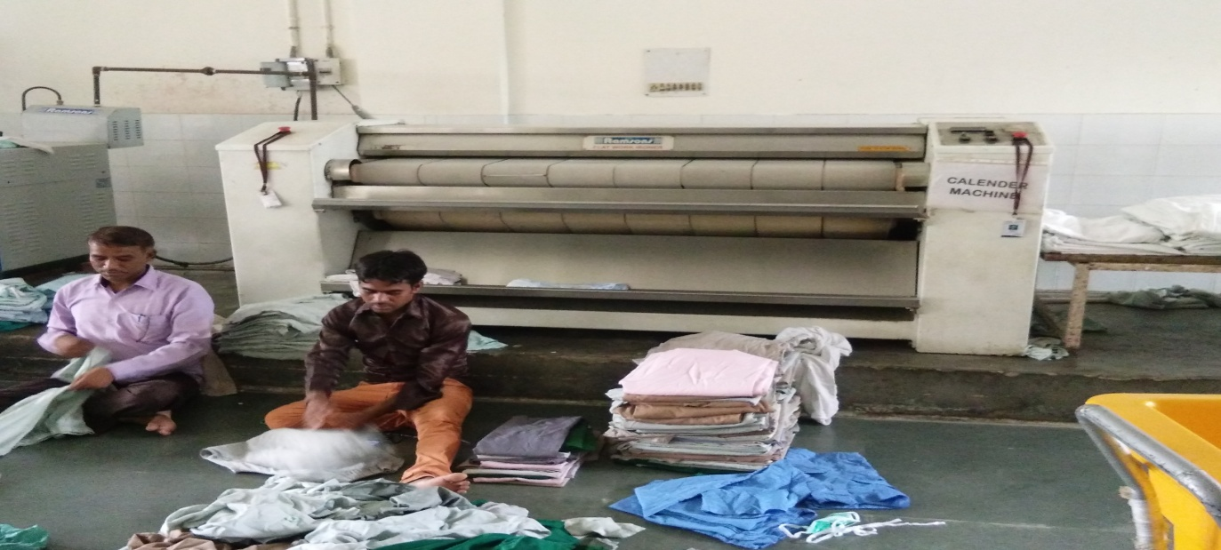
RACK:-
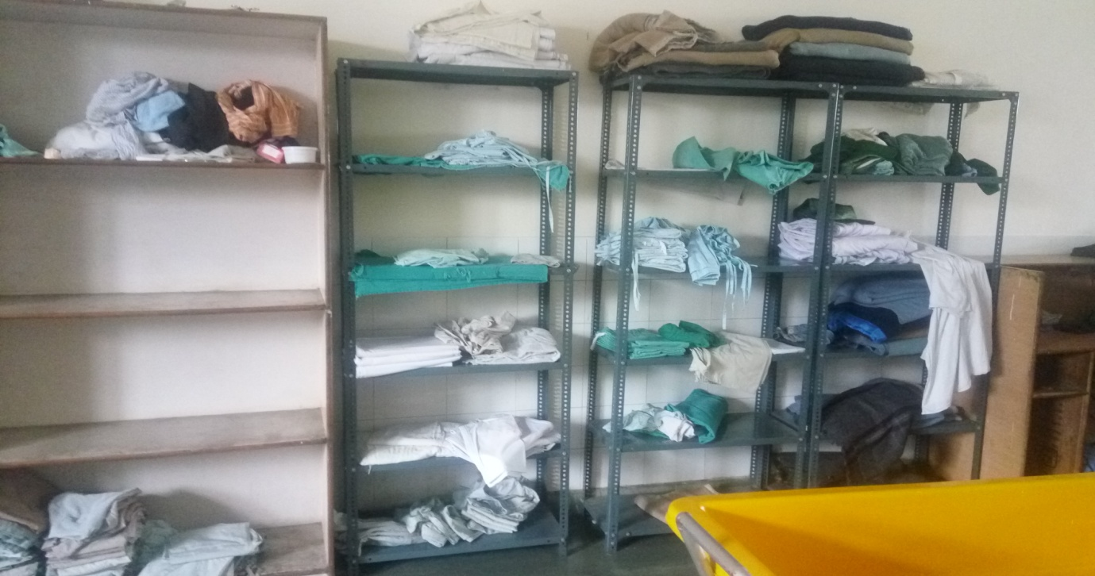

BIOMEDICAL ENGINEERING DEPARTMENT
Modern patient care revolves around not just the skill of the doctor, but technology as well. When the equipment is running correctly, it allows the docs to do their job to the best of their ability. With the most accurate diagnostic equipment at the docs' disposal, the patients have a better chance at survival and recovery. When things are running smoothly around the facility and nothing is broken, the biomedical maintenance flight technicians use the time to perform routine preventative maintenance on all the equipment. They also provide the medics with training on how to properly use new equipment to prevent user error. Biomedical equipment models and makes also changes almost every day, It's not realistic to think you can learn everything about every piece of equipment. The technical school helps prepare the engineers by giving the foundation and framework -- the basics. The junior engineers fill in the gaps as they sort of teach themselves by using the literature and skills picked up along the way from co-workers." Plumbers work on pipes, carpenters work with wood, but we can work on everything in the hospital. We're not limited to one field, when you work on medical equipment, you have to know how to fix everything, and we do because there's no telling what you're going to see. HOD – Parmode marwah
HOD WORKING HOURS General Shift 9.00 am to 5.00 pm
PROCUREMENT:-
The department participates in the decision making process of the procurement of Biomedical Equipment (Hospital Assets) in the hospital. It receives copies of purchase orders placed for procurement of biomedical assets. On arrival of the ordered equipment, the opening of the pack is done in presence of a biomedical engineer who inspects the equipment for physical fitness and technical compatibility. Then if the consignment meets the hospital requirements, the items are approved and in-warded. Then the goods receipt number - GRN is prepared and forwarded by the stores to the Accounts department. The installation and operating of the equipment should be demonstrated to the biomedical.
Also the biomedical engineer needs to be demonstrated and trained to handle some basic breakdowns. Most important thing is that the engineers should be trained on what should not be done during the course of maintenance. What activities would lead to the lapse of warranty etc.,

PREVENTIVE MAINTENANCE:-
The biomedical engineer has to perform daily routine visit to all departments to take stock of the condition of the biomedical equipments. The visits are registered in a routine visit register. This register contain all the details of any new breakdowns, breakdowns pending repair, equipment wear and tear etc.

BREAKDOWN MAINTENANCE:-
When there is a breakdown call from any department, the Engineers visit the site and attend to it. There are many aspects to be taken care before opening an equipment for service/maintenance.
The things to be checked before starting the maintenance procedure are as follows:
1. Check whether the power chords and plugs of the equipment are not damaged.
2. The power supply sockets are not damaged
3. The equipment warranty should be checked. If it is still under warranty, the equipment should not be opened and the service ticket has to be raised with the technical support of the vendor.
4. If the equipment is on a major breakdown, and the equipment is high value equipment and has been insured, then appropriate procedures to make the claim should be followed.
5. If equipment broken down can be repaired by the department engineers, only then it has to be opened.
6. If the equipment cannot be maintained by the departmental engineers, the respective vendors should be informed and followed up to ensure the equipments are restored with minimal breakdown time.
7. High Value equipment which are out of warranty period should be periodically checked for the validity of AMC and insurance so that

AMBULANCE SERVICE IN SHARDA HOSPITAL:-
INTRODUCTION
An ambulance is a vehicle for transporting sick or injured people, to, from or between places of treatment for an illness or injury. The term ambulance is used to describe a vehicle used to bring medical care to patients outside of the hospital or to transport the patient to hospital for follow-up care and further testing. The word is most commonly associated with the land- based, emergency motor vehicles that administer emergency care to those with acute illnesses or injuries, hereafter known as emergency ambulances. These are usually fitted with flashing warning lights and sirens to facilitate their movement through traffic. It is these emergency ambulances that are most likely to display the Star of Life, which represents the six stages of prehospital medical care. Other vehicles used as ambulances include trucks, vans, station wagons, buses, helicopters, fixed-wing aircraft, boats, and even hospital ships. The term ambulance comes from the Latin word ambulare, meaning to walk or move about which is a reference to early medical care where patients were moved by lifting or wheeling. The word originally meant a moving hospital which follows an army in its movements. During the American Civil War vehicles for conveying the wounded off the field of battle were called ambulance wagons.[5] Field hospitals were still called ambulances during the Franco-Prussian War[6] of 1870 and in the Serbo-Turkish war of 1876[7] even though the wagons were first referred to as ambulances about 1854 during the Crimean War. There are other types of ambulance, with the most common being the patient transport ambulance. These vehicles are not usually (although there are exceptions) equipped with life- support equipment, and are usually crewed by staff with fewer qualifications than the crew of emergency ambulances. Their purpose is simply to transport patients to, from or between places of treatment. In most countries, these are not equipped with flashing lights or sirens. In some jurisdictions there is a modified form of the ambulance used, that only carries one member of ambulance crew to the scene to provide care, but is not used to transport the patient. In these cases a patient who requires transportation to hospital will require a patient- carrying ambulance to attend in addition to the fast responder.

An Ambulance is a vehicle for transportation of sick or injured people to, from or place between places of treatment for an illness or injury and in some instances will also provide out of hospital medical care to the patient.
The ward is often associated with road going emergency ambulance which from part of an emergency medical service, administering emergency care to those with actual medical problems.
The term ambulance does, however, extend to a wide range of vehicles other than those with flashing warning lights and sirens. The term also includes a large number of non urgent ambulance which are for transport of patients without an urgent acute condition.
The term ambulance comes from the Latin word “ambulare” as meaning to walk or move about which is a reference to early medical care where patients were moved by lifting or wheeling. The word originally meant a moving hospital, which follws an army in its movements

.
TYPES OF AMBULANCES IN SHARDA HOSPITAL:-
- BASIC LIFE SUPPORT (BLS).
- ADVANCED LIFE SUPPORT (ALS).

Total no. Of calls for BLS =12
Total no. Of calls for ALS =8
Total no. Of calls of discharging or referring=6

BASIC LIFE SUPPORT (BLS) AMBULANCE:-
A basic life support ambulance is equipped with life support equipment like an oxygen cylinder, BP monitor and stethoscope. This type of ambulance can be used for emergencies when the patient can be transported to the hospital quickly.

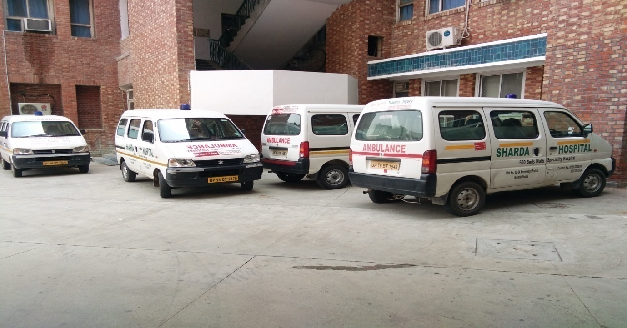
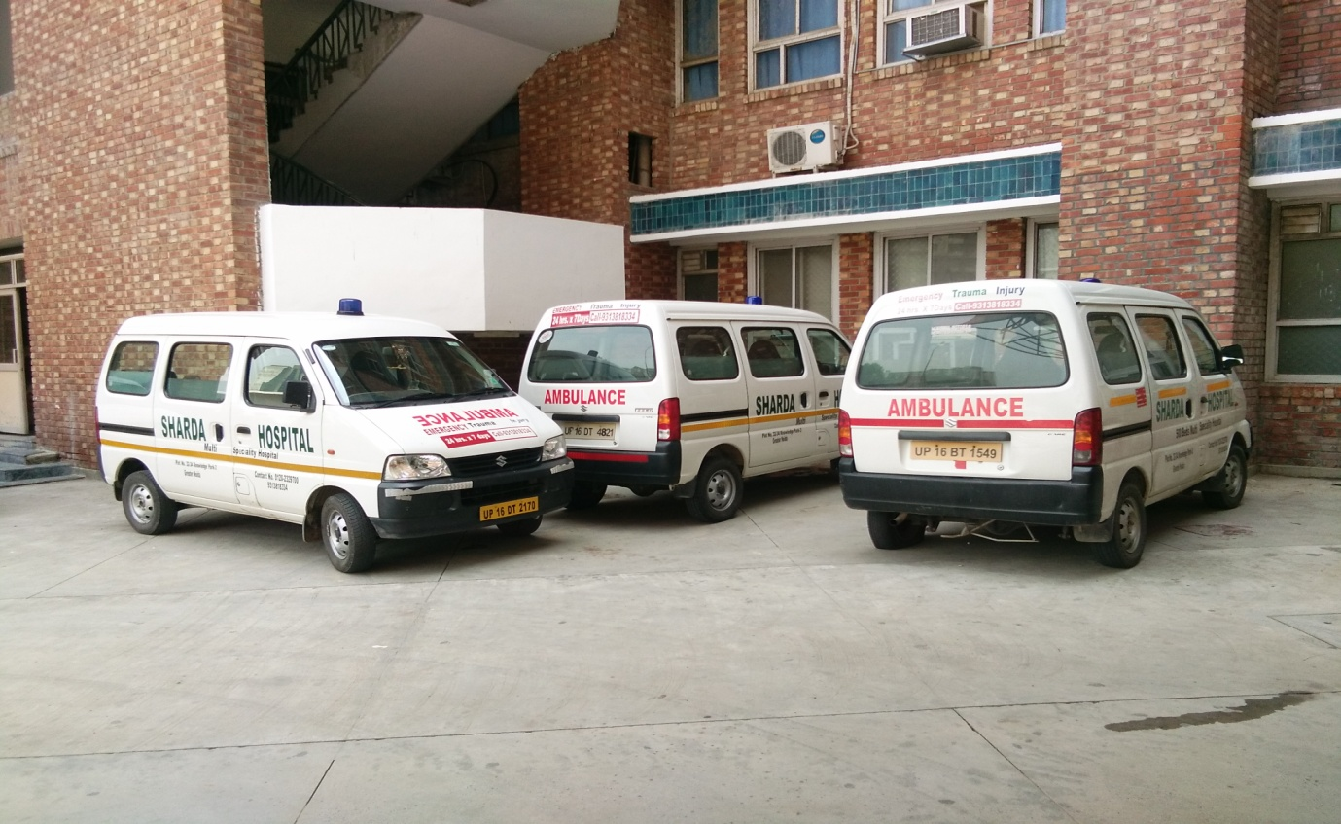

ADVANCED LIFE SUPPORT (ALS) AMBULANCE:-
This ambulance is fitted with advance life support machines such as defibrillators (a machine used to restart the heart), ECG machine (used to keep a check on the heart rate of a person), ventilator, oxygen cylinder, pulseoxymeter (used to check for amount of oxygen in the blood), resuscitations kit, suction machine, and nebulizer and BP apparatus.
This kind of ambulance can be used in cases where the patient is either unconscious, has had a heart attack or is a known patient of heart disease. It can also be used in cases the patient has to be transferred to a hospital that is far away, or he she is immobile and on life support.
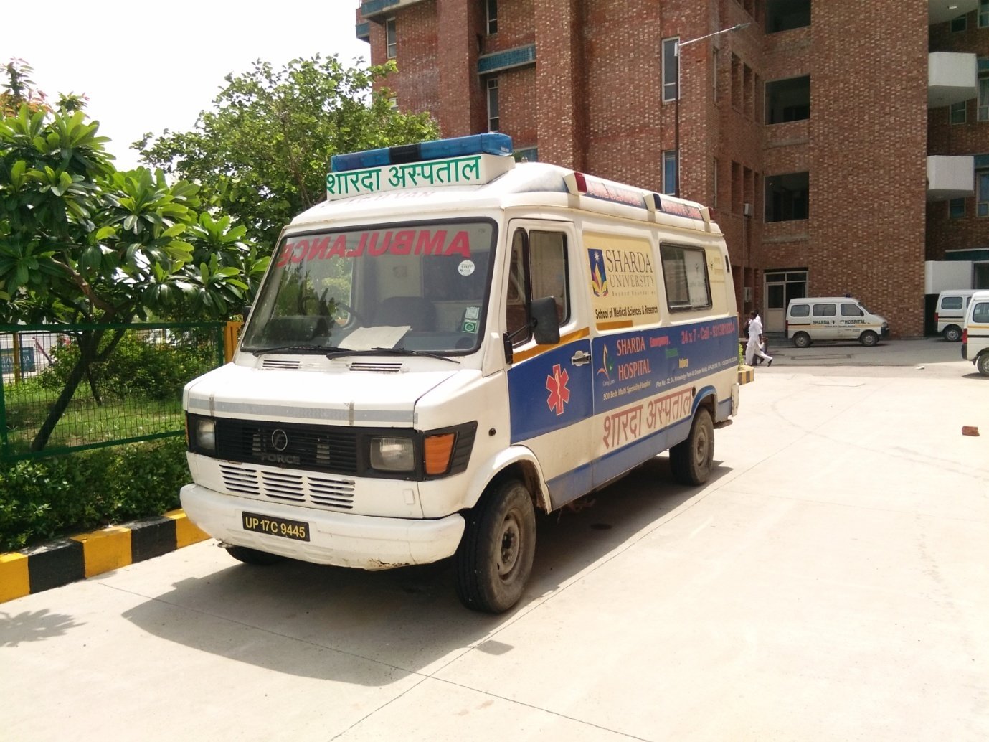
Advanced life support ambulance is also known as cardiac ambulance.
It contains:-
*Doctor *Trained Nurse
*E.C.G *Cardiac Monitor
*Defibrillator * Portable ventilator
*suction machine * Pulse Oxymeter
*oxygen *Emergency medicines
*Resuscitation kit * Nebulizer
*Syringe Pump *Bipap
*Pace Maker * Spine Board

BASIC AND ADVANCE LIFE SUPPORT (CARDIO PULMONARY RESUSCITATION)
BASIC LIFE SUPPORT
Given 1to 4 minutes
A - Airway
B - Breathing
C - Circulation
ADVANCE LIFE SUPPORT
Given 5to 8 minutes
D - Defibrillator
E - ECG
F - Fluid and drugs
G - Gauze parameters
H - Human and Machine function

TYPES OF AMBULANCE:-
EMERGENCY AMBULANCE-
The most common type of ambulance which provide care to patients with an acute illness or injury. These can be road-going vans, boats, helicopter (known as air ambulances).
PATIENT TRANSPORT AMBULANCE-
A vehicle which has the job of transporting patients to, from or between places of medical treatment, such as hospital or dialysis center for non urgent care. These can be vans, buses or other vehicles.
RESPONSE UNIT-
Also known as a fly car or a (quick response vehicle), which is used to reach an actely ill patient quickly, and provide on scene care.
BARIATRIC AMBULANCE-
A special type of patient transport ambulance designed for extremely obese patients equipped with the appropriate tools to move and manage these patients.

HOW IT WORKS:-
- Call on the reception.
- Where the call placed from.
- Type of emergency.
- Name of patient.
- Billing.
- Charges
- Inform to patient.(YES/ NO)
- Contact to driver.
If the case of LAMA no ambulance service is given to patient.

- CASE OF EMERGENCY: (VIVO BUS ACCIDENT TAKE PLACE AT GOALCHAKER NEAR PARI CHOWK).
- Where the call is placed from
- Type of emergency
- No. Of people injured and the condition of the injured.
- The callers name and contact number- for location guidance if required.

- No ambulance service provided for death cases.
- Out sourced ambulance called for them.

- REFERING OR DISCHARGING cases ambulance service can be provided.
- Total no. Of ambulance service in sharda hospital is 8.
7 in source ambulance (BLS) and 1 (ALS).
ELIGIBILITY FOR USE OF TRANSPORT AMBULANCE:-
A patient who has to be transported on a stretcher or wheel chair.
A patient who is mentally visually or orthopedically handicap and cannot use public transport.
Require oxygen during transport.
Suffering from infectious, where is chance of spread in public transport.
Require an attendant to move around.
The ambulance is booked by filling a requisition form and depositing requisite payments if any.
DONTS IN USE:-
Never allow the ambulance for carrying dead bodies as it may spread infection, may cause psychological trauma to the pt.
Speed of vehicle should be optimum on the road.
All ways use exclusively for patient transportation only.
Never Use ambulances for carrying stores, diet or Hospital Staff.

DIETICIAN:
This helps the caterer to power, to guide and to educate the patients in their feeding habits, to give to the ward sister a feeding of confidence and security as far as the food service is concerned. This very fact brings the caterer into contact with a far greater number of people than any other service operation. There are no more possession than good health. We must all eat. There is no other department in the hospital which is called to provide at such a short and regular intervals to both patients and staff through out the day and night.
Equipment and personnel hygiene should be stressed.ωAll walls and ceilings should be painted every 2 years and washed down every 6 months. Floor cleaning in the kitchen must be a routine job. The importance of hygiene in a hospital kitchen cannot be over emphasized. We are all susceptible to bacterial infection, but a sick person with lowered resistance is doubly so.
Hospital catering services are an essential part of patient care. Good-quality, nutritious meals play a vital part in patients’ rehabilitation and recovery, and limit the unnecessary use of nutritional supplements. Hospital catering services should be cost effective and flexible enough to provide a good choice of nutritious meals that can accommodate patients’ specific dietary requirements and preferences.
Effective hospital catering services rely on sound planning and co-ordination of a range of processes involving menu planning, procurement, food production and distribution of meals to wards and patients. Many staff groups are involved in meeting the nutritional needs of patients. In addition to the catering service staff who procure and prepare the food, nursing and medical staff play vital roles in assessing and monitoring the nutritional status of patients.

Dieticians need to be involved in menu planning and in providing expert guidance and treatment for patients with dietary and nutritional problems. Speech and language therapists also have an important role in assessing and monitoring patients with swallowing difficulties and other associated complications. Effective co-ordination and communication they need in hospital.

The dietary service is one of the important supporting services of the hospital unlike any other supporting services.
Are qualified to translate the science of nutrition in health and disease into practical information about food.
Work as member of multidisciplinary team to look after patients who are under the care of consultants.
Visit IPD patients to check on their health and ensure their diet meets their requirements.
Act as advisors to the doctors on the nutritional standard and specifications for the patient food services to meet the patient’s needs.
The diet and kitchen ERP assists the hospital kitchen staff to provide meals to inpatients as per the instruction of dietician and physician. The dietician works with the physician to define the diet for the patient
A balanced diet in term of calories, proteins, fats, carbohydrates, mineral, electrolyte and vitamins is essential for a healthy life. A proper diet provides daily requirement of nutrients to the body thus enhancing the immunity of the person.
Create a daily meal plan for different patients for breakfast, lunch& dinner.

THE WORK IN SHARDA HOSPITAL IN DIETICIAN DEPARTMENT;-
The department has a dietician team consisting of 3 expert dietician with the head of department, MS.
They follows the rules of NABH.
The dietician’s remains active in patient’s care and keep reporting the nutritional status of the patients as well as act advisor to the physician and the medical team.
The dietician remains in touch with the patients and visit them many times in daily.
Normal diet, soft ,semisolid, liquid, clear liquid diets and feeds are provided to the patients- all based on the nature of disease- diet provided to the admitted patients are complimentary. No food from outside is allowed.
Dietician at SHARDA works in coordination with F&B department.
Dietician goes for round many times in days.

THE WORKS INCLUDES
THERAPEAUTIC DIETS:-
Patients receive medical help with their condition, but some have condition that can also benefit from special diets. Eating more of certain foods and avoiding certain things can help to control a patient’s symptom.
Nutritional support:
This means feeding patients who are unable to feed themselves. Example of this type of patients includes patients who had a stroke or a patient who is very weak this can lead to the speedy recovery of the patient.

OPD PATIENTS:-
Outdoor patients coming to diet clinic are:-
Diet chart are given in a language, easily comprehended by the patients.
Diet consultancy for OPD is attended on the basis of first come first serve basis.
Patients from all categories are accommodated special attention is given to vulnerable patients.
All the aspects viz physical, emotional, clinical& social are kept in mind while doing counselling.
Best levels are made to individualize each and every patient diet plan to enhance or improve adherence and compliance to diet plan provided to the patient.
Service is offered to the patients between 9:00am to 4:00pm daily.

IPD PATIENTS:-
The majority of patients in hospital are greatly interested in food and in their meals. The stay in hospital offers an excellent opportunity for food education. A patient should leave hospital with new ideas on menu planning, on the serving of food and on balancing a diet.

SERVICES FOR IPD PATIENTS:-
Breakfast
Lunch soup
Lunch
Evening tea
Dinner

NUTRITIONIST ROUNDS:-
They take five to six round in every day.
It is planned in such away that there is always one dietician to attend the call & patients as well.
It will help us to build a good relation between patients and dietician.
When ever changes are made by the dietician, they concerned doctor and F&B department are informed.

CRITICAL IPD PATIENTS:-
For patients requiring extra care, dietician recommended following three ways for intake of food:
Oral (with the help of nurse)
Tube feed (nasogastric tube/ rye’s tube)
Parental feed

INTRODUCTION TO PHARMACY DEPARTMENT
Pharmacy (from the Greek 'pharmakon' = drug) is the health profession that links the health sciences with the chemical sciences, and it is charged with ensuring the safe and effective use of medication. The scope of pharmacy practice includes more traditional roles such as compounding and dispensing medications, and it also includes more modern services related to patient care, including clinical services, reviewing medications for safety and efficacy, and providing drug information. Pharmacists, therefore, are the experts on drug therapy and are the primary health professionals who optimize medication use to provide patients with positive health outcomes. The term is also applied to an establishment used for such purposes. The first pharmacy in Europe (still working) was opened in 1241 in Trier, Germany.[citation needed] The word pharmacy is derived from its root word pharma which was a term used since the 1400–1600's. In addition to pharma responsibilities, the pharma offered general medical advice and a range of services that are now performed solely by other specialist practitioners, such as surgery and midwifery. The pharma (as it was referred to) often operated through a retail shop which, in addition to ingredients for medicines, sold tobacco and patent medicines. The pharmas also used many other herbs not listed. In its investigation of herbal and chemical ingredients, the work of the pharma may be regarded as a precursor of the modern sciences of chemistry and pharmacology, prior to the formulation of the scientific method. The pharmacy is one of the most extensively used therapeutic facilities of the hospital; it is one of the few areas of hospital where large amounts of money are spent of purchases on a recurring basis. It is also one of the highest revenue generating centers. A fairly high percentage of the total expenditure of the hospital goes for pharmacy services. It caters to out patients, inpatients, other areas like OT, Clinical laboratory.

NEED FOR THE DEPARTMENT
Make available all the drugs and pharmaceuticals needed for patient care according to the hospital formulary: the right drug in the right formulary and dosage. An efficient dept should determine in advance and stock adequate quantities of drugs, at the same time avoiding idle inventory. Disseminate information regarding drugs among the users, functioning as Drug information centre. Prepare certain medicines (usually intravenous fluids, mixtures and ointment) depending on the policy of the hospital. Observe high studies of professional skill in dispensing medicines according to the prescriptions.

FUNCTIONS:-
The features of the hospital pharmacy are as follows
Procuring pharmaceutical items:-
(a) Requisition
(b) Purchase
(c) Receiving
(d) Checking
(e) Storing.

Dispensing items
(a) Preparing
(b) Packaging
(c) Labeling
(d) Dispensing.

Distribution of items to different departments as per their requirements
Quality control of drugs received by the hospital
(a) Check on arrival
(b) Periodic check
(c) Random check
(d) Dispensing.

• Maintaining information regarding quality, cost and sources of supply of all drugs, chemical, and other items for information of medical, nursing, and other staff.
• Ensuring adherence to the laws, acts, rules, and statutory, regulations applicable to pharmacies and dispensing.
• Establishing and maintaining adequate accounting procedures for pharmacy charges, supplies, concessions and free services.
• Furnishing reports of the activities, periodically and a comprehensive report annually.
• Serve as a member of the drug and therapeutics committee be actively involved in its function and activities, and implement its decisions.
• Carry out research and participate in the evaluation of new drugs. • Participate in performing therapeutic assessment of drugs and in the preparation of a hospital formulary so that equally effective but less of expensive drugs may be put on the formulary A formulary is a list of drugs approved by the medical staff and the pharmacy committee for hospital use and kept in the inventory.
• Keep a note of essential list of drugs prepared by WHO.
• Have up to date information of drugs and have been banned in India or other countries.
• Investigate problems of complaints related the drug therapy i.e.
(a) Evaluation of potency and active ingredient
(b) Detection of harmful agent resulting due to adulteration, improper preservation or expiry of drugs

PHYSICAL STRUCTURE
The Pharmacy department at sharda Hospitals is having three internal departments. They are the Central Pharmacy, In-patient Pharmacy and Out-Patient Pharmacy. The Central Pharmacy supplies the necessary drugs to the In-Patient and the Out-Patient Pharmacies.

OUT-PATIENT PHARMACIES:-
The drugs are stored in racks along the walls and there are refrigerators to store medicine that need to be maintained at cold temperatures. There is easy accessibility for people/ patients as it is along the main common walkway and easy to locate.

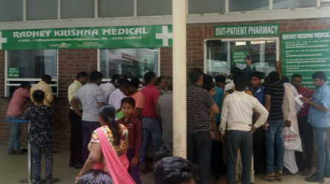

IN-PATIENTS PHARMACIES:-
The inpatient pharmacy is located in the Gr. Floor very close to the lifts. The drugs are stored in racks along the walls and there are refrigerators to store medicine that need to be maintained at cold temperatures.
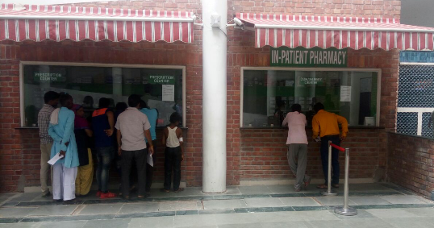

CENTRAL PHARMACIES:-
The drugs are stored in racks along the walls and there are refrigerators to store medicine that need to be maintained at cold temperatures.

OUTPATIENT PRESCRIPTIONS:-
Doctors give the prescriptions to the patient which he/she brings it to the pharmacy. The pharmacist receives the prescription. He/she then places all the medicines and items required one by one at the space below the dispensing counter. She then gives the prescription to the computer operator for entering the particulars taken, amount taken and issue a bill for the same (annexure 2). In the mean while the pharmacist packs the medicines well and puts it in a hand cover. After the bill is generated the computer operator hands it over to the pharmacist. Once the pharmacist receives the bill she gives it along with the packed medicines to the cashier. As the pass box through the cashiers counter is not too big, large amount of medicines cannot be given to the customer through the box. At such times the pharmacist gives only the bill to the cashier. After payment is done by the customer the pharmacist hands over the medicines. The cashier receives the cash from the customer puts a seal saying cash received and gives a copy to the customer and keeps the copy with himself. In case of payment being done by card, the customer has to inform earlier so that the mode of payment is entered in the bill. In case of card payment the customer will swipe the card and the customer copy of the bill generated is given to him and another copy signed by the customer will be kept by the cashier.

INPATIENT PRESCRIPTIONS :-
The doctor prescribes the medicines required. The prescription is brought by the patient’s attenders to the pharmacy. The drugs are dispensed in the same way as for outpatients and it’s the same principle cash and carry. If the patient is insured then the prescription for the patient is brought to the pharmacy by the nurse in-charge of that ward. There is a provision in the software where once the hospital number of the patient insured is entered, the address and the details of the patient are displayed. The total sales of drugs for the patient are fed in and the bill is given to the nurse to hand it to the patient or the patient’s attender

SEQURITY GUARD:-
Establishing or maintaining a sufficient degree of security is the aim of the work, structures, and processes called "security."
♦ It applies to any vulnerable and valuable asset, such as a person, dwelling, community, nation, or organization.
♦Security as a condition is the degree of resistance to, or protection from, harm.

Security guards are those persons whose is responsible for the any kind of interaction between the others and provide the safety to the patients, attendant and other organisation member.

A security guard, security officer, or protective agent is a private person who is hired to protect an organization's assets (property, people, equipment, money, etc.) from a variety of hazards (such as waste, damaged property, unsafe worker behaviour, criminal activity such as theft, etc.) by using preventative measures. They do this by maintaining a high-visibility presence to deter illegal and inappropriate actions, observing (either directly, through patrols, or by watching alarm systems or video cameras) for signs of crime, fire or disorder; then taking action to minimize damage (example: warning and escorting trespassers off property) and reporting any incidents to their client and emergency services, such as police and ambulance, as appropriate.

In sharda hospital, when patients is enter in to the emergency guard is responsible for reducing the no. attendants those who come with the patient. They allow two or three persons to go to the emergency room not with the patients but go for the admission or billing for the patients. When the billing and admission is done then guard go to the person and asks the attendant to wait outside of the emergency room or in waiting hall. And then guard allow the one attendant to remain in the emergency room.
If the patient attendant does not follows the guard rules then bouncer will help the guard to reduce the crowd in the emergency room.
In Sharda hospital, there are four gates and four guards were sitting there to help the person who fined difficulty.
And four-five bouncer were also sit in the ground floor who were checking the visitors passes who have to come to meet with the patients.
In Sharda hospital there is 12-13 lift where two bouncers are sit and checking the passes. And two bouncers were sitting to the steers and they also doing the same work and one was sitting to the ramp.
When the bouncers were goes for round in the hospital their position is occupied by the guards.
And bouncers go for rounds in hospital three or four times in a day and they also again checking the passes and if any of person were find without the pass in the hospital they said the attendant to wait in the waiting room.

In Sharda hospital, there are six floors and six blocks.
Every floor has four to five security remains there.
They help us to reduce the any kind of accident in the hospital.
And this type of procedure is also doing in the night shift.
In case of any fire or emergency, guard and bouncers will reaches their immediately to reduces the risks or uncertainty because they know how to the fire extinguishers.

Sometimes guard and bouncers will give the direction to the patients if some one if find difficulty to find the department in the hospital.
In admission or billing, guards will help the patients/attendant to maintain the line.
There is regular checking of bags that the patients and attendants that carry.
This checking is used for safety of patients and avoids some attacks in the hospital.

Security guards prevent risks and deter crime, watch out for looming danger, and report any crime they may encounter.
- A security guard or security officer is a person who is paid to protect property, assets, or people. They are usually privately and mostly comprised with civilian personnel.

Does not provide treatment to patients, but is a very visible hospital employee, often greeting patients when they enter the facility.

Main duty is to protect people, property, information, and reputation.
Responds rapidly to security emergencies within the hospital or health care setting.
May help people into and out of their cars, receive hospital deliveries at night, and escort patients as needed.
Typically has completed a basic security officer’s program covering subjects from laws of arrest to weapon safety. Requirements beyond this program vary by state.

Reports to a shift supervisor, operations chief, or hospital security supervisor.
Becomes involved with patients when assistance is requested by medical or nursing staff, or when patients or their families ask for assistance or information.

4. LITERATURE REVIEW
A literature review is a text of a scholarly paper, which includes the current knowledge including substantive findings, as well as theoretical and methodological contributions to a particular topic. Literature reviews use secondary sources, and do not report new or original experimental work.

Types of literature review:
Most often associated with academic-oriented literature, such as a thesis, dissertation or peer-reviewed journal article, a literature review usually precedes the methodology and results section. Literature reviews are also common in a research proposal or prospectus (the document that is approved before a student formally begins a dissertation or thesis). Its main goals are to situate the current study within the body of literature and to provide context for the particular reader. Literature reviews are a staple for research in nearly every academic field.
A systematic review is a literature review focused on a research question, trying to identify, appraise, select and synthesize all high quality research evidence and arguments relevant to that question. A Meta analysis is typically a systematic review using statistical methods to effectively combine the data used on all selected studies to produce a more reliable result.

Why do we write literature reviews?
Literature reviews provide you with a handy guide to a particular topic. If you have limited time to conduct research, literature reviews can give you an overview or act as a stepping stone. For professionals, they are useful reports that keep them up to date with what is current in the field. For scholars, the depth and breadth of the literature review emphasizes the credibility of the writer in his or her field. Literature reviews also provide a solid background for a research paper’s investigation. Comprehensive knowledge of the literature of the field is essential to most research papers.

Who writes these things?
Literature reviews are written occasionally in the humanities, but mostly in the sciences and social sciences; in experiment and lab reports, they constitute a section of the paper. Sometimes a literature review is written as a paper in itself.

SUGGESTION:-

FOR HOUSEKEEPING:-
Housekeeping is service which makes the first impression on the patient and the attendant mind with the clean, safe and mentally comfortable environment which increases the confidence of the hospital.
Hire the right housekeepers. Look for more than a warm body to clean a room and floors. (not to look a older man).
And giving the right training to these people about using the chemical and equipment.
Create a rewards program to generate excitement within the department. With these rewards we can increases the productivity and efficiency.
In my way most of time Housekeepers interact with the patients and the attendant. Because the dress that they wear makes different from the other so patients can easily approach to these for guidance/help. Make sure they're handling that well. Smile, be polite and helpful.
Giving instruction to housekeeper using the “gloves” at every time when they are working in the hospital.

FOR LAUNDARY:-
Giving instruction to workers/ward boys using the gloves for segregation of clothes.
Make sure that equipment is remaining to be clean.
Also make sure that chemical to be remains far away from the machines, and the workers.
Make the working environment clean.
Make sure that equipment to be remaining their where is place of equipment.
Giving instruction to ward boys to using ramp for linen.
Or using lift when there is no patient in the lift.

FOR AMBULANCE:-
Road service:-
Ambulance Services provide fully equipped tempo-travellers and ICU vans that have everything that a patient might be in need of. To deal up with this scenario, a number of developments have been made to serve people in a more advanced manner in crucial emergency medical situations.
Basic Life Support (BLS):
This support is for less than emergency situations. The benefits include
Transportation is for those non-emergency situations when reaching the local hospital for Radiology or X-Ray is a priority
For discharges from the hospital
For any kind of medical appointments like Dialysis, Physiotherapy etc.
Advanced Cardiac Life Support (ACLS):
These transportation services are for critical cases.
In case of cardiac emergencies or cases of dead tissues, or precarious Angina or for any such criticality when a patient needs to be transported to a higher facility instantly
There are cases where people are on constant life support and prescriptions that are running. This may happen due to multiple fractures or any ailment that needed major attention. For such patients to be transported to a care or specialized centers without the removal of the prescriptions and life support, we have the backup. Our ICU vans are equipped with all facilities that one may need during this emergency.

FOR DIETICIAN:-
The main purpose of these is to provide disease specific and nutritionally well balanced diet to the patient which shall improve their nutritional status resulting in wellness.
The patient’s 24-hour diet recall is taken and diet modified as per the patient’s dietary habits and disease specific requirements. The diet prescribed is written and handed over to the patient/ relative.
FOR SEURITY:
Giving responsibility to security guard for checking the passes.
Secures premises and personnel by patrolling property; monitoring surveillance equipment; inspecting buildings, equipment, and access points; permitting entry.
Obtains help by sounding alarms.
Prevents losses and damage by reporting irregularities; informing violators of policy and procedures; restraining trespassers.
Controls traffic by directing drivers.
-

