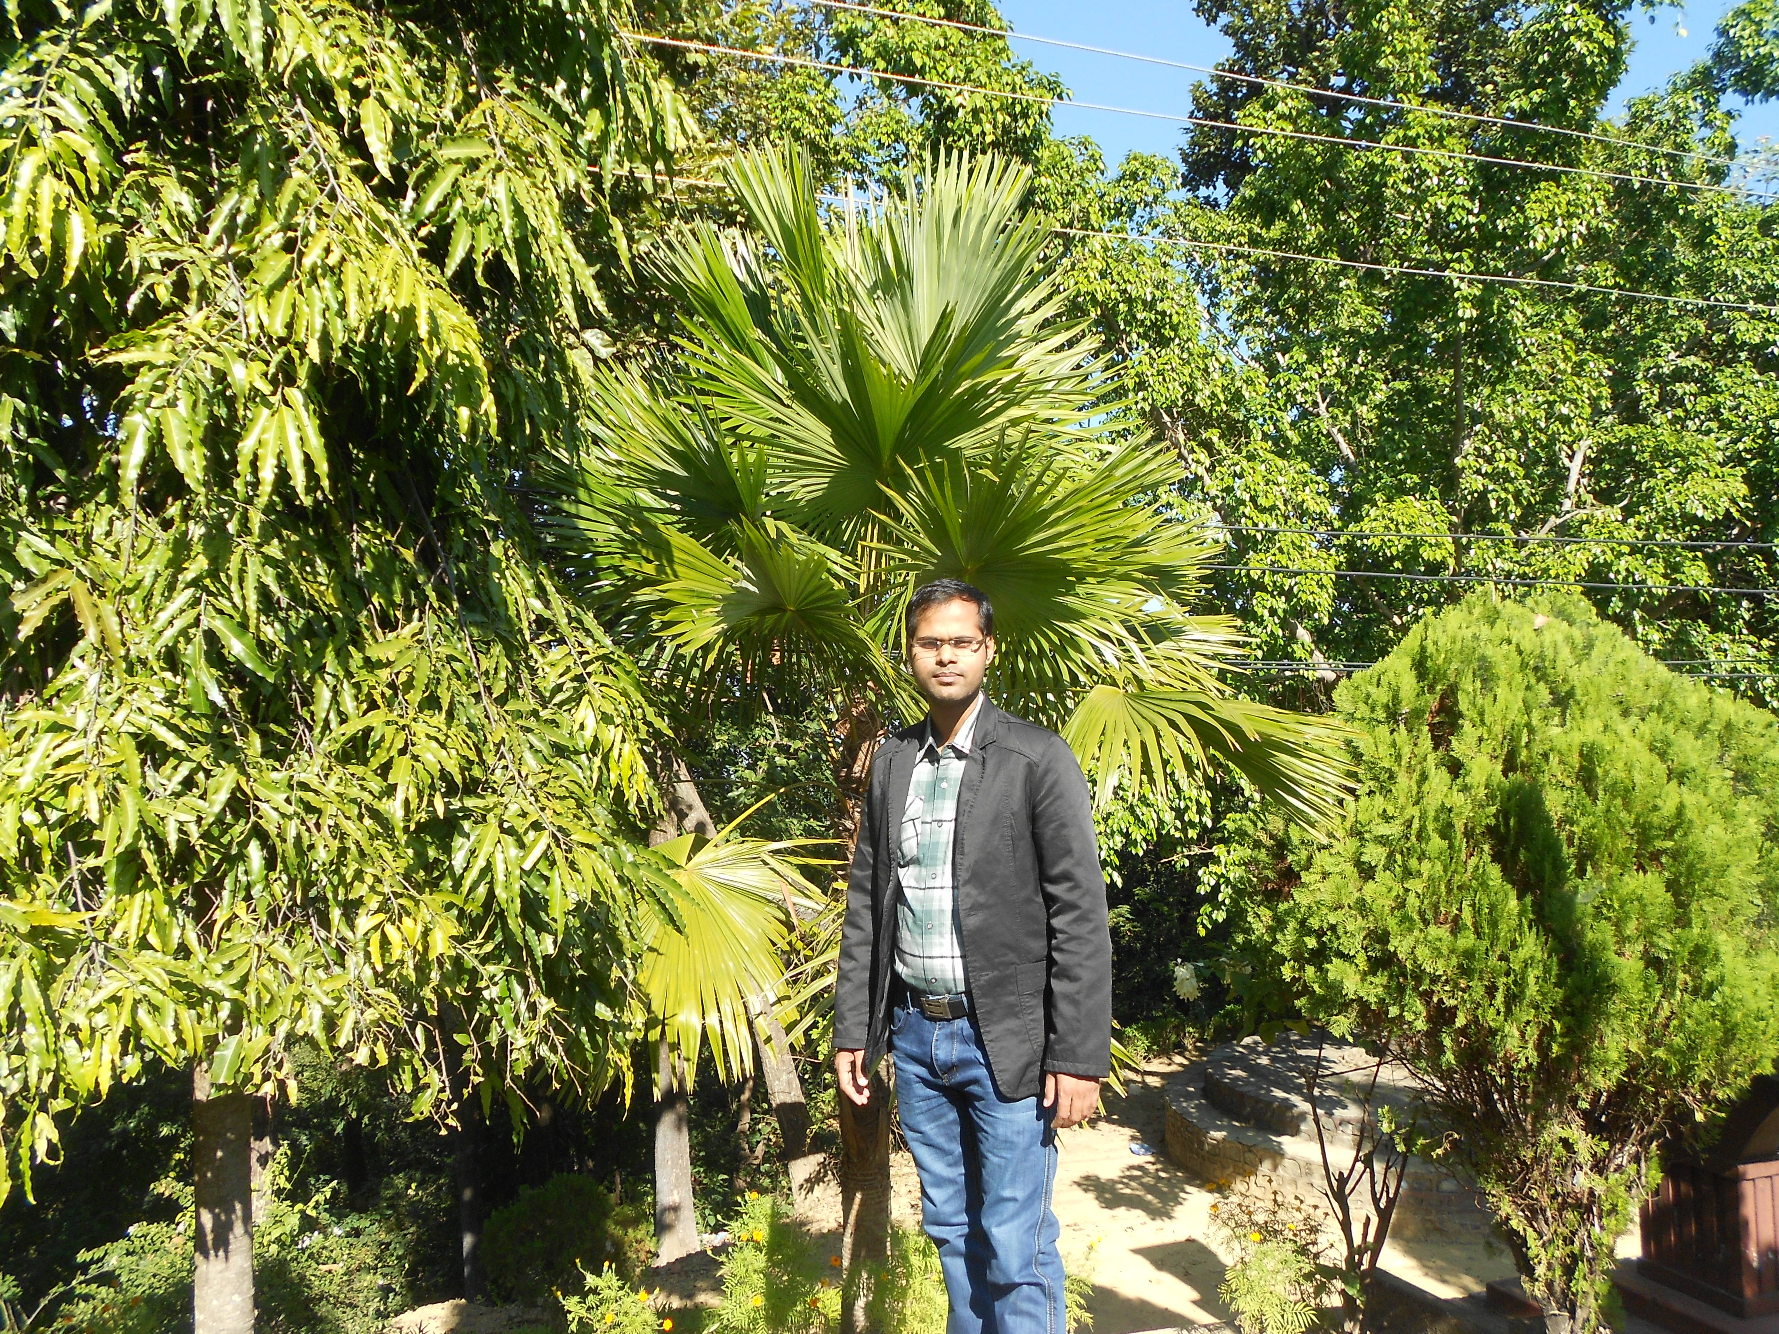

Title: Impact of adolescent’s obesity in cardiac function: An association of Cardiac structural and metabolic risk factors with physical fitness

Name: Dr. Ram Lochan Yadav
Chitwan Medical College, Nepal

There is evidence of metabolic, cardiac structural, and functional derangements in the elderly obese. However, such alterations including physical fitness in early age obesity are still controversial. This study aimed to evaluate physical fitness, cardiac structural, functional, and metabolic remodeling and their association with BMI markers in adolescents.
This cross-sectional comparative study included 90 adolescents with median age -14(2) years were grouped into Normal weight (NW) and Overweight/Obese (OW/OB) based on the BMI percentile for age and sex, WHO, 2007 CDC. International Diabetes Federation criteria for adolescents selected for lipid profiles, fasting sugar, SBP and DBP. Echocardiographic standard 2-dimensional measurements for cardiac structures, percent ejection fraction (EF%) were performed with standard procedure. Physical fitness index (PFI) was graded using the modified Harvard step test. The data compared with Mann Whitney U test and Spearman’s Rank correlation test was used to find an association among study variables.
The cardiac functional and metabolic parameters-heart rate (NW Vs OW/OB: 80 (9)- 91(12) beats/min, p<0.001), SBP, DBP (NW Vs OW/OB: 74.33±3.64- 80.32±4.8 mmHg, p<0.001), LDL were higher whereas HDL (NW Vs OW/OB: 45.5 (8)- 40(6), p<0.001) was lower in OW/OB adolescents. They had cardiac structural remodeling with increased left atrial wall thickness, EDD with significantly reduced % LV ejection fraction (NW Vs OW/OB: 65(4)- 63(8), p=0.002). PFI was ‘fair-poor’. Moreover, physical fitness (PFI, rho=0.589, p<0.001), cardiac structural (LA, rho=+0.473, p<0.001; %EF, rho= -0.346, p=0.001) and functional (SBP, rho=+0.308, p=0.003) parameters revealed unfavorable correlation with obesity markers.
Adolescent obesity ensues detrimental consequences in early life-modifying not only the metabolic, hormonal, and chemical functions but also bringing unfavorable structural changes especially in cardiovascular and musculoskeletal health thereby halting overall physical fitness to poor.
and conduction velocities strongly suggest involvement of slow conducting fibers.

Biography
Dr. Yadav is an Associate Professor and Head of the Department of Clinical Physiology at Chitwan Medical College, CMC, affiliated to Tribhuvan University, Nepal. He obtained MD degree in Basic and Clinical Physiology under full scholarship from B.P. Koirala Institute of Health Sciences, Nepal (listed in the WHO and FAIMER/IMED). He bears an expertise of Clinical Neurophysiology including NCS, EMG, EEG, VEP, BERA and AFT clinical tests. He has dynamic professional experience for more than 9-years in teaching Physiology to under-and post-graduate medical students. He is a core member of curriculum development and health professional workshops. He has worked as MBBS–I phase and PBL coordinators and a medical education trainer in several teacher’s trainings. He has more than 27 publication records in peer reviewed journals. He serves as a manuscript reviewer for several national and international journals. His research interests are Neurophysiology, Cardio physiology, Metabolic disorders, obesity and Medical education.
Presenting author details
Full name: Dr. Ram Lochan Yadav
Personal email id: dr.ramlochan04@gmail.com
Mobile Number: +977 9848096590
Linked In account: https://www.linkedin.com/in/dr-ram-lochan-yadav-md-b63b3992/
Session name/ number:
Category: (Oral presentation/ Poster presentation)

