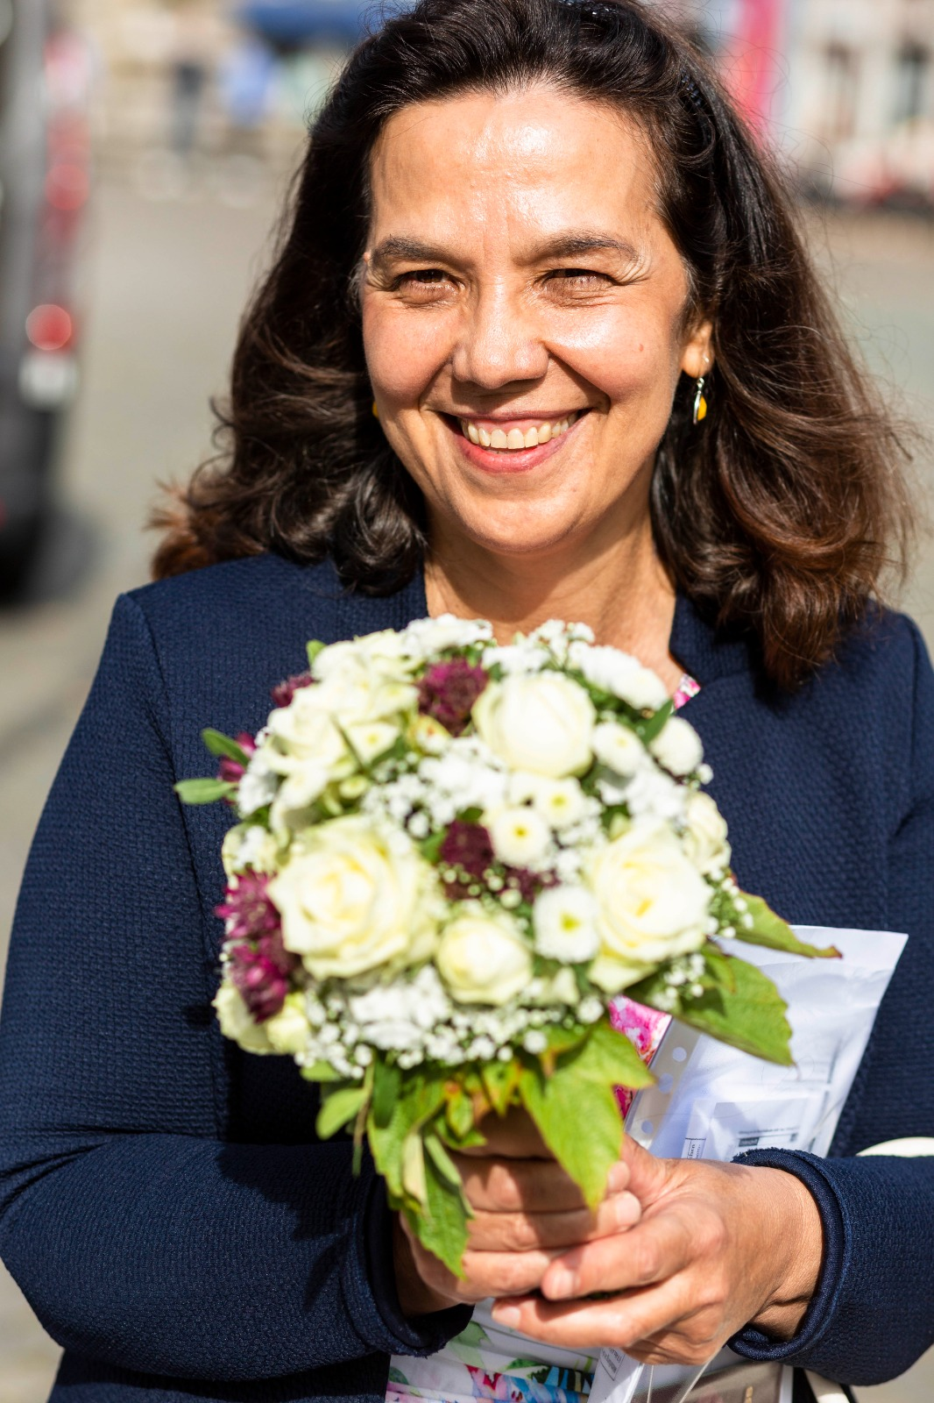

Wellbeing at the workplace from a holistic perspective

Dr.Madlena Kantscheff -Your Wellbeing Expert

People are the company.
The most important capital for every company is Human Capital.
This is even more true for all humans involved in the medical area like nurses.
Nurses work under enormous working conditions, especially during the last 20 months.
Social connection, employment, and educational engagement, access to physical exercise, daily routine, access to health services fell dramatically during this time and increased the stress conditions.
The wellbeing and mental health at the workplace have been challenged in a way never seen and experienced before.
Every nurse must take her time and recharge herself and her energy regularly.
In my presentation, I will show you the Top 3 habits how to recharge yourself and your practice/when you have one/
Because all areas of your life as a nurse are connected.
The purpose of my presentation is to invite you to look at the wellbeing and mental health in every area of your life from a new perspective with New eyes.
And to give you practical tools on how to keep your wellbeing vital all the time.
Despite the challenges and the stress you as a nurse face at the workplace.

Biography:
Dr.Madlena Kantscheff completed her medical education at the age of 23 at The Medical University in Sofia, Bulgaria. She looks back at working as a dentist for 20+years at her dental practice in Bavaria, Germany.
2016 she expanded her services and started working as a Wellbeing Expert.
Following her mission:
To add her contribution to Disrupt the wellbeing and mental health model at the workplace.

Dr.Madlena Kantscheff
+4917699589537
LinkedIn account:
https://www.linkedin.com/in/madlenakantscheff/

Instagram:
https://www.instagram.com/madlenakantscheff/

Session Name: Wellbeing at workplace form holistic perspective
Category: Others

