Influence of HIV on the distribution of high-risk HPV types among women with cervical precancerous lesions in Yaoundé, Cameroon
André Pascal Goura, Bsc - MPH, FMSB, University of Yaoundé 1, Cameroon

Abstract
Persistent infections with high-risk HPV are the leading causes of cervical intraepithelial neoplasia and cervical cancer, yet this infection is not monitor enough. This study aimed to characterize high-risk HPV types associated with cervical precancerous lesions in women living in Yaoundé, Cameroon, and to determine their distribution with HIV status.
Women with abnormal pap smears recorded from February 2015 to May 2019 at Saint Martin de Porres’ Health Centre, Yaoundé, Cameroon, were recruited in this study after obtaining informed consent. Pap smears were collected and re-examined. Human immunodeficiency virus (HIV) serology was determined. HPV16, 18, 33, and 45 were assessed using standard PCR.
All included participants (370) were HPV-positive and had either low grade squamous intraepithelial lesions (67.03%) or high grade squamous intraepithelial lesions (31.35%). They were subdivided into HIV-positive (N =102) and HIV-negative (N =268). In the HIV-negative subgroup, we observed 66.04% HPV16-positve, 41.79% HPV18-positve, 21.27% HPV33 positive and 8.21% HPV45-positve. In the HIV positive subgroup, we observed 22.55% HPV16-positve, 5.88% HPV18-positve, 75.49% HPV33-positve, and 49.02% HPV45-positve. Married HIV positive participants (47.14 ± 1.19) were older than both their single counterparts (34.94±1.22, P = 0.0008) and HIV-negative participants (41.43 ± 0.79, P = 0.0001). Single HIV-positive women reported higher numbers of miscarriages (P = 0.0023), and had later first sexual intercourse than HIV-negative (P = 0.0079) women.
Our study suggested differential expressions in high-risk HPV types with HIV status and cervical precancerous lesions and warrants more extensive studies.

Image
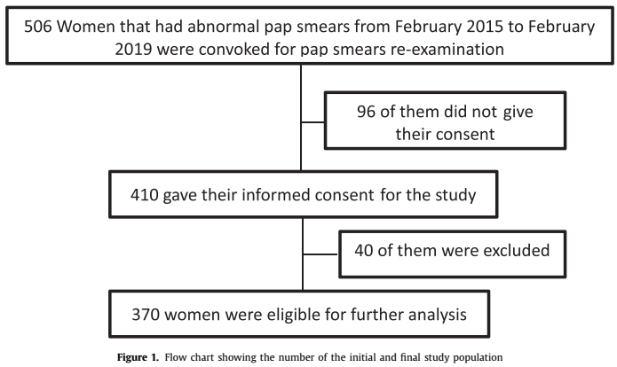
Recent publications
1. Debes AK, et al. Characterization of enteric disease in children using a low-cost specimen preservation method. J Clin Microbiol. 0(ja):JCM.01703-21.
2. Ateudjieu J, et al. EPI immunization coverage, timeliness and dropout rate among children in a West Cameroon health district: a cross sectional study. BMC Public Health. 2020 Feb 13;20(1):228.
3. Goura AP, et al. Geographical Distribution of HIV-patients with Respect to HIV-treatment Units in Cameroon: A Cross-sectional Study. Int J HIVAIDS Prev Educ Behav Sci. 2019 May 20;5(1):59.
4. Ateudjieu J, et al. Health facility preparedness for cholera outbreak response in four cholera-prone districts in Cameroon: a cross sectional study. BMC Health Serv Res [Internet]. 2019 Jul 8;19. Available from: https://www.ncbi.nlm.nih.gov/pmc/articles/PMC6615310/
5. Ateudjieu J, et al. Tracking Demographic Movements and Immunization Status to Improve Children’s Access to Immunization (TDM-IAI): Protocol for a Field-Based Randomized Controlled Trial. JMIR Res Protoc. 2021 Feb 8;10(2):e21734.
6. Esong MB, et al. Distribution of sources of household air pollution: a cross-sectional study in Cameroon. BMC Public Health. 2021 Feb 8;21:318.

 Biography
André Pascal Goura is a Cameroonian Epidemiologist, Public Health Specialist (MPH) and Health Researcher. He has been working for the past 6 years in the research era for close to 15 projects targeting infectious and chronic diseases; prevention and response to outbreaks; disease surveillance; clinical and field trials; vaccines and immunization; WASH; epidemiological studies and ethics, in collaboration with national and international organizations and partners. He believes that health research findings is what is needed to reach the sustainable developments goals.
Email: andrepascalgoura@gmail.com

Presenting author details
Full name: Goura André Pascal
Contact number: (+237) 679336464
Session name/ number:
Category: (Oral presentation/ Poster presentation)

