Influence of HIV on the distribution of high-risk HPV types among women with cervical precancerous lesions in Yaoundé, Cameroon
André Pascal Goura, Bsc - MPH, FMSB, University of Yaoundé 1, Cameroon

Abstract
The treatment of HIV-patients is a key component to HIV/aids control strategies. Since 2007, Cameroon is treating HIV-patients for free within decentralized treatment units created in functional health districts. This study aimed to map the geographical distribution of HIV-patients with respect to that of treatment units in Cameroon.
We conducted a cross-sectional study in which functional health districts with HIV-treatment units were exhaustively sampled to map the local access to antiretroviral care in the Cameroon West region. Patients from these units were randomly selected and recruited during their monthly period of receiving antiretroviral drugs.
Four hundred and seventy-two patients were included. The mean age of participants was 42 (± 10) years with a sex ratio male/female of 1/3. Fourteen units were distributed in 09 health districts (45% coverage) and 11/20 districts had no Treatment unit. Sixty two percent (294/472) of participants resided in the health district of their screening and 65% (308/472) were follow up in the health district of residence. Nine of ten patients resided in their treatment health region. Less than 10% of patients travel from health districts
with no HIV-treatment unit. Close to 1/5 (74/382) patient migrated from local health district with treatment unit to another local health district for follow up. Second line treatment was not available except in one public and one private treatment unit.
The distribution of HIV-treatment units is strongly linked to the geographical distribution of HIV-patients across health districts. We therefore believe that the creation of treatment units in health districts still lacking them can significantly increase screening and treatment of patients in this region.

Image
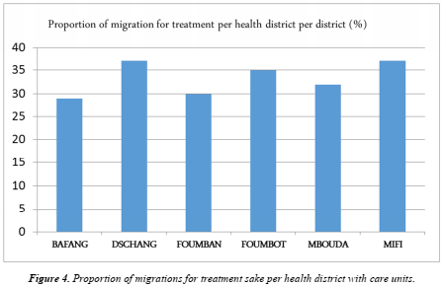
Recent publications
1. Debes AK, et al. Characterization of enteric disease in children using a low-cost specimen preservation method. J Clin Microbiol. 0(ja):JCM.01703-21.
2. Ateudjieu J, et al. EPI immunization coverage, timeliness and dropout rate among children in a West Cameroon health district: a cross sectional study. BMC Public Health. 2020 Feb 13;20(1):228.
3. Simo RT, et al. Influence of HIV infection on the distribution of high-risk HPV types among women with cervical precancerous lesions in Yaoundé, Cameroon. Int J Infect Dis. 2021 Sep 1;110:426–32.
4. Ateudjieu J, et al. Health facility preparedness for cholera outbreak response in four cholera-prone districts in Cameroon: a cross sectional study. BMC Health Serv Res [Internet]. 2019 Jul 8;19. Available from: https://www.ncbi.nlm.nih.gov/pmc/articles/PMC6615310/
5. Ateudjieu J, et al. Tracking Demographic Movements and Immunization Status to Improve Children’s Access to Immunization (TDM-IAI): Protocol for a Field-Based Randomized Controlled Trial. JMIR Res Protoc. 2021 Feb 8;10(2):e21734.
6. Esong MB, et al. Distribution of sources of household air pollution: a cross-sectional study in Cameroon. BMC Public Health. 2021 Feb 8;21:318.

 Biography
André Pascal Goura is a Cameroonian Epidemiologist, Public Health Specialist (MPH) and Health Researcher. He has been working for the past 6 years in the research era for close to 15 projects targeting infectious and chronic diseases; prevention and response to outbreaks; disease surveillance; clinical and field trials; vaccines and immunization; WASH; epidemiological studies and ethics, in collaboration with national and international organizations and partners. He believes that health research findings is what is needed to reach the sustainable developments goals.
Email: andrepascalgoura@gmail.com

Presenting author details
Full name: Goura André Pascal
Contact number: (+237) 679336464
Session name/ number:
Category: (Oral presentation/ Poster presentation)

