Amylase inhibitor from Withania somnifera: Role in post-harvest pest management and food (potato) processing.
Sainath S. Kasar ª, Pankaj K. Pawar ^{c} and Vijay L. Maheshwari ª
a. School of Life Sciences, K. B.C. North Maharashtra University, Jalgaon,
c. Department of Biochemistry, Shivaji University, Kolhapur
Email ID- ksaibaba2010@gmail.com/ sskasar2010@gmail.com

Abstract
A glycoprotein alpha amylase inhibitor (α-AI), molecular weight of 8.3 kDa, was isolated and purified from seeds of Withania somnifera (WSAI), an important indigenous medicinal plant. It is thermostable and non-competitive type inhibitor of fungal amylase. Mass spectrometric analysis revealed that it shares 59% sequence similarity with Wrightide II type α-AI from W. religiosa. When the adults of T. castaneum were fed with WSAI (1.6 mg/g), decrease in consumption, growth and efficiency of conversion of ingested food were evident along with over 4-fold increase in feeding deterrence index and decrease in longevity. In another approach, the treatment of WSAI to potato slices at 200 ppm concentration for 30 min was found to reduce the browning (60%), residual amylase and polyphenol oxidase activities (~40%) and reduction in reducing sugar level by 25% over control. In conclusion, i) WSAI has good potential in mitigating overall growth and development of T. castaneum and thus make it a potential candidate for its management, individually or in combination with other insect controlling biological molecules and ii) WSAI treatment results in reduction in browning and generation of acrylamide in potato during processing. Thus, it offers a heathier (better nutritional value) and economical (significant improvement in dry weight post frying) alternative method without compromising the overall sensory quality of the finished product.
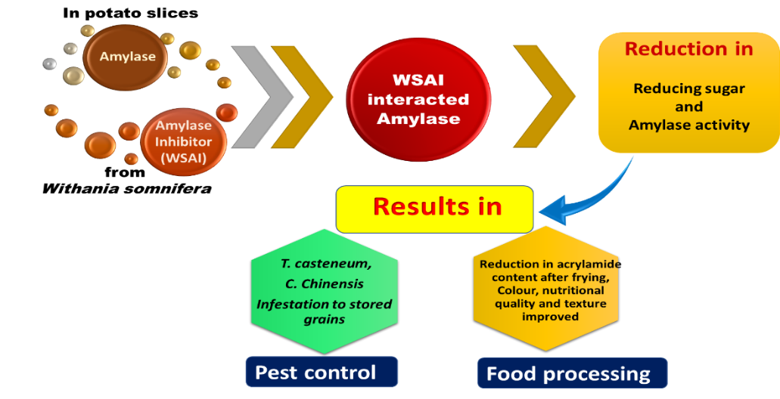
Graphical Abstract

