
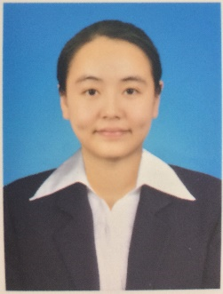
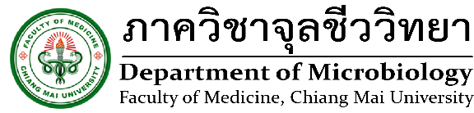

Evaluation of Wound Healing Efficacy of Gynura procumbens Leaf Extract in Streptozotocin-induced Diabetic Mice

Name: Nutda Sutthammikorn

Department of Microbiology, Faculty of Medicine, Chiang Mai University, Thailand.
Atopy (Allergy) Research Center, Juntendo University Graduate School of Medicine, Tokyo, Japan.

Wound healing impairment in the diabetic foot ulcers is the most frequently recognized complication in diabetic patients. Therefore, there is a substantially unmet need to develop new interventions that are effective, cheap and with fewer side effect burden. Gynura procumbens (GP) is commonly found in Southeast Asian countries. The leaves extract of GP are used in folk medicine for treatment of various ailments such as fever, rash, inflammation, kidney disease, migraine, rheumatism, cancer, viral infection, hypertension, hyperglycemic and hyperlipidemia. However, the effect of GP on the healing of diabetic wounds has not been reported. In this study we examined the effects of GP gel treatment on wound healing in streptozotocin-induced diabetic mice and found that GP treatment significantly promoted wound healing faster than solcoseryl jelly, which is usually used as a wound healing drug in diabetic patients. GP also promoted angiogenesis around the wound area, and significantly increased the skin expression of angiogenin, endothelial growth factor, fibroblast growth factor, transforming growth factor ß1 and vascular endothelial growth factor in both normal and diabetic mice. Moreover, GP elevated the expression of various growth factors in human fibroblasts, keratinocytes, endothelial cells and mast cells. Interestingly, GP promoted keratinocyte and fibroblast proliferation and enhanced fibroblast, keratinocyte and mast cell migration. These findings suggest that GP may be used as a wound healing drug in diabetic ulcers.

Biography

Nutda Sutthammikorn has completed her bachelor's degree from Mahidol University and master's degree from Faculty of Medicine at Chiang Mai University. Now she is a Ph.D. candidate at Chiang Mai University and international research student at Juntendo University Graduate School of Medicine.

Presenting author details
Full name: Nutda Sutthammikorn
Contact number: 03-5802-1591 (Atopy (Allergy) Research Center, Juntendo University Graduate School of Medicine)
Linked In account:
Session name/ number:
Category: Poster presentation

