
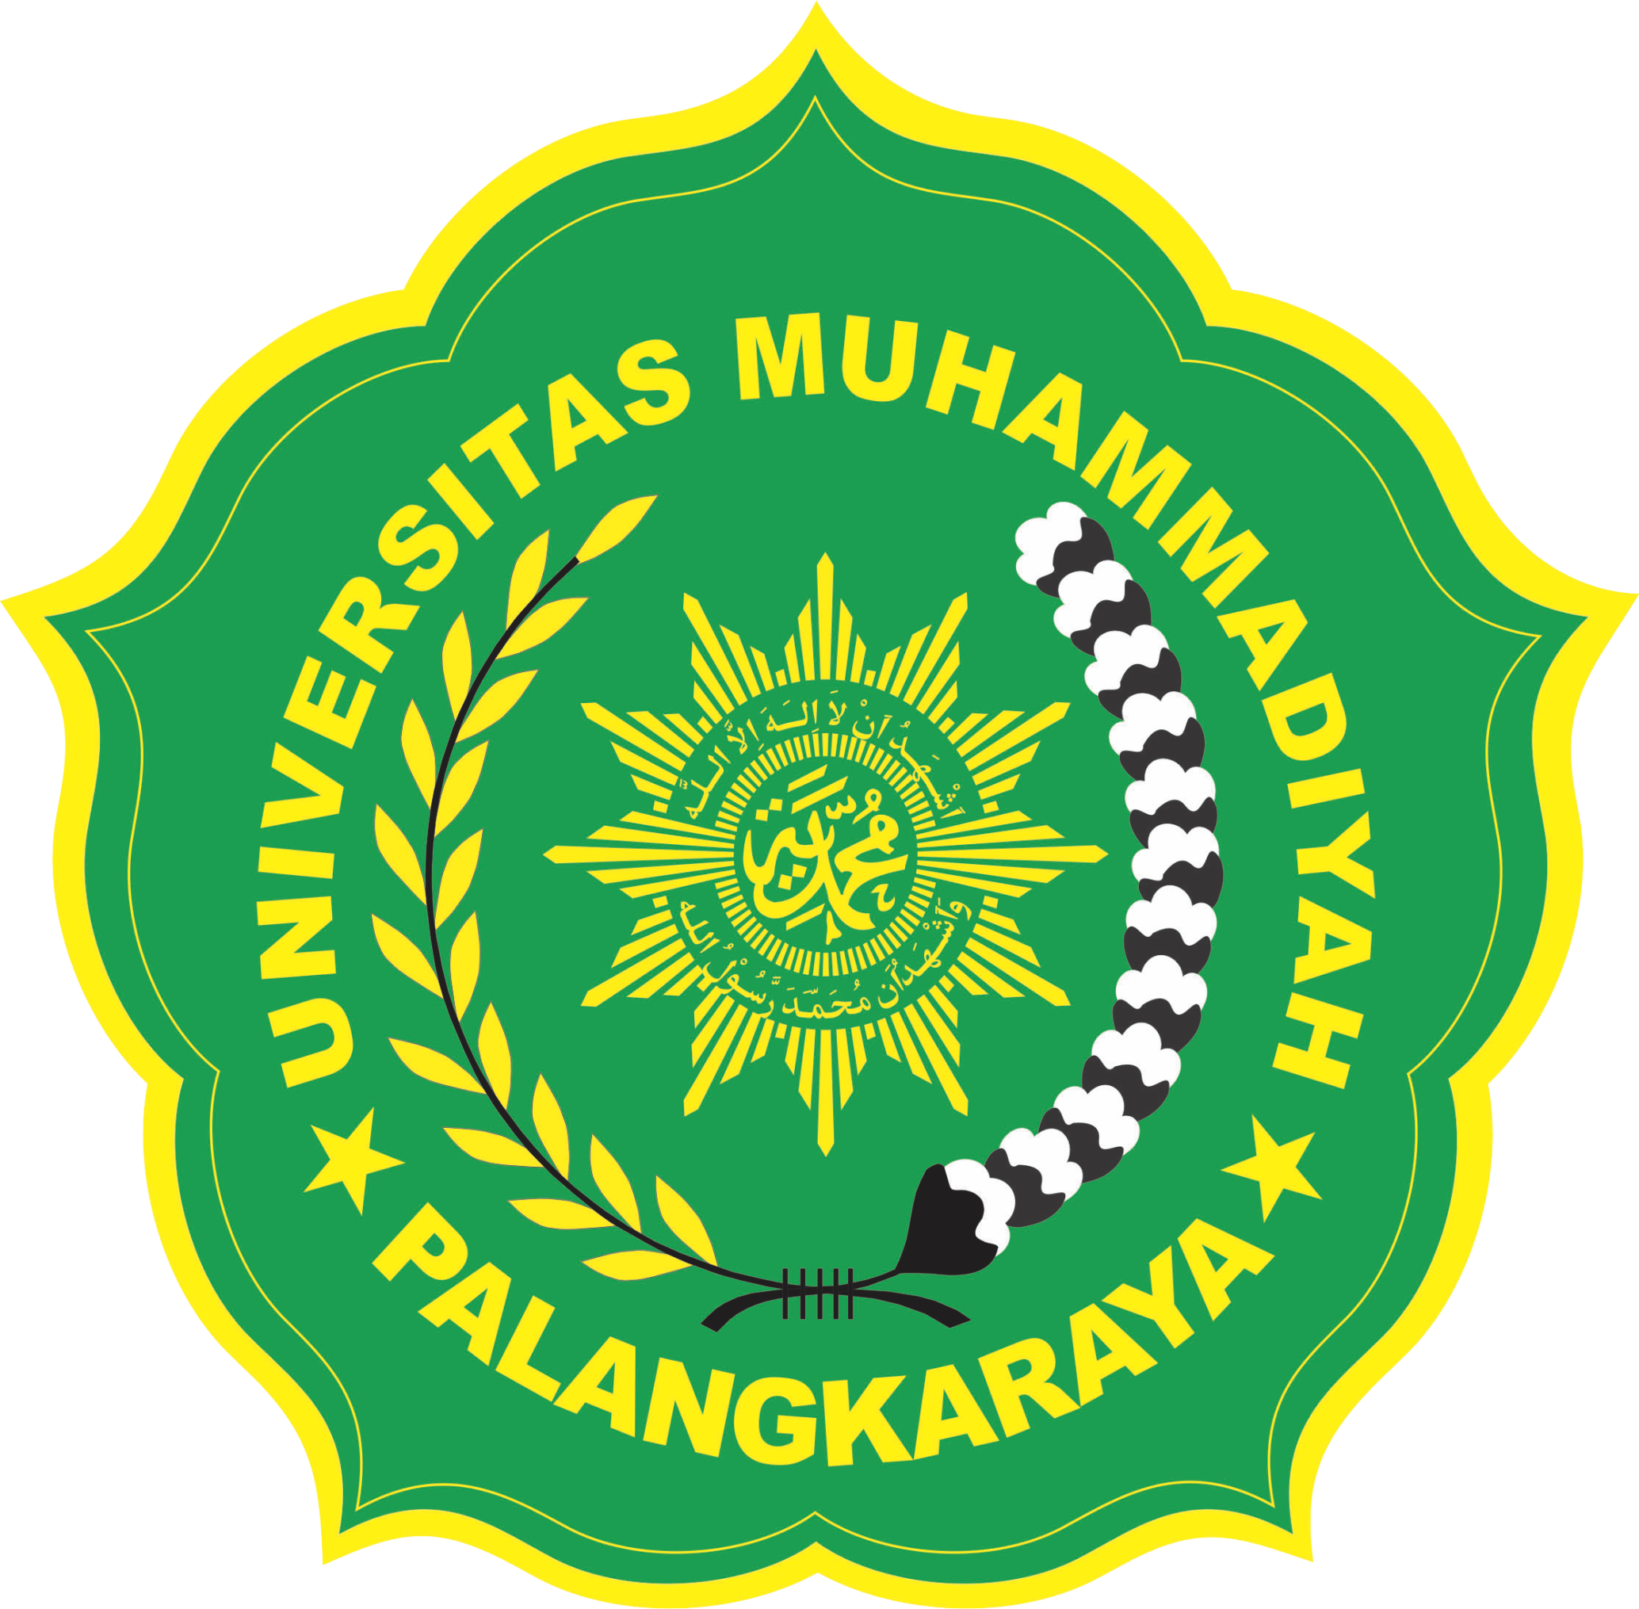
Paste your Photograph Here
Title: ETHNOBOTANICAL STUDY OF QUR`AN PLANTS
Name: Nurul Qamariah
Muhammadiyah University of Palangkaraya, 73112, Central Kalimantan, Indonesia

In Islam, ethical teachings of biomedical ethics are linked with Holy Qur`an and Prophet Muhammad (PBUH). Qur`an is the central religious text of Islam, which Muslims believe to be a revelation from God. The Quran is divided into chapters (surah in Arabic), which are then divided into verses (ayah). Qur`an mention a great number of wild plants that are still used in folk medicine. Qur`an is one of the best reference books describing the importance of plants for medical benefits, where there are 28 Chapter (Surah) those mentioned specific name of plants in Al-Qur`an. This paper aims to compile the up-to-date information about some medicinal plants that mentioned in Al-Qur`an. Based on the collected data, there are 27 plant species mentioned in Al-Qur`an. In this paper, plants species were arranged in systematic order of identity of plant (The identity of the selected plants were confirmed from existing literature such as, books, journal article, and family and species of plants were confirmed from nomenclatural and bibliographic database), followed by Indonesian name, English name, Family, references cited from Holy Qur`an, part used, chemical constituents, and efficacy of herbal medicine that has been used both empirically and scientifically.

Biography

Nurul Qamariah was born in Palangkaraya, Indonesia, in 1990. She received the B.E degree in Chemistry Education from Palangkaraya University, Central Kalimantan, Indonesia, in 2011, and the M.Sc degree in Pharmacy Herbal Medicine from University of Indonesia, Indonesia, in 2014. In 2014 She joined Faculty of Health Science, Muhammadiyah University of Palangkaraya, as a Lecturer. Since 2015, she became
Head of planning and database division of Muhammadiyah University of Palangkaraya. Her current research interests include herbal medicine, natural product, and ethnobotanical.

Presenting author details
Full name: Nurul Qamariah
Contact number: +6285751144479
Twitter account: -
Linked In account: Nurul Qamariah
Session name/ number:
Category: Oral presentation

