The Role of Clinical Chinese Pharmacists in TCM Practice
Zhijian Lin; Xiaomeng Zhang; Bing Zhang*
Corresponding author: zhangbing@263.net
Beijing University of Chinese Medicine, Beijing China 100029

Abstract
Chinese medicine is one of the great medical systems in the world, which performs treatment based upon principle of ZHENG Classification and Treatment (Bian Zheng Lun Zhi, 辨證論治in Chinese). And ZHENG (TCM syndrome) classification could be identified as clinical special phenotypes by symptoms and signs of patients.
In ancient times, practitioners of Traditional Chinese Medicine (TCM) performed two roles as clinical physicians and clinical pharmacists. And TCM practitioners provided an effective approach for personalized diagnosis and treatment in clinic. In other words, clinical Chinese pharmacists have been practicing personalized drug therapy for thousands of years.
Modern education of Chinese medicine began in the 1950s. According to the modern education system, physicians and pharmacists of Chinese medicine are two different groups of health-care professionals. The fundamental role of Chinese pharmacists is to distribute drugs prescribed to patients, to produce drugs in the manufacturing companies, and to research and develop new drugs in laboratories. As is known to all, a medication may demonstrate effectiveness in clinic, yet it may be less effective to some particular patients, or even results in adverse drug reaction /adverse drug event (ADR/ADE) and failure to reach desired treatment goals. Clinical Chinese pharmacists have now moved from laboratory to the patients’ bedsides to provide pharmaceutical care. They are positioned to play an active role in pharmaceutical care to improve personalized medications, such as consulting with physicians on individual patient’s needs, discussing the therapy based on the principle of ZHENG Classification and Treatment, performing therapeutic drug monitoring(TDM), ADR/ADE supervision, medication prescription assessment, providing recommendations of alternative treatments as necessary, and educating patients and families about drug rational use.

Image
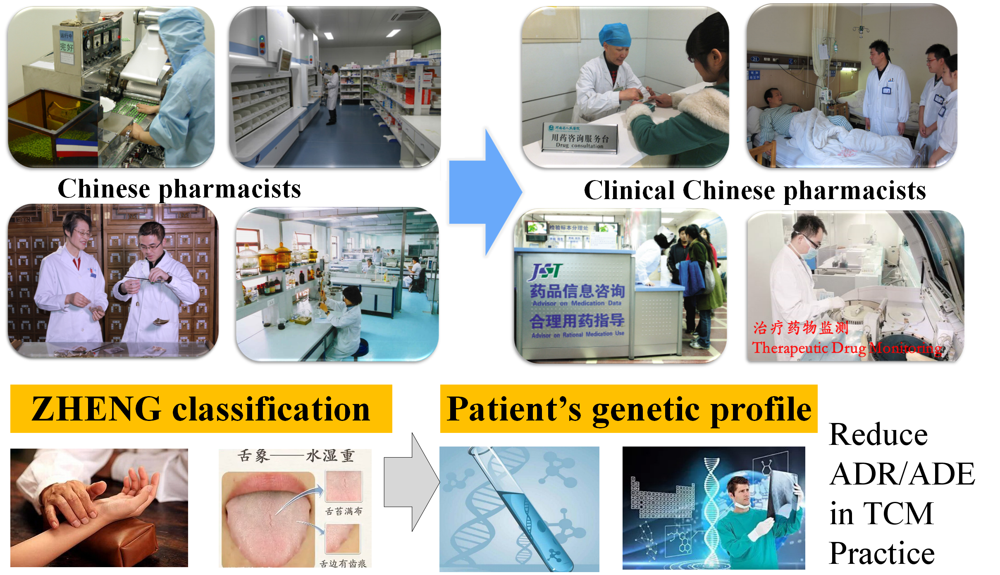
Recent Publications (minimum 5)
- Lin Z, Zhang B, et al. Effects of chicory inulin on serum metabolites of uric acid, lipids, glucose, and abdominal fat deposition in quails induced by purine-rich diets. J Med Food. 2014，17(11):1214-21.
- Zhijian Lin, Bing Zhang, et al. Symptom and pathologic features of hyperuricemia combined with abdominal obesity quail model with chinese medicine symptom categorization method. Journal of alternative and complementary medicine. 2014; 20(5):A32-3.
- CS Zhu, B Zhang, ZJ Lin, et al. Relationship between High-Performance Liquid Chromatography Fingerprints and Uric Acid-Lowering Activities of Cichorium intybusL. Molecules 2015, 20(5), 9455-9467..
- Zhijian Lin, Bing Zhang, et al. Abdominal fat accumulation with hyperuricemia and hypercholesterolemia quail model induced by high fat diet. Chinese Medical Sciences Journal，2009；24（3）:191-194.
- Zhu CS, Lin ZJ, Xiao ML, Niu HJ, Zhang B. The spectrum-effect relationship-a rational approach to screening effective compounds, reflecting the internal quality of Chinese herbal medicine. Chin J Nat Med. 2016 Mar;14(3):177-84.

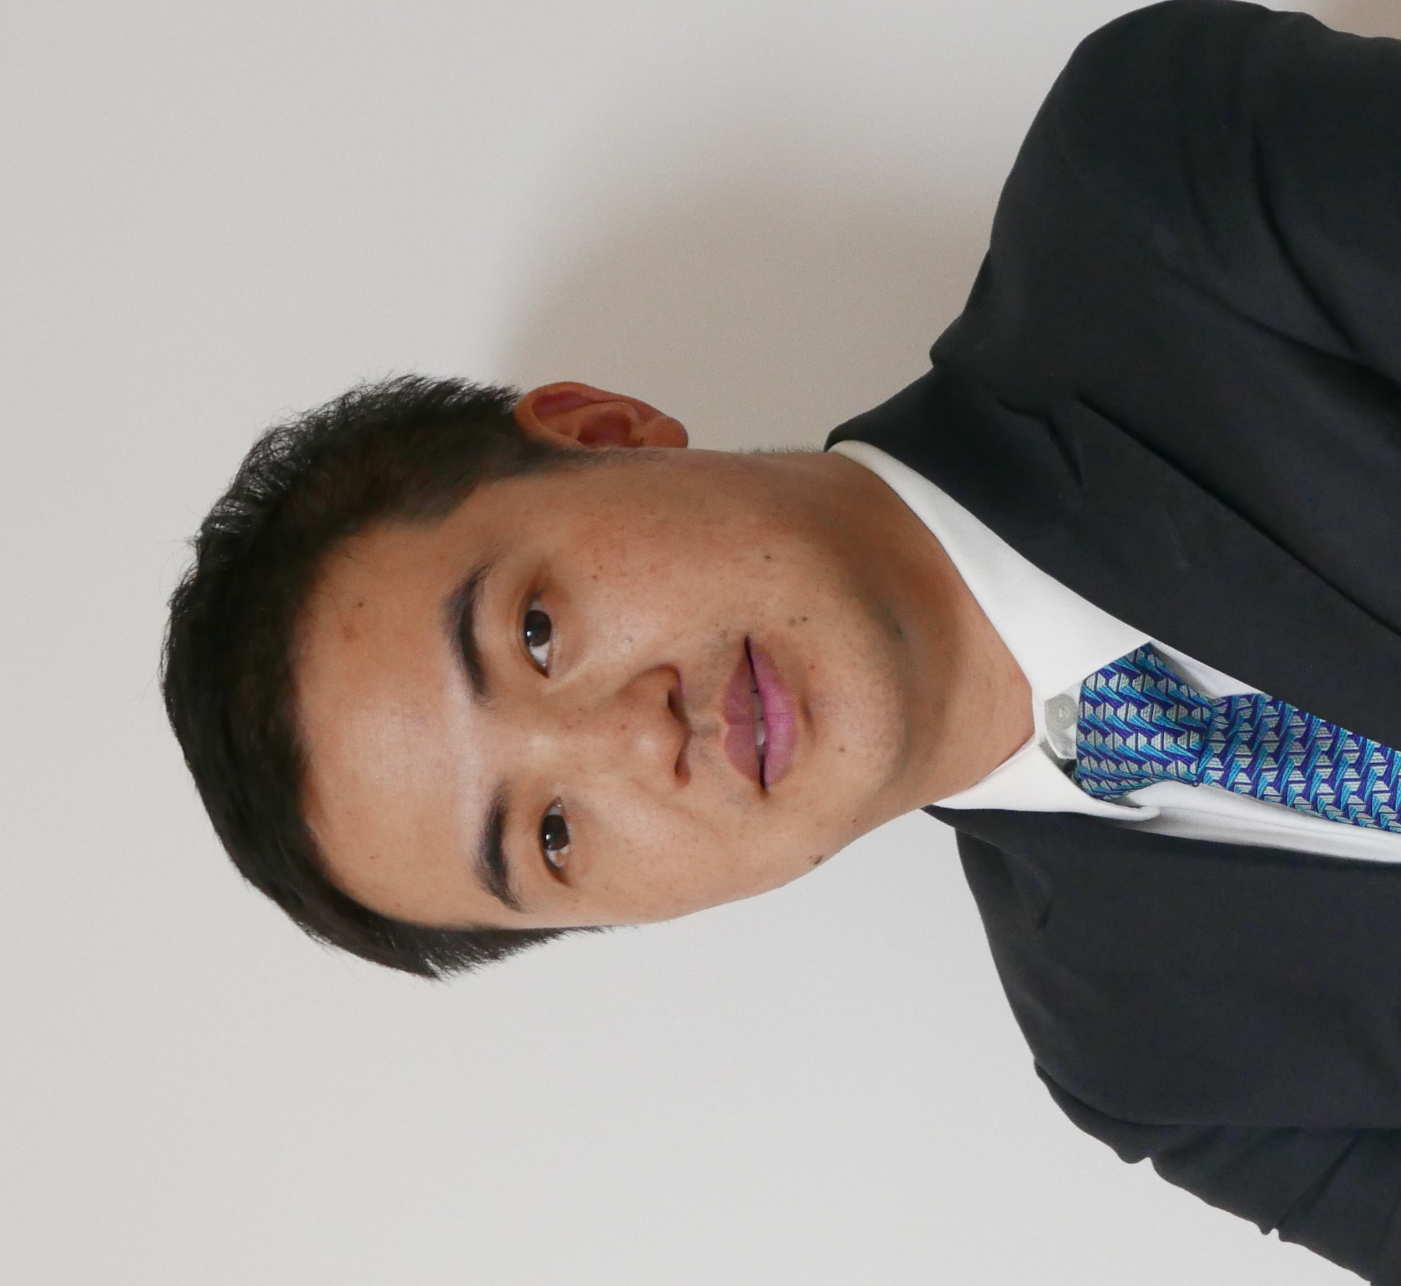 Biography (150 word limit)
Zhijian LIN has his expertise in clinical Chinese Pharmacy and passion in ADR research on Chinese Materia Medica. He has well experience in rational use of Chinese Materia Medica after years of research and teaching in Beijing University of Chinese Medicine. He teaches Chinese Pharmacy and applied integrative teaching methods for simulating real world clinical practice to advance students’ problem solving skills. And he also has a strong interest in basic pharmacological research on hyperuricemia and metabolic disorders with Chinese Materia Medica.
Email: linzhijian@bucm.edu.cn

Notes/Comments:

