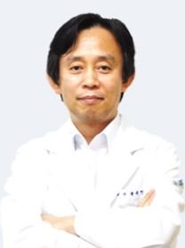
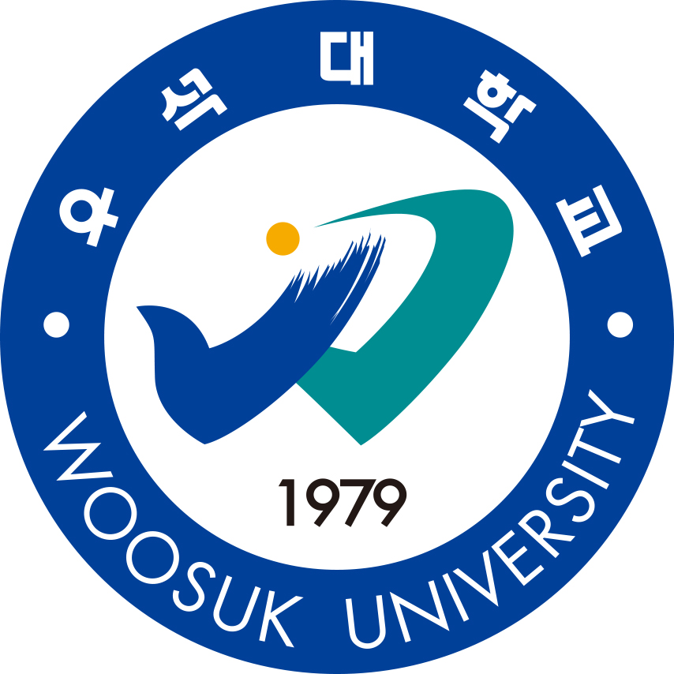

Title: A Study of Facial sEMG Measurements between left and right in Healthy Normal Adults
- Focused on Ratio comparing smaller value with bigger value and Asymmetry Index
Name: Tae HanYook
Department of Acupuncture & Moxibustion Medicine, Korean Medicine Hospital of Woosuk University

This study aims to measure the facial sEMG from 20 to 60 years old in normal person and measure Ratio comparing smaller value with bigger value and Asymmetry Index, and to confirm whether there are differences according to gender, age and three sites of measurement.
We measured 3points on face, frontalis muscle(GB14), zygomaticus muscle(SI18), orbicularis oris muscle(CV24) of 154 normal person by sEMG. 154 normal persons are composed of Korean male and female in 20’s to 60’s. sEMG instrument QEMG-4XL was used. After training exercise of facial muscles, sEMG's root mean square value was measured.
In Ratio comparing smaller value with bigger value, the mean of the frontalis muscle was 81.70 ± 14.60%, the mean of the zygomaticus muscle was 73.74 ± 19.12%, and the average of the orbicularis oris muscle was 79.72 ± 14.77%. There was no statistically significant difference between the three sites and between men and women.
In Asymmetry Index, the mean of the frontalis muscle was 10.87 ± 10.14%, the mean of the zygomaticus muscle was 16.71 ± 14.79%, and the mean of the orbicularis oris muscle was 12.10 ± 10.05%. There was no statistically significant difference between the three sites and between men and women.
As a result of analyzing Ratio comparing smaller value with bigger value and Asymmetry Index for each age from 20s to 60s, there was no statistically significant difference between the ages, and it was hard to find significant tendency for each age group.
In Ratio comparing smaller value with bigger value and Asymmetry Index in normal person there was no difference according to gender, age and three sites of measurement.
The results of this study are expected to be useful for diagnosis of facial diseases, evaluation of prognosis, and evaluation of recovery.

Biography
Tae HanYook Graduated from Daegu Haany University College of Oriental Medicine at 1991. He has completed his PhD at 2000 from Daegu Haany University.
Since 1995, he has been working as a professor at Woosuk University College of traditional korean Medicine. He has published more than 15 papers in reputed journals.

Presenting author details
Full name: Tae HanYook
Contact number: 82-10-6797-6004
Twitter account: (E-mail) nasiss@naver.com
Linked In account:
Session name/ number:
Category: (Oral presentation/ Poster presentation)

