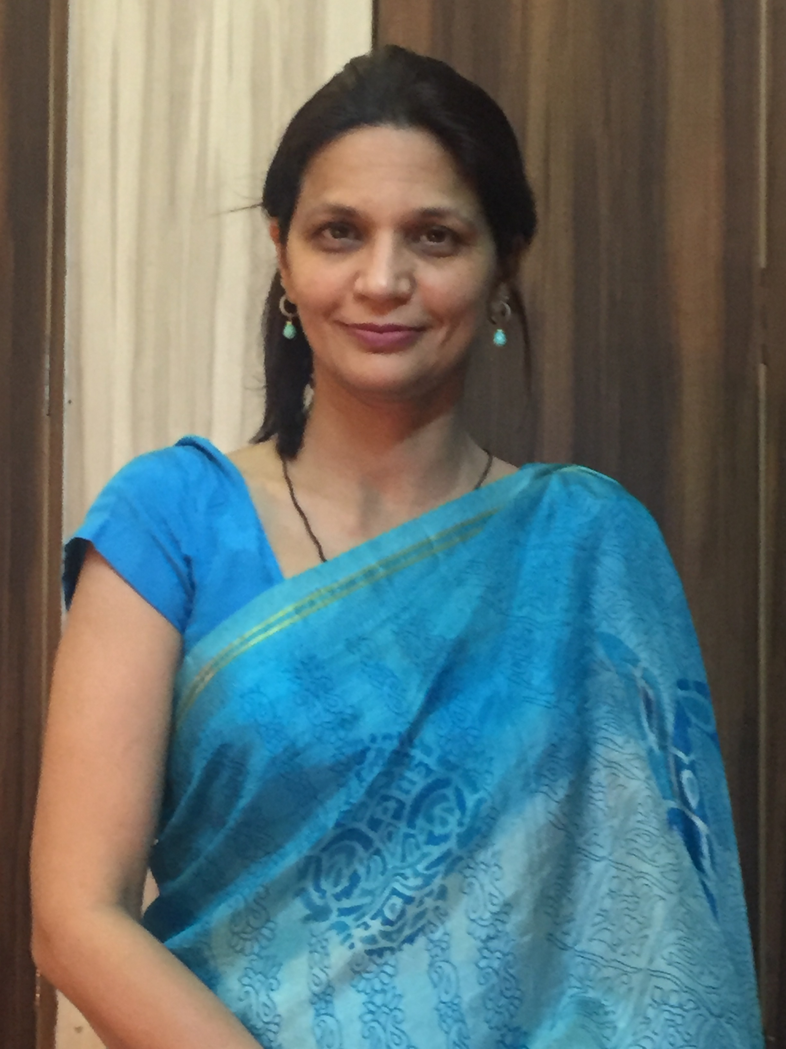
Development and Evaluation of Poly-herbal topical formulation against Acne
Shweta (Kapoor) Bajaj
College of Pharmacy, JSS Academy of Technical Education, Noida

Acne vulgaris is a major clinical problem, causing concern and need for effective non-synthetic treatments. Acquisition of risk and side effects associated with previously used therapies, this study was undertaken with the aim to develop and evaluate the topical poly herbal anti-acne cream against acne. Four herbal anti-acne creams (A1-A4) were prepared by adding ethanolic extracts of Aloe barbadensis, Ocimum sanctum, Glycerriza glabra, Melaleuca alternifolia, Vitex negundo, Calendula officinalis, Cocon nucifera, Lavendula angustifolia, Azadirachta indica, Santalum album, in increasing concentration (1.45 - 5 % w/w from A1-A4) into prepared cream base (AB, control). A3 and A4 found unstable, so efficacy studies had been carried out for of A1, A2, AB formulation. Mean facial sebum excretion (µg/cm²) using Sebumeter and acne count were assessed. Statistical analysis was performed using STAT software, P value < 0.05 was considered to be statistically significant. Thirty volunteers divided in three groups, each group contain ten volunteers and having oily skin and moderate acne. Volunteers instructed to apply their respective treatment twice daily for 3 months, and were reviewed for observations at 4th, 8th and 12th week. At the end of 12 weeks marked improvement in acne count 80-90% with both cream A1 and A2; 15- 20% with AB and 55–65% (A2), 51-65% (A1), 7-12% (AB) reduction in sebum production were observed in the treated volunteers. Study provides scientific claims for anti-acne effect of poly herbal creams, hence proved their suitability as alternatives in existing treatments for moderate acne and seborrhea.
Biography
Dr Shweta (Kapoor) Bajaj has completed her PhD at the age of 32years from Pt. Ravishanker Shukla University, Raipur. She is working as Associate professor in College of pharmacy, JSS Academy Technical Education, Noida. She is having academic & Research experience of 17 years. Life member of governing bodies APTI and Indian Cosmetic society, 29 articles at national and international reputes and one book in her credentials. Number of abstract presented at national and international seminars and workshops.
Presenting author details
Full name: Dr. Shweta (Kapoor) Bajaj
Contact number: 9971996602
Linked In account: kapoorsk07@gmail.com
Session name/ number: Herbal cosmetics and nutraceuticals
Category: (Oral presentation)

