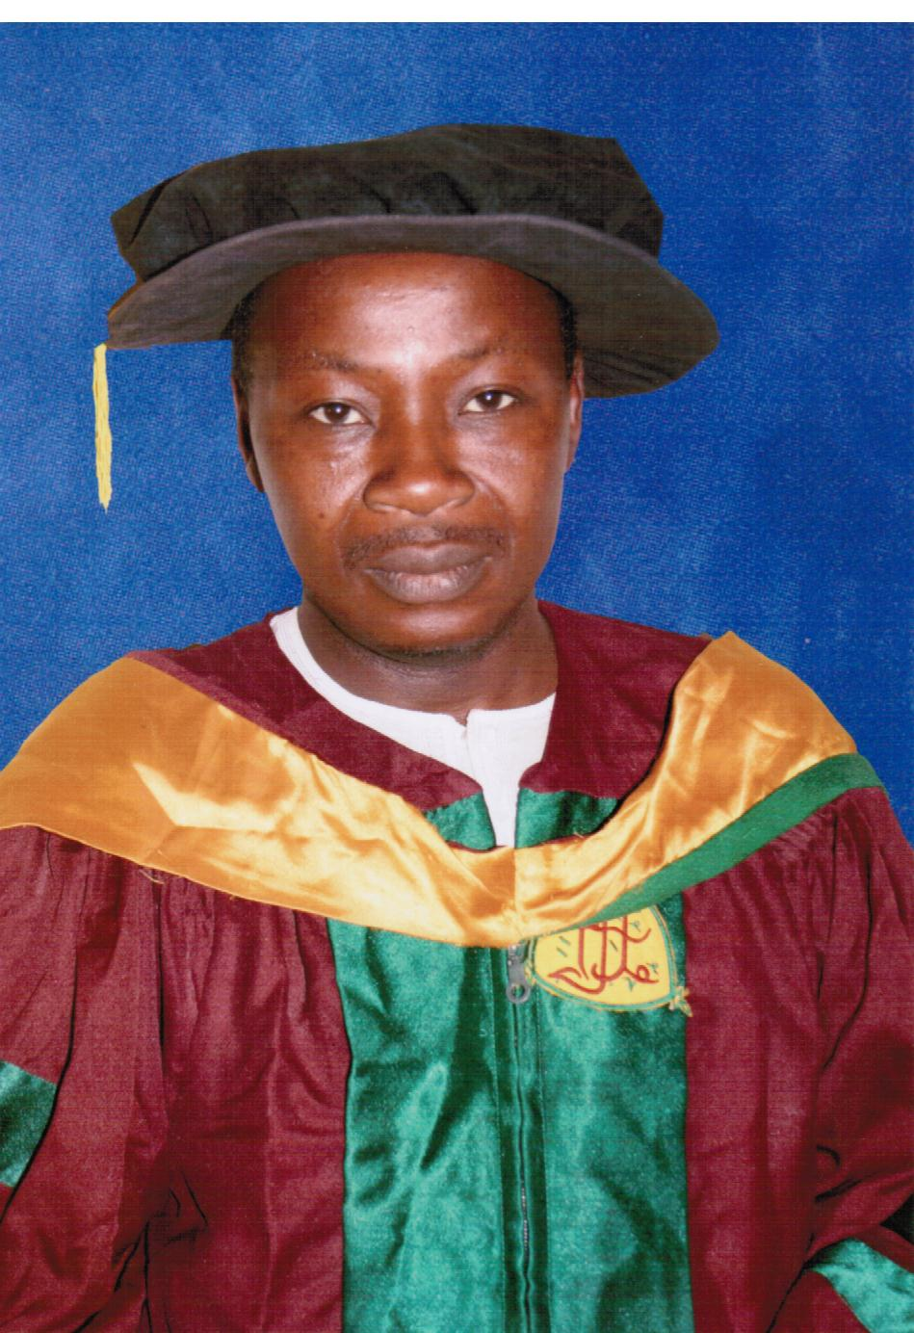

Title: The Management and treatment of cancers by the Hausa and Fulani tribes of Northern Nigeria
Name: Mujtaba, S. Abubakar

Department of Pharmacognosy and Drug Development,
Faculty of Pharmaceutical Sciences,
Ahmadu Bello University, Zaria. Nigeria

A perspective on the methods of pharmacological surveys of Hausa/Fulani folk remedies, concept and perceptions about cancers and inflammations are discussed. We carry out surveys involving traditional medical healers, herbalists, hunters, farmers and Fulani nomads and we have identified plants useful in the treatment of cancers. Identifications were done via taxonomic means and the plants were classified according to their habitats, families, genera. Evidently the plants span families and genera. The survey provides an inventory of useful plants which are commonly used across the Hausa and Fulani communities of Northern Nigeria. The process of determination of the scientific basis for the continued use of specific medicinal plants in the treatment of cancers using appropriate pharmacological evaluation are also discussed. Medicinal plants are important natural resources that serve as the most reliable source of drugs for rural populations in Africa. The knowledge of plant remedies is available through African traditions and folklore, thus the application of this popular knowledge on the use of medicinal plants can contribute to the development and production of products for the pharmaceutical market. Active anti-cancer products from medicinal plants are derived from a wide variety of plant Genera and Species; herein we provide the concept of utilization of the plants from an ecological, sustainable development point of view.

Biography

Mujtaba Sulaiman Abubakar is a professor of pharmacognosy, at Ahmadu Bello University, Zaria, Nigeria. His particular interest is in the development of drugs from the flora and fauna of Nigeria. He has been involved in the development of laboratory models for evaluating the potentials of extracts/ plant constituents as drugs. He is involved in the identification and characterization of biologically active compounds from medicinal plants that have been shown to be useful in Nigerian folk medicine.
Presenting author details
Full name: Mujtaba Sulaiman Abubakar
Contact number:+2348063165499
Twitter account:
Linked In account:
Session name/ number: Pharmacognosy and Phytochemistry
Category: Oral presentation

