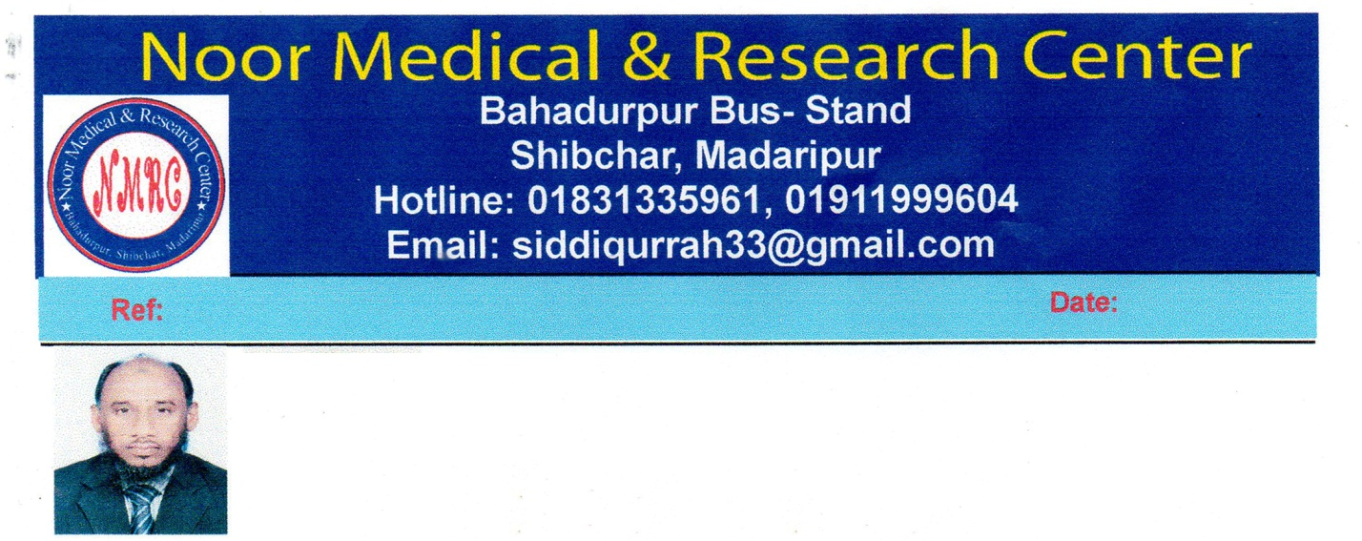

09.01.2020

Dr. Md Siddiqur Rahman

Abstract Theme: “DIABETIC HERBAL MEDICINE”

DIABETIC HERBAL MEDICINE has been serving for a long time for human treatment. As taking treatment this natural medicine, derived from natural extracts, the human relieves from various diseases, on the other hand it has no side effect. In this stage I am addressing main point of my words. The main point of my words is “DIABETIC HERBAL MEDICINE” In different time it is found in Clinical Trial that, using Pharmacopeia Medicine to control Diabeties is negative effect for the human body (Insolence and orally) (Ref: Dhaka University Research Unite, Bangladesh). As a result the organ of human body becomes week step by step. As a result the Immunity decreases day by day, at he one stage the patent unable to control the Disbetics in spite of using Immense Insulin. It is proved, keeping clinical trial some patient whom were unable to control their Diabetics in-spite of using Insulin, while it is possible to control the diabetics treating with DIABETIC HERBAL MEDICINE and the patient felt healthy (Ref: Noor Medical & Research Center, 2010). It is proved in Research theory that, it is possible to lead a healthy life controlling the Diabetics using DIABETIC HERBAL MEDICINE without any side effect. (Ref: Noor Medical & Research Center, 2010). I would like to mention that, Herbal treatment is a Researchable treatment to relieves from Diabetics. Further I would like to inform the cosmopolite that, Take the DIABETIC HERBAL MEDICINE, BE HEALTHY, I requst to the people of the world through “11th INTERNATIONAL CONFERENCE ON HERBAL THERAPY & ACUPUNTURE” that, please take appropriate action to extent the Herbal Medicine

Thankfully
Dr. Md Siddiqur Rahman and others

