
MEMORY ENHANCING AND METAL CHELATING ACTIVITIES OF CLERODANE DITERPENOIDS ISOLATED FROM Tinospora cordifolia (Willd.) Miers ex Hook. F. & Thoms
Onoja O.J.^{1,2}, Elufioye T.O.¹, Zaid Anis Sherwani³ and Zaheer Ul-Haq³
- Department of Pharmacognosy, Faculty of Pharmacy, University of Ibadan, Ibadan, Nigeria.
- Department of Pharmacognosy and Environmental Medicine, Faculty of Pharmaceutical Sciences, University of Nigeria Nsukka, Nigeria
- Dr. Panjwani Center for Molecular Medicine and Drug Research, University of Karachi, Karachi-75270, Pakistan
Corresponding author: toonitaiwo@yahoo.com
Alzheimer’s disease (AD) is a neurodegenerative disorder characterized by cognitive impairment, which consequently leads to decrease in the quality of life, affecting at least 50 million people worldwide. There are few drugs available for the management of AD with accompanying debilitating side effects, necessitating the search for new potent therapeutic options. Inhibition of acetylcholinesterase (AChE) is considered a promising strategy for AD management. This study, was therefore, aimed at isolating and identifying inhibitors of AChE from selected medicinal plants identified from Nigerian ethnomedicine.
Tinospora cordifolia (TC) stem (FHI 112287) crude extract was successively partitioned into n-hexane, dichloromethane, ethyl acetate and aqueous fractions. Ethyl acetate fraction was subjected to chromatographic separations (Column chromatography and Thin layer chromatography) to isolate and purify bioactive compounds. The isolates were evaluated for AChE inhibitory activity using Ellman colorimetric in vitro assay using eserine as standard. In vitro analyses were used to evaluate the metal chelating potential of the compounds. Structures of isolated compounds were determined by spectroscopic analyses (1D, 2D NMR, EI-MS, FT-IR and UV). Molecular docking was done using software (MOE 2015.010) to anticipate the binding affinity between drug candidates with protein targets using PDB ID: 10CE (Acetylcholinesterase). Standard curves were generated and calculation of IC₅₀ values was done using Microsoft Excel. Data were analysed using Student’s t-test and Wilcoxon matched-pairs signed rank test at α_{0.05}

Three clerodane diterpenoid namely; 8-hydroxycolumbin, tinosporide and columbin were isolated. Columbin (IC₅₀ of 1.29±0.17mg/mL) and 8-hydroxycolumbin (IC₅₀ of 1.33±0.04 mg/mL) gave the promising AChE inhibitory activity at 1 mg/mL compared to eserine (IC₅₀ of 0.53±0.34 mg/mL). 8-hydroxycolumbin also had the highest metal chelating potential (IC₅₀ = 0.5672±0.00 mg/mL) compared to EDTA (IC₅₀ of 0.05±0.11 mg/mL). Molecular docking revealed hydrophobic, hydrogen bonding and π -stacking interactions among tested compounds and the active site of AChE residue, which indicates their ability to mitigate symptoms associated with AD.
Columbin and 8-hydroxycolumbin isolated from Tinospora cordifolia showed high acetylcholinesterase inhibitory activities. The two biomolecules could serve as potential leads for novel drug development for the management of Alzheimer’s disease.
Keywords: Alzheimer’s disease, Acetylcholinesterase inhibition, Columbin, 8-hydroxycolumbin
Images
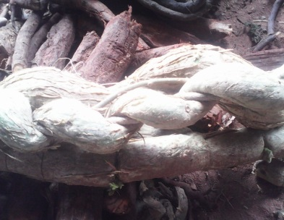
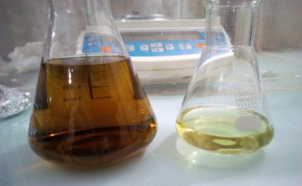
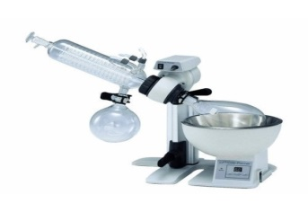
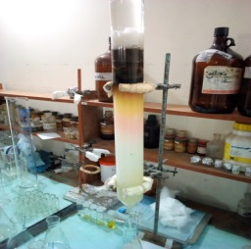
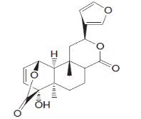
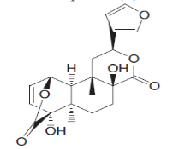
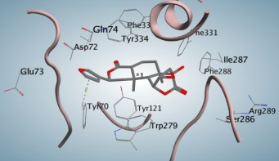
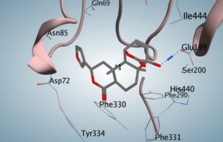

Tinospora cordifolia stem

Plant extract

Concentration of plant extract at 50ºC

Column chromatography

Columbin

8-hydroxycolumbin
AChE assay
Molecular docking

Recent Publications (minimum 5)
Taiwo O. Elufioye and Onoja O. J. (2016). Anti-oxidant capacity and Phenolic content of methanolic extract of Cleome viscosa L. whole plant and its derived fractions. European Journal of Medicinal Plants. 11 (1), 1-9.
Taiwo O. Elufioye and Onoja O. J. (2016). In vivo anti-malarial activity ofCleome viscosa L. whole plant. Research Journal of Phytochemistry. 10 (1):30-38.
M.K. Tchimene, A.O. Anaga, C.E.C. Ugwoke, O.J. Onoja, C.O. Ezugwu, C. Okunji and M.M. Iwu. 2016. Anti-diabetic Profile of Extract, Kolaviron, Biflavonoids and Garcinoic acid from Garcinia kola seeds. Int. J. Curr. Microbiol. App. Sci. 5(2): 317-322.
Onoja O. J. (2015). Efficacy of selected plant extracts against Tribolium castaneumHerbst in stored groundnut (Arachishypogaea L.). African Journal of Plant Science. 9 (2): 90-96.
Taiwo O. Elufioye and Onoja O. J. (2015). Acute Toxicity and Histopathological assessment of methanolic extract of Cleome viscosa (Linn.) whole plant. Journal of Medicinal Plants Research. 9 (11): 360-369.

Biography
Mr. Onoja Ojogbane Joel is a post graduate student (Ph.D.) of the Department of Pharmacognosy, University of Ibadan, Ibadan, Nigeria. He is also an academic staff of the Department of Pharmacognosy and Environmental Medicine, University of Nigeria Nsukka, Enugu State, Nigeria. He has published seven papers in reputed journals.
Presenting author details
Full name: Onoja Ojogbane Joel
Contact number: +2348062872407, jojogbane@yahoo.com
Twitter account: https://twitter.com/JoelOjogbaneOno
Linked In account: https://www.linkedin.com/in/joel-onoja-a33b0a79/
Session name/ number:
Category: (Poster presentation)

