THE COMBINED HAMAKER COEFFICIENT: A Surface Thermodynamic measure for the Efficacy of a
Particle-Particle Interaction.

Being a conference paper
To be presented by

MBABUIKE1, I. U., & Nwadike2, E. C.

1Mechatronics Engineering Technology department

2Mechanical Engineering department

1 Akanu Ibiam Federal Polytechnic, Unwana Ebonyi state

2Nnamdi Azikiwe University, Awka Anambra state

Abstract
Surface thermodynamics study is the application of the mind to an investigative search for the nature and rate of heat transfer on the surface of any particle-particle interaction. This paper presents the theory and a designed practical manual for the demonstration of the Combined Hamaker Coefficient-a thermodynamic method for the determination of the nature and effectiveness of the interactions between any two or more interacting particles. In essence, the Hamaker theory established that “if two particles are embedded in a fluid and the London-van der Waal’s force between the particles and the fluid is greater than between the particles themselves, it might be thought that the resultant action will be repulsion rather than an attraction”. In a case study of; a healthy blood lymphocyte and a HIV particles in a serum fluid containing herbal antiviral drug particle, the Hamaker theory that is fundamentally based on the Van der Waal’s theory for the potential surface heat energy of attraction and repulsion can be demonstrated. Furthermore, the interfacial work done by particles can be investigated during their combined interaction in an in-vivo experiment. The data obtained can prove that the Combined Hamaker Coefficient, when negative is responsible for particle-particle repulsion and positive for particle-particle attraction. Negative absolute combined Hamaker coefficient (A132abs.), implies repulsion of say, a virus particle2 in lymphocyte, by drug particle3 in an intervening liquid medium like serum, and as such, particle1 which is considered to be a virus-free lymphocyte, is coated against a possible contact with particle2. Hence, the overall change of the chemical energy potential of all particle matter, to heat energy, is revealed to be a concurrent area of a Surface Thermodynamics science and engineering study that employs mathematical concepts and appropriate iteration softwares in a current design and formulation of drugs for the management of viral and other natural diseases.

1.0 Introduction
The application of the mind to an investigative search into the nature of heat transfer on the surface of interacting systems, is regarded as Surface Thermodynamic Study. The most basic prompt for inquiry about heat (Thermo.) and its dynamics in any two or three particles’ interactions would be to define a practicable model that would take into consideration the conditions of: internal energy, absolute temperature, entropy, pressure, volume, chemical potential, surface area and concentration of a substance matter in a bulk system of solution, components of surface stress and strain, tensors along a direction in a perpendicular surface, a proportionality factor called the surface tension with its corresponding change, for any given system of interactions of identified particles.
The interaction between HIV and blood cells is hydrophobic in nature because it involves water (a polar agent), chemical active principles or extracts (acids and bases), proteins, and so on (Chaudhury, 2005). The uninfected human blood cell as a life unit is a particle say, P1. HIV as a virus against the human immunology, is similarly a particle say, P2 in its atomic or molecular state. Therefore, an interaction between HIV and blood cell is between two surfaces P1 and P2. Their surfaces are moist and in this moist condition, they would be able to come in contact with one another. The natural force of attraction that tends to attract all atoms towards the centre of the earth (with respect to the gravitational law), (Nelkon, 1980) in a simultaneous natural proportion, will influence the two atomic particles to touch. The intensity of interfacial free energy of every atom, is a measure of the aggregate number of free valence electrons perpetually in the network of revolving in orbit round its nucleus, (Okeke, et. al., 1998). Hence, chemical combination or penetration of any two or more atoms is initiated automatically by a contact which is naturally possible through an attraction force between atoms. The rate of interactions of attractions for chemical combinations between atomic particles, depends on their discrete energy levels. In general, the higher the energy of an atom’s valence electron, the farther its orbit from the nucleus (Anyakoha, 2010). This is to say that, an atom with a higher energy level, reaches out faster to a lower energy level atom and as such is attracted to it for interactions. According to the atomic theory, an associated natural type of bonding or coating at the minutest contact, initiates this form of action, and reactions produce more energy that radiates or spreads. Therefore, a chain reaction is set in motion which is a natural multiplication for self-maintaining interaction. This sort of interaction, between a viral and blood atomic particles, can bring about genetic changes or mutations, causing HIV and other diseases.
In herbal extract media, the interactions and reactions that has been initiated, becomes catalysed by another particle, say P3 and, the rate of interfacial forces of attraction between particles for coating, which is naturally a consequence of the 1st law of thermodynamics, either increases or decreases. Depending on the force of attraction or effectiveness of coating possibly of say, P1 by P3, an equal but opposite vector force of repulsion impacts on P2. The experimental work of Neumann et. al. (1979) presented a thermodynamic relation and the work of Omenyi (1978), led to the derivation of the Hamaker constants, combined constants and coefficients, which are discrete numerical quantities that are fundamentally based on thermodynamic laws that show the relationship between the interfacial free energy and change in adhesion force of atomic particles in a hydrophobic interaction.
Keywords: Hamaker theory, Surface thermodynamics, Combined Hamaker Coefficient, Free energy of Adhesion, Thermodynamic efficacy

1.1 Hamaker Theory
(London, 1930) derived an expression for the mutual attraction energy of two molecules in (Hamaker, 1937) in his classical paper claimed that his derived coefficients which are numbers that indicate the degree of energy change under given conditions, are in essence synonymous with the London-van der Waal (1873) force of attraction between spherical particles. A decade after, he then stated that,
“if two particles are embedded in a fluid and the London-van der Waals’ force between particles and fluid is greater than between the particles themselves, it might be thought that the resultant action will be repulsion rather than an attraction” - Hamaker, 1937.
Visser (1981) demonstrated most of the establishments in simple pictorials. On the discovery that the kinetic energy of molecules which strike a container wall is less than that of the bulk system of molecules as affirmed by London, et. al., (1873), he depicted as shown in figure 1.
V

Figure 1: Attraction of surface molecules by bulk molecules in a container of volume, V
(Visser, 1981)
On the statement of London about the mutual attraction energy of two molecules in a vacuum, he sketched as shown in figure 2.
1
1
H

Figure 2: Interaction of two identical molecules of a material 1 with polarizability, α and separation distance, H
On the mutual attraction of two molecules as in a solid body in a vacuum and the interaction of a sphere of radius, R at a separation, d from a solid surface of the same material, 1 in vacuum, Visser also depicted as shown in figure 3 and 4:
Figure 3: Interaction of two semi-infinite solid bodies 1 at a separation, d in vacuum
(Visser, 1981).
R
R

Figure 4: Interaction of a sphere of radius, R at a separation, d from a solid surface of the same material, 1 in vacuum (Visser, 1981)
Therefore, the Hamaker theory is based on certain considerations that are basic for particles separation or repulsion during any interaction. Hence, an experiment for the evidence of repulsion and attraction forces that govern interaction, would definitely precede any surface thermodynamics study.
1.2 Surface Thermodynamics
This concept is actually the thermodynamic approach to particle-particle interaction. Surface thermodynamics explains the idea of the Hamaker coefficients, of which in its explanation, it becomes necessary to consider the explanation of the deviations of an ideal gas law of 1834 by Èmile Clapeyron who is also known as Van der Waal. The Hamaker’s approach to the interaction between condensed bodies from molecular properties is otherwise a ‘microscopic’ approach to the thermodynamics of interactions.
Originally, the ideal gas law is given as:
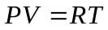 (1)
Where: P is the ideal gas pressure, V is the ideal volume, R is the universal gas constant for a spherical particle of gas, T is the ideal temperature.
At high pressure, van der Waal introduced the ‘corrections’ below (Hamaker, 1937) to the ideal gas law as stated in equ. (1):
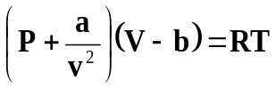 (2)
Where: P, R and T are as defined, 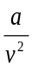 is the correction term to pressure, V is the volume, is the correction term to volume. The term 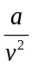 indicates that the kinetic energy of the molecules which strike the container wall is less than that of the bulk molecules. This effect is due to the fact that the surface molecules are attracted by the bulk molecules. In other words, molecules must attract each other by some kind of cohesive force, as Van der Waal stated. Since then, these forces of molecular attraction have been known as van der Waals forces.
London derived an expression for the mutual attraction energy of two molecules in vacuum. Hamaker (1937) equally considered that, for the mutual attraction of two molecules in an assembly of molecules, a solid particle must attract other particles. Thus, the interaction energies are obtained by the summation of all interaction energies of all molecules present. This resulted in a van der Waals pressure of attraction (attractive energy) between two semi-infinite (solid) particles at a separation distance, in vacuum. The equation for this expression is given by equation (3) in terms of the Hamaker constant as:
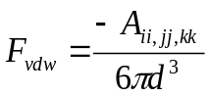 (3)
Where: -Aii,jj or kk is the negative Hamaker constant for two identical particles (11, 22 or 33). Hence, A11 Hamaker constant for the interaction between two identical particles of say, an Uninfected Lymphocyte (1). A22 Hamaker constant for the interaction between two identical particles of say, a HIV Infected Lymphocyte (2). A33 Hamaker constant for the interaction between two identical particles of say, either an Uninfected Serum with Drugs (3) or an Infected Serum with Drug (3). The Hamaker constants are non-geometrical contributions to the forces of attraction based on molecular properties only. 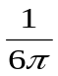is a constant of proportionality with respect to the circle, d is a minimum separation distance for a semi-infinite plate.
Multiplying (3) by πd (a function of the dielectric constant) for a spherical particle of radius 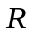, of a semi-infinite plate at a minimum separation distance , the attractive energy is then given by:
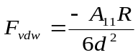 (4)
The experimental proof of separation or repulsion forces led to the belief that particles interacting in liquid may be identical or different. According to the Hamaker approach, the dispersion force of interaction between two identical atoms or molecules or particles, i separated by an infinitesimally short distance (in vacuum) can be expressed as:
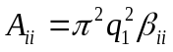 (5)
Where: Aii is a Hamaker constant, which is the non-geometrical contribution to the force of attraction, based on molecular properties only, q is the number of atoms per unit volume and βii is the London-van der Waals constant = −3ћνα2/4(4πε0)2.
The work of cohesion resulting from London dispersion force or interaction energy between any two identical particles is given as:
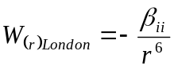 (6)
Where: r is the distance between the atoms, i.
Under this condition, the dispersion interaction energy becomes repulsive, i.e. W(r)London ˃ 0. The London dispersion interaction between two particles (identical or different) in vacuum is always attractive. In other words, when two different materials 1 and 2 interact immersed in liquid 3, A11 ≠ A22 and a net repulsion occurs.
Using the macroscopic approximation, the total dispersion energy for two semi-infinite flat parallel bodies (of material i), separated by a distance, r (in air or in vacuum), becomes (for r greater than a few atomic diameters):
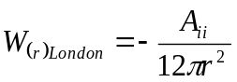 (7)
Where: Aii is the Hamaker constant for material, i.
Hence, the Hamaker pair-wise summation procedure can be used to calculate the combined Hamaker constant of two macroscopic identical particles interacting in a third medium. For any two atoms of different materials, (1, 2 and 3) or (i, j and k), the combining rule of thumb is:
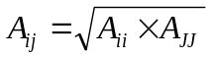
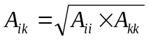
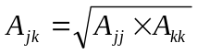

Padday (1969) demonstrated the applicability of the Hamaker approach to n-alkanes by calculating the theoretical values of surface tension (γii) of various n-alkanes using the following equations:
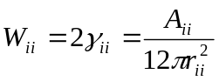 (8)
Where: Wii is work of cohesion resulting from London dispersion forces
rii is separation distance between two atoms in bulk.
The Hamaker’s approach considered molecular properties, hence it is regarded as a microscopic approach and thus, it had its limitations due to its neglect of the ‘screening effect’ of the molecules which are on the surface of two interacting bodies with respect to the underlying molecules in the bulk. This perceived limitations by Lifshitz et. a., (1961) led them to develop an alternative derivation of the Van der Waal’s forces between solid bodies. Considering the interaction between solid particles on the basis of their macroscopic properties, the Hamaker coefficient was expressed in terms of bulk material properties as:
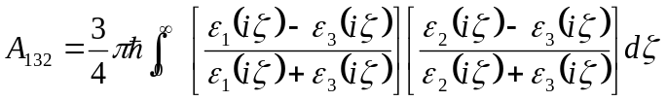 (9)
Where: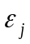 is the dielectric constant of material j along the imaginary frequency axis 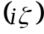 and it is the Plank’s constant divided by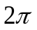. This equation is rather complex and would be difficult to use hence, several approximations have been given. But using the Liftshitz approach for van der Waals interaction (in condensed media), Chaudhury (2005) experimentally demonstrated that dispersion(London), induction(Debye) and dipole (Keesom) contributions to the Lifshitz-Van der Waal or (polar) components of the surface tension 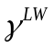are additional.
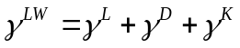 (10)
It follows that on a macroscopic level, the three types of Van der Waals interactions; (Keesom, Debye and London) can be treated together as the total of polar or Lifshitz-Van der Waals (LW) interaction. Hence, the interfacial tension 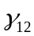 between two different materials 1 and 2 is one of the important concepts in colloidal and surface science as it leads directly to a quantitative expression for the free energy of inter-particle or inter-molecular interaction in condensed phase system. The interfacial tensions between two reasonably immiscible liquids can be measured directly but the interfacial tensions between solids and liquids and between solids and solids cannot be determined directly. It thus becomes important to deduce these interfacial tensions, via the surface tension 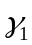 and 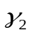 of the interacting solid material 1 and liquid material 2.
The interfacial tension between a solid and a liquid (if only dispersion interaction forces are available between the two condensed phase materials of the solid and the liquid) as demonstrated experimentally by Good-Grifalco-Fowkes is given by:
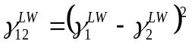 (11)
Or
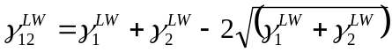 (12)
Equation (12), is the Good-Grifalco-Fowkes combining rule. But, the surface tension 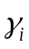(i.e. the surface free energy per unit area of a liquid in vacuum) is equal to one half of the free energy of cohesion (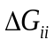) and opposite in sign; that is to say that:
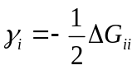 (13)
Therefore, the polar component of the free energy of cohesion of material 1 is:
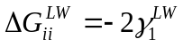 (14)
Hence, the free energy of interaction between materials 1 and 2 in vacuum is related to the surface tension by the Dupre equation:
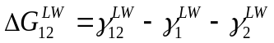 (15)
Substituting equation (11) into (13), we obtain:
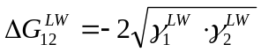 (16)
Since the Lifshitz-Van der Waals forces are universal and always available at the surface, the equation (16) is stating that the atoms at an interface are pulled by those in the neighbouring phase. It is also suggesting that the energy of interaction is negative, that is interaction energy between two purely polar condensed phases is always attractive. Similarly, the interaction energy between molecules or particles of material 1 immersed in a liquid 2 is:
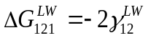 (17)
Therefore, two different particles 1 and 2 immersed in a liquid 3 are related to the interfacial tensions by:
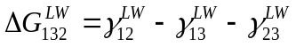 (18)
Using equations (11) and (15) to expand the interfacial surface tensions in equation (18) gives:
(19)
From equation (16) it follows from equation (19) that;
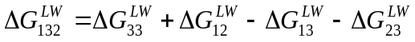 (20)
This is the Hamaker coefficient combining rule obtained through a purely surface thermodynamic treatment provided:
- The geometric mean combining rule (24) holds for LW interactions.
- The equilibrium distance, r has the same value for all types of 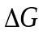 interactions.
- The constancy of r for LW interactions of all materials is as confirmed by (Van oss et. al., 1978).
According to the Hamaker combining rule, the following combined Hamaker coefficients have been established:
1. For a combination of two particles of material 1 when the gap between them is filled with a medium 3, for example water or serum containing herbal extract(s):
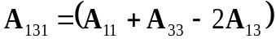 (21)
This according to Hamaker is always either POSITIVE or ZERO. It has hitherto been discovered that the A131 is positive when the Lymphocyte-Serum interaction is with drugs and is zero or negative when the Lymphocyte-Serum interaction is without drugs. The convention here is that the first and the third character in the triplet subscript identify the two particles which are interacting through a liquid medium, identified by the second character.
2. For a combination of two particles of material 2 when the gap between them is filled with a medium 3, for example water or serum containing herbal extract(s):
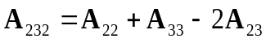 (22)
3. For a combination of one particle each of three different materials 1, 2, and 3; when the gap between two of the particles 1 & 2 is filled with a medium 3, for example water or serum containing herbal extract(s):
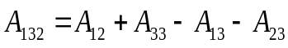 or,
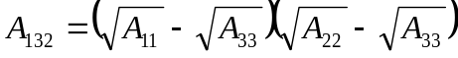 (23)
Equation (23) shows that for a three-component system involving three materials 1, 2 & 3; 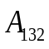 can become negative, when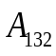 < 0 or when 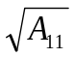 > 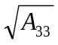 and 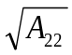 < or when
A11 < 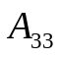 < A22 or when A11 > > A22
Hamaker had stated that London-Van der Waals’ forces were always attractive for two particles of the same material embedded in a liquid fluid. He added that if the particles were of different composition (as is of HIV, blood and drug in serum), the resultant force would be repulsive. This indicates as well, changes in free energy and hence, a thermodynamic prediction of interacting systems. If A132 is NEGATIVE, it indicates a thermodynamic criterion for Drug-coated lymphocyte repulsion of HIV. But if A132 is POSITIVE, it indicates a thermodynamic criterion for Lymphocyte attraction of Drug.

The Hamaker theory is quite significant in establishing a thermodynamic criterion for particle-particle interaction prediction and as such, this tool is obviously valuable in engineering and bioengineering studies. On the hypothetical combinations of material for a negative Lifshitz-Hamaker constant, Visser (1981) developed a table 1 as shown below:
Table 1: Combination of materials for which negative Lifshitz-Van der Waals’
constant A132 are found (Visser, 1981)
System | A132/Ev
Si/Al2O3 | - 0.19
Ge/Cds/Polystyrene | - 0.28
Cu/MgO/KCl | - 0.17
Au/Si/KCl | - 0.81
Au/Polystyrene/H2O | - 0.14

1.3 The Free Energy of Adhesion, 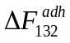 and its relationship to the Hamaker Coefficient
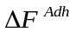can be determined by various approaches apart from the surface free energy approach. It is the classical Hamaker work of 1937 that is most appropriate.
The Hamaker coefficient has been established, and representatively quoted in this work as 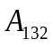 and the free energy of adhesion as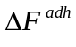. Hence, for all given combinations, it is possible to express in terms of van der Waals energies. For example, for two flat-flat plate geometry:
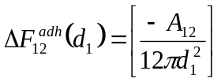 (24)
Similarly,
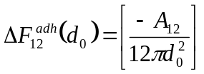 (25)
By extension (for three flat-flat-flat plane geometry):
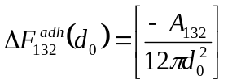 (26)
Where:
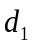→ a vacuum separation gap or distance
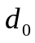→ a liquid separation gap or distance
On the basis of these results and in line with Van oss et. al. (1979), the bulk van der Waals interaction term is referred to as the Hamaker coefficient rather than the Hamaker constant. It is only in the case of a material interacting with itself through a vacuum is the Hamaker coefficient, 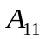a constant, with its own specific equilibrium interfacial separation distance. In establishing this relationship, Visser (1981) made the following deductions:
- Interfacial separation distance between solid bodies vary depending on the materials involved, in particular, immersion of a system in a liquid can alter the equilibrium position between the adherents
- Surface tension data are the most useful tool to predict conditions for three-component systems to be repulsive leading to phase separation.
- The occurrence of van der Waals repulsion for component systems can experimentally be demonstrated as well as theoretically.
1.4 Experimental Design – this is a manual for the investigation for the occurrence of van der Waal’s force of repulsion in a real-life 3D component system. An experimental design could follow the major steps:
1.4.1 Collection, Preparation and Phytochemical Profiling/Characterization of Herbal particles – For flora-based particles, phytochemical profiling and FT-IR analysis for the active compounds present and their functional groups respectively should be carried out and results recorded as prescribed on table 2.
Table 2: Phytochemical Quantities of Active compounds present in experimental plants (Mbabuike et.al., 2018)
Drug  No. | Abv. | Source  of  Herb | Name  of  Specie | Qty.  (mg)  Used | Active  com-  pounds  of  interest | Func-  tional  groups | Qty.  (mg)  in  10 ml  of sterile  H2O | % compo-sition | Qty.  (mg)  in  0.2 ml  of sterile  H2O

But if fauna-based particle, like a pathogen, its carrier would be identified, collected and preserved.
1.4.2 Collection, Handling and Preservation of Pathogen particles – under ethical conditions, pathogens like bacteria, fungus and even virus can be voluntarily collated and clinically handled to ensure their activeness before interaction with other prepared particles.

1.4.3 Samples preparation for Spectroscopy – the spectroscope uses a defined size of plane glass strips like a 25.4 x 76.2 x 1.2mm microscope slides for a digital UV visibleMetaspecAE1405031Pro spectrophotometer. Hence, with respect to various samples that would stand as controls for experiments, the following pictorials could offer the matrix for the actual number of slides required for investigation and measurement of light absorbance values.

a. Herbal particles in sterile water – these would stand as controls for the herbal particles when interacted with pathogen or other particles and as a measure towards degree of coating or binding to other particles in an interacting system.
I ml of sterile H2O
2 ml of sterile H2O
3 ml of sterile H2O
4 ml of sterile H2O
5 ml of sterile H2O
Drugs1-m

Figure 5: Particles3 in five (5) different millilitres of sterile water
In fig. 5, if there are five different samples of Particle3 in five separate quantities of sterile water solvent, that means 5 x 5 = 25 slides would be prepared and allowed to air-dry in a dust-free laboratory ready for spectrophotometric analysis.
b. Serial dilution of Particle3 in sterile water – these would serve as aliquot solutions of diluted particle samples that would be used for inoculation that introduces interactions.
Drugs1-m

3rd serial dilution of Drugs1-m
2nd serial dilution of Drugs1-m
1st dilution of Drugs1-m

Figure 6: Serial dilution of Particle3 samples
In fig. 6, if five (5) different Particles3 are serially diluted to say the 3rd level, there would be five (5) different 3rd serially diluted solutions to be used in interaction with Particles1 and 2.

c. Interaction of pathogen uninfected Particle1 with Particle3
Unf. Particle1
+
Particle3

Se1-n : D1-m
Er1-n : D1-m

Wh1-n : D1-m

Ly1-n : D1-m

Figure 7: Pathogen Uninfected (Unf.) Particles1 with Particle3
In the fig. 7, four (4) different particles; Serum (Se), Lymphocyte (Ly), Erythrocyte (Er) and Whole (Wh) are infected by a pathogen. If a number of samples say, n = 10 are to be interacted the same quantity of five (5) different Particles3, 4 x 10 x 5 = 200 slides would be prepared and allowed to air-dry in a dust-free laboratory ready for spectrophotometric analysis.
d. Pathogen uninfected Particle1 without Particle3
Unf. Particle1
without
Particle3

Ly1-n
Se1-n
Wh1-n

Er1-n

Figure 8: Pathogen Uninfected (Unf.) Particles1 without Particle3
In the fig. 8, four (4) different particles; Serum (Se), Lymphocyte (Ly), Erythrocyte (Er) and Whole (Wh) are uninfected with a pathogen. If a number of samples say, n = 10 are not to be interacted with Particles3, 4 x 10 = 40 slides would be prepared and allowed to air-dry in a dust-free laboratory ready for spectrophotometric analysis.

e. Interaction of pathogen infected Particle2 with Particle3
Inf. Particle2
+
Particle3
Ly1-n : D1-m
Se1-n : D1-m
Wh1-n : D1-m

Er1-n : D1-m

Figure 9: Pathogen infected (Inf.) Particle2 with Particle3
In the fig. 9, four (4) different particles; Serum (Se), Lymphocyte (Ly), Erythrocyte (Er) and Whole (Wh) are infected by a pathogen. If a number of samples say, n = 10 are to be interacted with the same quantity of five (5) different Particles3, 4 x 10 x 5 = 200 slides would be prepared and allowed to air-dry in a dust-free laboratory ready for spectrophotometric analysis.
igure 1: Pales in sterile waterolvent, 5 x 5 = 25 slides
f. Pathogen infected Particle2 without Particle3

Inf. Particle2
without
Particle3

Ly1-n
Se1-n
Wh1-n

Er1-n

Figure 10: Pathogen infected (Inf.) Particles2 without Particle3
In the fig. 10, four (4) different particles; Serum (Se), Lymphocyte (Ly), Erythrocyte (Er) and Whole (Wh) are uninfected with a pathogen. If a number of samples say, n = 10 are not to be interacted with Particles3, 4 x 10 = 40 slides would be prepared and allowed to air-dry in a dust-free laboratory ready for spectrophotometric analysis.
1.4.4 Spectrophotometry and Hamaker Computations
The science of spectrophotometry makes use of a spectrophotometer which is an instrument for detecting the relative intensity of two spectra or of the corresponding bands of colour in two spectra. This is based on the principle of a simple spectroscope which is equally an optical instrument for forming and analysing spectra emitted by bodies or substances. The analysis of spectra begins with the measurement of absorbance, â in nanometres (nm) over set wavelengths, λ in Angstrom (Å). Absorbance is the quality of a substance to take in by chemical or molecular action, as gases, heat, liquid, light, etc. The action of intercepting an ultraviolet visible spectrum, with a wavelength of 10-8m (Nelkon, 1981) as it is beamed onto a substance smeared uniformly on a plane glass slide, records the magnitude of the heat of interaction. Hence, the wavelength is a fundamental unit in the study of radiant energy on the surface of particles.

Plate 1: A digital UV visibleMetaspecAE1405031Pro spectrophotometer interfaced with a dedicated PC that uses the spread sheet of a Metaspec pro–[multi-wavelength analysis (mwl1611300004)] software. Mbabuike, et. al., (2018)*
With obtained absorbance, values, for all non-interacted particles and interacted system of particles; can be simulated with a software like Excel or Matlab to calculate absolute values of .
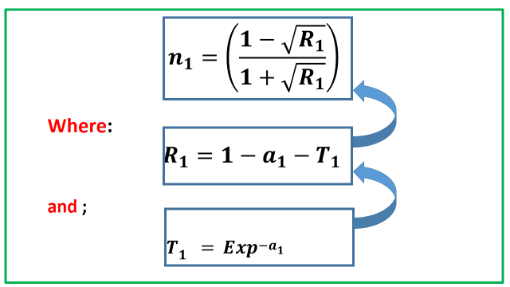
Where for every particle: T is the transmittance, R is the reflectance and n is the refractive index of the substrate slide.
A11 like A22 and A33 is then computed with:
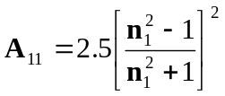 (27)
The combined Hamaker coefficients are in turn computed with:
(21)

(22)

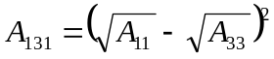 (23)

All combined Hamaker coefficients are expressions of thermodynamic interactive terms. Other thermodynamic parameters that could be measured are: absorption coefficient, 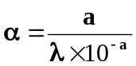; extinction coefficient, 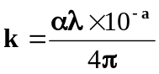; real dielectric constant, 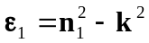 and imaginary dielectric constant, 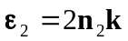. 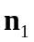and 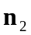are the positive (real) and negative (imaginary) parts of the refractive index, n.
1.5 Conclusion
The principle of the Negative Combined Hamaker Coefficients, by this analysis could be demonstrated in an in-vivo experiment and proved when negative to be responsible for Particle-Particle repulsion and positive for Particle-Particle attraction. Negative A132abs. (for any virus+ sample) implies repulsion (of virus particle2 in lymphocyte, by drug particle3 in intervening liquid medium). Positive A132abs. (for any virus+ sample) implies attraction (of uninfected lymphocyte particle1 by drug particle3 in serum). Positive A131abs. (for any HIV- sample) > Positive A232abs.(for any HIV+ sample) implies Attraction (of uninfected lymphocyte particle1 by drug particle3 in serum). Positive A131abs. (for any HIV- sample) < Positive A232abs. (for any HIV+ sample) implies Repulsion (of uninfected lymphocyte particle1, by drug particle3 in serum). The determination of the effectiveness of say, of herbal antiviral drug and blood particles using the surface thermodynamics approach, can be useful in the treatment of viral and other diseases.

References
Anyakoha, M. (2010):
Chaudhury, A. (2005): The Nef protein of HIV-1 induces loss of cell surface stimulatory molecules CD80 and APCs. Journal of Immunology 2005. 175. 4566-4574.

Lifshiftz, F.J., Hunt, S.M., Gore, J.M., and Curby, W.A. (1961): Cryobiology. Vol.12 pp.181
London, Van der Waal, J. D. (1873): Thesis Leiden

Mbabuike, I. U., Achebe, C. H., Chukwuneke, J. L. (2018): Surface thermodynamics study and spectrophotometric data analysis of human immunodeficiency virus (HIV)-antiviral herbal drug coated blood interactions.

Mbabuike, I. U., Achebe, C. H., Ani, O. I. (2018)*: Application of negative Hamaker coefficient to in-vitro human immunodeficiency virus (HIV)-blood interactions in antiviral herbal extract media
Hamaker, H.C. (1937): Phisica. Vol. 4 p. 1058
Van oss C. J., and Grossberg, A. L. (1979): in: Principles of Immunology: Rose, N. R.., Milgram, F. and Van Oss C.J. Macmillan, New York, chapter 5.
Visser, J. (1981): Advances in Interfacial Science. Elsevier Scientific Publishing Co., Amsterdam. Vol. 15 pp. 157-169

Neumann A.W., Absolom D.R., Zingg W., and Van Oss C. J., (1979): Surface Thermodynamics of Leukocyte and Platelet adhesion to polymer surfaces, cell biophysics. Vol.1 (1), pp.79-92
Okeke, P.N., Okeke, F.N. and Akande, S.F. (2008): Senior secondary physics. Pp. 155-161.
Van der Scheer A. And Smolders C. A. (1978): Dynamic aspects of contact angle measurements on adsorbed protein layers. Journal of colloid and interface sciences. Vol.63, pp.7-15
Van Oss, C.J., Absolom, D.R., and Neumann, A.W. (1979): Separ science and technology. Vol. 14, no. 4
London, F. (1930): Z. Physics. Vol. 63 pp. 245
Padday J. F. (1969): Surface and colloid science. Matijevic ed. Vol.1, wiley intersciencs, NY. P.101

