Single or combined cadmium and aluminum intoxication of mice liver and kidney with possible
effect of zinc
Ahmed S. Ibraheem *, Amin A. Seleem, Mohamed F. El-Sayed, Heba A. Khalil
Zoology Department, Faculty of Science, Sohag University, Egypt

Abstract
In this study, we planned to test toxic effects of cadmium, aluminum either alone or combined with each other on sensitive organs as kidney and liver. The cadmium alone decreased the animal’s body weight. Meanwhile, aluminum did not affect the changes in body weight of cadmium treated animals; adding the zinc significantly reduced the loss of body weight. Serum creatinine and urea were significantly lower in treated group than in control group. Cadmium aluminum or combination of them resulted in a significant increase in serum GPT and GOT activity. Zinc did not prevent the changes caused by aluminum, however, the changes resulted by cadmium intoxication were almost healed or ameliorated by zinc. Treating with Zn alone resulted in drastic effects on kidney tissues more than either cadmium or aluminum. Treating with cadmium or aluminum resulted in infiltration of the liver parenchyma with lymphocytes, fibrosis, micro vesicular steatosis of the hepatocytes for both and appearance of many phagocytic cells, pyknotic cells and vacuolation for cadmium. Combined cadmium and aluminum treatment resulted in less damage than cadmium alone with exception of fatty degeneration. Unexpectedly, zinc induced acute cell vacuolation and steatosis. Cadmium and aluminum combined together did not worsen the situation as expected but was less damaging than cadmium alone, which suggests a possible synergistic effect of combination. Meanwhile, zinc failed to protect kidney from aluminum intoxication, which strengthens the suggestion of two different pathways of cadmium and aluminum intoxication. This finding meant that cadmium is more hepatotoxic than aluminum..

Image
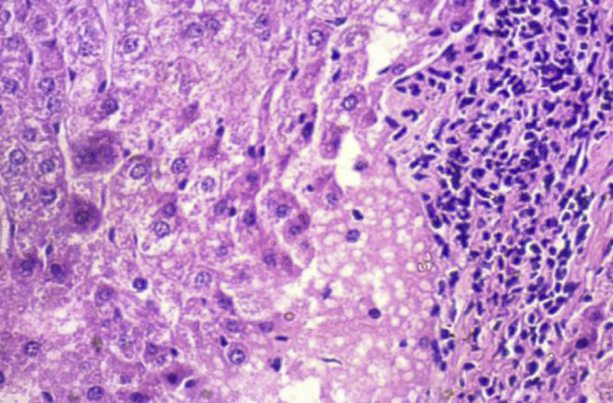
Photomicrograph of histological section through the liver cadmium treated mice (40X).
Recent publications
- Ibraheem, A. S., M. F. El-Sayed, H. a. Khalil 2016. Establishment of hepatitis model in rat liver induced by injecting extracted DNA: Histopathological study. JOBAS, 77,102-111.
- Ibraheem, A.S., El Sayed, M.F., Ahmed, R.A., 2013. Lymph node histopathological studies in a combined adjuvant-collagen induced arthritis model in albino rat Rattus rattus. JOBAS 66, 195–205.
- Acheson, K.J., Schutz, Y., Bessard, T., Anantharaman, K., Flatt, J.P.,Ande´quier, E.J., 2013. Deficiency of a glycogen synthase-associated protein, Epm2aip1, causes decreased glycogen synthesis and hepatic insulin resistance. J. Biol. Chem. 288, 34627–34637.
- Chatman, L.A., Morton, D., Johnson, T.O., Anway, S.D., 2009. A strategy for risk management of drug-induced phospholipidosis.Toxicol. Pathol. 37, 997–1005.
- Reasor, M.J., Hastings, K.L., Ulrich, R.G., 2006. Drug-induced phospholipidosis:issues and future directions. Expert Opin. Drug Saf. 5,567–583.

Biography
Deanna Dr. Ibraheem obtsined his Ph. D. from Virginia Common wealth University 2004 the moved Sohag University Egypt and later he is serving at Hail University, KSA, temprorley. The feid of specialization for him is Immunology with special focus on autoimmunity. .
Email: asibraheem@yahoo.com

Notes/Comments:

JOBAZ 77:102-111.

