Title: Elderly-onset Crohn’s disease remarkably responsive to ustekinumab: A case report
Name: MAHO IWAMOTO
Nihon University School of Medicine, JPN

Abstract (300-word limit)
Background Crohn’s disease is intractable and is frequently diagnosed in younger people. No clear policies exist regarding medical treatment for seniors with this disease, and its diagnosis and treatment are often hindered by difficulties attributable to comorbidities, complex differential diagnoses, and polypharmacy. We describe an elderly-onset Crohn’s disease patient showing a marked remission-maintaining effect with no adverse events after administration of ustekinumab.
Methods and results A 75-year-old patient with Crohn’s disease and a history of pulmonary tuberculosis had first presented to our hospital at age 64 years, and was hospitalized. Based on physical examinations, colonoscopy, and blood test results, Crohn’s disease was diagnosed. The patient experienced secondary losses of responsiveness to two tumor necrosis factor (TNF)-alpha inhibitors, and after repeated hospital admissions, she was administered ustekinumab. The patient’s symptoms, endoscopic findings, Crohn’s Disease Activity Index, serum albumin and physical activity levels improved markedly, and disease remission has been maintained for 2 years to date.
Conclusion Ustekinumab is an effective treatment option for elderly patients with intractable Crohn’s disease when TNF-alpha inhibitors are ineffective.

Image
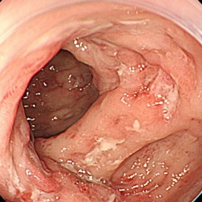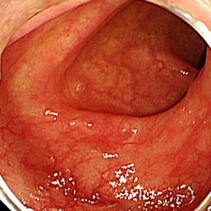
Recent Publications
1. Sturm A, Maaser C, Mendall M et al (2017) European Crohn's and Colitis Organisation topical review on IBD in the elderly. J Crohns Colitis 11:263–273.
2. Feagan BG, Sandborn WJ et al (2016) Ustekinumab as induction and maintenance therapy for Crohn's disease. N Engl J Med 375:1946–1960.
3. Sandborn WJ, Rutgeerts P, Gasink C et al (2018) Long-term efficacy and safety of ustekinumab for Crohn's disease through the second year of therapy. Aliment Pharmacol Ther 48:65–77.
3. Engel T, Yung DE, Ma C et al (2019) Effectiveness and safety of ustekinumab for Crohn's disease; systematic review and pooled analysis of real-world evidence. Dig Liver Dis 51:1232–1240.
5. Brassard P, Bitton A, Suissa A et al (2014) Oral corticosteroids and the risk of serious infections in patients with elderly-onset inflammatory bowel diseases. Am J Gastroenterol 109:1795–1802.



Paste your Photograph Here
Biography (150-word limit)
She works as an assistant professor at Division of Gastroenterology and Hepatology, Department of Internal Medicine, Nihon University School of Medicine in Tokyo. She specializes in inflammatory bowel disease.

Notes/Comments

