Title: Stem cell transplantation - Donors as Research Objects

The donor search process and beyond
Name: Susanne Morsch (CHTC)
Stefan-Morsch-Stiftung, Birkenfeld, Germany

Abstract (300 word limit)
Allogeneic hematopoietic stem cell transplantation (HSCT) has become an established therapy in the treatment of patients with a range of hematological and non-hematological disorders. The number of allogeneic stem cell transplants increases every year.
The risks and options for the stem cell recipients are well defined and documented and transplant physicians are well aware of the procedures in their facility. Physiological and psychological factors for the recipient are part of the daily routine.
In contrast to the situation for the recipients, hematopoietic stem cell donation is often considered a relatively safe procedure for the donor and the physiological and psychological impact on the donor is not the focus of the transplant physician. When donors are included in studies and become research objects the process gets even more complicated.
The knowledge and understanding about the obstacles and challenges of all the parties involved in stem cell donation are fundamental for the success of the allogeneic hematopoietic stem cell transplantation.
We believe it is necessary to create an understanding in the clinical community of the impact the stem cell donation has on the donors and how important the exchange of information is with regard to preserving donor commitment and availability.

Image
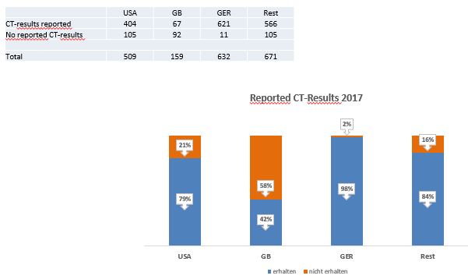
Figure 1: Number of reported CT results by Transplant Centers in 2017
Recent Publications
- Morsch S, (2015). Proud. In: Sharing life: inspiring stories of transplant patients and their lifesaving heroes. Leiden: World Marrow Donor Association.
- Punzel, M., Bogolepov, V., Fisher, R., Harper, C., Liu, A., Liu, S., Morsch, S. and Wiegand, T. (2014). Chapter 4. In: A gift for life; WMDA handbook for blood stem cell donation, 1st ed. Leiden: World Marrow Donor Association.

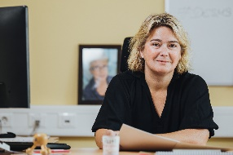
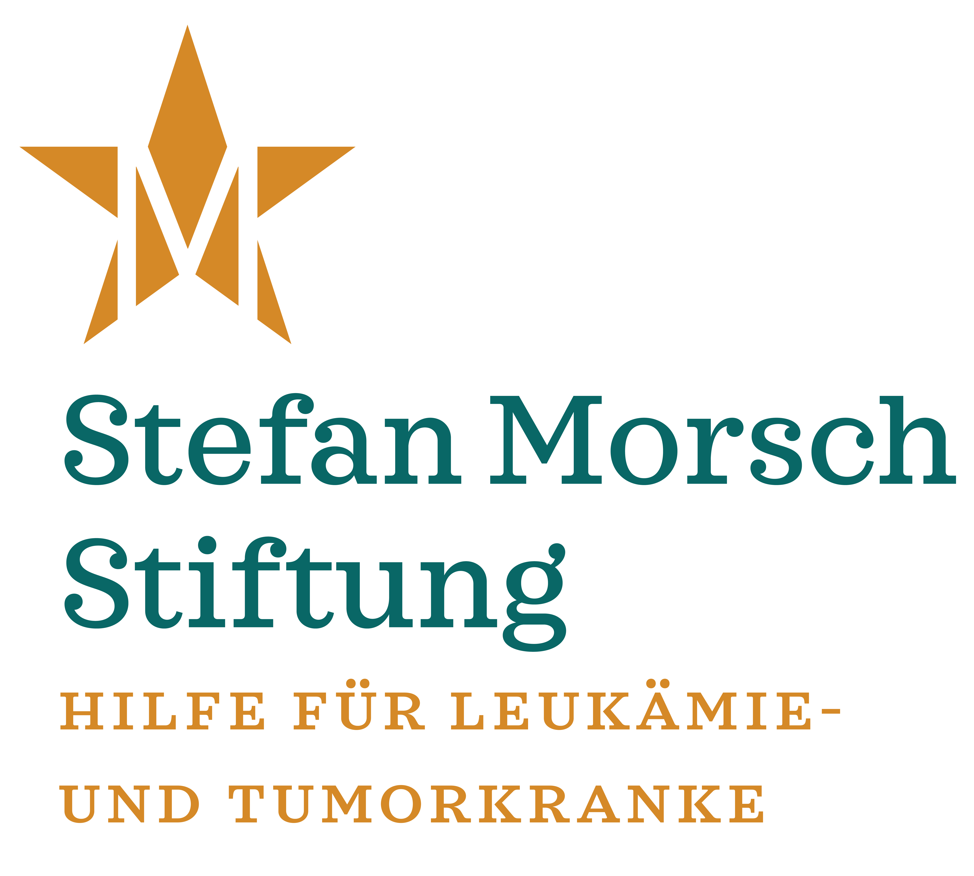
Biography (150 word limit)
Susanne Morsch is the CEO of the Stefan-Morsch-Stiftung, a charitable non-profit foundation that established Germany’s first unrelated stem cell donor registry in 1986 (more than 450.000 donors in 2018). For more than 30 years, the foundation has been working with transplant physicians sharing the experience in donor and patient support. Susanne is a Certified Hematopoietic Transplant Coordinator (CHTC) with more than 15 years of experience in the search for unrelated stem cell donors. She has built the foundation’s “International Search Center” to help transplant centers around the globe to identify the best-matched unrelated donors for their patients in the worldwide database. In addition, she holds a degree in social economics -Sozialwirtin (FH)- and is member of the World Marrow Donor Association (WMDA) and the European Group for Blood and Marrow Transplantation (EBMT).
Email: susanne.morsch@stefan-morsch-stiftung.com

Notes/Comments

