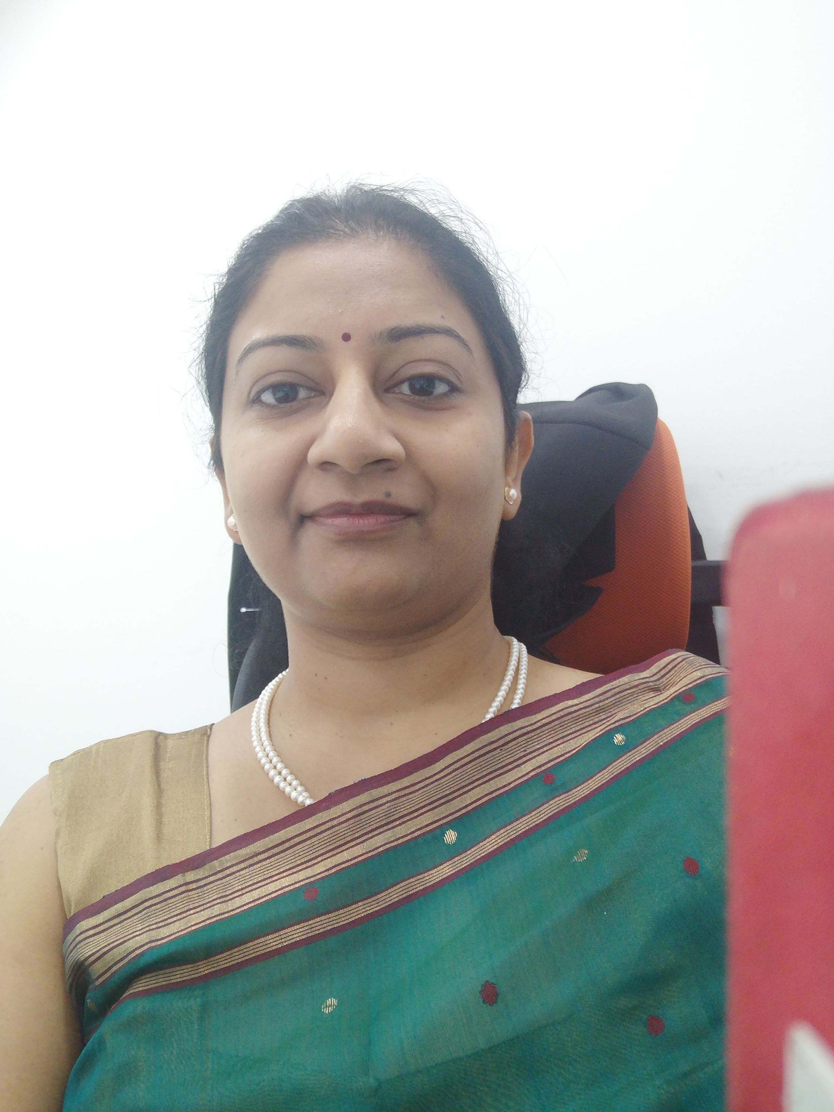

Title: Utility of Global Coagulation Assay in Assessing Severity of Liver disease: Scenario from a Developing Country

Name: Dr. Priyanka Saxena

Rainbow Children’s Hospital, New Delhi, India

While chronic liver diseases (CLDs) present with deranged hemostasis, patients with acute on chronic liver failure (ACLF) present with added acute insults on CLD and thus have a poorer prognosis with severely profound coagulopathies.

Aims: To find out the efficacy of global coagulation assay parameters in predicting the severity of liver disease in ACLF patients.

Methods: A prospective study approved by Institutional Ethics Board, with informed consent, was carried out in 60 adult patients of ACLF (Asian Pacific Association for Study of Liver, APASL criteria). Prothrombin time (PT), International Normalized Ratio (INR) and Activated Partial Thromboplastin Time (APTT) were determined on citrated plasma samples (coagulometric assays) while global coagulation assay (Sonoclot) was determined using glass bead activator on whole blood and Activated clotting Time (ACT), Clot Rate (CR) and Platelet function (PF) noted. Severity of liver disease was assessed using Child -Pugh Criteria (CTP) and Model for End Stage Liver Disease (MELD). All the coagulation parameters were correlated with CTP and MELD respectively using Pearson’s correlation. P values considered significant if <0.05.

Results: The mean age was 42.2±13.1 years with 90% patients being males. The most common etiology was alcohol. While INR correlates best with MELD (correlation coefficient r=0.61, p<0.05), CR correlates best negatively with MELD (r= -0.41, p<0.05) and PF correlates best with CTP (r=0.2, p=0.1).
Conclusion: Global coagulation may be used as a single test assay for assessing severity of liver disease and may better predict the intricate coagulopathies in ACLF patients as compared to routine coagulation assays.

Biography

Dr. Priyanka Saxena completed her MD (Pathology) from PGIMS, Rohtak, India and has over 13 years of experience in this field. Currently, she is Senior Consultant and Head of Laboratory at Rainbow Children’s Hospital, New Delhi. Earlier, she was Professor of Pathology at Maulana Azad Medical College, New Delhi. She has presented at several national and International conferences and published more than 25 papers in International journals of repute. She was Principal Investigator of projects funded by Deptt. of Science and Technology, India. Her main area of interest is coagulopathies especially in liver diseases.

