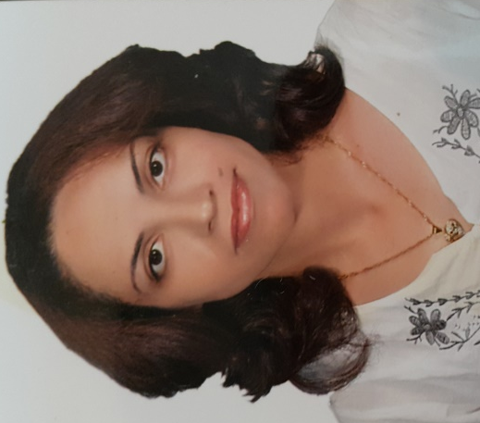
Fresh- Frozen Plasma transfusion as replacement therapy in a child with plasminogen deficiency and ligneous conjunctivitis: delayed but did not prevent recurrence
Dr. Hanan Fawzy Nazir
Alexandria Faculty of Medicine- Sultan Qaboos University Hospital, Muscat, Oman
Ligneous conjunctivitis is a rare form of pseudomembranous conjunctivitis that develops specifically in patients with type 1 plasminogen deficiency. Lack of plasmin activity in those patients result in defective fibrinolysis and formation of fibrin- rich membranous material/ masses that develops on the palpebral conjunctiva as well as other sites in the body.(1) Current management involve surgical excision of the masses that is usually complicated by multiple recurrences. Recently, use of topical plasminogen concentrates helped delaying recurrence, but currently, those concentrates are not commercially available.(2)
Hereby, we report on the perioperative use of FFP transfusion as an alternative replacement of plasminogen during surgical excision of ligneous conjunctivitis.
AA is an 8 year-old Omani girl with hypoplasminogenemia, diagnosed at the age of 6 months. Her plasminogen level was 0.140 u/ml (normal range 0.730-1.270 u/ml), confirming congenital plasminogen deficiency. However, the diagnosis was suspected at the age of 2 months when she developed pseudomembranous conjunctivitis ( ligneous conjunctivitis). Her parents are cousins, and there was no family or personal history of abnormal bleeding/ thrombosis. There was no other clinical manifestations involving her gingiva, ears, skin, respiratory or genitourinary tracts.
Her clinical course was marked with recurrent ligneous conjunctivitis, and she had her first left sided eye surgery when she was 3 months old. Between the age of 3 months till 3.5 years, she underwent 6 eye surgeries for excision of ligneous lesions. Topical steroids, cyclosporine ED and lubricants were used in an attempt to prevent or delay recurrence. Treatment with topical plasminogen was considered, but it was not available and was logistically difficult to prepare in our blood bank. Topical FFP eye drops were thought of as an alternative but was technically difficult to prepare.(3)
In October 2015 (age 6.5 yrs), she had worsening of bilateral ligneous lesions with left lower mechanical entropion. Surgical excision was considered of poor prognosis because of risk of recurrence and high incidence of complications (Symblepharon). At the age of 7 years, conjunctival lesions became bulky, causing mechanical ptosis in both eyes and started to encroach on the limbus (figures 1,2). She had left sided conjunctival mass excision and amniotic membrane grafting followed after 2 months by right-sided similar procedure (figures 3,4). Replacement therapy was needed to insure good plasminogen level around the time of eye surgery and to obtain best chances of normal healing. Because plasminogen concentrates were not available, the choice was between FFP and cryoprecipitate. Decision for the best available option to optimize her plasminogen level required assessment of plasminogen recovery by testing serial plasminogen levels after FFP and cryoprecipitate transfusions. (table 1)

Table (1): Plasminogen recovery after FFP ( 15 ml/kg) and cryoprecipitate (one bag/5 kg body weight) transfusions.
Replacement | FFP ( 15 ml/kg) | Cryo ( one bag/5kg)
Plasminogen level (u/ml)
Baseline | 0.245 | 0.304
Immediate after transfusion | 0.475 | 0.410
30 min | 0.490 | 0.378
1 hour | 0.415 | 0.381
2 hours | 0.388 | 0.326
4 hours | 0.347 | 0.308

As shown in table (1), her plasminogen levels remained subnormal after either FFP or cryoprecipitate administration. With FFP, the maximum concentration reached was almost 50% of normal. On the other hand, although half- life of plasminogen is known to be 2-2.5 days, (4) the patient seemed to have a high catabolic rate after receiving cryoprecipitate, with plasminogen levels reaching basal levels within 4 hours.
Because levels were higher with FFP, we opted to give FFP before and after surgery. Her perioperative management included FFP transfusion at 20 ml/kg/12 hours one day before and for 3 days post operatively, followed by 10 ml/kg once daily from day 4-6, then 20 ml/kg on 7th post- operative day. Topical treatment started with antibiotic ED, steroid, followed by Heparin ED on the second day. On follow up, she used topical heparin, cyclosporine, prednisolone, and lubricant eye drops. Clinical picture remained stable for almost I year post operatively.
Conclusion:
Until topical and plasminogen concentrates are widely available, systemic use of FFP transfusion around the time of surgical excision of ligneous conjunctivitis can delay but not totally prevent recurrence.
References:
- Celkan T. Plasminogen deficiency. J Thromb Thrombolysis 2017; 43:132– 8. DOI 10.1007/s11239-016-1416-8

- Ang MJ, Papageorgiou K, Chang SH, Kohn J, Chokron Garneau H, Goldberg RA. Topical Plasminogen as Adjunctive Treatment in Recurrent Ligneous Conjunctivitis. Ophthal Plast Reconstr Surg. 2017 Mar/Apr;33(2):e37-e39. doi: 10.1097/IOP.0000000000000694.

- Tabbara KF. Prevention of ligneous conjunctivitis by topical and subconjunctival fresh frozen plasma. Am J Ophthalmol 138:299–300.

- Miyashita C, Wenzel E, Heiden M. Plasminogen: a brief introduction into its biochemistry and function. Haemostasis. 1988;18 Suppl 1:7-13.

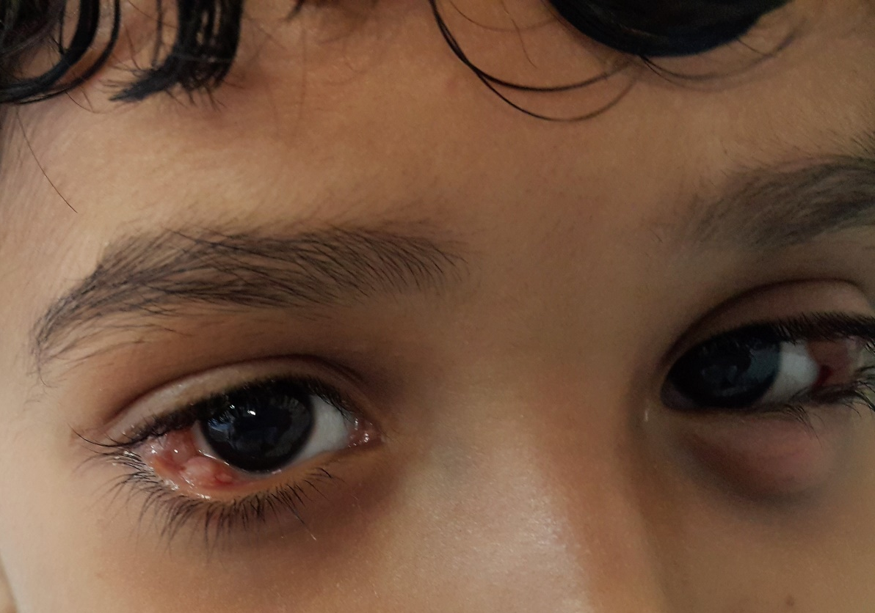
Figure (1): Bilateral bulky ligneous conjunctivitis before surgery

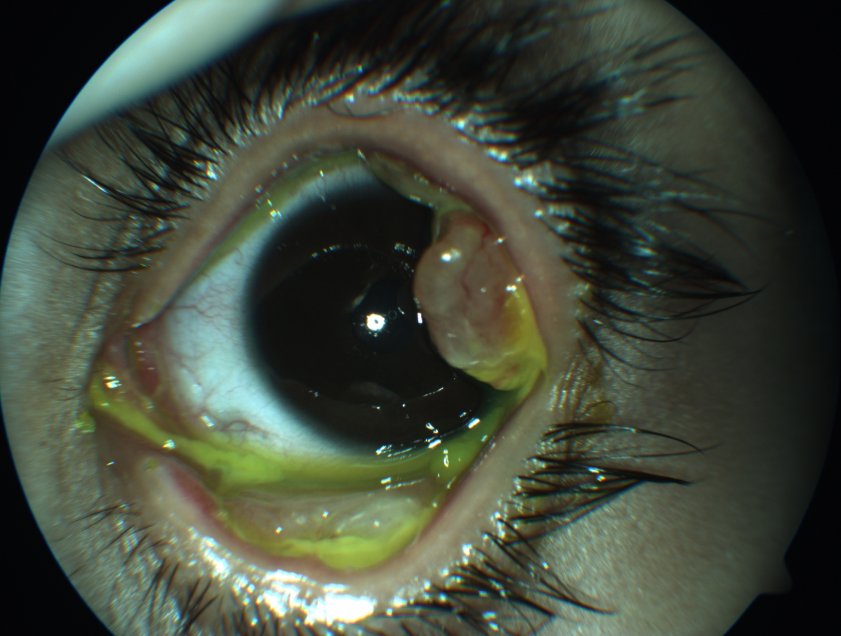

Figure 2: closer view on left sided conjunctival lesions

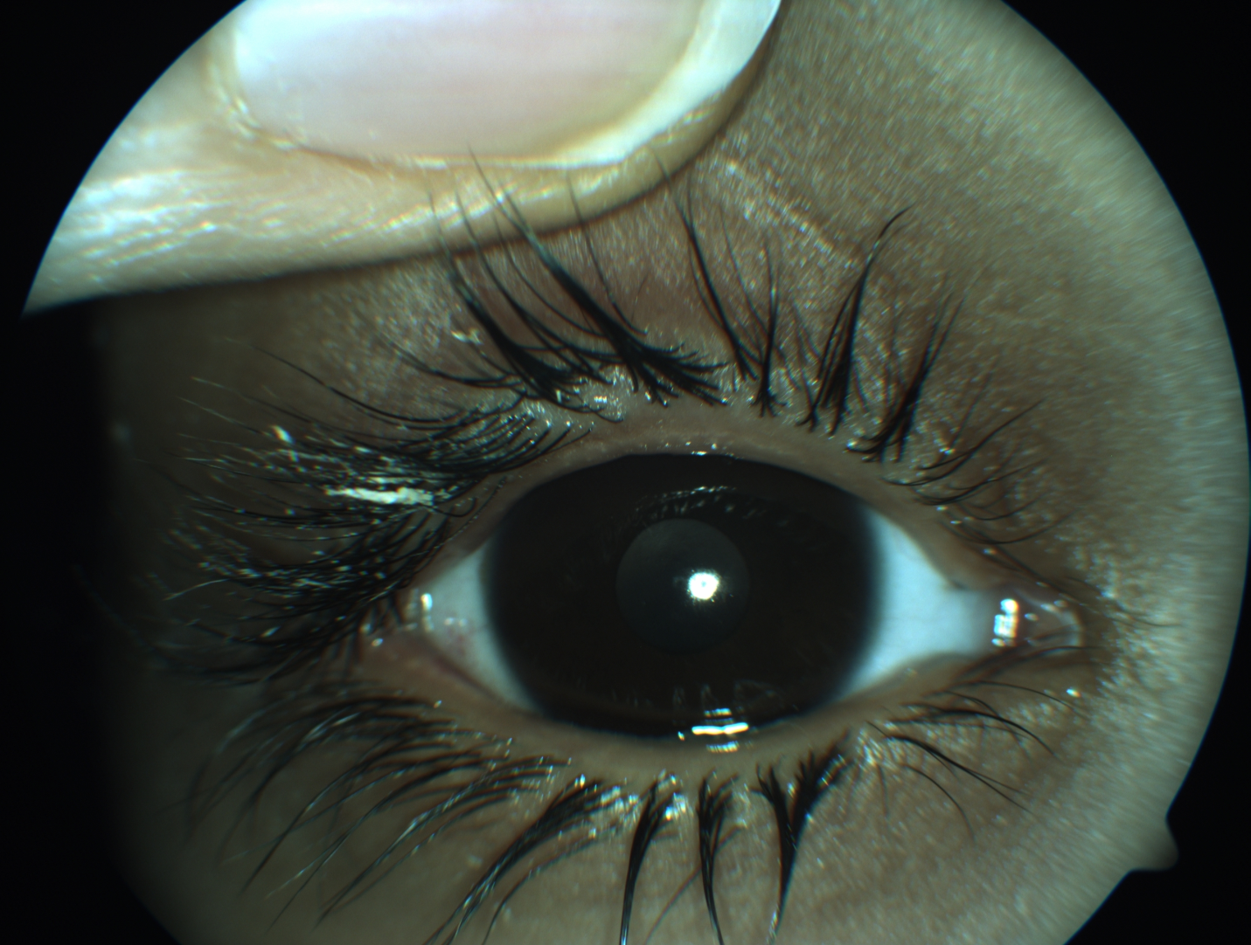
Figure (3): Right eye after surgical excision of ligneous lesions
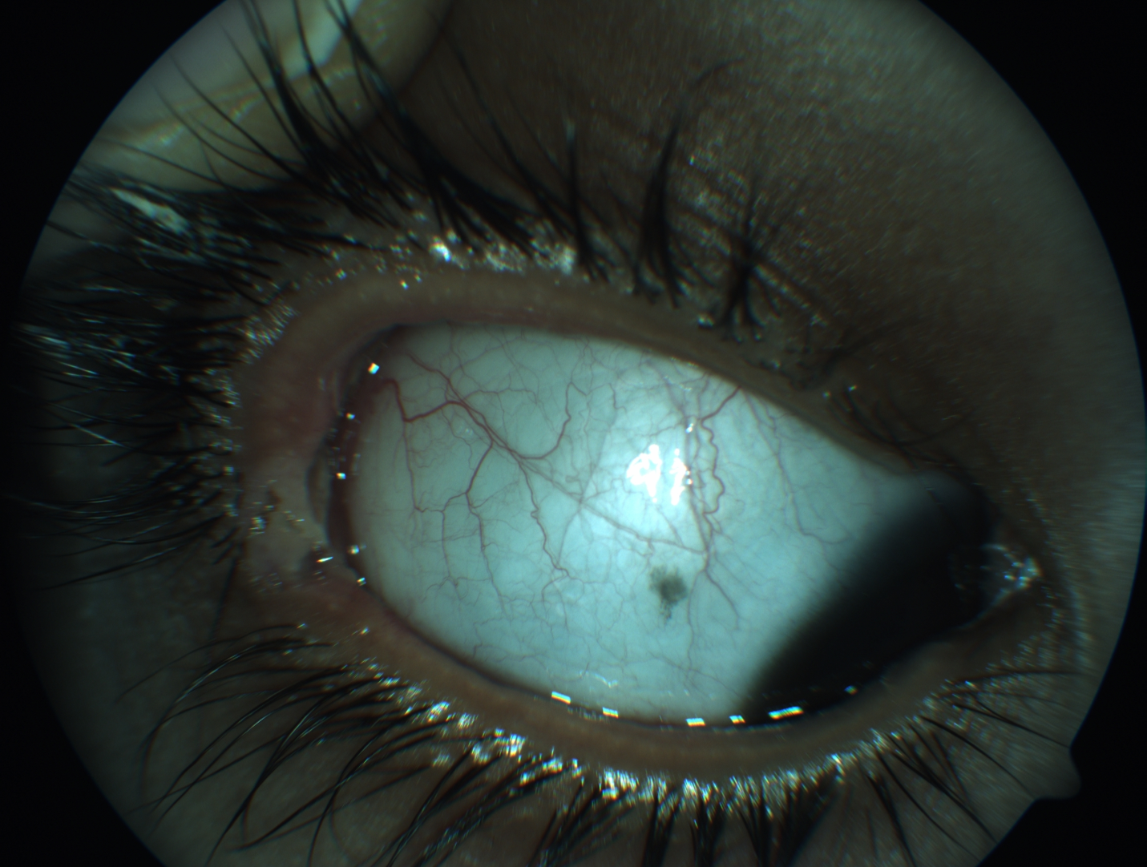

Figure (4): closer view on Rt eye post- surgical excision of ligneous conjunctivitis

Biography
Dr. Hanan Nazir completed her Master Degree in Pediatrics, followed by Doctorate Degree in Pediatric Hematology and Oncology from Alexandria University of Medicine in 2011. Currently, she is a lecturer in pediatrics at Faculty of Medicine, Alexandria University, and senior specialist in Pediatric Hematology and Oncology in Sultan Qaboos University Hospital, Muscat, Oman.

Presenting author
Dr. Hanan Fawzy Nazir
E-Mail: dr.hanannazir@yahoo.com
Phone: +96896556198
Category: (Oral presentation/ Poster presentation)

