
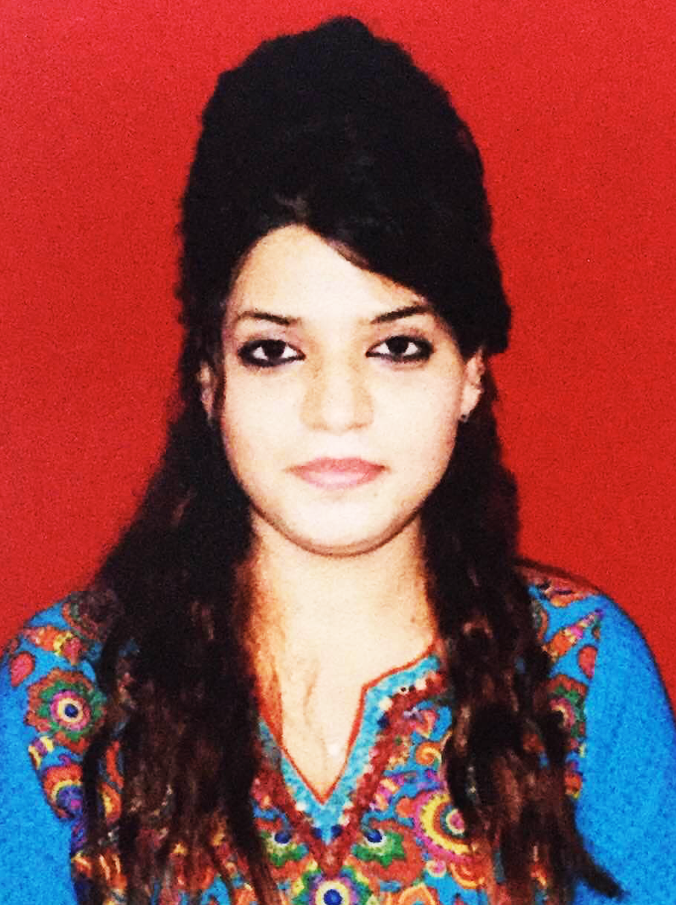

TITLE: IS SEROPREVALENCE OF HTLV-I/II AMONG BLOOD DONORS IN INDIA RELEVANT?

Name: Dr Jehan Nizam Ansari, E-mail: jehan@nizamansari.com

Dr DY Patil Medical College and Research Centre, DPU, Pune, India

Human T-cell lymphotropic virus type I/II (HTLV-I/II) is associated with certain hematologic and neurologic disorders. Seroprevalence studies demonstrate that the distribution of HTLV-I/II is heterogeneous worldwide and not specific to one region. Because blood is one of the major routes of transmission of the virus, blood banks of several countries routinely screen all blood donations for HTLV-I/II. The aim of the present study was to ascertain the seroprevalence rate of HTLV-I/II antibodies among Indian blood donors. Over a period of two years, consecutive blood samples from 10,000 blood donors were collected in a Blood Bank in Central India. These samples were screened for HTLV-I/II by enzyme-linked immunosorbent assay (ELISA). We obtained 18 (0.18%) positive samples, of which 14 (77.8%) samples were also positive by PCR (polymerase chain reaction). The prevalence of HTLV-I/II carriers in Indian blood donors was negligible and not identified as a major public health hazard. Hence, routine screening of Indian blood donors for antibody to HTLV-I/II is not warranted due to its low prevalence in India.

Biography:
Dr. Jehan Nizam Ansari is a licensed medical practitioner by the Medical Council India, after completing her graduation (MBBS), with top rank in the university.
Currently she is pursuing Post graduation in Pathology, She is passionate about her field and working on various Thesis project.
Presenting author Details:
Full name: Dr Jehan Nizam Ansari
Contact number: 0091-7744865894
Twitter account: @jehansari
Linked In account: https://in.linkedin.com/in/jehan-ansari-737341a3
Session name: 5th World Haematologists Congress Aug 18-19, 2016 London, UK
Category: E-Poster

