Title:: Thoracotomy Approach for Surgical Removal of Dislodged PDA Occludder Device Without Cardiopulmonary Bypass

Author & affiliation : Sushil Kumar Singh, Professor & Head, CVTS Department, King George’s Medical University, Lucknow ( INDIA )

Isolated Patent Ductus Arteriosus (PDA) constitutes 6-11% of all congenital heart disease and surgical closure wasthe gold standard for treatment. Recently, transcatheter devices are first line of treatment with satisfactory outcomes. However, fatal complications like device embolization, pulmonary artery stenosis, hemolysis etc.have been reported.
A sixteen year old girl was planned for transcatheter cocoon device closure ofa 6mmPDA with left to right shunt which iatrogenically migrated into the left pulmonary artery- angiographically confirmed.After an unsuccessful attempt at percutaneous retrieval surgery was undertaken by CTVS department.
A left thoracotomy approach without cardiopulmonary bypass was undertaken.PDA was ligated first. Pulmonary artery was exposed after vertically incising the mediastinal pleura.Device was located by palpation. Following a purse string suture,a small left pulmonary arteriotomy was done. Using a long curved forceps device was retrieved and purse string was tied ( Figure 1 ). Thoracotomy was closed in standard fashion.Postoperative course was uneventful.
Technological advances have made non surgical intervention of PDA simple and routine. However, when complications are encountered,surgery becomes lifesaving. Device embolization rate is 3.8%. Due to difference in pressure gradients, this occurs preferably to the pulmonary rather than systemic circulation.
Early removal of embolized devices to pulmonary arterial tree is warranted. Delay causes increased adhesions and technical difficulty.To our knowledge,all reported surgical attempts for device removalusedmedian sternotomy with cardiopulmonary bypass( CPB ). The main stand point of the method was avoiding sternotomy and CPB.
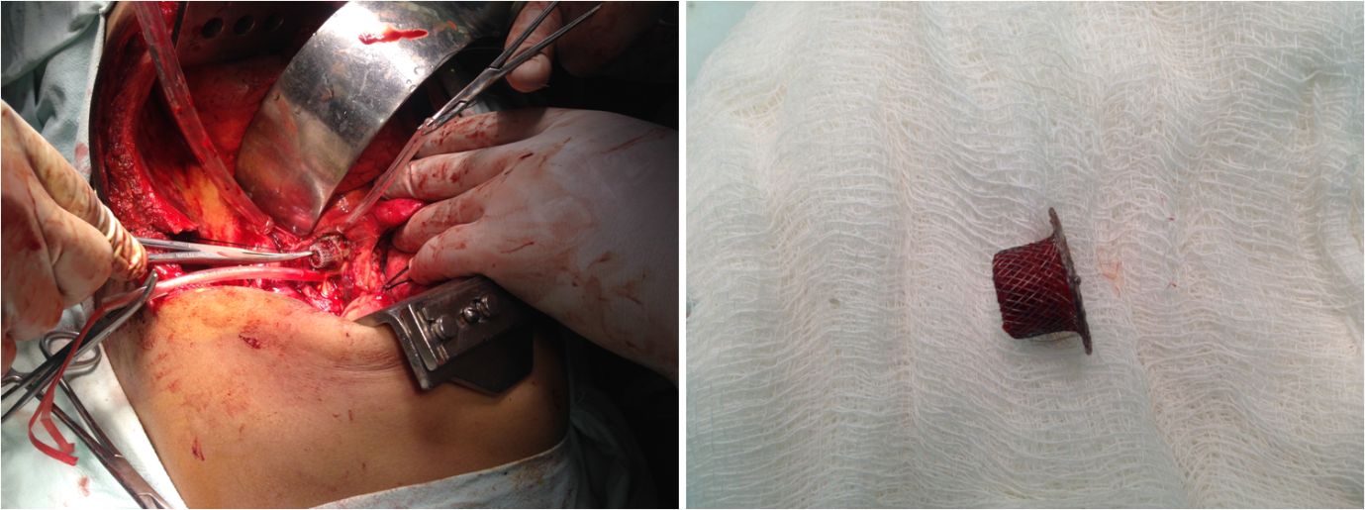
Figure 1 : Retrieval of PDA device from left pulmonary artery

Name : Dr Sushil Kumar Singh
Contact no. 919415017189
Email : doctorsushil@hotmail.com
Twitter account :
Session Name / no. Cardiothoracic Surgery
Category : Poster Presentation

