Blood Pressure Morning Surge in Hypertensive Filipino Patients:

A 24-Hour Ambulatory BP Monitoring Study in a Tertiary Hospital
Jason S. Santos, M.D.
University of Santo Tomas Hospital, Philippines

Statement of the Problem: In the Philippines, an increasing prevalence of hypertension had been observed over the past decade and remains to be the most common cause of morbidity and mortality in the country. Many display an exaggerated increase in blood pressure levels in the morning, referred to as morning surge, a phenomenon known to increase the risk of cardiovascular events. This study aims to determine whether morning surge is present in hypertensive Filipino patients and whether this correlates with control of hypertension.
Methodology: This is a retrospective cross-sectional study. 134 hypertensive patients who met the inclusion criteria were included. Morning surge was defined as the difference between blood pressures 2 hours before and after the waking hour. A difference of more than 20 was considered significant. Morning surge scores were then compared to age, gender, and control of hypertension to examine the association between these factors.
Findings: Blood pressure morning surge was significantly increased in the older subjects compared to the younger subjects (p = 0.031) and the proportion of patients with significant surge score was higher among men (65.3%) compared to women (34.69%). There was no significant correlation between control of blood pressure and the morning surge (p = 0.210). Multivariate analysis showed that gender was the risk factor with the highest correlation with morning surge, with male patients having 2.7 times the risk of having a morning surge score of more than 20 than female patients.
Conclusion: Morning surge was present in hypertensive Filipino patients who underwent 24 hour ambulatory BP monitoring. Control of hypertension had no correlation with morning surge. The presence of morning surge showed a trend towards the older age group and the male gender being the most afflicted with this phenomenon. Between the different factors analyzed, gender has the most impact on morning surge.

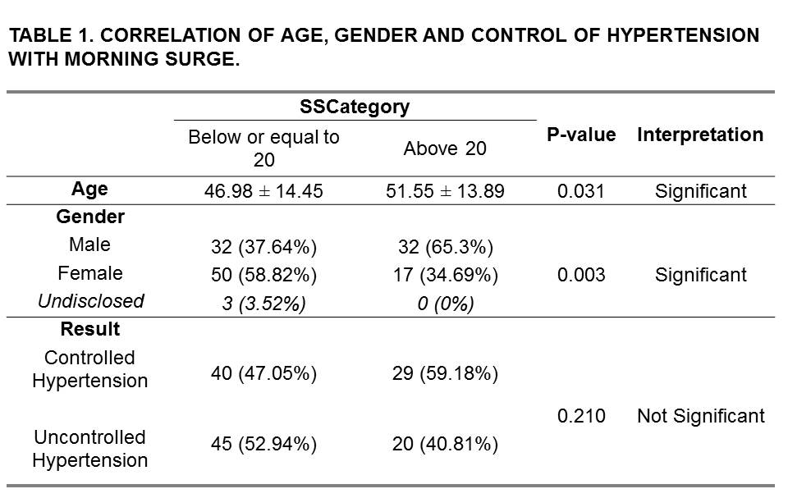
Recent Publications
- Amar, Jacques et al. 2000. “Nocturnal Blood Pressure and 24-Hour Pulse Pressure Are Potent Indicators of Mortality in Hemodialysis Patients.” Kidney International 57(6):2485–91.
- Daugherty, Stacie L. et al. 2011. “Age-Dependent Gender Differences in Hypertension Management.” J Hypertens Wolters Kluwer Health Journal of Hypertension 29(29):0–0.
- Everett, Bethany and Anna Zajacova. 2015. “Gender Differences in Hypertension and Hypertension Awareness Among Young Adults.” Biodemography and Social Biology 61(1):1–17.
- Foundation, National Heart, High Blood Pressure, and Consensus Committee. 2011. “Ambulatory Blood Pressure Monitoring.” Australian Family Physician 40(11):877–80.
- Grezzana, Guilherme Brasil, Airton Tetelbon Stein, and Lucia Campos Pellanda. 2013. “Blood Pressure Treatment Adherence and Control through 24-Hour Ambulatory Monitoring.” Arquivos Brasileiros de Cardiologia 100(4):335–61.
- Grossman, Ehud. 2013. “Ambulatory Blood Pressure Monitoring in the Diagnosis and Management of Hypertension.” Diabetes Care 36(SUPPL.2).
- Hara, Azusa et al. 2012. “Ambulatory versus Home versus Clinic Blood Pressure: The Association with Subclinical Cerebrovascular Diseases: The Ohasama Study.” Hypertension 59(1):22–28.
- Kaplan, Norman M. 2003. “Morning Surge in Blood Pressure.” Circulation, 1347.
- Kario, K., K. Shimada, and T. G. Pickering. 2003. “Abnormal Nocturnal Blood Pressure Falls in Elderly Hypertension: Clinical Significance and Determinants.” Journal of Cardiovascular Pharmacology 41 Suppl 1:S61-6.
- Kario, Kazuomi. 2005. “Morning Hypertension: A Pitfall of Current Hypertensive Management.” Japan Medical Association Journal 48(5):234–40.
- Kario, Kazuomi. 2007. “Preceding Linkage between a Morning Surge in Blood Pressure and Small Artery Remodeling : An Indicator of Prehypertension ?” 1573–75.
- Kario, Kazuomi. 2010. “Morning Surge in Blood Pressure and Cardiovascular Risk: Evidence and Perspectives.” Hypertension 56(5):765–73.
- Kario, Kazuomi et al. 2011. “Additional Impact of Morning Haemostatic Risk Factors and Morning Blood Pressure Surge on Stroke Risk in Older Japanese Hypertensive Patients.” European Heart Journal 32(5):574–80.
- Kario, Kazuomi et al. 2015. “Sleep Blood Pressure Self-Measured at Home as a Novel Determinant of Organ Damage: Japan Morning Surge Home Blood Pressure (J-HOP) Study.” Journal of Clinical Hypertension 17(5):340–48.

- Lee, Dong Hyeon et al. 2009. “Age Is an Independent Risk Factor for the Early Morning Blood Pressure Surge in Patients Never-Treated for Hypertension.” Korean Circulation Journal 39(8):322–27.
- Mancia, G. and G. Parati. 2000. “Ambulatory Blood Pressure Monitoring and Organ Damage.” Hypertension 36(5):894–900.
- Minh, H. Van, P. Byass, N. T. K. Chuc, and S. Wall. 2006. “Gender Differences in Prevalence and Socioeconomic Determinants of Hypertension: Findings from the WHO STEPs Survey in a Rural Community of Vietnam.” Journal of Human Hypertension 20(2):109–15.
- Neutel, J. M., H. Schumacher, P. Gosse, Y. Lacourcière, and B. Williams. 2008. “Magnitude of the Early Morning Blood Pressure Surge in Untreated Hypertensive Patients: A Pooled Analysis.” International Journal of Clinical Practice 62(11):1654–63.
- O’Brien, E. .. et al. 2013. “European Society of Hypertension Position Paper on Ambulatory Blood Pressure Monitoring.” Journal of Hypertension 31(9):1731–68.
- Ohkubo, T. et al. 1998. “Reference Values for 24-Hour Ambulatory Blood Pressure Monitoring Based on a Prognostic Criterion: The Ohasama Study.” Hypertension 32:255–59.
- Palatini, Paolo and Guido Grassi. 2011. “The Morning Blood Pressure Surge: A Dynamic and Challenging Concept.” Journal of Hypertension 29(12):2316–19.
- Pasic, Jagoda, David Shapiro, Sarosh Motivala, and Ka Kit Hui. 1998. “Blood Pressure Morning Surge and Hostility.” American Journal of Hypertension 11(2):245–50.
- Pinto, Elisabete. 2007. “Blood Pressure and Ageing.” Postgraduate Medical Journal 83(976):109–14.

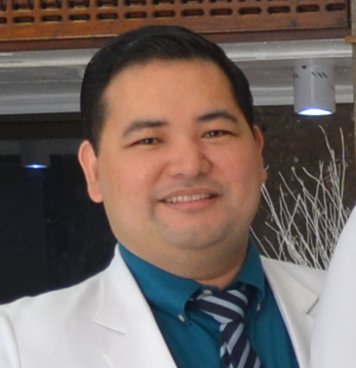 Biography
Dr. Jason S. Santos, is on his 3rd year of Fellowship Training in Cardiology at the University of Santos Tomas Hospital and is currently the Chief Fellow. He completed his Residency training in Internal Medicine and Post-Graduate Internship at the Chinese General Hospital and Medical Center and had his degree in Medicine at the Royal Pontifical University of Santo Tomas, Faculty of Medicine and Surgery.
E-mail: brod_jay@hotmail.com
Phone: +632-922-9106068

Notes/Comments:

- Pipo, M. M. Q., M. A. Lelis, and J. Q. Javelona. 2015. “Antihypertensive Management of High-Risk Patients in the Philippines.” Philippine J Intern Med 53(3):1–8.
- Reckelhoff, J. F. 2001. “Gender Differences in the Regulation of Blood Pressure.” Hypertension 37:1199–1208.
- Sheppard, James Peter et al. 2015. “Prognostic Significance of the Morning Blood Pressure Surge in Clinical Practice: A Systematic Review.” American Journal of Hypertension 28(1):30–41.
- Sison, Jorge et al. 2007. “Philippine Heart Association-Council on Hypertension Report on Survey of Hypertension and Target Organ Damage ( PRESYON 2-TOD *) A Report on Prevalence of Hypertension , Awareness , Treatment Profile and Control Rate RESULTS.” 2–3.
- Sun, Ningling, Yang Xi, Shan Jing, and Xining Lu. 2009. “Morning Blood Pressure Surge Varies with Age and Gender in Hypertensive Individuals.” International Journal of Cardiology 135(2):272–73.
- Suzuki, Y. et al. 1993. “The Relation between Blood Pressure Variation and Daily Physical Activity in Early Morning Surge in Blood Pressure].” Nihon Ronen Igakkai Zasshi.Japanese Journal Of Geriatrics 30(10):841–48. Retrieved
- Tomii, Yasuhiro et al. 2011. “Effects of 24-Hour Blood Pressure and Heart Rate Recorded with Ambulatory Blood Pressure Monitoring on Recovery from Acute Ischemic Stroke.” Stroke 42(12):3511–17.
- Tseng, Y. Z. 2006. “Applications of 24-Hour Noninvasive Ambulatory Blood Pressure Monitoring.” Journal of the Formosan Medical Association 105(12):955–63.
- Verdecchia, Paolo et al. 2012. “Day-Night Dip and Early-Morning Surge in Blood Pressure in Hypertension: Prognostic Implications.” Hypertension 60(1):34–42.

