Cardiomyopathy in Systemic Lupus Erythematosus (SLE) Patient
Lusiani MD, Ryan Ranitya MD, M Syahrir Azizi MD, Annisa Ratya MD
Cipto Mangunkusumo General Hospital, Indonesia

Abstract
Background: Cardiomyopathy is a rare cardiac complication of SLE and potentially dangerous complication. We are presenting a case of cardiomyopathy in SLE patient as a cardiac complication of SLE.
Case description: A 27-year-old grade IV lupus nephritis woman came to our outpatient clinic for cardiovascular evaluation. She is a non-compliance dialysis patient and had no symptom. She had history of myocarditis 4 year ago. Physical examination revealed of hypertension, pale conjunctiva and cardiomegaly. Laboratory results showed Hb of 6,0 mg/dL, ureum of 122 mg/dL, creatinine of 3,9 mg/dL, eGFR of 15,1ml/min/1,73 m², C3 of 60,6 mg/dL, C4 of 16 mg/dL, and anti dsNA of 2550,2 IU/mL. Newer echocardiography showed segmental hypokinetics, eccentric LVH and LVEF of 34%. She had methylprednison 2x16 mg, valsartan 1x160mg, and mycophenolate mofetil 2x1000mg.
Discussion: Ineffective clearance of apoptotic bodies later induce endothelial dysfunction is the main reason of atherosclerosis induce ishemia cardiomyopathy as theoritical etiology in this case. This case demonstrated a SLE patient who has cardiovascular complication since 4 years ago and now progressively to cardiomyopathy. Risk factors of cardiomyopathy in this patient are untreated myocarditis, non-compliance, and Chronic Kidney Disease (CKD). Promoting effects of SLE and CKD lead to a high cardiovascular risk in lupus nephritis. Coronary angiography should remain a cornerstone of the evaluation in this patient.

Conclusion: Myocardial involvement in lupus is one of the major causes of morbidity and mortality with SLE. Echocardiography remain the best imaging tool to investigate cardiovascular event, follow by other imaging modalities to help diagnoses. Prompt recognition and knowledge of cardiomyopathy might help the prognosis and survival SLE patient.

Keyword: Cardiomyopathy, systemic lupus erythematosus, myocarditis

Image
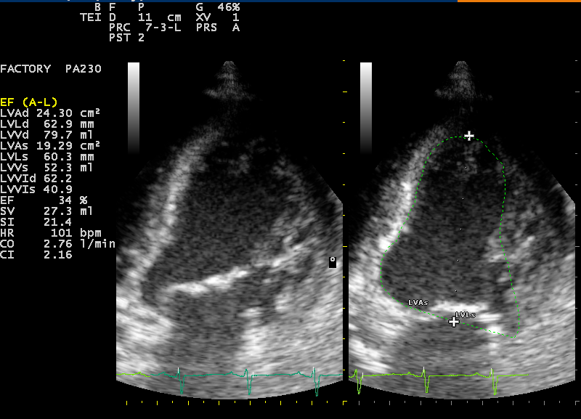


Biography
Dr. Lusiani has been graduated from University of Indonesia as Medical Doctor, with the specialties including Internal Medicine from the University of Indonesia. Presently she has been working at the at the Cardiology Division, Internal Medicine Departement of Cipto Mangunkusumo General Hospital and Internal Medicine Departement of Aminah Hospital.
Email : doclus78@gmail.com
Phone : +6281 1926 190

