Updates on Intracoronary Physiology: FFR, if, and CFR
Ali Elsharkawi, Mouwasat Hospital, KSA

Abstract (300 word limit)

Coronary artery disease (CAD) remains the leading cause of death worldwide with approximately 1 in 30 patients with stable CAD experiencing death or acute myocardial infarction each year. Interpret the significance of coronary flow physiology for defining the extent and severity of CAD and for guiding PCI. Select medical therapies that improve endothelial function and clinical outcome. the lecture will explain how to calculate the fractional flow reserve (FFR) and to understand the difference between CFR and FFR. And will describe key facts on vascular endothelial biology and epidemiology of vascular endothelial dysfunction.

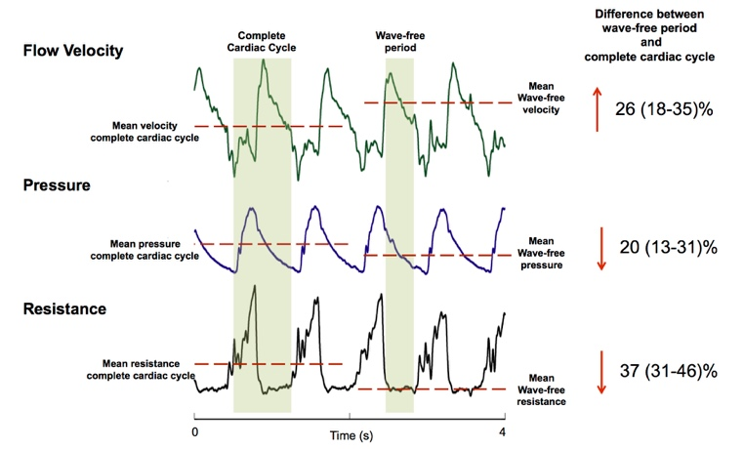

In determining the physiological significance of an angiographically intermediate coronary stenosis, the fractional flow reserve (FFR) and instantaneous wave-free ratio (iFR) both quantify the trans-stenotic pressure ratio as a surrogate measure of coronary flow. FFR is measured under conditions of maximal pharmacological hyperemia whereas iFR is measured in the resting state.

In up to 20% of cases, FFR and iFR disagree on the functional significance of a stenosis. The recently reported DEFINE-FLAIR (Functional Lesion Assessment of Intermediate Stenosis to Guide Revascularization) and iFR-SWEDEHEART (Evaluation of iFR vs FFR in Stable Angina or Acute Coronary Syndrome) trials demonstrated in over 4,500 patients that iFR was noninferior to revascularization guided by FFR with respect to major adverse cardiac events (MACE) at 1 year. Furthermore, patient-level pooled meta-analysis of both trials demonstrated significantly less revascularization based on iFR versus FFR interrogation, but similar MACE in the both FFR and iFR deferred populations. This combination of findings has led some to question whether, in comparison to iFR, FFR overestimates the true flow-limiting potential of angiographically intermediate coronary stenosis. This is will be discussed in the lecture.

Image
Recent Publications (minimum 5)
- J.E. Davies, S. Sen, H.-M. Dehbi, et al. Use of the instantaneous wave-free ratio or fractional flow reserve in PCI. N Engl J Med, 376 (2017), pp. 1824-1834
- M. Götberg, E.H. Christiansen, I.J. Gudmundsdottir, et al. Instantaneous wave-free ratio versus fractional flow reserve to guide PCI. N Engl J Med, 376 (2017), pp. 1813-1823
- M. Götberg, E.H. Christiansen, I. Gudmundsdottir, et al. Instantaneous Wave-Free Ratio versus Fractional Flow Reserve guided intervention (iFR-SWEDEHEART): rationale and design of a multicenter, prospective, registry-based randomized clinical trial. Am Heart J, 170 (2015), pp. 945-950
- R. Petraco, Hoef TP van de, S. Nijjer, et al.Baseline instantaneous wave-free ratio as a pressure-only estimation of underlying coronary flow reserve results of the JUSTIFY-CFR study (Joined Coronary Pressure and Flow Analysis to Determine Diagnostic Characteristics of Basal and Hyperemic Indices of Functional Lesion Severity–Coronary Flow Reserve). Circ Cardiovasc Interv, 7 (2014), pp. 492-502
- M.R. Patel, G.J. Dehmer, J.W. Hirshfeld, et al. ACCF/SCAI/STS/AATS/AHA/ASNC/HFSA/SCCT 2012 appropriate use criteria for coronary revascularization focused update. J Thorac Cardiovasc Surg, 143 (2012), pp. 780-803
- S. Windecker, P. Kolh, et al.2014 ESC/EACTS Guidelines on myocardial revascularization: The Task Force on Myocardial Revascularization of the European Society of Cardiology (ESC) and the European Association for Cardio-Thoracic Surgery (EACTS) * Developed with the special contribution of the European Association of Percutaneous Cardiovascular Interventions (EAPCI). Eur Heart J, 35 (2014), pp. 2541-2619
- S.D. Fihn, J.M. Gardin, J. Abrams, et al.2012 ACCF/AHA/ACP/AATS/PCNA/SCAI/STS Guideline for the diagnosis and management of patients with stable ischemic heart disease: a report of the American College of Cardiology Foundation/American Heart Association Task Force on Practice Guidelines, and the American College of Physicians, American Association for Thoracic Surgery, Preventive Cardiovascular Nurses Association, Society for Cardiovascular Angiography and Interventions, and Society of Thoracic Surgeons. J Am Coll Cardiol, 60 (2012), pp. e44-e164
- M. Götberg, C.M. Cook, S. Sen, S. Nijjer, J. Escaned, J.E. DaviesThe evolving future of instantaneous wave-free ratio and fractional flow reserve. J Am Coll Cardiol, 70 (2017), pp. 1379-1402

Biography (150 word limit)
Ali Elsharkawi has his expertise in management of cardiology patients and he worked as a lecturer in the National Heart Institute in Egypt, and currently working in Mouwasat Hospital in Riyadh, he holds the MD degree from Ainshams University in Egypt, he has a lot of publications and presentations in several conferences worldwide, he had clinical experience in working with physiological assessment devices, he had an experience as an interventional cardiologist and device implant. He has built this model after years of experience in research, evaluation, teaching and administration both in hospital and education institutions. He had been recognized locally an expert in Cairo and Riyadh, and he was the director of several Cath labs in both countries.
Email: ali.elsharkawi@yahoo.com
Phone: +966543459768, +201140000922

.

