Clinical Profile, Investigation findings, Prescription-Pattern and Adverse Drug Reaction in Ischemic Heart Disease inpatients of a Tertiary Hospital of Eastern Nepal; A Record-Based Descriptive Study
Panday DR*, Sangraula R, Sahu A, Kumara A, Yadav K, Shikha M, Goyal N, Ranjan S, Rauniar GP
Departments of Clinical Pharmacology & Therapeutics, BPKIHS, Nepal

Abstract (300 word limit)
Statement of the Problem: Ischaemic heart disease (IHD) is a condition resulting from reduced blood supply to the myocardium. An accurate documentation and analysis of IHD clinical profile, investigation, prescription pattern and resulting Adverse Drug Reactions (ADRs) in a specified population is essential for the implementation of education and better treatment. The study was carried out with the objective of describing the Clinical Profile, Investigation findings, Prescription-Pattern and ADRs of IHD inpatients of a Tertiary Hospital of Eastern Nepal in the previous year. Methodology & Theoretical Orientation: It was a record-based Descriptive Cross-Sectional Study carried out during 19th April to 16th May, 2017. 165 physician-diagnosed IHD were the sampling frame. CCU files of past one year was obtained from Hospital record section. Any inpatients with IHD in the hospital was included. Patient Leaving Against Medical Advice (LAMA) were excluded. Data entry software epidata ver. 3.1 was employed for data-entry and analysis was done using Microsoft Excel sheet and the latest available SPSS software. Findings: Most patients were from Dharan (29%) where the hospital was located, mostly male (60.37%) and dependent (62.42%). ST Elevation Myocardial Infarction (STEMI) was the most common diagnosis (58.79%). Median age was 62 years with IQD 54-70 and patients stayed mostly for 4 days with IQD 2-6.7.
Tobacco consumption (50.3%), Alcohol use (22.8%), Diabetes (25%) and Hypertension (43.1%) were frequent among the patients. Typical Chest pain (60.6%), Dyspnea (42.0%) and Diaphoresis (23.7%) were very common. 54.0% patients had anemia and 41.6% had Leucocytosis. Aspirin (100.00%), Clopidogrel (97.55%) and HMG-CoA inhibitor (97.55%) were used in almost all patients. Conclusion & Significance: Our study established conventional clinical profile, investigation findings and prescription pattern among the IHD inpatients of the hospital, however, adequate ADR documentation and reporting could not be appreciated.

Image
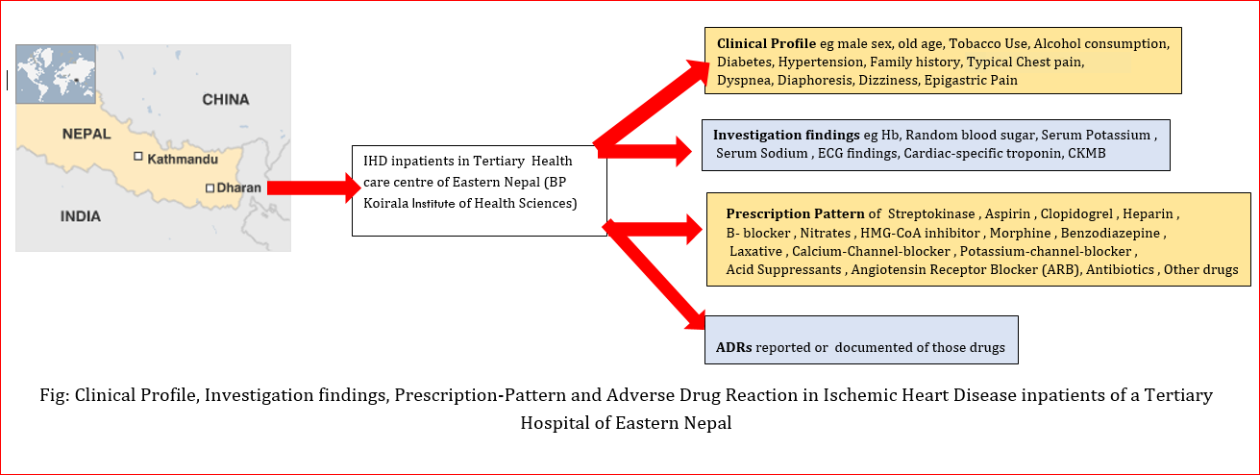
Recent Publications (minimum 5)
- Bangalore, S. et al., 2017. Body-Weight Fluctuations and Outcomes in Coronary Disease. New England Journal of Medicine, 376(14), pp.1332–1340.
- Bucholz, E.M. et al., 2016. Life Expectancy after Myocardial Infarction, According to Hospital Performance. The New England journal of medicine, 375(14), pp.1332–1342.
- Bhandari, G.P. et al., 2014. State of non-communicable diseases in Nepal. BMC public health, 14, p.23.
- Council, N.H.R., 2013. Non-Communicable diseses risk factors: STEPS Survey Nepal 2013, Ramsapath Kathmandu, Nepal.
- Boden, W.E. et al., 2007. Optimal Medical Therapy with or without PCI for Stable Coronary Disease. New England Journal of Medicine, 356(15), pp.1503–1516.

 Biography (150 word limit)
Dr. Dipesh Raj Panday, MD, Pharmacology is a reputed scholar, teacher, speaker, researcher and a software enthusiast. He was first noticed when he got 81.79% in his Pharmacology Post-graduate final exams. It was the highest score ever obtained by any post-graduate of any discipline in 17 years PG history of the Nation’s top medical Institute (BPKIHS). He is bidding for “Nepal Bidya Bhusan”, the highest award of the country for academic excellence. Needless to say, he is a hardworking person. In the first year of his teaching medical, paramedical and nursing students, he became so popular that he has been constantly voted as ‘The Most Popular’, ‘The Most Inspiring’ and ‘The Most Hardworking’ teacher. No wonder, he has been awarded “The Best Teacher-2016”. As a competent researcher, he has published in several reputed medical journals including BioMedical Central Journal. His writing is clear, precise and lucid. Everyday, he receives several mails from round the world to join the editorial boards.
Email: dipesh@bpkihs.edu
Phone: +977-9862124700

Notes/Comments:

