Heart Failure Outcomes in Patients with Ischemic Cardiomyopathy after Ventricular Tachycardia Ablation
Himanayani Mamillapalli, M.D., Viorel Florea, M.D.,PhD, Mackenzie Mbai, M.D., Sravya Veligandla, B.S., Smitha Murthy, MBBS, Jill M. Morgan, LPN, Jian-Ming Li, M.D., PhD, FHRS and Venkatakrishna N.. Tholakanahalli, MD, FHRS. University of Minnesota, MN, Minneapolis VA Health Care System, MN, University of Louisville, KY, Jawaharlal Nehru Medical College, Belagavi, India

Background:
Patients with congestive heart failure (CHF) are at an increased risk of developing ventricular tachycardia (VT). It is unclear how VT ablation affects CHF outcomes.

Objective:
The goal of this study is to evaluate CHF exacerbations and echocardiogram findings based on location of myocardial scar in patients with Ischemic Cardiomyopathy (ICM) who have undergone VT ablation.

Methods:
This was a selected cohort of consecutive patients with ICM who underwent VT ablation at Minneapolis Veterans Affairs Health Care System between July 2008 and September 2019. CHF outcomes and echocardiogram variables were assessed.

Results:
Seventy-five patients with ICM underwent VT ablation, average age was 67.6 ± 7 years old and 100% male. Inferior wall scar (IWS) was the most prevalent (Figure, Table 1A). On pre-ablation echocardiogram, anterior wall scar (AWS) group overall had a lower mean ejection fraction (EF) of 26%, compared to IWS group of 32% (Table 1B). On post-ablation echocardiogram, patients with AWS had statistically significant (p < 0.03, two-tailed test) lower mean EF of 23% compared to IWS group of 30% (Table 1C). Twenty-five patients had admissions for CHF exacerbation post-ablation, 17 were in the first year after ablation (12 IWS and 5 AWS). Average time from ablation to CHF exacerbation was 2.1 years. Patients with IWS presented earlier with CHF exacerbation compared to AWS group (1.6 vs 1.8 years).

Conclusion:
Patients with ICM and AWS scar had a statistically significant mean lower EF post VT ablation compared to IWS scar group. However, patients with IWS scar had higher rates of admission for CHF exacerbation.

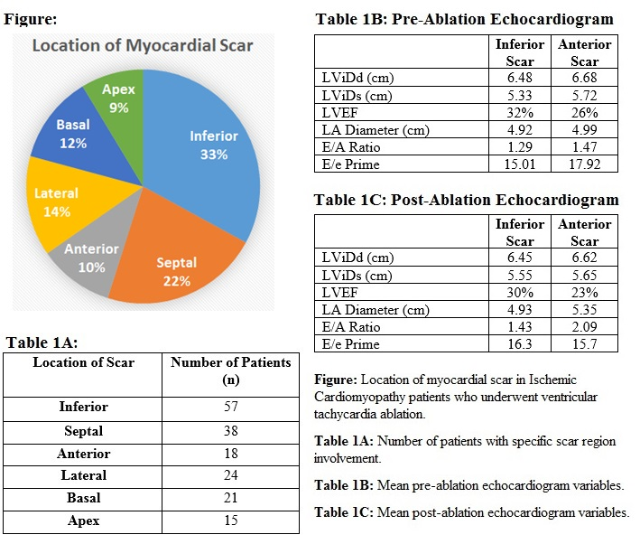

Biography
Himanayani Mamillapalli completed college and medical school in the competitive BS/MD combined medical degree program at the University of Connecticut. She is currently a third year Internal Medicine resident at the University of Minnesota with plans to pursue a career in academic Cardiology.

Presenting author details
Full name: Himanayani Mamillapalli
Contact number: 203-927-1374
Linked In account: Himanayani Mamillapalli

