Abstract
Background: This study evaluated the relationship between the patient of chronic kidney diseases in Acute Coronary Syndrome Patient and angiographic severity of coronary artery diseases.
Method: The cross sectional observational study done in the department of cardiology, NICVD, Dhaka, from June 2015 to June 2017. Acute coronary syndrome patients were grouped based on renal function assessed by eGFR; those with normal renal function (group-II) and those with impaired renal function (group-I). Coronary angiogram was done during index hospitalization and the severity of the coronary artery disease was assessed by vessel score and Genseni score.
Results: Of 500 patients assessed, (mean age 55 years) according to Gensini score CAD was mild in 9.1% (5) patients in group Ι and 23.6% (13) patients in group ΙΙ and mild CAD was significantly low in group Ι (p=0.04). Moderate CAD was found in 60% (33) patient in (group-Ι) and 69.1% (38) patients in group ΙΙ with insignificant difference (p=0.31). Mean age of the study patients was 55.6±7.5 years in decreased GFR group and 49.4±6.6 years in normal GFR group. Male female ratio was 10:1.Studied patients of two groups were well matched in terms of demographic variables like gender distribution, drugs used, biochemical analysis except serum creatinine & TG which were significantly high in impaired renal function group.
conventional risk factors of CAD, diabetic patients were excluded from study; smoking & family history of CAD were found non-significant but hypertension & dyslipidaemia were significantly high in impaired renal function group. In group-I the mean eGFR was 60.70 ±12.6 ml/min/1.73m² and in group-II it was 100.40±8.4 ml/min/1.73m² and this difference was statistically significant.

Mean Gensini score was 42.30±24.9 in impaired renal function group and 25.65±17.9 in normal renal function group and the difference was statistically significant. We found significant weak association between eGFR and vessel score (r=-0.30, p=0.004) and a moderate negative correlation between eGFR and Gensini score (r =-0.65, P=0.001). With the decrease of GFR and so renal function, vessel score and Gensini score increases demonstrating more severe coronary artery disease.
Univariate logistic regression analysis of variables of interest revealed that age (P=0.03), hypertension (P=0.007), dyslipidemias (P=0.004), serum creatinine (P=0.002) and eGFR (p=0.003) were independent predictor of severe coronary artery disease with odds ratio (OR) being 1.88, 3.93, 5.01, 5.54 and 5.70 respectively. In multivariate logistic regression analysis, after adjustment of factors eGFR remain independent predictors of severe CAD (P=0.004, OR -5.73).In subgroup study, mean Gensini score was 29.97±15.5 in mildly decreased GFR group and was 69.76±19.6 in moderately decreased GFR group and the difference was statistically significant. So from this study, it is evident that renal impairment is directly associated with coronary artery disease severity.
Conclusion: Impaired renal function is associated with Angiographic Severity of Coronary Artery Disease in Acute Coronary Syndrome Patient.
Key Words: Impaired renal function assessed by eGFR, Acute Coronary Syndrome, Coronary Angiography, Vessel Score and Gensini score.

1 INTRODUCTION
Cardiovascular disease are the number 1 cause of death globally: more people die annually from CAD then from other cause (WHO 17th May 2017). An estimated 17.7 million people died from CVD in 2018 presently 31% of all death. Over three quarter of CVD death in low and middle income countries like Bangladesh, India, Pakistan, Nepal, srilanka .Out of seventeen million death due to noncommunicable disease in 2015,more than 75% are in low and middle income countries and 37% are caused by coronary vascular diseases .
Cardiovascular disease (CVD) is a global non-communicable epidemic, and is the leading cause of mortality in both developed and developing countries (Murray and Lopez, 1997). Estimates from the global burden of diseases study suggests that by the year 2020 the south Asian region ( India, Pakistan, Bangladesh, Nepal) will have more individuals with atherothrombotic CVD that any other region (Murray and Lopez, 1997). Like other South Asians, Bangladeshis are unduly prone to develop coronary artery disease (CAD), which is often premature in onset, follows a rapidly progressive course and angiographically more severe (Islam and Maunder, 2013).

The South Asian countries of India, Pakistan, Bangladesh, Srilanka and Nepal contribute the highest proportion of the burden of cardiovascular diseases (CVDs) compared to any other region globally (Reddy and Yusuf, 1998).

Bangladesh is a small country with vast population. CVD becoming a significant burden on health care services in Bangladesh (Islam, Ali and Ali, 2004). Khandaker, et al. (1987) found that Myocardial infarction is one of the leading cause of death in Bangladesh mostly in the 4th decade of life. In a study of 2690 patients, in hospital mortality was 11.8%. According to one survey, prevalence of IHD in Bangladesh was 3.4% in 2001 (Zaman, Ahmed and Choudhury, 2007).

Chronic kidney disease (CKD) increases the risk of CVD death (New England Group 2004). Chronic kidney disease increases the risk for CAD in USA (ASN 2004). Chronic kidney disease is a world wide public health problem with adverse outcome of CAD and premature death (Elsevier V-67, Jan 2005). Atherosclerotic cardiovascular disease accounts for approximately half of death in ESRD and annual mortality of 23%. Incidence of MI 5 to 15 fold high in dialysis patient (journal of Nephrology 2013).
Chronic kidney disease (CKD) is recognizing as independent CAD risk state particularly in elderly and has been defined by level of eGFR and markers of kidney damaged (American heart journal 2008).
Chronic kidney disease (CKD) is strongly associated with very high mortality and accelerated cardiovascular disease (Sarnak, et al., 2003). CVD is the leading cause of morbidity and mortality in CKD patients (Go, et al., 2004). This association is independent of traditional risk factors and is observed even with modest decrements in kidney function (Joachim, et al., 2008). Individuals with CKD are more likely to die of CVD than to develop end-stage renal disease (Shulman, et al., 1989). Most of the traditional CVD risk factors such as older age, diabetes mellitus, systolic hypertension, LVH and low high-density lipoprotein (HDL) cholesterol are highly prevalent in CKD (Sarnak, et al.,2003).
Framingham risk equation is insufficient to capture the extent of CVD risk in subjects with CKD (Cheung, et al., 2000). This increased risk of Cardiovascular mortality in patients with CKD caused by non-traditional risk factors such as anemia, altered calcium-phosphorus metabolism, increased homocysteine level, inflammation and oxidative stress ( Baigent, Burbury and Wheeler, 2000).
Bhat (2008) showed that inflammation and oxidative stress have been linked to the pathogenesis of plaque formation and plaque rupture. Calcification in vascular wall is another important mechanism in the pathogenesis of CAD in CKD patients (Demer, 2002). The possible etiology of uremic vasculopathy is derangement of the calcium-phosphate-parathyroid hormone axis resulted in secondary hyperparathyroidism. Strong relationships between increased serum phosphate, calcium-phosphate product, parathyroid hormone and cardiovascular mortality have been demonstrated (Ganesh, 2001). Activated monocytes & macrophages infiltrate the vascular wall and enhance vascular calcification via cell-cell interaction and inflammatory mediators such as TNF-alpha (Tintut, 2002).
The glomerular filtration rate (GFR), determined by the Cockcroft- Gault equation, is a more precise and accurate way of estimating kidney function than measuring serum creatinine (Barrio, et al., 2007). The United States National Kidney Foundation (2002) uses GFR rather than serum creatinine level to define renal dysfunction. National Kidney Foundation recommended estimated GFR for use in recognition, treatment and prevention of chronic kidney disease. It is considered as the overall best indicator of kidney function. Serum creatinine alone fails to identify many patients whose kidney function is reduced. For example, an elderly person could lose half of their kidney function before serum creatinine rises above the normal level (National Kidney Foundation, 2002).
The estimated GFR is derived from a equation that takes other things besides the patient’s creatinine into account. The equation uses a patient’s age, gender, race and weight. These factors correlate with muscle mass which determines the serum creatinine level. The estimated GFR is a more accurate predictor of kidney function because it accounts for these expected differences in muscle mass (Woodhouse, et al., 2006).
The Gensini score was developed by Gensini and takes into consideration the geometrical severity of lesions by angiography, the cumulative effects of multiple obstructions and the significance of jeopardized myocardium. A nonlinear score is assigned to each lesion based on the severity of stenosis as indicated by the reduction of lumen diameter. A multiplier is applied to each lesion score based upon its location in the coronary tree depending on the functional significance of the area supplied by that segment. The final Gensini score is the sum of the lesion scores (Gensini, 1983).

Renal function is an important predictor of the presence and severity of angiographic CAD in patients without severe renal impairment (Stamatelopulous, et al., 2008). Early stages of CKD that are characterized by relatively preserved renal function are associated with increasing incidence of de novo and recurrent CVD events (Manjunath, et al., 2003).As GFR diminishes the prevalence and severity of CAD increases (Go, et al., 2004). Patients with CKD have more severe CAD that’s why there is a high rate of cardiovascular events in CKD patients (Kiyosue, et al., 2010). Moderately impaired renal function was related to coronary artery calcification (Chang, et al., 2012). In women with chest pain, mild renal insufficiency is an independent predictor of significant angiographic CAD (Reis, et al., 2002).The incidence and severity of obstructive CAD increases as GFR declines (Nakano, et al., 2010). CAD shows a pattern of d[[[iffuse multi-vessel involvement with calciﬁcation in patients with CKD (Chonchol, et al., 2008). There is a significant association between serum creatinine & blood urea nitrogen level and the presence of CAD (Akanda et al.,2013). CAD quantified by Gensini score is significantly associated with the severity of renal impairment and this association is independent of age and other cardiovascular risk factors (Cay, Metin and Korkmaz, 2007).

1.1 RATIONALE OF THE STUDY

Chronic kidney disease (CKD) patient there is risk of developing coronary artery disease. When renal impairments association with coronary artery disease there is increase risk of mortality .
Cardiovascular morbidity and mortality in patients with acute coronary syndrome and chronic kidney disease is worsens outcome of cardiovascular disease. Renal impairments patients will die of cardiovascular disease before they require dialysis for their kidney disease. From different studies concerning renal impairment and severity of CAD in Aces patient have been carried out mainly in the developed countries. In our study patients with Acute Coronary Syndrome patient included to make it more authentic and coverage the all field of cardiac diseases . In our study renal function is assessed by eGFR which can be can be calculated easily with reasonable accuracy and precision from serum creatinine and can be a non invasive tool for the prediction of severe CAD. Assessment of renal impairment by eGFR may be used to stratify high risk patients who requires invasive evaluation and aggressive management of CAD. So the present study is quite justified.

  - HYPOTHESIS

Association of renal impairment with the severity of coronary artery disease.

2. OBJECTIVES

General objective:
To assess the relationship between impaired renal functions assessed by eGFR with the angiographic severity of coronary artery disease in patients with

Specific objectives:
1. To evaluate the renal function by eGFR in patients with acute coronary syndrome.
2. To evaluate coronary artery disease severity by angiogram in ACS patients.
3. To find out the relationship between impaired renal function and coronary artery disease severity in patients with ACS patient.

3. LITERATURE REVIEW
3.1. Epidemiology
3.1.1 Global burden of cardiovascular disease
Cardiovascular disease is one of the leading causes of death worldwide, affecting not only high-income but also low and middle-income countries. Globally, age-standardized acute myocardial infraction incidence and angina prevalence have decreased, and ischemic heart failure prevalence has increased since 1990. Despite decreased age-standardized fatal and nonfatal IHD in 2010. The global burden of HID increased by 29 million disability- adjusted life-years (29% increase) between 1990 and 2010. About 32.4 percent of the growth I global IHD disability-adjusted life-years between 1990 and 2010 was attributable to aging of the world population, 22.1% was attributable to population growth. The number of people living with nonfatal IHD increased more than the number of IHD deaths since 1990 (Moran, et al., 2014). Nearly 80% of all estimated cardiovascular disease related deaths worldwide now occur in low-and middle-income countries, where nearly 30% of all deaths are attributable to cardiovascular disease (Kelly, Narula and Fuster, 2012).
Over three quarter of CVD death in low-and middle-income countries like Bangladesh, India, Pakistan, Nepal and Srilanka (WHO) out of the 17 million premature death (under the age of 70) due to non communicable disease in 2015 more than 75% are in low-and middle-income countries and 37% are cause by CVDs. • Each year cardiovascular disease (CVD) causes 3.9 million deaths in Europe and over 1.8 million deaths in the European Union (EU). CVD accounts for 45% of all deaths in Europe and 37% of all deaths in the EU. CVD is the main cause of death in men in all but 12 countries of Europe and is the main cause of death in women in all but two countries. Death rates from both ischaemic heart disease (IHD) and stroke are generally higher in Central and Eastern Europe than in Northern, Southern and Western Europe. CVD mortality is now falling in most European countries, including Central and Eastern European countries which saw considerable increases until the beginning of the 21st century. In 2015, there were just under 11.3 million new cases of CVD in Europe and 6.1 million new cases of CVD in the EU. In 2015, more than 85 million people in Europe were living with CVD and almost 49 million people were living with CVD in the EU.
According to American heart association about 23,000 American die of cardiovascular disease. Each year on an average death every 38 second. About 92.1 million American adults are living with same of cardiovascular disease. CVD accounts for 1 in 7 death in USA killing 366800 people a year. Approximately every 40 seconds an American will have hart attack.

Each year cardiovascular disease (CVD) causes over 4 million deaths in Europe and 1.9 million deaths in the European Union (EU).CVD causes 47% of all deaths in Europe and 40% in the EU.CVD is the main cause of death in women in all countries of Europe and is the main cause of death in men in all but 6 countries. Overall CVD is estimated to cost the EU economy almost €196 billion a year (European Society of Cardiology, 2012)

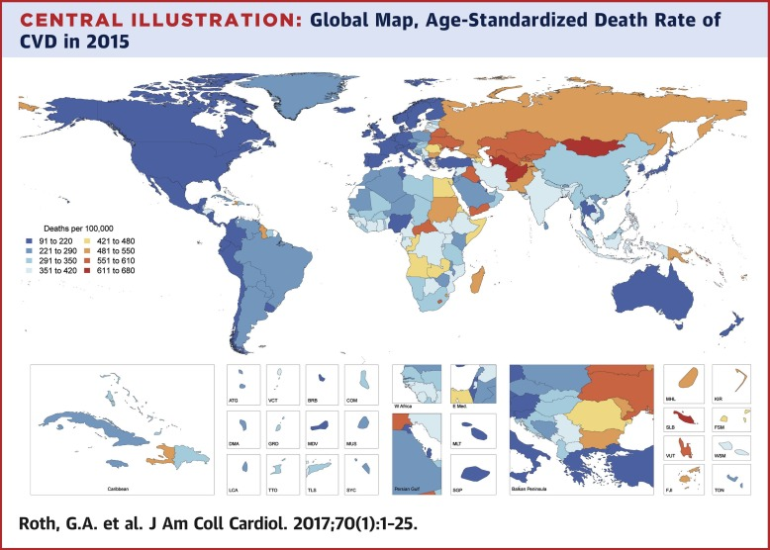
Fig 1: World map showing the burden of ischemic heart disease in males (age standardized, per 100 000) (WHO, 2015.p.12)

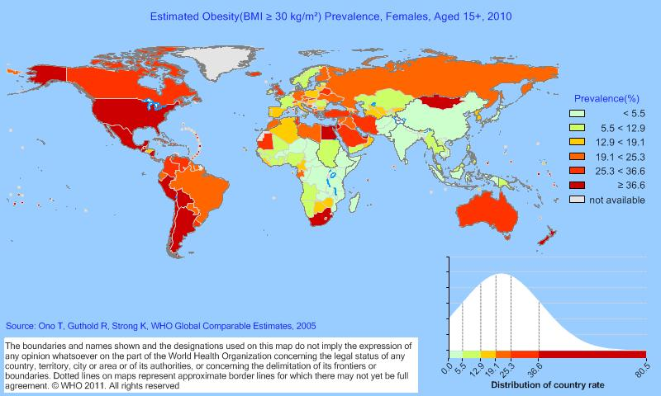

Fig 2: World map showing the burden of ischemic heart disease in females (age standardized, per 100 000) (WHO, 2010.p.12).
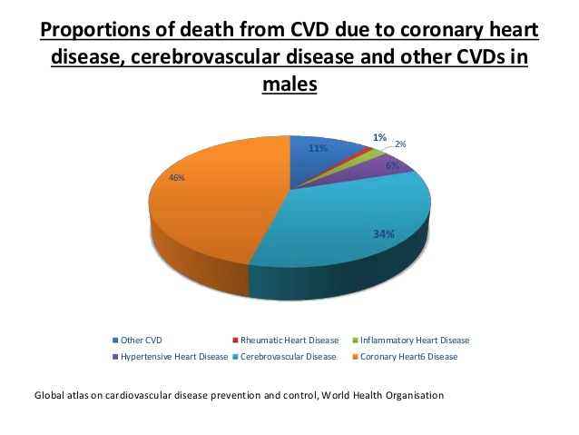
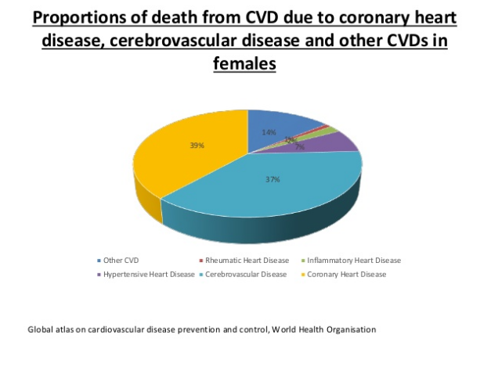
Male Female
Fig-3: Distribution of CVD deaths due to heart attack, strokes and other types of cardiovascular disease in male and female.

3.1.2 Perspective in Bangladesh
Due to poor socio economic condition and lack of awareness CVD is increasing day by day. CVD in 1976 was 3.3 per 1000 population and 17.2 in in 1986 witch is 5 fold increase in 10 years. Coronary artery disease is an increasingly important medical and public health problem, and I s the leading cause of mortality in Bangladesh. Like other South Asians, Bangladeshis are unduly prone to develop CAD, which is often premature in onset, follows a rapidly progressive course and angiographically more severe. Cardiovascular disease (CVD) is an increasingly important cause of morbidity and mortality in Bangladesh. Over the past few decades, because of epidemiological transition, the prevailing disease pattern in this country changed from predominantly communicable to predominantly non- communicable disease, CVD contributes to the latter a lot. Actually, CVD particularly coronary artery disease (CAD) is getting epidemic proportion day by day. Hypertension and heart failure are on the rise, whereas the prevalence of acute rheumatic fever is declining. However, despite some efforts, reliable data concerning various aspects of CVD is inadequate at present. The current prevalence of hypertension, CAD, rheumatic fever and rheumatic heart disease and stroke may be 20-25%, 4-6%, <1/1000, 0.3- 1.0% respectively. Besides conventional risk factors for different CVD, genetic predisposition and some novel issues like high salt intake, arsenicosis, hypovitaminosis D and air pollution may play important role in the aetiopathogenesis of CVD in this population. Formulation of appropriate policy and more emphasis on preventive strategy may help combat CVD in Bangladesh.( Bangladesh Heart Journal 2016; 31(2) : 80-99</p). Of all South Asian countries, Bangladesh probably has the highest rates of CVD and yet is the least studied; in the global combat against CVD, Bangladesh is a country “missing in action”. The underlying pathophysiology is poorly understood. Genetic predisposition, high prevalence of metabolic syndrome and conventional risk of factors play important role. Lifestyle related factors, including poor dietary habits, excess saturated and trans fat, high salt intake, and hypovitaminosis D, arsenic contamination in water and food-stuff, particulate matter air pollution may play unique role (Islam and Majumder, 2013)
The exact prevalence of CAD in Bangladesh is not known. Only a limited number of small-scale epidemiological studies are available. Probably the prevalence of IHD was first reported in 1976, which was 0.33% (Malik, 1976)
A recent indicated that, the prevalence of CAD among Bangladeshi populations was between 1.85% and 3.4% in rural and 19.6% in an urban sample of working professionals (Islam and Majumder, 2013). According to WHO data, overall age-standardized death rate for ischemic heart disease (IHD) in Bangladesh was 203.7 per 100,000 in 2008, which was higher in comparison with the IHD date rates in Srilanka, Nepal, Myanmar, Maldives and India. However, IHD was the most common cause of death among the estimated total deaths due to different types if CVD. Acute myocardial infarction (AMI) appeared as the top leading cause (3.7%) of deaths across 504 public hospitals in Bangladesh 2012, as reported by the “Health Bulletin 2013”(Al Mamun, et al; 2016).
The prevalence of CAD among Bangladeshis greatly exceeds that of Caucasians. Studies involving the immigrants in abroad have found that among the South Asians, Bangladeshis are even more prone to develop CAD, and are associated with higher morbidity and mortality related to CAD. Bangladeshis in New York, USA had more extensive and severe heart disease with 53% having triple-vessel disease compared to 26% among whites (Silbiger, et al; 2011)

Table I. Cardiovascular death in Upazila Health Complexes, District & General Hospitals and Medical college hospitals of Bangladesh in 2011 (Ministry of Health & Family Welfare, 2011.p.70).
Body System Involved | Upazila Health Complex |  | District & General Hospital |  | Medical college hospital
Body System Involved | No. | % | No. | % | No. | %
Cardiovascular system | 1339 | 23.19 | 3911 | 27.72 | 8817 | 32.35

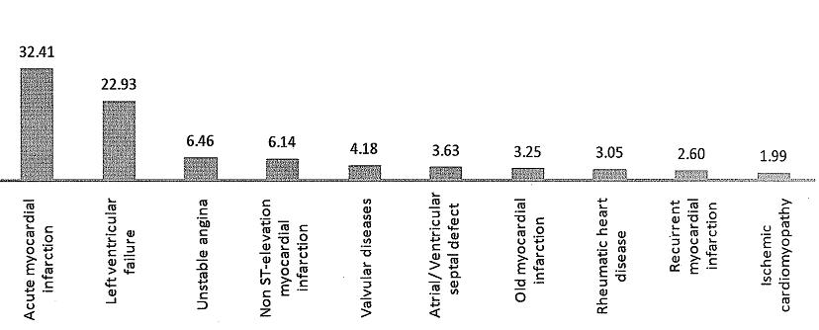
Fig 4. Percent distribution of causes of mortality (all ages and both sexes) in NICVD in 2010 (Total death 3,110) (Ministry of Health & Family Welfare, 2011.p.76).

3.2. Acute coronary syndrome (ACS)
Definition: ACS is a syndrome (set of signs and symptoms) due to decreased blood flow in the coronary arteries such that part of the heart muscle is unable to function properly or dies. ... New-onset angina is also considered unstable angina, since it suggests a new problem in a coronary artery.
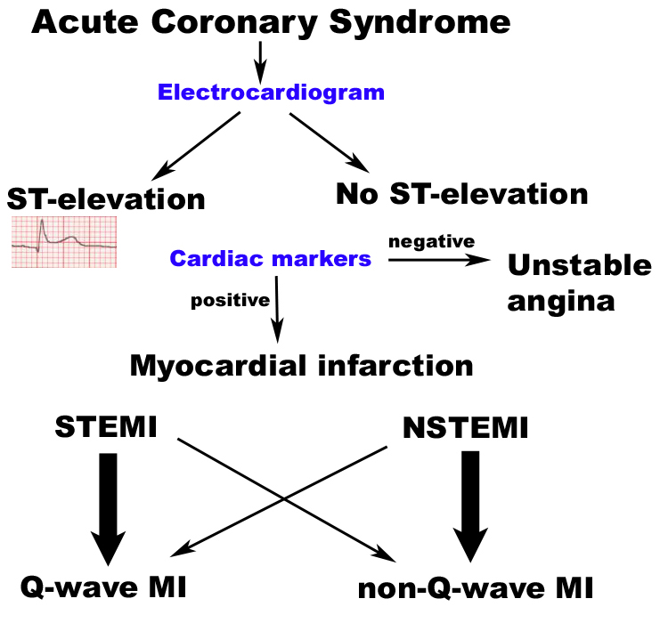

3.2.1. Chronic stable angina (CSA)

Definition: Chronic stable angina (CSA) is defined as the predictable occurrence of pressure or a squeezing chest pain /sensation in the substernal area of the chest and adjacent areas with exertion or emotional upset due to transient myocardial ischemia. Anginal equivalents (exertional breathlessness, fatigue and/or nausea) may also occur with physical activity or emotional stress and relieved by rest and nitroglycerine (Abrams and Thadani, 2005).

3.2.2. Pathophysiology:
Chest pain occur due to imbalance between supply and demand and there is regional myocardial ischemia caused by inadequate coronary perfusion and is usually but not always induced by increases in myocardial oxygen requirements. Cardinal features of chronic stable angina include complete reversibility of the symptoms and repetitiveness of the anginal attacks over time, typically months to years. New, prolonged, or recent-onset symptoms are characteristic of unstable angi- na. Coexisting conditions, such as poorly controlled hypertension, anemia, or thyro- toxicosis, can precipitate or accentuate angina.
As coronary atherosclerosis progresses, there is deposition of plaque external to the lumen of the artery; the plaque may extend eccentrically and outward without compro- mising the lumen (Fig. 1). Thus, stress testing or angiography may not suggest coronary disease, even in the presence of significant atherosclerosis. As atherosclerosis worsens, encroachment of the plaque mass into the lumen can result in hemodynamic obstruc- tion and angina1 (Fig. 1). Disordered endothelial vasomotor function of the coronary arteries is common in patients with angina and results in diminished vasodilatation or even vasoconstriction in response to various stimuli, including exercise.5,6 Occasionally, patients with severe aortic-valve disease or hypertrophic cardiomyopathy have angina- like chest pain in the absence of overt coronary disease. (Jonathan Abrams )

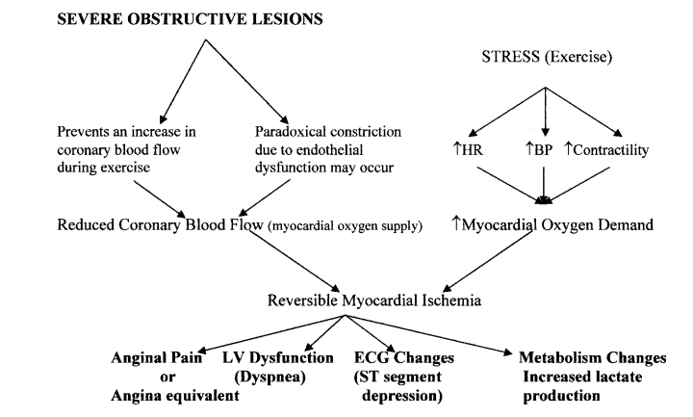

Fig 5: Patho-physiological mechanism of CSA (Abrams and Thadani, 2005, p.1).

3.2.3. Evaluation of patients with ACS:

ACS is diagnosed by patient history including review of symptoms and CVD risk factors, physical examination and evaluation of a resting ECG. In patients with symptoms suggestive of CAD additional investigation, including the physiologic response to stress may be indicated. This may include stress ECG, stress echocardiography or MRI or radionuclide perfusion imaging, CT coronary angiogram. Invasive CAG should be done in selected patients.

History:

Patients history is very important to evaluation the chest pain includes severity and duration of pain; radiation; associated symptoms; provocative factors and alleviating factors. Adjectives often used to describe anginal pain include “squeezing,” “grip-like,” “suffocating,” and “heavy,” but it is rarely sharp or stabbing and typically does not vary with position or respiration. On occasion the patient might demonstrate the classic Levine’s sign by placing a clenched fist over the precordium to describe the pain. Many patients do not, however, describe angina as frank pain but as tightness, pressure, or discomfort. Other patients, in particular women and the elderly, can present with atypical symptoms such as nausea, vomiting, midepigastric discomfort, or sharp (atypical) chest pain (American College of Cardiology Foundation, 2012).

Anginal pain caused by cardiac ischemia typically lasts minutes. The location is usually substernal, and pain can radiate to the neck, jaw, epigastrium, or arms. Pain above the mandible, below the epigastrium, or localized to a small area over the left lateral chest wall is rarely angina. Angina is often precipitated by exertion or emotional stress and relieved by rest. Sublingual nitroglycerin also usually relieves angina within 30 seconds to several minutes (American College of Cardiology Foundation , 2012).

CVD risk factors evaluation:

DM, hypertension, smoking, dyslipidaemia, family history of premature CAD and advanced age increases the risk of severe coronary artery disease and are associated with adverse outcome.

Physical examination:
In ACS patients physically nothing abnormalities is detected except BP and pulse thus the single best clue to the diagnosis of angina is the clinical history. Nonetheless, careful examination may reveal the presence or evidence of risk factors for coronary atherosclerosis or the consequences of myocardial ischemia.
- Elevated blood pressure and hypertensive vascular disease like retinopathy.
- Dyslipidemic conditions like xanthelasma or corneal arcus
- Evidence of carotid and other peripheral vascular disease.
- During an episode of chest pain- S₃ or S₄ gallop, systolic murmur of ischemic mitral regurgitation or rales (Krishnaswamy and Kapadia, 2013)

- Resting ECG:
ECG diagnostic value is zero to hundred percent. The resting ECG is normal in approximately half of patients with stable IHD, and even patients with severe CAD may have a normal tracing at rest. A normal resting ECG suggests the presence of normal resting LV function and is an unusual finding in a patient with an extensive previous MI. The most common electrocardiographic abnormalities in patients with chronic CAD are nonspecific ST-T wave changes (Morroow and Boden, 2012). The most convincing ECG evidence of myocardial ischaemia is obtained by demonstrating reversible ST segment depression or elevation with or without T-wave inversion, at the time the patient is experiencing symptoms. The ECG may show evidence of previous myocardial infarction (Newby, Grab and Bradbury, 2010).

- Echocardiography:
Echocardiography provides useful information in the overall assessment of chronic stable angina patients. Regional wall motion abnormality involving the left ventricle are commonly caused by CAD may present resting ischemia or prior myocardial infarction. Any impairment of LV systolic function, LV hypertrophy and presence of mitral regurgitation are associated with heightened clinical risk. LV systolic function may guide the choice of medical therapy versus revascularization (Krishnaswamy and Kapadia, 2013).

3.3 Coronary artery disease Severity assessment
3.3.1 Coronary angiography (CAG)
Introduction
Coronary angiogram is a gold standard diagnostic tool to identify the coronary stenosis and its severity. CAG is a cardiac catheterization procedure that is frequently performed to selectively examine the coronary circulation using contrast radiographic imaging technique. The angiographic details of both native coronary vessels and surgically constructed bypass grafts are examined. Despite considerable limitations and dependence on non-invaisve functional testing, selective CAG remains the reference standard for clinical evaluation of patients with known or suspected CAD With the progressive evolution in catheter design, radiographic imaging, contrast media and options for the treatment of CAD, diagnostic CAG has become a safe and widely practiced component of cardiac catheterization (Baim, 2006).
CAG EVALUATION HISTORY
Werner Forssmann resident of Germany in 1929, he was the first to pass the catheter into the heart of a living person – himself. Further development came rapidly from 1950s and 1960s. Retrograde left heart catheterization was first reported by Zimmerman and others and Limon- Lason and Bouchard in 1950. The percutaneous rather than cut-down technique was developed by Seldinger in 1953 .Selective CAG was reported by Sones and other in 1959 and was perfected to a remarkable excellence over the ensuing years. Ricket’s and Abram’s in 1962 and Judkins modified CAG for a percutaneous approach in 1967 (Baim, 2006). CAG was modified for percutaneous approach by Rickets and Abrams in 1962.The Judjudkins technique has become the most widely used in worldwide
Principle
The basic principle of radiographic coronary imaging is that radiation produced by the x ray tube is attenuated as it passes through the body and is detected by the image intensifier. Iodinated contrast medium injected into the coronary arteries enhances the absorption of x-rays and produces a sharp contrast with the surrounding cardiac tissues. The x-ray shadow is then converted into a visible light image by an image intensifier, displayed on fluoroscopic monitors. The major epicardial branches and their second and third-order branches can be visualized by coronary arteriography (Popma,2011).
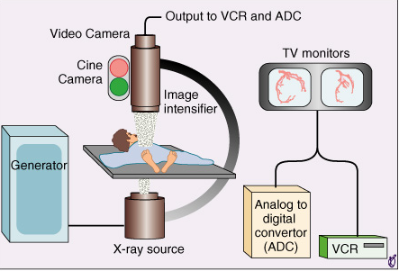
Fig 6: Cine-angiographic equipment (Popma, 2011, p.412).
Vascular access
CAG are performed in variety of vascular approaches .The available approach for CAG like femoral, radial, brachial arterial ,ulnar and distal redial approach. The selection of the vascular access depends on operator and patient preferences, anticoagulation status and presence of peripheral vascular disease. The right and left femoral arteries are the most commonly used access sites for coronary arteriography.
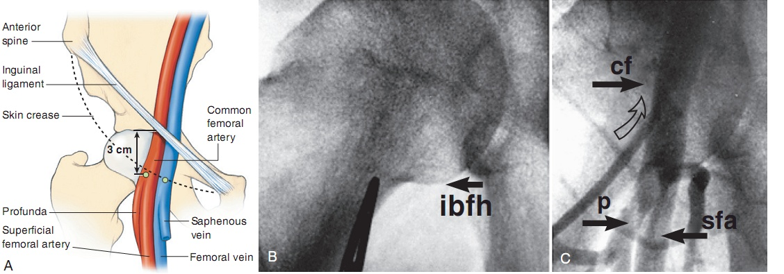
Fig 7: A. Regional anatomy relevant to vascular access. B. Fluoroscopic localization of skin nick (marked by clamp tip). C. Catheter (open arrow) inserted through this skin nick has entered the common femoral artery (cf ) (Davidson and Bonow,2011, p.383).

Angiographic views
Several angiographic view need to understand the proper location and severity of disease vessel. Various views unveiling overlapped vessel segments must be used. These views highlight specific and distinct view of underlying pathology. This understanding of the usefulness of various radiographic views is essential for proper evaluation of CAD.

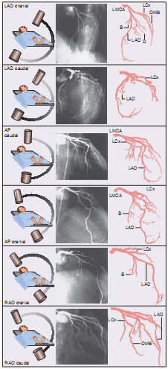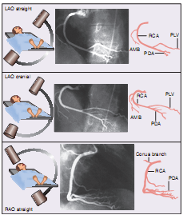
A B
Fig 8: Angiographic views of left coronary artery (A) and right coronary artery (B) (Popma, 2011, p.414).
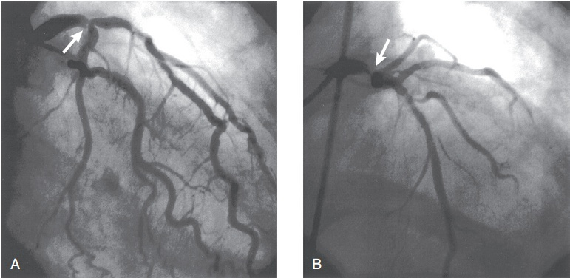
Fig 9: CAG: Severe stenosis of the distal left main coronary artery. A, Right anterior oblique projection with caudal angulation B, An anteroposterior view with cranial angulation ( Popma, 2011, p.416).
Complications of CAG
Major complications are uncommon (<2%) after coronary arteriography and include death (0.10% to 0.14%), myocardial infarction (0.06% to 0.07%), contrast agent reactions (0.23%), stroke (0.07% to 0.14%) and local vascular complications (0.24% to 1%) (Popma, 2011).
Pitfalls of Coronary Arteriography (Popma, 2011).
- Inadequate vessel opacification: Inadequate filling of the coronary artery with contrast medium results in incomplete vessel opacification or “streaming,” which may misrepresent the degree of ostial and side branch disease and overestimate the amount of thrombus or the stenosis severity.
- Eccentric stenoses: Although most segments of the artery wall are involved in the atherosclerotic process, eccentric or slit like lesions may be seen by angiography in regions of more focal plaque accumulation.
- Superimposition of branches: Superimposition of major branches of the left and right coronary arteries can result in failure to detect significant stenoses or total occlusions of these branches

- Micro channel recanalization: It is sometimes difficult to differentiate very severe (>90%) coronary stenoses (with an anterograde lumen) from total occlusions (with no anterograde lumen) that have been recanalized with microchannels and bridging collaterals

3.3.2 Angiographic severity of CAD
Coronary angiography is an important tool for the quantification of coronary artery disease (CAD) burden in both clinical practice and scientific investigation. Researchers have attempted to define angiographic CAD burden using quantitative scoring systems. Historically, this was performed by designation of a single, double, triple-vessel and left main disease classification, with luminal stenosis of either ≥50% or ≥70% used to define significance. However, this simple scoring system was limited in its ability to stratify patients with different levels of disease risk and led to the development of more comprehensive scoring systems for defining atherosclerotic burden and prognosis (Neeland, et al., 2012).
a. Vessel score:
This is the number of vessels with a significant stenosis (for left main coronary artery 50% or greater and for others 70% or greater reduction in luminal diameter) (Chaitman, et al., 1981). Score ranges from 0 to 3, depending on the number of vessel involve. Left main coronary artery will be scored as single vessel disease (Sullivan, Thomas, Marwick and Ben, 1990).
Score 0 = no vessel involvement.
Score 1 = single vessel involvement.
Score 2 = double vessel involvement.
Score 3 = triple vessel involvement.
b. Friesinger score: (Ringsqvist, et al., 1983)
The Friesinger score ranges from 0 to 15. Each of the three main coronary arteries is scored separately from 0 to 5.
Score 0 : No arteriographic abnormality
Score 1: Trivial irregularities (lesion from 1-29%)
Score 2: Localized 30-68% luminal narrowing
Score 3: Multiple 30-68% luminal narrowing of same vessel
Score 4: 69-100% luminal narrowing without 100% occlusion of proximal segments
Score 5: Total obstruction of a proximal segment of a vessel.
c. Gensini Score
The Gensini score was developed by Gensini and takes into consideration the geometrical severity of lesions by angiography, the cumulative effects of multiple obstructions and the significance of jeopardized myocardium. A nonlinear score is assigned to each lesion based on the severity of stenosis as indicated by the reduction of lumen diameter. A multiplier is applied to each lesion score based upon its location in the coronary tree depending on the functional significance of the area supplied by that segment. The final Gensini score is the sum of the lesion scores (Gensini, 1983).
d. Proximal arterial segments score-
The score of this index ranges from one to seven. The criteria for presence of proximal obstruction are the same as for the number of vessels diseased. The score reflects both the number of proximal segments diseased and the location of the lesion.
Score 1.No proximal segment diseased.
Score 2.One proximal segment diseased, either the LCX or RCA.
Score 3.Proximal segment of LAD diseased.
Score 4.Proximal segments diseased in both the LCX and RCA.
Score 5.Proximal segment diseased in LAD and in LCX or RCA.
Score 6.LMCA diseased.
Score 7.Three proximal segments diseased with or without a diseased LMCA
e. Leaman score :
A coronary scoring system to determine the severity of the underlying CAD. Leaman score is based on the severity of luminal diameter narrowing and weighed according to the usual blood flow to the left ventricle in each vessel or vessel segment (Leaman, et al., 1991).

f. Coronary Artery Surgery Study Score
The Coronary Artery Surgery Study (CASS) score was developed by Ringqvist et al. Each of the 3 major epicardial vessels with ≥70% stenosis is assigned 1 point; stenosis of ≥50% in the left main coronary artery is considered a 2-vessel disease and assigned 2 points. The final score is the sum of all points and is analogous to single-, double-, or triple-vessel disease in the coronary tree.
Two versions of the CASS score were used in this analysis: the original description with lesion significance defined as ≥70% stenosis and a modified version with lesion significance defined as ≥50% stenosis (Neeland,et al., 2012).
g. Duke Jeopardy Score
The Duke Jeopardy Score was developed by Dash et al and validated by Califf et al. The coronary tree is divided into 6 segments: the LAD, diagonal branches of the LAD, septal perforating branches, the circumflex coronary artery, obtuse marginal branches, and the posterior descending coronary artery. Each segment distal to ≥70% stenosis is assigned 2points. The maximum possible number of points is 12 (Neeland,et al., 2012).
h. Sullivan Scores
The Sullivan Scores represent 3 separate scoring techniques developed by Sullivan et al to encompass different aspects of atherosclerotic burden. The Vessel score ranges from 0 to 3 and is simply the number of vessels with ≥70% stenosis; left main stenosis is scored as a single-vessel disease. The Stenosis score is identical to the Gensini score as previously described. The Extent score indicates the proportion of each vessel involved by atherosclerotic plaque, identified as luminal irregularity, and multiplied by a factor representative of the vessel's functional significance. The final score is out of 100, representing the percentage of coronary intimal surface area involved by atherosclerotic plaque (Neeland,et al., 2012).
i. Jenkins Score
The Jenkins score divides the coronary tree into 8 segments and assigns a score to each segment based on the maximal degree of luminal stenosis in the proximal aspect of that segment. The points for each lesion are summed to get the final Jenkins score which reflects the extent and severity of disease in the proximal portions of the coronary tree.
Table II. Comparison of angiographic scoring system (Neeland, et al., 2012, p.548).
Scoring system | No. of vessels  involved | Severity  of lesion | Functional  significance of lesion | Comments
Gensini  Score | +++ | +++ | +++ | Most widely used
Vessel | +++ | + | + | Widely used
CASS | ++ | ++ | + | Oldest scoring system
Friesinger  Score | + | +++ | + | Modified CASS  Score
Duke Jeopardy | ++ | +++ | ++ | Widely used, well validated
Jenkins  Score | +++ | +++ | + | Uses proximal  disease only
Sullivan | +++ | +++ | +++ | 3separate scores

Key: No. of vessels Involved: +++, includes all epicardial and branch vessels; ++, includes all epicardial vessels only; +,does not include all epicardial vessels (ie, no left main).
Severity of lesion: +++, includes varying degrees of stenosis; recognizes significance of stenosis, per accepted criteria;++, includes 1 degree of stenosis only; recognizes significance of stenosis per accepted criteria; +, includes 1 degree of stenosis only; does not recognize significance criteria.
Functional significance: +++, quantifies the functional significance of myocardium affected by stenotic lesions for the major epicardial and branch vessels; ++, quantifies the functional significance of myocardium affected by stenotic lesions for select vessels only; +, does not quantify functional significance of myocardium vessels and their targets.
All of the indices evaluated are highly significant statistically in predicting survival. Although the most widely used index of severity of CAD has been the number of vessels involved, the modified Gensini index seems a little better than the other indices. The data demonstrate that all the arteriographic indices are very predictive and have roughly the same magnitude of predictive power (Neeland, et al., 2012).
3.4. Renal impairment and cardiovascular disease
The United States National Kidney Foundation (2002) uses GFR rather than serum creatinine level to define renal dysfunction. National Kidney Foundation recommended estimated GFR for use in recognition, treatment and prevention of chronic kidney disease and defined CKD as eGFR <90 ml/min/1.73m² or more with evidence of kidney damage or eGFR < 60 ml/ min/ 1.73 m² for more than 03 months with or without kidney damage.
Table III: Classification of Chronic Kidney Disease (Gupta, Birnbaum and Uretsky,2004, p.1343)
Stage | Feature | GFR (ml/mim/1.73m² )
1 | Evidence of kidney disease in urine, blood or imaging with normal or increased GFR | ≥ 90
2 | Mildly decreased GFR | 60-89
3 | Moderately decreased GFR | 30-59
4 | Severely decreased GFR | 15-29
5 | Renal failure | <15 or renal replacement therapy.

Cardiovascular complications are the leading cause of mortality in patients with end-stage renal disease (ESRD). The excess cardiovascular risk and mortality is already demonstrable in early renal disease and in patients with chronic renal failure, with the highest relative risk of mortality in the youngest patients. The high risk for cardiovascular disease (CVD) results from the additive effect of multiple factors, including hemodynamic overload and several metabolic and endocrine abnormalities more or less specific to uremia (London, 2003).
CVD includes disorders of the heart (left ventricular hypertrophy, cardiomyopathy) and disorders of the vascular system (atherosclerosis, arteriosclerosis) these two disorders being usually associated and interrelated. LVH is the most frequent cardiac alteration in CKD, resulting from a combined pressure and volume overload. LVH in general is an ominous prognostic sign and an independent risk factor for arrhythmias, sudden death, heart failure and myocardial ischemia. Regression of LVH needs a combined intervention to reduce hemodynamic overload and is associated with improved prognosis and survival. Clinical studies have shown that damage of large conduit arteries is a major contributing factor for the high incidence of congestive heart failure, LVH, ischemic heart disease, sudden death, cerebrovascular accidents and peripheral artery diseases (London, 2003).
In a study of 6,223 people in the Framingham study, 18% of men and 20% of women with renal impairment already had CVD. The incidence rate of cardiovascular events was 21.3/1,000 patient-years for men and 25.6/1,000 patient-years for women with stage 3 CKD. This contrasts with 18.5 and 11.0 per 1,000 patient-years in men and women, respectively, with a lower serum creatinine. The Framingham Heart Study found the prevalence of CVD in people with renal impairment to be 64% higher compared with individuals with lower Serum creatinine values (Kundhal and Lok, 2005).

3.5 Mechanisms of Cardiovascular Complications in Renal Disease
3.5.1. Hypertension
Hypertension prevalence in CKD ranges from 60% to 100%, depending on CKD cause and severity and population studied. Hypertension may cause or be an effect of CKD and confers an increased risk of cardiovascular events in all patient subsets (Gupta, Birnbaum and Uretsky, 2004). Hypertension in and of itself represents a powerful risk factor for CVD in CKD and is almost invariably present in patients with renal failure. Sodium retention and activation of the renin-angiotensin system have been considered the most important mechanisms involved in the elevation of blood pressure in subjects with kidney disease. Sympathetic nervous system activation also plays a role. Plasma catecholamine concentrations are elevated, and increased nerve sympathetic traffic has been demonstrated in renal failure (Schiffrin, Lipman and Mann, 2007).
Hypertension is a well-established risk factor not only for myocardial ischemia, atherogenesis and coronary artery calcification but also for the development of left ventricular hypertrophy (LVH). By contributing to LVH, hypertension represents an important risk for sudden cardiac death. Forces on arterial and aortic walls produced by increased BP alter vascular endothelial cell function by inciting arterial oxidative stress and inflammatory responses. These effects in turn initiate the atherosclerotic process and stimulate various growth promoting peptides. The attendant endothelial dysfunction can lead to hypertrophy, hyperplasia, lipid incorporation, and calcification of the vascular smooth muscle and to associated reductions in vascular compliance and thus to tissue ischemia. The reduced elasticity of the aorta and peripheral arteries further contributes to increased cardiac work, LVH, and increased cardiovascular mortality in ESRD patients (Rostand, 2000)
3.5.2. Dyslipidaemia
Hyperlipidemia prevalence is increased in CKD. Lipid abnormalities include increased serum triglycerides, very low-density lipoprotein, and intermediate density lipoprotein and decreased high-density lipoprotein. Elevated total cholesterol is found in 30% of CKD patients (Gupta, Birnbaum and Uretsky, 2004). Dyslipidemia associated with CKD contributes to the inflammatory response in renal failure. Hepatic apo-lipoprotein A-I synthesis decreases and high-density lipoprotein levels fall. High-density lipoprotein is an important antioxidant and also protects the endothelium from the effects of proinflammatory cytokines. Apolipoprotein C-III, a competitive inhibitor of lipoprotein lipase, is increased in CKD. Serum triglyceride levels increase as a result of accumulation of intermediate-density lipoprotein, which comprise very low-density lipoprotein and chylomicron remnants. These impair endothelial function and are associated with CVD (Schiffrin, Lipman and Mann, 2007).
3.5.3. Inflammation
Between 30 and 50% of CKD patients have elevated serum levels of inflammatory markers such as C-reactive protein, fibrinogen, interleukin-6, tumor necrosis factor, factor VIIc, factor VIIIc, plasmin-antiplasmin complex, D-dimer, and the adhesion molecules E-selectin. Mechanisms are unclear but increased inflammatory mediators have been attributed to increased oxidative stress, accumulation of post synthetically modified proteins, advanced glycation end products and other agents normally cleared by the kidney. Thus, causes of inflammation may include comorbidities, oxidative stress, infections and hemodialysis-related factors that depend on membrane biocompatibility and the dialysate. Progressive deterioration of renal function in CKD may lead to dyslipidemia or accumulation of uremic toxins, which can stimulate oxidative stress and inflammation, which in turn may contribute to endothelial dysfunction and progression of atherosclerosis (Schiffrin, Lipman and Mann, 2007).

3.5.4. Oxidative Stress
A major contributor to the increase in circulating inflammatory biomarkers in CKD may be enhanced oxidative stress. Mechanisms of oxidative stress in uremia may involve activation of reduced nicotinamide adenine dinucleotide (NADPH) oxidase, xanthine oxidase, uncoupled endothelial NO synthase, myeloperoxidase and mitochondrial oxidases. NADPH oxidase is probably the most important source in the vasculature and it is stimulated by angiotensin II and other agents. Increased production of reactive oxygen species by uncoupled endothelial NO synthase as well as reduced inactivation of ROS by antioxidant systems such as superoxide dismutase also play an important role. MPO is present in neutrophils and monocytes/ macrophages and has been shown to be expressed to a significant degree in human atheroma. It may thus play a role in the accelerated atherosclerosis of renal failure. It has recently been reported that a single nucleotide polymorphism in the promoter region of the MPO gene associated with reduced expression of MPO is accompanied by a lower prevalence of CVD in ESRD patients. Active MPO is released from white blood cells during hemodialysis and this could be a mechanism whereby MPO plays a role in vascular injury in subjects with ESRD (Schiffrin, Lipman and Mann, 2007).
3.5.5. Endothelial Dysfunction, Nitric Oxide Bioavailability and ADMA in Renal Disease
Impairment of endothelial function is recognized as one of the initial mechanisms that lead to atherosclerosis. Endothelial dysfunction, which occurs in both large and small arteries, is present in renal disease. Endothelial dysfunction in turn may contribute to CV mortality already in mild renal insufficiency. Reduced bioavailability of nitric oxide (NO) appears to be one of the main factors involved in chronic renal failure associated endothelial dysfunction Prevalence of impaired endothelial function, low grade inflammation, and dyslipidemia associated with incipient and progressive renal disease may explain the acceleration of atherosclerosis and, together with hypertension, may explain the high prevalence of coronary ischemia and CV events in CKD (Schiffrin, Lipman and Mann, 2007).
ADMA is a competitive inhibitor of NO synthase. Plasma concentrations of ADMA are increased in association with endothelial dysfunction and/or reduced NO production, particularly in renal failure. Increased ADMA in renal failure may result from both increased activity of protein arginine methyltransferase and decreased metabolism by dimethylarginine dimethylaminohydrolase. It is unclear whether endogenous ADMA concentrations increase sufficiently to inhibit NO production in vivo ADMA is now considered one of the strongest markers of atherosclerosis. Elevated plasma concentrations of ADMA are associated not only with endothelial dysfunction and atherosclerosis but predict mortality and CV complications in CKD (Schiffrin, Lipman and Mann, 2007).
3.5.6. Renin-Angiotensin System
Activation of the renin-angiotensin system occurs in many forms of renal disease. Angiotensin II stimulates NADPH oxidase, which leads to generation of superoxide anion and contributes to endothelial dysfunction and vascular remodeling and growth. When angiotensin II acts through the AT1 receptor, it stimulates generation of ROS by NADPH oxidase and other enzymes systems which leads to up regulation of inflammatory mediators, which include cytokines, chemokines, adhesion molecules and plasminogen activator inhibitor 1, and superoxide scavenging of NO. These events, together with the mechanisms already mentioned, promote endothelial dysfunction, vascular remodeling, and the progression of atherosclerosis (Schiffrin, Lipman and Mann, 2007).
3.5.7. Anemia
Anemia contributes to myocardial ischemia by producing high cardiac output and increased cardiac work, reduced coronary artery filling times, reduced myocardial oxygen delivery and reduced coronary artery dilator reserve. These effects are additive to those of LVH. It now is well established that treatment of uremic anemia with erythropoietin can improve cardiac performance. Although correction of hematocrit to concentrations above 30% has improved the well-being of most patients undergoing renal replacement therapy and may have decreased the number of anginal episodes, there are no studies to show that the number of other fatal and nonfatal cardiac events has been reduced (Rostand, 2000).

3.5.8. hyper homocysteinemia.
Poor oral intake and decreased homocysteine renal clearance, promoted hyper- homocysteinemia. Hyper homocysteinemia is associated with an increased incidence of cardiovascular event in renal impairment. Hyper homocysteinemia may produce endothelial dysfunction; smooth muscle proliferation; platelet aggregation; activation of factors V, X, and XII and modulation of tissue plasminogen activator, all creating a prothrombotic environment (Gupta, Birnbaum and Uretsky, 2004).
3.5.9. Sympathetic nervous system over-activity
Epidemiologic studies have demonstrated that SNS overactivity is independently associated with an increased risk of cardiovascular mortality in patients with renal failure and other disease states. The mechanisms by which chronic SNS over activation leads to increased CV risk have not been fully elucidated. One potential mechanism is indirect, via increased blood pressure induced by alpha adrenergic vasoconstriction that leads to an increase in total peripheral resistance (Park, 2012).
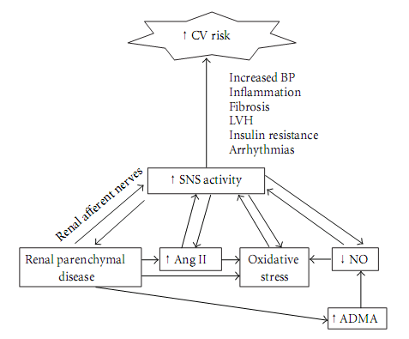
Figure 10: Pathogenesis of sympathetic over activity in chronic kidney Disease factors contributing to increased sympathetic nervous system (SNS) activity in chronic renal failure, leading to increased cardiovascular (CV) risk. ADMA refers to asymmetric dimethyl arginine. NO refers to nitric oxide. Ang II refers to angiotensin II.LVH refers to left ventricular hypertrophy (Park, 2012, P.2).

3.5.10. Calciotropic hormone and Calcium/Phosphorus dysregulation
HPTH, hypovitaminosis D and hyperphosphatemia are usually found in advanced renal disease. Vitamin D depletion can produce vascular smooth muscle cell growth and proliferation and hypo-vitaminosis D is associated with coronary artery calcification, in renal failure. HPTH is associated with reduced luminal diameter of small intramyocardial arteries. Vitamin D deficiency and HPTH can produce increased cardiac mass and are associated strongly with heart valve calcification, and HPTH is associated with myocardial fibrosis and calcification. Elevated calcium-phosphate products are associated with calcification of soft tissues, including the aorta, coronary, and other medium sized arteries (Rostand, 2000). Calcification can be found in atherosclerotic plaques and in the vascular media, smooth muscle cells and elastic laminae of large elastic and medium muscular arteries as well as in cardiac valves. Increased phosphate levels are also a source of increased CV risk, probably as a result of worsening vascular calcification (Schiffrin, Lipman and Mann, 2007).
3.6. Special issues in CKD patients
3.6.1. Symptoms
Chest pain specificity for CAD is reduced in CKD as a result of ischemia from anemia, poorly controlled hypertension and/or left ventricular hypertrophy as well as CAD. Conversely, CKD patients with CAD may not experience chest pain owing to diabetic or uremic neuropathy. Dyspnea on exertion is also less specific for angina as it may be secondary to anemia, volume overload, diastolic dysfunction, respiratory compensation for metabolic acidosis, and/or physical de-conditioning (Gupta, Birnbaum and Uretsky, 2004).
3.6.2. Noninvasive evaluation
The electrocardiogram in CKD may display widened QRS and ST-T changes of left ventricular hypertrophy, volume overload, and electrolyte abnormalities. Peak exercise capacity may be limited by physical de-conditioning, musculoskeletal problems, poorly controlled blood pressure, and anemia. Baseline electrocardiographic abnormalities and an inability to reach target heart rate in exercise electrocardiographic testing lowers sensitivity and specificity versus non-CKD
patients. Dobutamine stress-echocardiography in dialysis patients has a sensitivity of 75% to 95% and specificity of 76% to 86%. Dipyridamole radionuclide stress testing has a sensitivity of 80% and specificity of 37% to 73% (Gupta, Birnbaum and Uretsky, 2004).
3.6.3. Invasive evaluation
The invasive evaluation of CAD in CKD patients is complicated by an increased CIN risk, defined as an absolute serum creatinine increase ≥ 0.5 mg/dl or relative increase ≥ 25% above baseline 24-48 hours after contrast administration. The most important CIN risk factors are age> 70 years, pre-existing CKD and DM. In DM patients with CKD, the CIN rate may exceed 25%. Contrast-induced nephropathy is usually nonoliguric. Treatment includes fastidious maintenance of fluid balance, avoidance of nephrotoxic agents and monitoring of renal function and electrolyte status. Dialysis is necessary in only a small percentage (0.4% to 0.8%) of patients undergoing PCI. Most patients recover by one to three weeks, but a small percent do not, or only partially. Patients with mild to moderate CKD who develop CIN after PCI show increased one-year mortality (Gupta, Birnbaum and Uretsky, 2004).
3.6.4. Reliability of biomarkers
Creatine kinase-myocardial band (CK-MB) elevations have been found on routine testing in dialysis patients without clinical or electrocardiographic evidence of AMI. It is unclear whether these elevations represent false positives, ongoing myocardial damage, or reduced CK-MB clearance.Troponin measurement may have similar limitations. In one study, cardiac troponin was found to be the most consistent AMI marker in all CKD strata including dialysis patients and was more sensitive and had a higher negative predictive value than myoglobin and CK-MB (Gupta, Birnbaum and Uretsky, 2004).

3.6.5. Morphology of atherosclerotic plaque in CKD
Postmortem data of CKD vessels showed increased medial thickness and smaller lumen area compared with age and gender-matched control subjects. Control plaques were mostly ﬁbro-atheromatous, whereas CKD plaques were calcified. An electron beam computed tomography study in ESRD adults showed coronary calcification in 92%; on average, calcium scores exceeded >10-fold the 95th percentile, the severity related to ESRD duration (Gupta, Birnbaum and Uretsky, 2004).
3.7 Assessment of renal function
Estimation of renal function is important in a number of clinical situations, including assessing renal damage and monitoring the progression of renal disease. Renal function should also be calculated if a potentially toxic drug is mainly cleared by renal excretion (Nankivell, 2001).
3.7.1. Serum Creatinine
Serum creatinine is commonly used to screen for renal disease, to investigate urinary sediment abnormalities, hypertension or non-specific symptoms such as tiredness, Serum creatinine can also be used to monitor renal function in chronic renal disease and the effects of nephrotoxic drugs such as contrast media.
Serum Creatinine is mainly produced by the metabolism of creatine in muscle, but also originates from dietary sources of creatinine such as cooked meat. Creatinine generation from the muscles is proportional to the total muscle mass and muscle catabolism. In people with a relatively low muscle mass, including children, women, the elderly, malnourished patients and cancer patients, the serum creatinine is lower for a given GFR. There is a danger of underestimating the amount of renal impairment in these patients, as their serum creatinine is also relatively lower. For example, the GFR may be reduced as low as 20–30 mL/min in a small elderly woman, while her serum creatinine remains in the upper range of normal (Nankivell, 2001). While Increase in serum creatinine is quite specific for renal impairment, the test has low sensitivity, often requiring a 50% fall in GFR to cause an appreciable rise in serum creatinine, the so-called “creatinine blind” region of renal impairment (Jones and Lim, 2003).

3.7.2. Blood urea nitrogen (BUN)
BUN can be used to estimate renal function but is highly variable, less accurate and prone to errors (Nankivell, 2001).

3.7.3. Glomerular Filtration Rate
Glomerular filtration rate (GFR) is the total amount of the filtrate produced per minute by the functioning nephrons in the kidney. Normal GFR varies according to age, sex, and body size; in young adults it is approximately 120-130 ml/min. In most healthy people, the normal GFR is 90 ml/min or higher (National Kidney Foundation, 2005). It is a sensitive marker to detect changes in the overall renal function and useful in the early detection of renal impairment and for monitoring renal function and also provides guidance in the dosing of drugs. The GFR cannot be directly measured in humans, but can be measured from urinary clearance of a substance (creatinine clearance) or estimated from serum creatinine based formulae (estimated GFR) (Jones and Lim, 2003).
- Measured GFR/Creatinine clearance
Creatinine clearance has been used for many decades to measure GFR. Creatinine clearance is often used for the initial evaluation of renal diseases, to monitor the progression of chronic renal failure and the response to therapy or to help decide when to start dialysis in patients with declining renal function (Nankivell, 2001).
Measured GFR or Clearance of a substance can be calculated by the given formula $Mesured GFR=\frac{U×V}{P}$ , where U is the urinary concentration of an ideal filtration marker, V is the urine flow rate and P is the average plasma concentration of marker. An ‘ideal filtration marker’ is a substance that is freely excreted by glomerular filtration, without tubular reabsorption or secretion. The clearance of ideal filtration markers can be shown mathematically to be an accurate estimate of GFR (Nankivell, 2001).
The major problem with measuring creatinine clearance is that it involves a 24-hour urine collection which may be incomplete; often urine is passed into the toilet rather than into the collection bottles. This results in an underestimation of renal function and has led some commentators to recommend alternative measures such as estimated GFR or an isotopic GFR (Nankivell, 2001).

- Estimated GFR
The best overall index of renal function is considered to be GFR and inulin clearance is widely regarded as the gold standard for measuring GFR. As an alternative to the cumbersome and costly process of GFR measurement, several serum creatinine based formulas for estimating the renal function in adults were created and the most widely used one is the Cockcroft-Gault formula (Botev, 2011)
$$eGFR =\frac{140-age [years] ) × weight [in kg] }{serum creatinine [mg/dL] ×72}$$
For female patients, obtained value was multiplied by 0.85
The most well-known Cockcroft-Gault formula is relatively simple to use and reasonably accurate (Nankivell, 2001).The eGFR has a very important role in large epidemiologic studies whenever GFR measurement is not feasible for practical and cost-containing reason (Botev, 2011).
The National Kidney Disease Education Program of the National Institute of Diabetes and Digestive and Kidney Diseases, National Kidney Foundation and American Society of Nephrology recommend estimating GFR from serum creatinine. Two commonly used equations are the Cockcroft-Gault equation and Modifcation of Diet in Renal Disease Study equation. Both equations use serum creatinine in combination with age, sex, weight, or race to estimate GFR and therefore improve upon several of the limitations with the use of serum creatinine alone. The Chronic Kidney Disease Epidemiology Collaboration equation is a new equation based on serum creatinine (NKF, 2005).
- Isotopic GFR
Isotopic GFR is the most accurate measurement of GFR, especially at low levels of renal function or with alterations of muscle mass. The most common isotopic marker is technetium 99m DTPA, given as a single injection. Two plasma samples are taken at 1–3 hours after injection. The GFR is calculated from the plasma clearance of the isotope. Isotopic GFR can be used for monitoring renal function over time, or in chronic renal failure patients approaching dialysis. Patients are usually tested every two to five years, because of the cost and inconvenience of the procedure.
Table IV: Comparison of different methods for assessment of renal function (Nankivell, 2001, p.17)
Method | Accuracy | Cost | Convenience
Serum Creatinine | ++ | + | +++
Blood Urea | + | + | +++
eGFR | +++ | + | +++
Measured GFR | ++ to +++ | ++ | +
Isotopic GFR | ++++ | +++ | +

3.8. Related Studies
Chonchol, et al. (2008) in a study evaluated the relationship between CKD and severe coronary artery disease. Patients with chronic kidney disease (CKD) have a dramatically increased risk for cardiovascular mortality. The likelihood of CAD increased monotonically with decreasing eGFR, from 51% among patients with eGFR ≥ 90 ml/min to 84% in those with eGFR < 30 ml/min (p = 0.0046). Patients with CKD were more likely than those without CKD to have at least one significant coronary obstruction (75.9 vs. 60.7%, p = 0.016). Patients with CKD also had more significant CAD, that is, were more likely to have three-vessel and/or left main disease than those without CKD (34.9 vs. 16.9%, p = 0.0035). In logistic regression analysis, controlling for demographics and comorbidity, CKD continued to be independently associated with the presence of significant CAD (p = 0.0071). CKD patients have a high prevalence of obstructive coronary disease, which may contribute to their high cardiovascular mortality.
In a study, Monjunath, et al.(2003) included 15,350 subjects. The goal of the study was to determine whether the level of kidney function is an independent risk factor for atherosclerotic cardiovascular disease (ASCVD). During a mean follow-up time of 6.2 years, 965 (6.3%) of subjects had ASCVD events. Subjects with GFR of 15 to 59 ml/min (n=444, hazard ratio 1.38 [1.02, 1.87]) and 60 to 89 ml/min (n= 7,665, hazard ratio 1.16 [1.00, 1.34]) had an increased adjusted risk of ASCVD compared with subjects with GFR of 90 to 150 ml/min. Each 10 ml/min lower GFR was associated with an adjusted hazard ratio of 1.05 (1.02, 1.09), 1.07 (1.01, 1.12), and 1.06 (0.99, 1.13) for ASCVD, de novo ASCVD and recurrent ASCVD, respectively.
Davoodi, et al. (2011) in a study enrolled a total of 7968 patients who underwent diagnostic coronary artery catheterization [mean age = 54.8 ± 10.6 years, 74.4% males]. There were 2133 (26.8%) patients with GFR ≥ 90 ml/min, 4574 (57.4%) patients with 60 ≤ GFR < 90 ml/min, 1073 (13.5%) with 45 ≤ GFR < 60 ml/min and 181 (2.3%) with 15 < GFR < 45 ml/min. After adjustment for traditional cardiovascular risk factors (age, sex, dyslipidemia, low to high-density lipoprotein ratio, smoking status, and family history), the GFR showed a significant association with the severity of CAD and remained a significant predictor of CAD (Odds Ratio raised from 1.1 in patients with 60 ≤ GFR < 90 ml/min/1.73 m² to 1.8 in patients with 15 < GFR < 45 ml/min/1.73m²).
Budooff, et. al. (2011) in a study analysed 1,908 participants who underwent coronary calcium scanning and reported a strong and graded relationship between lower eGFR and increasing CAC. In unadjusted models, ORs increased from 1.68 (95% CI, 1.23-2.31) for eGFR of 50-59 ml/min/1.73 m2 to 2.82(95% CI, 2.06-3.85) for eGFR 30 ml/min/1.73 m2. Multivariable adjustment only partially attenuated the results (OR, 1.53; 95% CI, 1.07-2.20) for eGFR 30 ml/min/ 1.73 m2.
Kiyosue, et. al. (2010) in a study examined the relationship between renal dysfunction and the severity of coronary artery disease (CAD). The severity of CAD in 572 patients was graded according to the number of stenotic coronary arteries and the eGFR was monitored. Those who showed more deterioration of eGFR had more severe CAD than those who did not (1.20±0.06 vs 1.61±0.06, P<0.001). Multivariate analysis revealed that the severity of CAD was independently and significantly associated with the deterioration of eGFR.
In a study Joosen, et. al. (2012) stated that Coronary calcium score increased significantly with decreasing renal function (P,0.001). Coronary plaque prevalence was higher in patients with mild CKD (OR 1.83, 95%CI 1.52–2.21) and moderate CKD (OR 2.46, 95%CI 1.69–3.59) compared to patients with normal renal function (both P,0.001). Coronary plaques with 70% luminal stenosis were found significantly more often in patients with mild CKD (OR 1.67 (95%CI 1.16 2.40) and moderate CKD (OR2.36, 95%CI 1.35–4.13) compared to patients with normal renal function (P<0.01).
Cay,Metin and korkmaz (2007) in a study studied 43 patients with decreased renal function (calculated eGFR<80 ml/min) with a mean age of 67.8+/-9.0 years and 49 patients without impaired renal function (calculated eGFR ≥80 ml/min) with a mean age of 52.5+/-10.3 years consecutively from March 2005 to September 2005. In linear regression analysis, a negative correlation was found between renal function and the severity of coronary atherosclerosis (r=0.326, p=0.002). All patients were classified into quartiles of Gensini score level. In multivariate analysis, the multiple-adjusted odds ratio (OR) of the risk of decreased renal function was 0.99 (95% CI 0.24-4.15) for quartile 2, 4.38 (95% CI 1.11-17.20, p=0.03) for quartile 3, and 7.01 (95% CI 1.72-28.61, p=0.007) for quartile 4 of Gensini score level compared with the quartile 1.
Na, et al (2008) in a study included 3,637 patients who underwent CAG at Seoul National University Bundang Hospital in Korea between May 2003 and January 2006. The presence of CAD was 48% in CKD stage 1, 61% in stage 2, 73% in stage 3, 87% in stage 4, and 81% in stage 5. eGFR is a strong independent prognostic marker among patients undergoing CAG and the severity of CAD increases progressively with worsening renal function.
Stamatelopoulos, et al. (2008) in a study examined the impact of renal dysfunction on both coronary and peripheral atherosclerosis in patients with coronary artery disease (CAD) without severe renal impairment. Significant CAD (>50% stenosis) was identified in 139 patients. GFR independently correlated with the presence and severity of CAD.
In a study titled “Serum Creatinine and Blood Urea Nitrogen Levels in Patients with Coronary Artery Disease” Akanda, et. al,.(2013) stated that a significant association has been found between serum creatinine and BUN level with the presence of CAD (r=.34, p=<0.001).

4. MATERIALS AND METHODS
4.1 Study Design:

4.1.1. Type of study: Observational analytical study with a group comparison.
4.1.2. Place of study: Department of Cardiology, National Institute of cardiovascular disease (NICVD), Dhaka.

4.1.3 Study period: June 2015 to June 2017.

4.2 Ethical issue:

The study protocol was approved by the ethical review board. Informed written consent was taken from each patient or near relative. Confidentiality maintained strictly and the patient had right to withdraw himself / herself from the study at any time during the study period.

4.3 Study population:
Patients with chronic stable angina admitted for coronary angiogram in NICVD during June 2015 to June 2017 were the study population.
4.4 Enrollment of subjects:
- Inclusion criteria:
Patients with chronic stable angina admitted for coronary angiogram in NICVD during the study period.
- Exclusion criteria:
- Patient with valvular or congenital heart disease and cardiomyopathy.
- Diabetes mellitus.
- LVEF < 40%
- Prior PCI or CABG.
- Patient doesn’t agree to be enrolled in the study
4.5 Sampling method:
Purposive sampling.
4.6. Sample size calculation:
The sample size was determined by following formula
 (1)

Where,
n = the desired sample size which would help to measure the different indicators z = the standard normal deviate, usually set at 1.96 at 5% level which corresponds to 95% confidence level.
Here p=0.50 q=1 - 0.50 =0.50 d = allowable error (normally from 1 – 10%) = 0.044
(Assumed 4.4%)
So, the sample size for this study
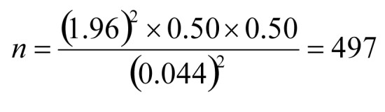
n=497 (targeted sample size)
4.7 Grouping of study population:
A total of 497 patients were selected, study populations were divided into two groups on the basis of eGFR.
Group I (Impaired renal function group, n=298): Patients with eGFR< 90 ml/min/1.73m²
Sub-group : Mildly decreasedGFR (eGFR 60-89 ml/min/1.73m²), n=157
Moderately decreasedGFR (eGFR 30-59 ml/min/1.73m²), n=141
Group II (Normal renal function group, n=199): Patients with eGFR ≥ 90 ml/min/1.73m²
4.8 Variables to be studied
Dependent variable:
Angiographic severity of coronary artery disease-
- Vessel score
- Gensini score

Independent variables:
- Age
- Sex
- Body mass index (BMI)
        - Smoking
        - Hypertension
        - Dyslipidaemia
        - Family history of CAD.
- Hb%
- Blood sugar
- Serum creatinine
- Estimated GFR
- Fasting lipid profile
- Echocardiography - LVEF%
.

4.9 Methodology
- Diagnosis of ACS: When the patient has predictable occurrence of pressure or a squeezing chest pain/sensation in the substernal area of the chest and adjacent areas with exertion or emotional upset and relieved by rest or nitroglycerine or prior history of CAD but after evaluation in the hospital, the episode of discomfort was not thought to have represented unstable angina.
- Patients with chronic stable angina admitted for CAG into Cardiology Department of NICVD, Dhaka, were considered for inclusion in the study after considering inclusion & exclusion criteria.
- Informed written consent was taken from each patient before enrollment.
- Meticulous history was taken and detailed clinical examination was performed and recorded in pre-designed structured form.
- Demographic data such as age, sex, occupation, BMI etc was recorded.
- Risk factors profile including smoking, hypertension, dyslipidaemia and family history of premature CAD were noted.
- Drugs used before, during and after procedure were recorded.
- Laboratory investigations: Serum creatinine, Blood Sugar, Serum electrolytes, Urine R/M/E & other screening tests for coronary angiogram were done.
- ECG: 12 lead resting ECG was done at a paper speed of 25 mm/s and 10mm standardization at admission.
- Echocardiography: Trans-thoracic echocardiography was done by 2D & M-mode and Doppler echocardiography modalities. Left ventricular ejection fraction (LVEF) was measured by Ticholtz’s method.
- Anthropometric measurement: Height and weight of patients were measured & BMI was calculated through dividing weight in kilograms by height in meters squared and described as kg/m2.
- Assessment of renal function: Estimated glomerular filtration rate (eGFR) was used for the evaluation of renal functional status and was calculated by the Cockroft & Gault formula:
$$eGFR=\frac{140-age [years] ) × weight [in kg] }{serum creatinine [mg/dL] ×72}$$
(For female patients, obtained value was multiplied by 0.85)
- Coronary angiography and severity of coronary artery disease: Coronary angiogram was done after appropriate patient preparation. Nephrotoxic drugs (eg.NSAIDs) were stopped and hydration with intravenous normal saline was done to prevent contrast induced nephropathy in high risk patients. Femoral artery cannulation was used for arterial access site and Judkins system was applied for cannulation of the left and right coronary arteries. All angiography were evaluated by two experienced cardiologists who were blinded to the study. The severity of the CAD was assessed by Vessel score and Gensini score.
Vessel score: From the categorical viewpoint, significant coronary artery disease was defined as > 70% stenosis in any of the three major epicardial coronary arteries or >50% stenosis a left main coronary artery. Angiograms revealing coronary artery stenosis <70% in major epicardial coronary arteries were termed non-obstructive CAD. Extent of CAD was defined as insignificant, single, two or three vessel CAD (Chaitman, et al., 1981). Score ranges from 0 to 3, depending on the number of vessel involve. Left main coronary artery will be scored as single vessel disease (Sullivan, Thomas, Marwick and Ben, 1990).
Score 0 = No vessel involvement / Insignificant CAD.
Score 1 = Single vessel involvement.
Score 2 = Double vessel involvement.
Score 3 = Triple vessel involvement.
Gensini Score:The Gensini score was developed by Gensini and takes into consideration the geometrical severity of lesions by angiography, the cumulative effects of multiple obstructions and the significance of jeopardized myocardium. A nonlinear score is assigned to each lesion based on the severity of stenosis as indicated by the reduction of lumen diameter. A multiplier is applied to each lesion score based upon its location in the coronary tree depending on the functional significance of the area supplied by that segment. The final Gensini score is the sum of the lesion scores (Gensini, 1983). According to Gensini score CAD is categorized as mild (1-10), moderate (10-50) and severe (>50) (Ozgirgin, et al.,2000).

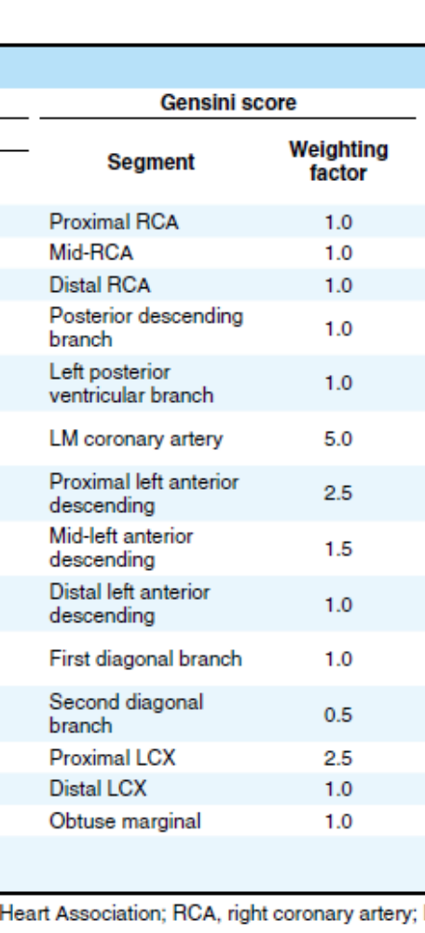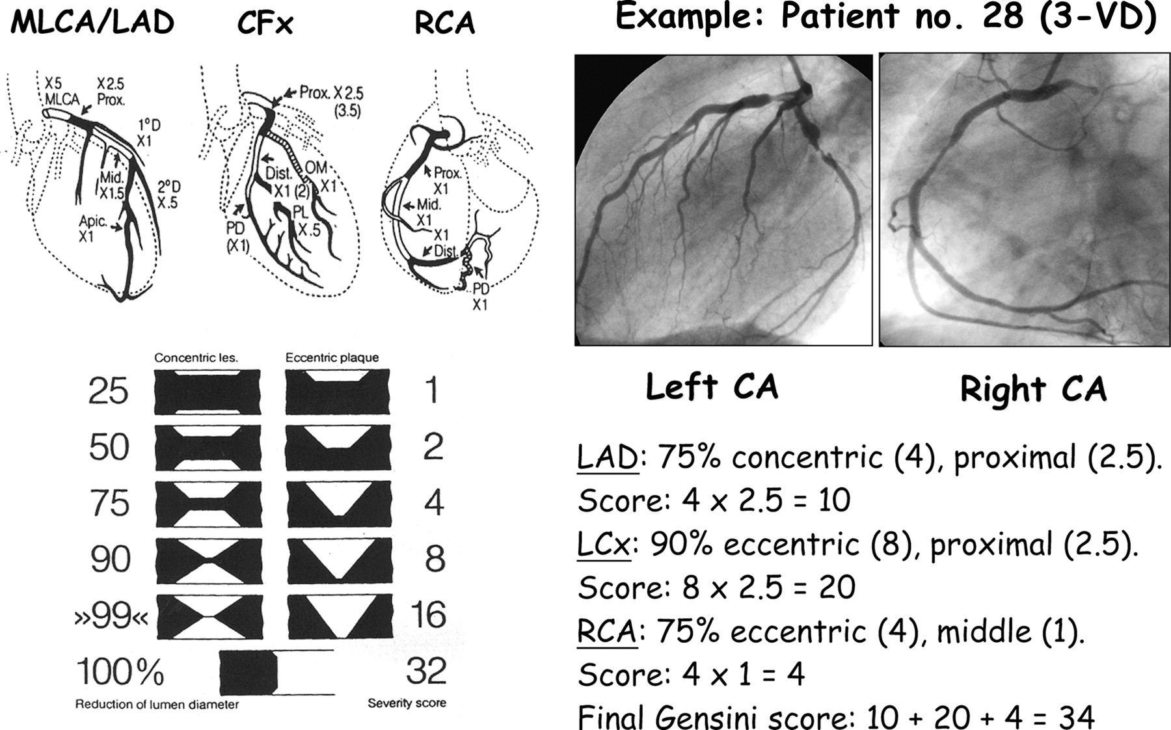
Figure 11: Gensini Score: Left panel- weighting factor according to the importance of vessel in the coronarytree (Huang, et al., 2010, p. 491). Right panel-severity score according to reduction of lumen diameter (Montorsi , et al., 2006, p.2634).

4.10 Data collection:
Data were collected by using a preformed data sheet.

4.11 Statistical methods
The numerical data obtained from the study were analyzed and significance of differences were estimated by using statistical methods. The SPSS Statistical Software (16.0 version, SPSS Inc., Chicago, Illinois, USA) was used for data analysis. Continuous variables were expressed in mean & standard deviation and categorical variables as frequency and percentage. Quantitative variables were analyzed by Student’s t-test and ANOVA and Categorical variables were analyzed by chi-square test and Fisher’s exact test as applicable. To test association between impaired renal function and coronary artery disease severity pearson’s and Spearman’s rank order correlation test used. Univariate and multivariate logistic regression analysis were done to evaluate the independent predictors of severe CAD. The odds ratio (OR) and 95% confidence interval were calculated. p value of less than 0.05 was considered as significant.

5. RESULTS AND OBSERVATIONS:
This observational analytical study was conducted in the department of Cardiology, National Institute of Cardiovascular Diseases, Dhaka from June 2015 to June 2017. The main objective of the study was to find out the association between impaired renal function and coronary artery disease severity in patients with chronic stable angina. A total of 497 patients were included in the study and were divided into two groups according to the renal function assessed by eGFR.

Table V. Demographic and clinical factors of study patients
Variables | Impaired function (n=298) | renal group | Normal renal function group (n=199) | P value
Age, mean ± SD, years | 55.60±7.5 |  | 49.40±6.6 | 0.001
Sex, male: female | 10:1 |  | 10:1 | 1.000
BMI, mean ±SD, kg/m² | 22.70 ± 1.2 |  | 24.1±2.1 | 0.001
Hypertension, n (%) | 135 (45.3) |  | 51 (25.6) | <0.001
Dyslipidaemia, n (%) | 102 (34.2) |  | 33 (16.6) | <0.001
Smoking, n (%) | 97 (32.6) |  | 58 (29.1) | 0.423
Family history of  CAD, n (%) | 32 (10.7) |  | 15 (7.5) | 0.231
Drug history
Antiplatelet, n (%) | 269 (90.3) |  | 163 (81.9) | 0.006
Nitrates, n (%) | 189 (63.4) |  | 156 (78.4) | <0.001
Beta blocker, n (%) | 178 (59.7) |  | 119 (59.8) | 1.000
ACE Inhibitors, n (%) | 97 (32.6) |  | 72 (36.2) | 0.402
Statins, n (%) | 174 (58.4) |  | 108 (54.3) | 0.365

Above table shows that the mean age of group-1 patients is 55.60 and group-ΙΙ is 49.40 years and the difference is statistically significant. Male: Female ratio is 10:1.BMI is significantly low in group-Ι. Among the conventional CVD risk factors, hypertension and dyslipidemia are significantly high in group-Ι. No significant difference between two groups is found in case of smoking and family history of CAD. Study groups are well matched in terms of drug history.

Table VI. Laboratory characters of study patients (n=497)
Variables | Impaired renal function group (n=298) | Normal renal function group (n=199) | P value
Hb, mean±SD,  (gm/dl) | 12.30 ± 0.60 | 13.90 ± 1.20 | 0.640
RBS (mg/dl) | 5.9 ± 0.4 | 5.9 ± 0.4 | 1.000
Lipid profile
(mg/dl)
Total cholesterol | 171.10 ± 13.30 | 169.10 ± 10.50 | 0.080
LDL | 120.60 ± 12.90 | 114.50 ± 15.20 | 0.090
HDL | 36.20 ± 3.60 | 39.0 ± 2.60 | 0.440
S. Triglyceride | 143.60 ± 18.80 | 133.70 ± 16.90 | 0.005
Serum creatinine  (mg/dl) | 1.34 ± 0.30 | 0.80 ± 0.10 | 0.001
eGFR,  (ml/min/1.73m²) | 60.70 ± 12.60 | 100.40 ± 8.4 | 0.001
LVEF, mean± SD,  (%) | 49.60 ± 7.30 | 53.30 ± 8.50 | 0.020

The table shows that the differences in mean haemoglobin and RBS level between two groups
are insignificant. In lipid profile only TG was significantly high in group-Ι. The mean serum
creatinine level is 1.34±0.3 mg/dl in group-Ι & 0.80±0.1 mg/dl in group-ΙΙ and the difference
is statistically significant (p=0.001). The mean eGFR in group-Ι and group-ΙΙ are 60.70±12.60
and 100.40±8.4 ml/min/1.73m² respectively and the difference is significant. Mean LVEF is
49.60 & 55.30 % in group-Ι and group-ΙΙ respectively with a significant difference between two
group.

Table VII. Mean eGFR of study patients according to vessel score (n=497)
Vessel score | eGFR(ml/min/1.73m²) |  | p value
Vessel score | Mean | SD
Score 0 (n=54) | 100.1 | 14.5
Score 1 (n=212) | 81.0 | 21.3 | 0.005^{s}
Score 2 (n=153) | 77.6 | 22.3
Score 3 (n=78) | 71.2 | 24.7

S = Significant
P value reached from ANOVA test.

The table shows that mean eGFR of study patients is 100.1, 81.0, 77.6 and 71.2 ml/min/1.73m² for insignificant, single, double and triple vessel CAD respectively. There is significant association between mean eGFR and vessel score of the study patients (p <0.01).

Table VIII. Distribution of the study patients according to Gensini score (n=497)
Severity of CAD  Gensini score) | Gro  (n= | p Ι  298) | Group ΙΙ  (n= 199) |  | p value
Severity of CAD  Gensini score) | Number | % | Number | %
Mild (1-10) | 27 | 9.1 | 42 | 21.1 | <0.001^{s}
Moderate (10 –  50) | 178 | 59.7 | 141 | 70.9 | 0.110^{s}
Severe ( > 50) | 93 | 31.2 | 16 | 8.0 | <0.001^{s}

Group-Ι = eGFR <90ml/min/1.73m²
Group –ΙΙ= eGFR ≥ 90ml/min/1.73m²
s=Significant
p value reached from Chi Square test.

Above table shows that CAD was mild in 9.0% patients in group Ι and 23.6% patients in group ΙΙ and mild CAD was significantly low in group Ι (p=0.040). Moderate CAD was found in 59.6% and 69.1% patients in group Ι and group ΙΙ respectively with insignificant difference (p=0.310). Severe CAD was found in 31.3% patients in group Ι and 7.3% patients in group ΙΙ and was significantly higher in group Ι (p=0.001).

Figure 12: Bar diagram showing mean Gensini score of the study patients

Group-Ι = eGFR <90 ml/min/1.73m²
Group –ΙΙ = eGFR ≥ 90 ml/min/1.73m²
p value reached from unpaired student t test

Above Bar diagram shows the mean Gensini score was 42.30 in group Ι and 25.65 in group ΙΙ. The difference was statistically significant (p=0.001).

Table IX: Correlation of eGFR with vessel score and Gensini score (n=497)
Variable | R | P
Vessel score | -0.300 | 0.004
Gensini score | -0.650 | 0.001

Table X. Univariate logistic regression analysis of determinants of severe CAD.
Variables of interest |  | β | S.E. | p value | OR | 95% CI  (min – max)
Age> 45 years |  | 0.534 | 0.557 | 0.03^{s} | 1.88 | 0.632 – 2.662
Hypertension |  | 1.371 | 0.506 | 0.007^{s} | 3.93 | 1.460 –  10.620
Dyslipidemia |  | 1.867 | 0.531 | 0.004^{s} | 5.01 | 2.831 –  11.704
Smoking |  | 0.138 | 0.517 | 0.38 | 1.14 | 0.417 – 3.164
Family history premature CAD | of | 0.127 | 0.327 | 0.44 | 0.74 | 0.053 – 3.715
Serum creatinine |  | 2.001 | 0.603 | 0.002^{s} | 5.54 | 2.934 –  12.111
BMI |  | 0.255 | 0.147 | 0.08 | 1.11 | 0.581 – 1.241
LVEF |  | 0.213 | 0.104 | 0.12 | 0.95 | 0.888 - 1.015
eGFR<90 ml/min/1.73m² |  | 1.741 | 0.596 | 0.003^{s} | 5.70 | 1.775-  18.330

•Dependent variable: Severe CAD (Gensini score>50)
•Independent variables: Age>49years,
Hypertension, Dyslipidemia, Smoking, Family H/O of CAD, Serum creatinine, BMI, LVEF and eGFR<90 ml/min/1.73 m²,
s = Significant
Table X demonstrates univariate logistic regression analysis of varies in dyslipidemia, serum creatinine and eGFR are found significant predictors of severe CAD with ORs being 1.88, 3.93, 5.01, 5.54and 5.70 respectively likely to cause severe coronary artery disease.

Table XI. Multivariate logistic regression analysis of determinants of severe
CAD.

Variables of interest | β | S.E. | p value | OR | 95% CI
Age> 45 | 0.434 | 0.392 | 0.12 | 1.27 | 0.219 – 1.658
Hypertension | 1.245 | 0.499 | 0.006 ^{s} | 3.71 | 1.234 – 9.789
Dyslipidemia | 1.629 | 0.512 | 0.003 ^{s} | 4.95 | 2.110 – 10.111
BMI | 0.234 | 0.139 | 0.09 | 1.11 | 0.349 – 1.201
LVEF | 0.201 | 0.101 | 0.14 | 0.96 | 0.789 – 1.001
Serum creatinine | 1.826 | 0.592 | 0.003 | 5.36 | 2.224 – 7.114
eGFR < 90ml/min/1.73m² | 1.729 | 0.582 | 0.002 ^{s} | 5.73 | 1.725 – 17.234

Dependent variable: Severe CAD (Gensini score >50)
Independent variables: Age>45 years, Hypertension, Dyslipidemia, BMI, LVEF, serum creatinine and eGFR<90 ml/min/1.73m²
s = Significant
(eGFR and serum creatinine were entered into the model separately)

Table XI. demonstrates the multivariate logistic regression analysis of variables likely to cause severe coronary artery disease. Hypertension, dyslipidemia, serum creatinineand eGFR are found the independent predictors of severe CAD with ORs being 3.71,
4.95, 5.36 and 5.73 respectively.

Table XII. Mean Gensini score in subgroups of group-Ι patients (n=298)

GFR status | Gensini Score |  | p value
GFR status | Mean | SD
Mildly decreased GFR  (n=206) | 29.97 | 15.5 | 0.001^{s}
Moderately decreased  GFR  (n=92) | 69.76 | 19.6

Mildly decreased GFR (eGFR 60-89 ml/min/1.73m²)
Moderately decreased GFR (eGFR 30-59 ml/min/1.73m²)
s = Significant
p value reached from unpaired t- test.
The table demonstrates that mean Gensini score is
29.97±15.5 and 69.76±19.6 respectively in mildly decreased GFR and moderately decreased GFR subgroup of group Ι patients and the difference is statistically significant (p=0.001).

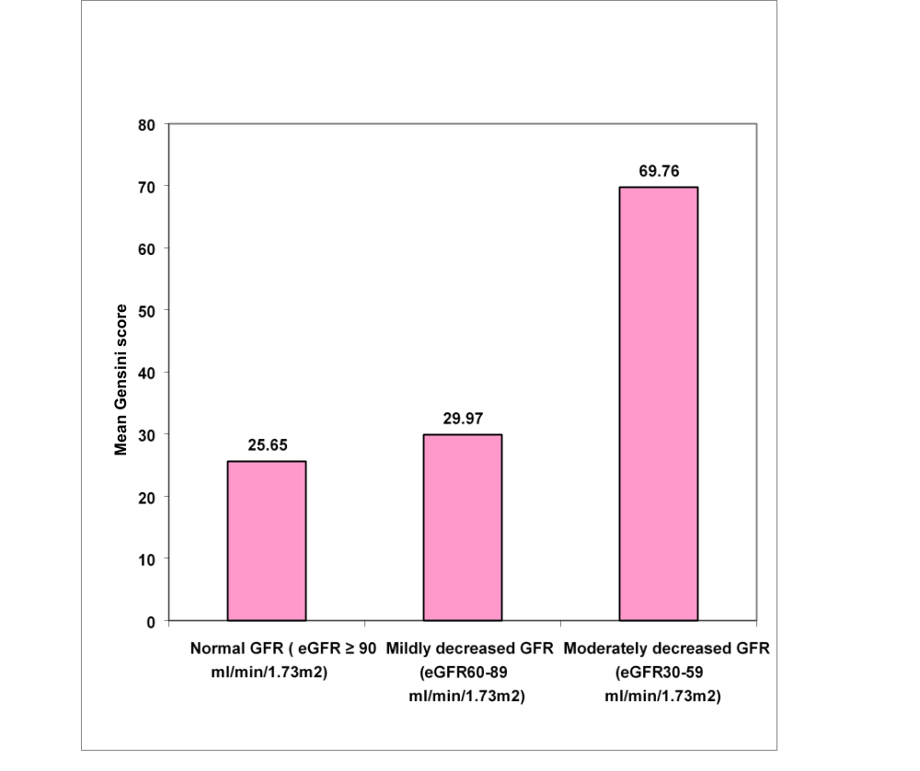
Figure 13: Mean Gensini score in the different study groups

The graph demonstrates that the mean Gensini score are 26.6 severity increases significantly with decreasing renal function. p value reached from students ‘t’ test and ANOVA test.5 in group-II (eGFR≥ 90 ml/ min/ 1.73m²), 29.97 in mildly decreased GFR subgroup and 69.76 in moderately decreased
GFR subgroup respectively. The CAD

6. DISCUSSION
This observational analytical study was conducted in National Institute of Cardiovascular Diseases (NICVD), Dhaka, from June 2015 to June 2017. The main objective of the study was to find out the association of impaired renal function with coronary artery disease severity in ACS patients. A total of 497 patients with ACS who underwent coronary angiography were included in the study based on predefined enrollment criteria. According to eGFR they were divided into two group: group-Ι with impaired renal function (eGFR<90ml/min/1.73m²) and group-ΙΙ with normal renal function (eGFR ≥90 ml/min/1.73m²). Patients of group-Ι were subdivided into mildly decreased GFR (eGFR 60- 89 ml/min/1.73m²) and moderately decreased GFR (eGFR 30 -59 ml/mim/1.73m²) group.
The mean age of the studied patients was 52.6±7.7years ranging from 38 to70 years. The mean age of group Ι patients was 55.6±7.5 years and that of group ΙΙ was 49.4±6.6 years. The mean age group Ι patients was significantly (p=0.001) higher than group ΙΙ. In a similar study conducted by Cay, Metin and Korkmaz, (2007) mean age was 67.8 ± 9.0 years in impaired renal function group and 52.5 ± 10.3 years in normal renal function group and difference was statistically significant ( p <0.001). It was evident from the study that patients with renal impairment tended to be older than those with normal renal function. Chronic kidney disease (CKD) is a growing public health concern that overwhelmingly affects older adults.
In this study impaired renal function group had 90.9% (50) male and 9.09% (5) female patients. In normal renal function group 90.9% (50) patients were male and 9.09% (5) were female with a male female ratio 10:1. No significant difference (p=1.0) was found between two groups in terms of sex distribution. There was also no significant difference between two groups in terms of drug history, so the study groups were well matched.
Body mass index of patients of group I and group II were 22.7 ±1.2 kg/m² and 24.1±2.1 kg/m² respectively and difference was statistically significant (P <0.05). This was consistent with the findings of Kisoue, et al. (2010), they observed that patients with CKD had lower body mass index levels than those with normal renal function (23.5 ±0.2 kg/m² vs. 24.0±.02 kg/m²). It might indicate malnutrition due to low protein diet, uremic toxicity and inflammation in patients with renal impairment.
The distribution of risk factors for coronary artery disease in the present study revealed that the most common risk factor was hypertension which was present in 45.5 % (25) patients in group I and 25.5% (14) patients in group II and the difference between the two groups was statistically significant (p=0.03). Khot et al.,(2003) in a study titled “prevalence of conventional risk factors in patients with coronary heart disease” showed prevalence of hypertension was 48.4%. 32.7% (18) patients of group Ι and 29.1% (16) patients of group II were smoker and the difference was not significant. In a related study Josen et al. (2012) found 28.6% smoker in IHD patients with normal renal function. Dyslipidaemia was found 34.5% (19) and 16.4 % (9) patients in group I and group II respectively and the difference between the two groups was statistically significant (P=0.03). In a related study Longenecker, et al., (2002) found hypertriglyceridemia was prevalent in 36% of impaired renal function patients, similar to our findings. Among other risk factors diabetic patients were excluded; positive family history of premature CAD were 10.9% and 7.3 % patients in group I and in group II respectively and the difference was not statistically significant (p>0.05) between the study groups. Andresdottir, et al., (2002) showed approximately 15% of all myocardial infarctions can be attributed to familial factors; consistent with our study.
Mean hemoglobin level was lower in group-I (12±0.6 gm/dl in group Ι and 12±0.5 gm/dl in group ΙΙ) but the difference of mean was not statistically significant (P >0.05). Hossain (2010) found mean Hb 11.6 gm/dl in 80 CKD patients who underwent coronary angiography. Anaemia is common in CKD patients, it usually correlates with the severity of renal failure and contributes to many of the non-specific symptoms of CKD. Several mecahanism are implicated including relative deficiency of erythropoietin-alpha, diminished erythropoiesis due to toxic effects of uremia on marrow precursor cells, reduced red cell survival, increased blood loss due to capillary fragility & poor platelet function and reduced dietary intake, absorption and utilization of iron ( Goodard, Turner and Stewart, 2010).
The mean random blood sugar was 5.9±0.4 mmol/l in group Ι and 5.9±0.4 mmol/l in group ΙΙ and the difference was statistically non significant (P> 0.05) in this study. It indicates that patients of two study groups were well matched in terms of blood sugar level. In a similar study Josen et al.,(2012) found RBS 5.91 mmol/l and 5.88 mmol/l in decreased GFR group and normal GFR group respectively.

Hypertriglyceridemia is most commonly observed in patients with renal impairment. Other lipoprotein abnormalities include elevated total serum cholesterol, VLDL, LDL and reduced HDL( Rostand, 2000). In our study mean value of total cholesterol, LDL-C, HDL-C and Triglyceride were 171.1±13.3, 120.6±12.9, 36.2±3.6 and 143.6±18.8 mg/dl respectively in group Ι and 169.1±10.5, 114.4±15.2, 39.0 ±2.6 and 133.7±13.9 mg/dl respectively in group ΙΙ. In a similar study conducted by Cay, Metin and Korkmaz, (2007) found total cholesterol, LDL-C, HDL-C and TG 172±25, 104±10, 41±10 and 134±65mg/dl and 164±28, 99±23, 42±10 and 118±50 mg/dl in decreased renal function group and normal renal function group respectively. However different studies carried out abroad demonstrated different patterns. This may be due to ethnic, cultural and dietary habit differences among the study populations.
There was no statistically significant difference in mean total cholesterol, LDL-C, HDL-C between two groups (P>0.05) but significant difference was observed in case of triglyceride (P=0.005). Though dyslipidaemia was found statistically significant in risk factor analysis, here lipoproteins level was well controlled which might be due to lipid lowering therapy with statins.
In our study we found the mean value of S. Creatinine was 1.34±0.3 mg/dl in group Ι and 0.8±0.1 mg/dl in group ΙΙ and the difference was statistically significant (P<0.05). In a similar study Kiyosue, et al. (2010) showed mean value of S. Creatinine 1.14±0.03 in CKD patients and 0.82±0.01 in normal GFR group. In a similar study conducted by Cay, Metin, and Korkmaz, (2007) mean value of S Creatinine was 1.47 ± 0.91 in decreased renal function group and 0.87 ± 0.17 in patients with normal renal function. In comparison with our study, similar value in normal renal function group but higher value of mean S Creatinine was observed in decreased GFR group which might be explained as they included patients with end-stage renal disease but we didn’t.
In group-I the mean eGFR was 60.70 ±12.6 ml/min/1.73m² and in group-II it was 100.40±8.4 ml/min/1.73m² and this difference was statistically significant. In a similar study conducted by Cay, Metin, and Korkmaz, (2007) mean eGFR was 55 ± 17 ml/min/1.73m² in impaired renal function group and 108 ± 24 ml/min/1.73m² in normal renal function group.Mean left ventricular ejection fraction (EF%) was 49.6 ± 7.3% in Group I and 53.3 ±8.5% in Group II. The difference of mean between the two groups was statistically significant (p=0.02). In a study Na et al., (2009) found mean left ventricular ejection fraction (EF%) 58.0±10.5% in decreased GFR group and 59.6±9.6% in normal GFR group.
According to vessel score, the mean eGFR of subjects with insignificant coronary artery disease was 100.1±14.5 ml/min/1.73m² and that of single, double and triple vessel disease were 81±21.3, 77.6± 22.3 and 71.2±24.7 ml/min/1.73m² respectively. So the mean eGFR was decreased with the increase in number of vessel involved and this association was statistically significant (p=0.005).
According to Gensini score CAD was mild in 9.1% (5) patients in group Ι and 23.6% (13) patients in group ΙΙ and mild CAD was significantly low in group Ι (p=0.04). Moderate CAD was found in 60% (33) patients in group Ι and 69.1% (38) patients in group ΙΙ with insignificant difference (p=0.31). Severe CAD was found in 30.9% (17) patients in group Ι and 7.3% (4) patients in group ΙΙ and was significantly higher in group Ι (p=0.001). So coronary artery disease severity was increased with decrease in renal function.
Mean Gensini score was 42.3±24.9 and 25.65±17.9 in group-I and group-II respectively and the difference of mean Gensini score was statistically significant (p=0.001). In a related study by Cay, Metin, and Korkmaz, (2007) found mean Gensini score was 35±33 in decreased renal function group and 13±16 in normal kidney function group and the difference was statistically significant (p=<0.001). So our findings are consistent with existing studies.
In our study correlation co-efficient between estimated glomerular filtration rate and vessel score was r=-0.30 (p=0.004) and correlation co-efficient between estimated glomerular filtration rate and Gensini score was r =-0.65 (p=0.001). In a similar study conducted by Cay, Metin and Korkmaz, (2007) the significant relationship between estimated GFR and Gensini score was reported (r=0.326, p=0.002). We found a moderate negative correlation between eGFR and coronary artery disease severity in terms of Gensini score. With the decrease of GFR and so renal function, vessel score and Gensini score increased, indicating more severe coronary artery disease. In simple linear regression analysis, regression co-efficient between eGFR & Gensini score was b=-0.65 and between eGFR & vessel score was -0.30 and both was statistically significant (P<0.05).
In this study univariate logistic regression analysis of variables likely to cause severe CAD revealed that age >45 years (P=0.03), hypertension (P=0.007), dyslipidaemia (P=0.004), serum creatinine (P=0.002) and eGFR (p=0.003) were independent predictor of severe coronary artery disease with odds ratio (OR) being 1.88, 3.93, 5.01, 5.54 and 5.70 respectively. However, smoking (p=0.38), BMI (P=0.08) and positive family history of premature CAD (p=0.44) were not independent predictor of severe CAD. In multivariate logistic regression analysis, after adjustment of factors, Hypertension, dyslipidemia, Serum creatinine and eGFR were found the independent predictors of severe CAD with ORs being 3.71, 4.95, 5.36 and 5.73 respectively.
In this study, group Ι patients (eGFR <90 ml/min/1.73m², n=55) were divided into two groups as mildly decreased GFR (60-89 ml/min/1.73m²) and moderately decreased GFR (30-59 ml/min/1.73m²) groups according to CKD disease classification to see whether severity of coronary artery disease increased with advanced renal impairment. We found that the mean Gensini score was 29.97 in mildly decreased GFR group and 69.76 in moderately decreased GFR group and the difference of mean was statistically significant (p<0.001).

7. SUMMARY
This observational analytical study was conducted in National Institute of Cardiovascular Diseases (NICVD), Dhaka, from June 2015 to June 2017. The main objective of the study was to find out the association of impaired renal function with coronary artery disease severity in chronic stable angina patients. A total of 110 patients with chronic stable angina who got admitted for CAG were included in the study based on predefined enrollment criteria.
All patients were evaluated by history, clinical examination, biochemical analysis, echocardio graphy. Renal function was assessed by estimated GFR which was calculated by Cockroft- Gault formula. They were divided into group Ι (with eGFR <90 ml/min/1.73m²) and group ΙΙ (eGFR ≥ 90 ml/min/1.73 m²) on the basis of estimated GFR. Group ΙΙ was further divided into mildly decreased GFR (eGFR60-89 ml/min/1.73m²) and moderately reduced GFR (eGFR 30-59 ml/mim/1.73m²) group according to NKF guideline.
Coronary angiogram (CAG) was performed during index hospital admission after proper preparation. Femoral artery cannulation was used for arterial access site and Judkins system was applied for cannulation of the left and right coronary arteries. All angiograms were evaluated by two experienced cardiologists. The severity of the CAD was assessed by angiographic Vessel score and Gensini score. According to Gensini score coronary artery disease was mild (1-10), moderate (10-50) and severe (> 50).
Mean age of the study patients was 55.6±7.5 years in decreased GFR group and 49.4±6.6 years in normal GFR group. Male female ratio was 10:1.Studied patients of two groups were well matched in terms of demographic variables like gender distribution, drugs used, biochemical analysis except serum creatinine & TG which were significantly high in impaired renal function group. Among the conventional risk factors of CAD, diabetic patients were excluded from study; smoking & family history of CAD were found non-significant but hypertension & dyslipidaemia were significantly high in impaired renal function group. In group-I the mean eGFR was 60.70 ±12.6 ml/min/1.73m² and in group-II it was 100.40±8.4 ml/min/1.73m² and this difference was statistically significant.

Mean Gensini score was 42.30±24.9 in impaired renal function group and 25.65±17.9 in normal renal function group and the difference was statistically significant. We found significant weak association between eGFR and vessel score (r=-0.30, p=0.004) and a moderate negative correlation between eGFR and Gensini score (r =-0.65, P=0.001). With the decrease of GFR and so renal function, vessel score and Gensini score increases demonstrating more severe coronary artery disease.
Univariate logistic regression analysis of variables of interest revealed that age (P=0.03), hypertension (P=0.007), dyslipidaemia (P=0.004), serum creatinine (P=0.002) and eGFR (p=0.003) were independent predictor of severe coronary artery disease with odds ratio (OR) being 1.88, 3.93, 5.01, 5.54 and 5.70 respectively. In multivariate logistic regression analysis, after adjustment of factors eGFR remain independent predictors of severe CAD (P=0.004, OR -5.73).In subgroup study, mean Gensini score was 29.97±15.5 in mildly decreased GFR group and was 69.76±19.6 in moderately decreased GFR group and the difference was statistically significant. So from this study, it is evident that renal impairment is directly associated with coronary artery disease severity.

8. CONCLUSION
From this study it may be concluded that impaired renal function assessed by estimated GFR is associated with angiographic severe coronary artery disease in ACS patients and this association is independent of conventional cardiovascular risk factors.

9. STUDY LIMITATIONS

Although the result of this study supports the hypothesis, there are some facts to be considered which might affect the results.
1. Though adequate number of study population was included in our study, we believe that it is still limited in number to generalize the results and it was conducted in a single centre.
2. Sampling method was not random rather purposive, so there is risk of selection bias.
3. To assess renal function we have used eGFR, calculated from single measurement of serum creatinine instead of direct measurement which may give some weakness to our data. However, eGFR is widely accepted and an available marker in clinical practice and has a very important role in large epidemiologic studies whenever GFR measurement is not feasible for practical and cost-containing reasons.

10. RECOMMENDATIONS

In patients with chronic stable angina, renal function should be assessed by eGFR which can be calculated easily with reasonable accuracy and precision from serum creatinine.
The eGFR may be an important predictor of severe coronary artery disease which requires invasive evaluation and aggressive management as cardiovascular disease is the main cause of morbidity and mortality in chronic kidney disease patients.
In future multicentre, population based prospective study needed to assess the causal association between renal impairment and severity of coronary artery disease in patients with chronic stable angina.

11. BIBLIOGRAPHY WHO report 2017,JASN 2004.ELSEVIER.Abrams, J. and Thadani, U., 2005. Therapy of stable angina pectoris: The uncomplicated patient. Circulation, 112, pp. 255-259.
American College of Cardiology Foundation, 2012. ACCF/AHA/ACP/AATS/PCNA/SCAI/STS Guideline for the Diagnosis and Management of Patients with Stable Ischemic Heart Disease. journal of the American College of Cardiology, 60, pp. 44-164.
American Diabetic association, 2013. Standards of Medical Care in Diabetes 2013. Diabetes care, 36, pp.11-66.
American Heart Association, 2013, Heart disease and stroke statistics 2013 Update: A Report From the American Heart association. Circulation, 127, pp.6-245.
Andresdottir,M.B., Sigurdsson,G., Sigvaldason,H. and Gudnason,V., 2002. Fifteen percent of myocardial infarctions and coronary revascularizations explained by family history unrelated to conventional risk factors. European Heart Journal, 23, pp.1655–1663.
Akanda,M.A.K.,Choudhury,K.N.,Ali,M.Z.,Kabir,M.K.,Begum,L.N.,and Sayami,L.A.,2013.
Serum Creatinine and Blood Urea Nitrogen levels in patients with Coronary Artery Disease. Cardiovascular Journal, 5, pp.141-145.
Baigent, C., Burbury, K. and Wheeler, D., 2000. Premature cardiovascular disease in chronic renal failure. The Lancet, 356, pp. 147-152.
Baim, D.S., 2006. Cardiac Catheterization History and Current Practice Standards. In: D.S. Baim,, ed. 2006. Grossman’s cardiac catheterization, angiography, and intervention. Philadelphia: Lippincott Williams and Wilkins. ch.1.
Bario,R.C.,Agustin,J.A.,Manzano,M.C.,Juan,C.,García-Rubira,J.C.,Fernández-Ortiz,A., Vilacosta,I. and Macaya,C.,2007, In-Hospital Prognostic Value of Glomerular Filtration Rate in Patients With Acute Coronary Syndrome and a Normal Creatinine Level. Revista Espanola Cardiologia, 60, pp.714-719.
Bech, G.J., Bruyne, B.D., Pijls,N.H.J., Muinck,E.D., Jan C.A. Hoorntje,J.C.A., Escaned,J., Stella,P.R., Boersma,E., Bartunek,J Jacques J. Koolen,J.J., and Wijns,W., 2001l. Fractional Flow Reserve to Determine the Appropriateness of Angioplasty in Moderate Coronary Stenosis: A Randomized Trial. Circulation, 103, pp.2928-2934.
Bhatt, D.L., 2008. Anti-inflammatory agents and antioxidants as a possible ‘third great wave’ in cardiovascular secondary prevention. American Journal of Cardiology, 101, pp. 4–13.
Bloomfield, P., Bradbury,A., Grubb, N.R. and Newby, 2006. Cardiovascular disease. In: N.A. Boon, N.,R.Colledge, and B.,R.Walker, eds. 2006. Davidson’s Principles & Practice of Medicine. Edinburg: Elsevier. Ch. 18.
Boersma,E., Mircado,N., Polderman, D., Gardien,M., Vos, J.and Simons,ML., 2003. Acute myocardial infarction. The Lancet, 361(9374), pp.847-858.

Botev,R., Mallie,J.P., Wetzels,J.F.M., Couchoud,C. and Schu,O.,2011. The Clinician and Estimation of Glomerular Filtration Rate by Creatinine-based Formulas: Current Limitations and Quo Vadis. Clinical Journal of American Society of Nephrology, 6, pp.937–950.
Bitar, S and Kern, M.J., 2003. Angiographic Data, In: M.J. Kern ,ed. 2003. The Cardiac Catheterization Handbook. New Delhi: Elsevier, ch.7.

Brunner, M.P., 2013. Stress Echocardiography. In: B.F. Griffin, ed. 2013. Manual of Cardiovascular Medicine. Philadelphia: Lippincott Williams & Wilkins.Ch.49.
Budoff,M.J.,Rader,D.J., Reilly,M.P., Mohler,E.R.,Lash,J.,Yang,W.,Rosen,L., Glenn,M., Teal,V. and Feldman,H.I., 2011. Relationship of Estimated GFR and Coronary Artery Calciﬁcation in the CRIC (Chronic Renal Insufﬁciency Cohort) Study. American Journal of Kidney Disease, pp.1-8.
Cannon,C.P.,Battler,A.,Brindis,R.G.Cox,J.L.,Ellis,S.G.,Every,N.R.,Flaherty,J.T.,Harrington,R.A.,Krumholz,H.M.,,Werf,V.D.,Weintraub,W.S.,Mitchell,K.R.,Morrisson;S.L.,Brindis,R.G.,Anderson,H.V.,Cannom,D.S., Cigarroa,J.E., Collins-Nakai,R.L., Ellis,S.G.,Gibbons,R.J., Grover, F.L. and Heidenreich,P.A., 2001. American College of Cardiology Key Data Elements and Definitions for Measuring the Clinical Management and Outcomes of Patients With Acute Coronary Syndromes. Journal of American Colledge of Cardiology, 38(7), pp. 2114-2130.
Cannon, C.P. and Braunwald, E., 2011. Unstable angina and non-ST Elevation Myocardial Infarction. In : R.O.Bonow, D.L. Mann, D.P. Zipes and P. Libby, eds. 2011. Braunwald’s Heart Disease: A Text Book of Cardiovascular Medicine. Philadelphia: Elsevier Saunders. Ch. 56.
Cay, S., Metin, F. and Korkmaz,S., 2007, Association of renal functional impairment and the severity of coronary artery disease. Anadolu Kardiyol Derg, 7(1), pp. 44-48.
Chang, J.H., Sung,J.Y., Jung, J.Y., Lee,H.L., Chung,W., Sung.Y.M. and Kim,S., 2012.The Relationship between Coronary Artery Calcifcation and Renal Function in Non dialyzed Patients. Yonsei Medical Journal, 53(4), pp.685-690.
Chaitman, B.R.,Bourassa,M.G. and Davis,K.,1981.Angiographic prevalence of high risk coronary artery disease in patients subsets. Circulation, 64(2), pp.360-367.
Cheung, A.K., Sarnak M.J., Yan G., Dwyer, J.T., Heyka, R.J., Rocco, M.V., Teehan, B.P. and Levey, A.S., 2000. Atherosclerotic cardiovascular disease risks in chronic hemodialysis patients. Kidney International, 58(1), pp. 353–362.
Chonchol, M., Whittle, J., Desbien, A., Orner, M.B., Petersen, L.A. and Kressin, N.R, 2008. Chronic kidney disease is associated with angiographic coronary artery disease. American Journal of Nephrology, 28(2), pp. 354–60.
Cockcroft, D.W. and Gault, M.H.,1976. Prediction of creatinine clearance from serum creatinine. Nephron, 16(1), pp.31-41.
Connolly, H. M. and Oh, J.K., 2011. Echocardiography. In : R.O.Bonow, D.L. Mann, D.P. Zipes and P. Libby, eds. 2011. Braunwald’s Heart Disease: A Text Book of Cardiovascular Medicine. Philadelphia: Elsevier Saunders. Ch.15.
Constellanos, A., Interian, A. and Myerburg, R.J., 2008. The Resting Electrocardiogram. In: V. Fuster, R.A. O’Rourke, R. A. Walsh, and P. Poole-Wilson, eds. 2008. Hurst’s The Heart, New York: McGraw Hill, ch.13.
Costa, M.A., Garcia-Garcia, H.M., and Serruys, P.W., 2011. Coronary Intravascular Imaging. In: V. Fuster, R.A. Walsh and R.A. Harrington, eds. 2011. Hurst’s The Heart. Newyork: Mc Graw Hill. Ch. 20.
Davidson, C.J. and Bonow, R. O., 2011. Cardiac Catheterization. In : R.O.Bonow, D.L. Mann, D.P. Zipes and P. Libby, eds. 2011. Braunwald’s Heart Disease: A Text Book of Cardiovascular Medicine. Philadelphia: Elsevier Saunders. Ch. 20.
Davies, W. S., 2001. Clinical presentation and diagnosis of coronary artery disease: stable angina. British Medical Bulletin, 59. pp.17-27.

Davoodi, G., Mehrabi, S, Rezvanfard, M., Sheikh, F., Amini, M, Hakki, E., Kazemisaeid, A. and Yaminisharif, A.,2012. Glomerular filtration rate is related to severity of obstructive coronary artery disease in patients undergoing coronary angiography. International journal of Urology and Nephrology, 44(4), pp.1161-1168.
Demer,L.L., 2002. Vascular calcification and osteoporosis: inflammatory responses to oxidized lipids. International Journal of Epidemiology, 31(4), pp.737–741.
Depre, C., Vanter, S. F., and Grross, G. J., 2011. Coronary blood flow and myocardial ischemia. In: V. Fuster, R.A. Walsh and R.A. Harrington, eds. 2011. Hurst’s The Heart. Newyork : Mc Graw Hill. Ch.54.
Dewey,M., 2011. Coronary CT versus MR Angiography: Pro CT—The Role of CT Angiography. Radiology, 258(2), pp.329–339.
Dhawan, S., Dharmasha, K. C. and Tak, T., Role of Magnetic Resonance Imaging in Visualizing Coronary Arteries. Clinical Medicine & Research, 2(3), pp.173-179.
Dickstein ,K.,Cohen-Solal ,A.,Filippatos,G., McMurray.J.J., Ponikowski,P., Poole-Wilson,P.A., Stro¨mberg,A. Veldhuisen,D.J., Atar,D., Hoes,A.W., Keren,A., Mebazaa,A., Nieminen,M.,Priori S.G. and Swedberg,K., 2008. ESC Guidelines for the diagnosis and treatment of acute and chronic heart failure. European Heart Journal, 29, pp.2388–2442.
Director General of Health Services, Bangladesh, 2012. Health Bulletin, 2011.Dhaka: MIS, DGHS, pp.90-98.
Ernesto L. Schiffrin, Mark, L., Lipman and Johannes F.E. Mann, 2005.Chronic Kidney Disease: Effects on the Cardiovascular System. Circulation, 116, pp. 85-97.
European Society of Cardiology, 2012. European Cardiovascular Disease Statistics.(pdf) Available at (www.escardio.org/about/what/advocacy/EuroHeart/Pages/2012-CVD-statistics. aspx) [Accessed 26 October 2013].
European Society of Cardiology, 2013. 2013 ESC guidelines on the management of stable coronary artery disease. European Heart Journal, 34, pp. 2949–3003.
Friedrich ,G.J., Moes, N.Y., Muhlberger, V.A., Gabl, C., Mikuz, G., Hausmann, D., Fitzgerald, P.J.and, Yock, P.G.,1994. Detection of intralesional calcium by intracoronary ultrasound depends on the histologic pattern. American Heart Journal, 128(3), pp. 435-441.

Ganesh,S.K., Stack, A.G., Levin,N., Hulbert-Shearon, T. and Port,F.K., 2001. Association of elevated serum PO4, Ca-PO4 product and parathyroid hormone with cardiac mortality risk in chronic haemodialysis patients. Journal of American Society of Nephrology, 12, pp. 2131–2138.
Gensini, G.G., 1983. A more meaningful scoring system for determining the severity of coronary heart disease. American Journal of Cardiology, 51(3), p.606.

Go, S.A., Chertow, G.M., Fan, D. and Hsu,C.Y., 2004. Chronic kidney disease and the risks of death, cardiovascular events and hospitalization. New England Journal of Medicine, 351, pp.1296–370.
Goodard, J., Turner, A.N., Stewart, L.H., 2010. Kidney and Urinary Tract Disease. In: N.R. Colledge, B.R. Walker, S.H. Ralston, eds. 2010. Davidson’s principles & practice of Medicine. Edinburgh : Elsevier.Ch.17.
Grube,E., Gerckens,U., Buellesfeld, L. and Fitzgerald, P.J., 2002. Intracoronary Imaging With Optical Coherence Tomography: A New High-Resolution Technology Providing Striking Visualization in the Coronary Artery. Circulation, 106, pp. 2409-2410.
Gupta,R, Birnbaum,Y.,and. Uretsky,B. F., 2004. The Renal Patient With Coronary Artery Disease: Current Concepts and Dilemmas. Journal of the American College of Cardiology, 44(7), pp. 1343-1353.

Hoffmann,U., Ferencik,M., Cury,R.C., and Pena, A.J., 2006. Coronary CT Angiography. Journal of Nuclear Medicine, 47, pp.797-806.

Hossain, M.S., 2010. Comparison of nephrotoxic effect of iso-osmolar and low-osmolar non-ionic contrast media in patient with chronic kidney disease undergoing coronary angiography. MD, Dhaka University.

Huang, G., Zhao, J.-L., Du, H., Lan, X.-B. & Yin, Y.-H. 2010. Coronary Score Adds Prognostic Information for Patients With Acute Coronary Syndrome. Circulation Journal, 74(3), pp.490 – 495.
Islam,N., AAS Majumder,A.A.S., Khalequzzaman,M.,Akhtaruzzaman,M., Choudhury,A.K.,
Ali,M.S., Shikder,M.R., Hasem,S., Nobi,A.B.M.N.and Kabir,M.S., Impact of Blood Glucose Levels on Contrast Induced Nephropathy after Percutaneous Coronary Intervention in Patients not known to be Diabetic with Acute Coronary Syndrome. Cardiovascular Journal, 6(1), pp.23-30.
Islam, M.N., Ali, M.A. and Ali, M., 2004. Spectrum of Cardiovascular Disease: The current scenario in Bangladesh. Bangladesh Heart Journal, 19, pp. 1-7.
Joachim, H. Ix., Ronit, K., Bry, K., Fried,F.L., Kramer,H., Catherine S.B., and Shlipak,M.G., 2008. Association of Mild to Moderate Kidney Dysfunction and Coronary Calcification. Journal of American Society of Nephrology, 19(3), pp.579–585.
Jones, G and Lim, E., 2003, The National Kidney Foundation Guideline on Estimation of the Glomerular Filtration Rate. Clinical Biochemist Reviews, 24(3), Pp. 95-98.
Joosen, I.A., Schiphof, F., Versteylen, M.O., Laufer, E.M., Winkens, M.H.,Nelemans,P.J., Kooman,J.P.. Hofstra,L.,Wildberger,J.E.,Leiner,T., 2012. Relation between Mild to Moderate Chronic Kidney Disease and Coronary Artery Disease Determined with Coronary CT Angiography. PLoS ONE, 7(10),pp.1-7.
Kabir, C.M.S., Ahmed, N. and Malik, A.,2011. In-Hospital outcome and coronary angiographic profile of patiernts with non ST-segment elevation myocardial infarction with chronic kidney disease. MD. Dhaka university.
Kern, M.J., 2003.The Interventional Cardiac Catheterization Handbook. Second edition. Philadelphia, Mosby Elsevier.
Kern, M.J.and King,S.B.,2008. Cardiac Catheterization, Cardiac Angioplasty, and Coronary Blood Flow and Pressure Measurement.In: V.Fauster, R.A.O’Rourke, R.A. Walsh and P. Poole-Wilson. 2008. Hurst’s The Heart. New York: Mc Graw Hill.
Khandaker, R.K., Hossain, D., Hossain M., 1987. Retrospective analysis of acute myocardial infarction: A 4 years study of 2690 patients. Bangladesh Heart Journal, 1, pp.14-17.
Khot,U,N., Khot, M.B.,Bajzer,C.T., Sapp, S.K.,Ohman, E. M.,Brener, S.J., Ellis, S.G.,Lincoff, A.M. and Toplo, J.E., 2003. Prevalence of Conventional Risk Factors in Patients With Coronary Heart Disease. Journal of American Medical Association, 290(7), pp. 898-904.
Kim, M.C., Kini, A.S. and Fuster, V., 2011. Definitions of acute coronary syndromes. In: V. Fuster, R.A. Walsh and R.A. Harrington, eds. 2011. Hurst’s The Heart. Newyork : Mc Graw Hill ch.56.
Kim, W. Y., Danish, P.G., Stuber, M., Flamm, S.D.,Plein, S.,Nagel, E.,Langerak, S. E., Weber, O. M.,Pedersen, E. M., Schimidt, M., Botnar, R. M. and Manning, W. J.,2001. Coronary magnetic resonance angiography for the detection of coronary stenosis. New England Journal of Medicine, 345(26), pp.1863-1869.
Kiyosue, A., Hirata, Y., Ando, J., Fujita,H., Morita,T.,Takahashi,M., Nagata,D., Kohro,T., Imai,Y. and Nagai,R., 2010. Relationship Between Renal Dysfunction and Severity of Coronary Artery Disease in Japanese Patients. Circulation Journal, 74, pp. 478-486.
Krishnaswamy, A and Kapadia, S.R., 2013. Stable Angina. In: B.P. Griffin, ed. 2013. Manual of Cardiovascular Medicine. Philadelphia : Lippincott Williams & Wilkins.Ch.6.
Kundal, K and Lok. C. E., 2005. Clinical Epidemiology of Cardiovascular Disease in Chronic Kidney Disease. Nephron Clinical Practice, 101, pp. 47–52.
Lange, R.M., Bierig, M., Richard, B., Devereux,F.A., Elyse Foster, E.,Patricia, A.,Picard, M.H., Roman,M.J., Seward,J.,Shanewise,J., Solomon, S., Spencer,K.,T.,and William Stewart,w., 2006. Recommendations for chamber quantification, European Journal of Echocardiography,7, pp. 79-108.
Leaman,D.M., Brower,R.W. and Meester,G.T.,1981. Coronary artery atherosclerosis: severity of the disease, severity of angina pectoris and compromised left ventricular function. Circulation, 63(2), pp. 285-299.
London, G. M., 2003. Cardiovascular disease in chronic renal failure: patho-physiologic aspects. Seminars in Dialysis, 16(2), pp.85-94.
Longenecker J.C., Coresh J., Powe, N.R., Levey, A.S., Fink, N.E., Martin. A. and Klag, M.J., 2002. Traditional cardiovascular disease risk factors in dialysis patients compared with the general population: the CHOICE Study. Journal of American Society of Nephrology, 13(7), pp.1918-1927.
Machin, D., Campbell, M.j., Tan,S.B. and Tan, S.H.,eds. 2009. Sample Size Tables for clinical studies. Third edition. Singapore: Wiley-Blackwell.
Malik, A., 1984. Problems of cardiovascular disease in Bangladesh and other developing countries, In: Proceeding of the Bangladesh-Japan conference on Cardiovascular disease. JICA,7, pp. 27-33.
Mamun,M.S., Majumder,A.A.S., M Ullah,M. and Alam,S, 2013. Angiographic Comparison of Coronary Artery Disease between Diabetic Men and Women. Cardiovascular Journal, 6(1), pp. 3-9.
Manjunath, H., Tighiouart, H., Ibrahim, Macleod, B., Salem, D.N., Grifith, J.L.,Coresh, J.Levey, A.S and.Sarnak, M.J., 2003. Level of kidney function as a risk factor for atherosclerotic cardiovascular outcomes in the community. Journal of the American College of Cardiology, 41(1), pp. 47–55.
Ministry of Health & Family Welfare, 2011. Health Bulletin,(pdf). available at: www.dghs.gov.bd [Accessed 17 October 2013].
Montorsi, P., Ravagnani, P. M., Galli, S., Rotatori, F., Veglia, F., Briganti, A., Salonia, A., Dehò, F., Rigatti, P., Montorsi, F. & Fiorentini, C., 2006. Association between erectile dysfunction and coronary artery disease. Role of coronary clinical presentation and extent of coronary vessels involvement: the COBRA trial. European Heart Journal, 27, pp.2632-2639.
Murray, C.J. and Lopez, A.D., 1996. Global health statistics: Global burden of disease and injury series. Volumes I and II. Boston: Harvard school of public health. Nature Medicine, 4, pp.1241-1243.
Na,K.Y., Kim,C.W., Song,Y.R.,Chin,J.H.Wan and Chae,D.W.,2009. The Association between Kidney Function, Coronary Artery Disease and Clinical Outcome in Patients Undergoing Coronary Angiography. Journal of Korean Medical Science, 24, pp.87-94.
Nakano, T., Ninomiya, T., Sumiyoshi, S., Fujii, H., Doi, Y., Hirakata, H., Tsuruya, K., Iida, M., Kiyohara, Y. And Sueishi, K., 2010. Association of kidney function with coronary atherosclerosis and calcification in autopsy samples from Japanese elders: the Hisayama study. American Journal of Kidney Disease, 55(1), pp.21–30.
Nankivell, B.j., 2001. Abnormal laboratory results: Creatinine clearance and the assessment of renal function. Australian Prescriber, 24(1), pp.15-17.
National Kidney Foundation. Kidney Disease Outcome Quality Initiative (K/DOQI), 2002. Clinical practice guidelines for chronic kidney disease: evaluation, classification and stratification. American Journal of Kidney Disease, 39, p.266.
National Kidney Foundation, 2005. Frequently asked question about GFR estimates.(pdf) Available at : ( www.kidney.org) [Accessed 20 October 2013].
Neeland, I.J., Patel,R.S., Eshtehardi, P., Dhawan,S., McDaniel,M.C.,Tanveer Rab,S.T., Vaccarino,V., Zafari,A.M., Samady, H., Quyyumi,A.A.,2012, Coronary Angiographic Scoring Systems: An Evaluation of Their Equivalence and Validity. American Heart Journal,164(4), pp.547-559.
Newby, D.E., Grubb, N.R. and Bradburry, A., 2010. Cardiovascular disease. In: N.R. Colledge, B.R. Walker and S.H. Ralston, eds. 2010. Davidsons Principles & Practice of Medicine. Edinburgh: Elsevier. Ch.18.

Ozgirgin,S., Ozmen,D., Mutaf,I., Turgan,N., Kültürsay,H., Bayindir,O. and Nişli, N.,2000. Serum Carnitine Levels in Patients with Coronary Artery Disease. Turkish Journal of Medical Sciences, 30(2000), pp.147-150.

Park, j., 2012. Cardiovascular Risk in Chronic Kidney Disease: Role of the Sympathetic Nervous System. Cardiology Research and Practice, 212(319432), pp.1-8.
Pijls, N.H.J., Gelder, V.N., Voort, P.V.,Peels, K.,Bracke, F.A., Bonnier, H.J. Gamal, M.I.,1995. Fractional Flow Reserve: A Useful Index to Evaluate the Influence of an Epicardial Coronary Stenosis on Myocardial Blood Flow. Circulation, 92, pp.3183-3193.
Popma, J. J., 2011. Coronary Arteriography. In : R.O.Bonow, D.L. Mann, D.P. Zipes and P. Libby, eds. 2011. Braunwald’s Heart Disease: A Text Book of Cardiovascular Medicine. Philadelphia: Elsevier Saunders. Ch. 21.
Rahman,M.A., AAS Majumder,A.A.S., Chowdhury,N.A. Rahman,M.Z., Islam, A.K.M.M., Ullah,M., MA Razzaque,M.A. and SMA Romel, S.M.A.2013. Mitral Annular Calcification is Associated with Severe Coronary Artery Disease in Patients Under 65 Years Old. Cardiovascular Journal, 6(1), pp.10-16.
Reddy, S. and Yusuf, Y., 1998. Emerging Epidemic of Cardiovascular Disease in Developing Countries. Circulation, 97, pp.596-601.
Reis, S.E., Olson, M.B., Fried, L. Reeser,V., Mankad,S., Pepine,C.J., Kerensky,R., Merz, R.C., Sharaf,B.L.,Sopko,G., Rogers,G.W. and Holubkov. R.,2002. Mild Renal Insufficiency Is Associated With Angiographic Coronary Artery Disease in Women. Circulation, 105, pp.2826-2829.
Ringqvist, I., Fisher, L.D., Mock,M. and Devis, K.B., 1983. Prognostic value of Angiographic Indices of coronary artery disease from the Coronary Artery Surgery Study (CASS). The Journal of Clinical Investigation,71(6), pp.1854-1866.
Rostand, S. G., 2000. Coronary Heart Disease in Chronic Renal Insufficiency: Some Management Considerations. Journal of the American Society of Nephrology,11, pp.1948–1956.
Sarnak,M.J., Levey,A.S., Schoolwerth,A.C. Coresh,J., Culleton,B., Hamm,L.L.McCullough, P.A., Kasiske,B.L., Kelepouris,E., Klag,M.J., Parfrey,P., Pfeffer,M., Raij,L., Spinosa,D.J. and Wilson,P.W.,2003. Kidney disease as a risk factor for development of cardiovascular disease: a statement from the American Heart Association Councils on Kidney in Cardiovascular Disease, High Blood Pressure Research, Clinical Cardiology, and Epidemiology and Prevention. Hypertension, 42(5), pp.1050–1065.
Schiffrin, E.L, Lipman, M.L. and Mann,J.F.E., 2007.Chronic Kidney Disease: Effects on the Cardiovascular System. Circulation, 116, pp.85-97.
Schunemann, H.J., Oxman, A.D., Brozek, J., Glasziou, P., Jaeschke, R. And Vist, G.E., 2008. Grading quality of evidence and strength of recommendations for diagnostic tests and strategies. British Medical Journal, 336, pp.1106-10.
Scot, M., 2002. National cholesterol education program expert panel on detection, evaluation and treatment of high blood cholesterol in adults (Adult treatment panel III). Circulation, 106, p. 3143.
Sharma, M.and Ganguly, N.K.,2005.Premature coronary artery disease in Indians and its associated risk factors. Vascular Health and Risk Management, 1(3), pp.217-225.
Shemesh, J., Tenenbaum, A., Fisman, E.Z., Apter, S., Rath,S., Rozenman, J., Itzchak, Y,and Motro, M.1996. Absence of coronary calcification on double-helical CT scans: predictor of angiographically normal coronary arteries in elderly women. Radiology, 199(3), pp.665-668.
Stamatelopoulos, K.S., Lekakis, J.P., Tseke, P., Ikonomidis, I., Kollias, G.E., Alevizaki, M. Kanakakis, I., Voidonikola, P., Zakopoulos, N. and Papamichael, C.M,2009.Differential associations of renal function with coronary and peripheral atherosclerosis. International Journal of Cardiology, 135(2), pp.162-164.
Shulman, N.B., Ford, C.E., Hall, W.D.,Blaufox,M.D.,Simon, D.,Langfor, H.G. and Schneider K.A., 1989. Prognostic value of serum creatinine and effect of treatment of hypertension on renal function:

s from the hypertension detection and follow-up program. The Hypertension Detection and Follow-up Program Cooperative Group. Hypertension, 13(5), pp.I80–193.
Sullivan, D.R., Thomas, H., Marwick,S. and Ben, F.D., 1990. A new method of scoring coronary angiograms to reflect extent of coronary atherosclerosis and improve correlation with major risk factors. American Heart Journal, 119(6), pp.1262-1267.
Taylor, A.J., 2011. Cardiac Computed Tomography. In : R.O.Bonow, D.L. Mann, D.P. Zipes and P. Libby, eds. 2011. Braunwald’s Heart Disease: A Text Book of Cardiovascular Medicine. Philadelphia: Elsevier Saunders. Ch. 19.
Thygesen, K., Alpert, J.S., Jaffe, A.S., Simoons, M.L., Chaitman, B.R., White,H.D.,2012. Third universal definition of myocardial infarction. Circulation, 126, pp.2020–2035.
Tintut,Y., Patel,J.,Territo, M., Saini, T., Parhami, F. and Demer, LL., 2002. Monocyte /macrophage regulation of vascular calcification in vitro. Circulation, 105(5), pp.650–655.
Udelson, J. E., Dilisizian, V. and Bonow, R.O., 2011. Nuclear Cardiology. In : R.O.Bonow, D.L. Mann, D.P. Zipes and P. Libby, eds. 2011. Braunwald’s Heart Disease: A Text Book of Cardiovascular Medicine. Philadelphia: Elsevier Saunders. Ch. 17.
Waller, B.F., Pinkerton, C.A. and Slack J.D., 1992. Intravascular ultrasound: a histological study of vessels during life—the new ‘gold standard’ for vascular imaging. Circulation, 85(6), pp.2305-2310.
Weintraub,W.S., Karlsberg,R.S., Tcheng,J.E., Boris,J.R., Buxton,A.E., Dove,J.T., Fonarow,G.C., Goldberg,L.R., Heidenreich,P., Hendel, R.S., Jacobs,A.S., Lewis,W.,Mirro,M.J., and Shahian, D.M.,2011. ACCF/AHA 2011 Key Data Elements and Definitions of a Base Cardiovascular Vocabulary for Electronic Health Records: A Report of the American College of Cardiology Foundation/American Heart Association Task Force on Clinical Data Standards. Circulation, 124, pp.1-24.
Woodhouse, S., Batten, W., Hendrik, H. and Malek,P.A., 2006. The Glomerular Filtration Rate: An Important Test for Diagnosis, Staging, and Treatment of Chronic Kidney Disease. Labmedicine, 37(4), pp.244-246.
World Health Organization,2002, Noncommunicable diseases in South-East Asia region.(pdf). Available at: (http://www.searo.who.int/entity/noncommunicable_diseases/documents) [ Accessed 27 October 2013].
World Health Organization, 2008.The global burden of disease : 2004 update (pdf). Available at: (http://www.who.int/healthinfo/global_burden_disease/GBD_report_2004update_full.pdf) [Accessed 15 October 2013]
World Health Organization, 2011. Global Atlas on Cardiovascular Diseases Prevention and Control (pdf). Available at: (www.who.int) [Accessed 19 september 2013].
World Health Organization, 2013, Cardiovascular disease.(pdf). Available at : ( www.who.int/mediacentre/factsheets/fs317/en/) [Accessed 26 October 2013].
Yang,E.H., Gersh, B.J.and O’Rourke.R.A., 2008. ST Segment Elevation Myocardial Infarction. In: V. Fuster, R.A., O’Rourke, R.A. Walsh, & P. Poole-Wilson, eds. 2008. Hurst’s The Heart, New York: McGraw-Hill, Ch.60.
Yousuf,S. and Ounpuu,S., 2001.Tackling the growing epidemic of cardiovascular disease in South Asia. Journal of American College of Cardiology,38(3), pp. 688-689.
Zaman, M.M., Ahmed, J., Choudhury, S.R.,Numan, S.M.,Parvin, K. and Islam, M.S., 2007. Prevalence of ischaemic heart disease in a rural population of Bangladesh. Indian Heart Journal, 59(3), pp. 239-241.

Appendix I
STUDY FLOW CHART
Patients admitted in NICVD with NSTEMI
Gr.II- HbA1c level
≥5.7% - 6.4%

Gr.I- HbA1c level <5.7%

(≤ 10 m/sec)
CAG
Assessment of angiographic severity
Data analysis
Observation, result and discussion
Patients undergoing CAG
Inclusion and exclusion criteria

Sample population will be stratified into two categories according to HbA1c level
Summary and conclusion
Appendix II
Consent Form

After being fully informed about the objectives, consequence of the study and my right to withdraw myself from the study at any time for any purpose, what so ever, I am ……………………………………………hereby giving consent to participate in the study conducted by Dr. Md. Mizanur Rahman Majumder, Phd (fellow), National Institute of Cardiovascular Diseases, Dhaka.
I fully recognize that my participation in this study will generate valuable medical information that might be used for the interest of patients in future.
Hospital authority, doctors or any other staff will not be responsible for any adverse consequences during the study.
I shall try my best to comply with the instructions given by the investigator throughout the whole period of study.

Signature………………………..
Date………………………….

(অবহিত সম্মতি পত্র)
(CONSENT FORM)
রোগীর নামঃ
বয়সঃ
ঠিকানাঃ
ভর্তির তারিখঃ
রেজিঃ নম্বরঃ

আমি স্বজ্ঞানে,স্বেচ্ছায় এবং সুস্থ মনে এই গবেষণামূলক কার্যক্রমে স্বেচ্ছায় অংশগ্রহন করতে সম্মত হয়েছি। আমাকে এই বলে আশ্বস্ত করা হয়েছে যে, এই গবেষনা কার্যক্রমে আমার কোন শারীরিক বা মানসিক ক্ষতি হবে না। যদি ক্ষতি সাধিত হয় তাহলে হাসপাতাল কর্তৃপক্ষ আমার চিকিৎসার ব্যায়ভার বহন করবে। আমাকে আরও জানানো হয়েছে যে, এই গবেষণা ফলদায়ক হবে এবং ভবিষ্যতে আমাদের দেশে এই ধরনের রোগিরা যথেষ্ট উপকৃত হবে। আমি এই গবেষণা কার্যক্রম হতে নিজেকে প্রত্যাহার করার অধিকার রাখি। আমি এই গবেষণার জন্য কোন আর্থিক সুবিধা গ্রহন করবো না। আমার ব্যক্তিগত গোপনীয়তা রক্ষা করা হবে। আমি স্বেচ্ছায়,স্বজ্ঞানে ও সানন্দে এই সম্মতি পত্রে স্বাক্ষর করলাম।

রোগীর স্বাক্ষর/টিপ সই  তারিখ :...................... | গবেষক/চিকিৎসক  নাম  তারিখ :  স্বাক্ষর

Appendix III
ABBREVIATIONS

ACS………………… Acute coronary Syndrome.
AMI…………………. Acute myocardial infarction.
CABG………………. Coronary artery bypass graft.
CAD………………… Coronary artery disease.
CAG………………… Coronary angiogram.
CHD………………… Coronary heart disease.
CVD………………… Cardiovascular disease.
COPD………………. Chronic obstructive pulmonary disease.
ECG…………………. Electrocardiogram.
FBS………………….Fasting blood sugar.
HDL………………… High density lipoprotein.
HbA1c………………..Glycated haemoglobin
LDL………………… Low density lipoprotein.
NICVD…………….. National institute of cardiovascular diseases.
NSTEMI…………...... Non -ST segment elevation myocardial infarction.
RBS…………………. Random blood sugar.
STEMI…………......... ST segment elevation myocardial infarction.
UA ………………….. Unstable angina

Appendix IV

NATIONAL INSTITUTE OF CARDIOVASCULAR DISEASES
DEPARTMENT OF CARDIOLOGY

DATA COLLECTION SHEET

TITLE: ASSOCIATION OF HAEMOGLOBIN A1c LEVEL WITH THE SEVERITY OF CORONARY ARTERY DISEASE IN NON-DIABETIC PATIENTS WITH NSTEMI
Serial no: Reg. no:

Particulars of the patient:

Name :
Age : Sex :

Address :

Occupation : Ward/Unit :

Bed :

Parameters of the observation:

Smoking status: a) Current b) Recent c) Former d) Never

Pack years:

Chewing tobacco user: a) Current b) Quitted c) Never Duration :

Type of chewing tobacco: a) Jarda b) Tobacco leaf c) Gul d) Other specify

Hypertension : Yes/ No Duration:

DM : Yes/ No/Not know Duration:

Dyslipidemia : Yes /No/Not known Duration:

F/H of IHD : Yes/No/ not known Duration:

H/O angina : Present/Not present Duration:

Clinical Examination :

Pulse : Blood Pressure :

Height : Weight : BMI :

Waist circumference/Hip circumference ratio :

Others :

Clinical diagnosis :

Investigations :

ECG :

Echocardiography: LVID(d) : LVID(s) : EF : RWMA :

Plasma glucose: at admission :

Troponin I :

Fasting Lipid profile :

T C -
T G -
LDL -
HDL -

HbA1C level :

CORONARY ANGIOGRAM:

Investigations for angiogram; fulfill criteria: Yes / No

Date:

Findings of angiography:

Vessel(s) involved ……………………
% of lesion ……………………
Segment involved ……………………

Length of lesion ……

Gensini score:

Left main artery lesion: ……………...x 5
Left anterior descending artery :
Proximal: ………x 2.5
Mid: …………x 1.5
Distal: ………..x 1
Left circumflex artery:
Proximal: ………x 2.5
Mid/distal: …………x 1
Right coronary artery: ………..x 1
Total score:

Dr. Md. Mizanur Rahman Majumder
Phd (Fellow)
Department of Cardiology
NICVD, Dhaka.

