Development of an Online Resource for the Prevention and Management of Low Back Pain in Nurses: A Mixed Method feasibility Study
Alduraywish, R. 1, 2, Hendrick, P. 1, Blake, H. 1, 3
1. School of Health Sciences, University of Nottingham, UK
2. School of Medicine, Imam Muhammed ibn Saud Islamic
University, Saudi Arabia
3. NIHR Nottingham Biomedical Research Unit, Nottingham, UK

Abstract
Low Back Pain (LBP) is a problem with substantial health burden on individuals and the community. Nurses have a higher incidence of LBP than other occupations globally. Studies in the Kingdom of Saudi Arabia (KSA) report high rates of LBP in nursing consistent with the findings of research conducted in other countries. Web based interventions have proved efficacy in supporting self-management of LBP and improvements in self-reported outcome measures of pain, function and quality of life . In this study, a social cognitive theory will be used to develop and design a web-based intervention program for nursing population. The study aims to explore the feasibility and acceptability of a web-based intervention programme for the self-management of LBP (WBI-BACK). The participants will be 50 nurses and/or nursing assistants with and without LBP working in hospitals in the KSA. This research will adopt a single group pre-post intervention in which a sequential mixed-method approach will be used. The first, exploratory phase is the design and development of the WBI-BACK programme. The WBI-BACK content is based on self-management principles of LBP based on previous literature and clinical guidelines for the treatment and prevention of LBP. It includes six modules; educational, exercise gallery, physical activity, ergonomics, the psychological unit and health lifestyles. The second, quantitative phase will involve recruitment of the participants, the implementation of the WBI-BACK programme and collecting feasibility and outcome measures data. The third, qualitative phase includes evaluation of the WBI-BACK programme through semi-structured interviews. Primary outcomes are the feasibility of the study design and methods and delivery of the WBI-BACK programme. Secondary outcomes will involve exploratory analysis, comparing certain outcomes before and after the intervention to assess whether they are sensitive to change, to inform a future effectiveness study. The ‘WBI-BACK’ programme will be delivered to participants over six weeks. The main rationale underlying the intervention is that keeping active is important for managing and preventing LBP.

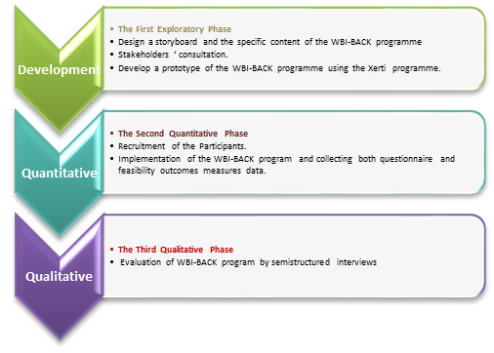
Image

Figure 1: Research Methodology

Biography

Rana Alduraywish is a lecturer at the College of Medicine at Imam Muhammed ibn Saud Islamic University in Riyadh, Saudi Arabia and a second year PhD student at the School of Health Sciences at Nottingham University in the UK. Rana has a master’s degree in physiotherapy (2017) from Cardiff University, UK. She worked as physiotherapist for more than ten years in Saudi Arabia. Her research interests are in the area of occupational lower back pain in nurses and self-management of lower back pain. She is also interested in the role of physical activity and exercise in lower back pain management. Her doctoral research investigates the feasibility and acceptability of using a web-based digital intervention for nurses working in hospitals in Saudi Arabia. She will develop and design a digital tool aimed at preventing and managing lower back pain in nurses. This will be the first study of its kind to assess issues specifically within the context of Saudi Arabia.

Email: ntxraa@exmail.nottingham.ac.uk

The University of Nottingham
Student ID: 4310529

