Development and Feasibility Testing of Web Based Intervention for Self-Management of Low Back Pain in Nurses: A Mixed Method Study
Alduraywish, R. 1, 2, Hendrick, P. 1, Blake, H. 1, 3
1. School of Health Sciences, University of Nottingham, UK
2. School of Medicine, Imam Muhammed ibn Saud Islamic
University, Riyadh, Saudi Arabia
3. NIHR Nottingham Biomedical Research Unit, Nottingham, UK

Abstract
Nurses have a higher prevalence of low back pain (LBP) than other occupations globally; this is associated with decreased job productivity, greater work absence, disability and functional limitation. Studies in the Kingdom of Saudi Arabia (KSA) report high rates of LBP in nursing consistent with findings from other countries. Digital interventions have demonstrated efficacy in supporting self-management of LBP and improvements in self-reported outcome measures of pain, functionality, quality of life. In this study, we will develop, design and test a theoretically-informed web based intervention programme for the nursing population. The purpose of this study is to test the feasibility and acceptability of a web-based intervention programme for the self-management of LBP (WBI-BACK) among a nursing population in the KSA. The feasibility study will employ a single group pre-post intervention using a sequential mixed-method approach. The first, exploratory phase, the design and development of a WBI-BACK programme. Social cognitive theory was used to develop a content of a WBI-BACK programme. WBI-BACK programme is designed as an interactive multi modules intervention including: educational gallery, exercise gallery, physical activity, ergonomics, the psychological unit and healthy lifestyles. The second, quantitative phase will aim to recruit 50 nurses and/or nursing assistants with and without LBP working in hospitals in the KSA and test the feasibility of implementing the WBI-BACK programme in the KSA. The third, qualitative phase will include evaluation of the WBI-BACK programme through semi-structured interviews. Primary outcomes are the feasibility of the study design and delivery of the WBI-BACK programme including: recruitment of nursing, participant’s retention, data completion rate, appropriateness of selected outcome-measures, the extent of participants’ usage of WBI-BACK programme, adherence to the intervention and adverse events. Secondary outcomes will involve exploratory analysis of LBP-related measures including: pain, disability, quality of life, physical activity and exercise self-efficacy. The ‘WBI-BACK’ programme will be delivered to participants over six weeks.

Image
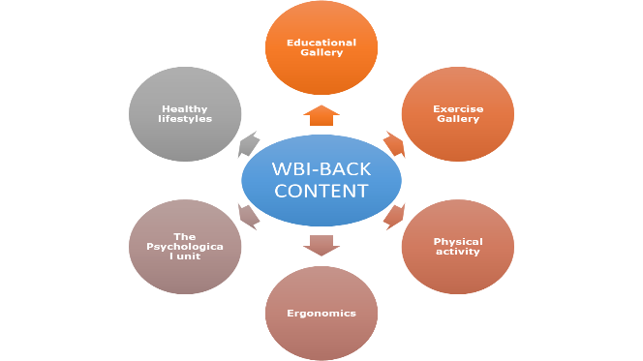

Figure 1: WBI-BACK package content

Biography

Rana Alduraywish is a lecturer at the College of Medicine at Imam Muhammed ibn Saud Islamic University in Riyadh, Saudi Arabia and a second year PhD student at the School of Health Sciences at Nottingham University in the UK. Rana has a master’s degree in physiotherapy (2017) from Cardiff University, UK. She worked as physiotherapist for more than ten years in Saudi Arabia. Her research interests are in the area of occupational lower back pain in nurses and self-management of lower back pain. She is also interested in the role of physical activity and exercise in lower back pain management. Her doctoral research investigates the feasibility and acceptability of using a web-based digital intervention for nurses working in hospitals in Saudi Arabia. She will develop and design a digital tool aimed at preventing and managing lower back pain in nurses. This will be the first study of its kind to assess issues specifically within the context of Saudi Arabia.

Email: ntxraa@exmail.nottingham.ac.uk

The University of Nottingham
Student ID: 4310529

