Using WBSN for mental Healthcare monitoring

Dr.Nasim Khozouie, University of Yasouj, Yasouj, Iran

Abstract
Today’s several researches using multimodal sensing devices and communication technology and smartphones to detect human activity, health condition and mental states. Sensing types in these researches can be wearable, external and software/social media. Alternatively, we can classify sensor data in three sensing type: physiological, mental and environmental. The biomedical platforms developed in this regard can be classified into three categories: (1) monolithic platform-based, (2) textile (fabric)-based, and (3) body-sensor-network-based. WBSN is common approach for health monitoring systems. In this approach the data sense and collect by sensors and transmitted wirelessly to a base station (such as smart phone, Actigraphy devices or Smart watches) for long-term storage and processing. Typical sensors that can be found in smart phone are accelerometers, gyroscopes, ambient light sensors, proximity sensors, GPS, Bluetooth, microphone, video camera, magnetometer, etc. With the ever growing popularity and capabilities of smartphones, several research works started to use them as a platform for data collection studies. Although the sensors data is not sensing mental state itself, but can be driven of sensing behavior that is emerging from physiological data. For example, circadian rhythm disturbances have been shown in studies of activation in bipolar disorder, Skin conductivity and heart rate are factors which used to extend nervous system. In order to early detect migraine attacks are used sleep time data from wearable sensors, and so on. Conclusion & Significance: in this present we discuss about WBSN technologies and usage machine learning model training to extract knowledge from raw data.

Image

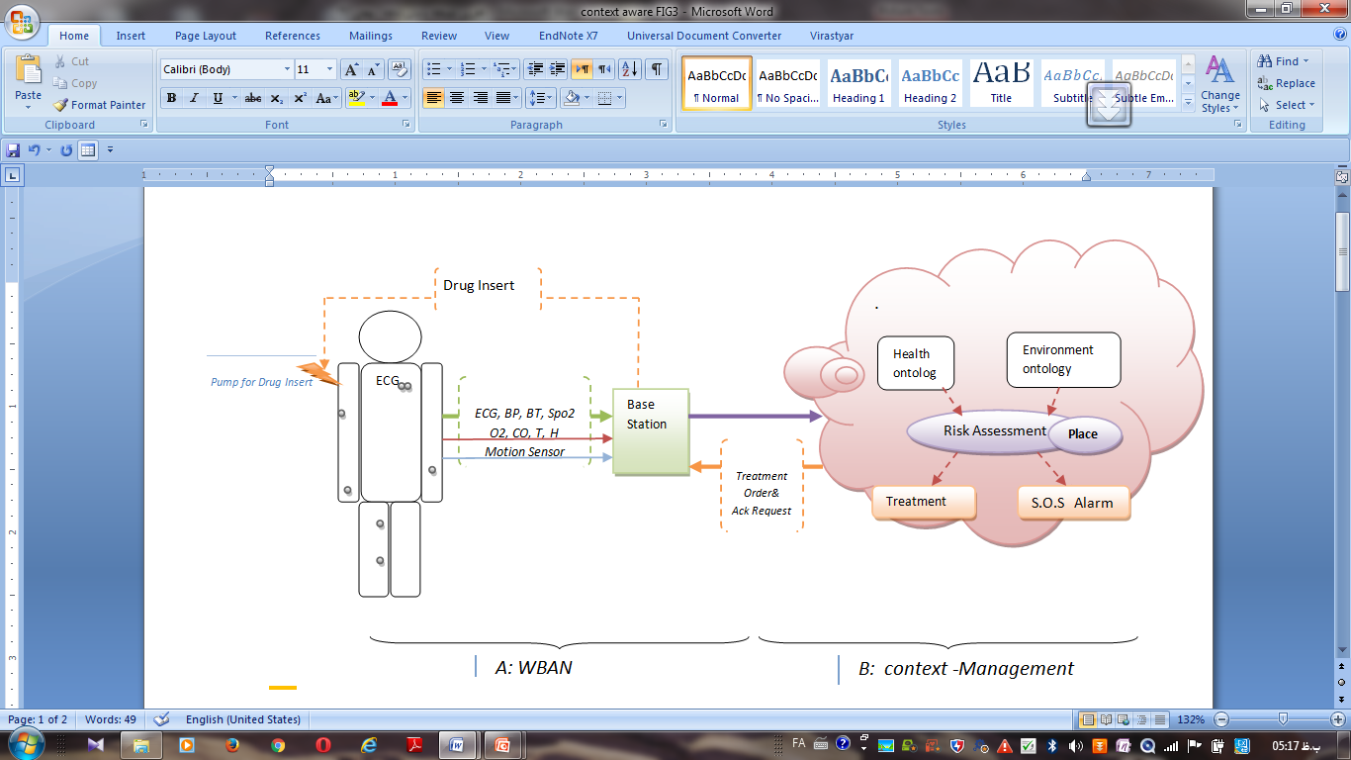

Figure 1. Conceptual model of a mobile patient monitoring framework

Recent Publications
- Khozouie, N., Fotouhi, F., Minaei, B. (2018). Context-aware modeling for spatio-temporal data transmitted from a wireless body sensor network. Journal of AI and Data Mining, (), -. doi: 10.22044/jadm.2018.6005.1707
- Khozouie, N., Fotouhi, F., Minaei, B. (2018). Ontological Mobihealth system, Indonesian Journal of Electrical Engineering and Computer Science, vol 10, No.1, 309-319.
- Khozouie, N., Fotouhi, F., Minaei, B. (2016). Pervasive and Ubiquitous Mobile-health application for pregnancy’s mother on android smart phone (Non-Stress Test application), Bulletin de la Société Royale des Sciences de Liège, Vol. 85, 2016, p. 409 – 417
- Khozouie, N., Fotouhi, F., Minaei, B. (2017). Developing a Context-Aware Mobile Patient Monitoring Framework with an Ontology-Based Approach, Proc. of the 2017 IEEE 3rd International Conference on Smart Instrumentation, Measurement and Applications (ICSIMA 2017) 28-30 November 2017, Putrajaya, Malaysia
- Haider Mshali, Tayeb Lemlouma, Damien Magoni, Adaptive monitoring system for e-health smart homes, Pervasive and Mobile Computing, Volume 43, 2018, Pages 1-19
- Lili Liu, Eleni Stroulia, Ioanis Nikolaidis, Antonio Miguel-Cruz, Adriana Rios Rincon, Smart homes and home health monitoring technologies for older adults: A systematic review, International Journal of Medical Informatics, Volume 91, 2016,Pages 44-59,
- Jun Qi, Po Yang, Geyong Min, Oliver Amft, Feng Dong, Lida Xu, Advanced internet of things for personalised healthcare systems: A survey, Pervasive and Mobile Computing, Volume 41, 2017, Pages 132-149,
- uehong YIN, Yan Zeng, Xing Chen, Yuanjie Fan, The internet of things in healthcare: An overview, Journal of Industrial Information Integration, Volume 1, 2016, Pages 3-13.
- Malik G., Vij S., Tayal D., Jain A. (2019) E-alive: An Integrated Platform Based on Machine Learning Techniques to Aware and Educate Common People with the Current Statistics of Maternal and Child Health Care. In: Mishra D., Yang XS., Unal A. (eds) Data Science and Big Data Analytics. Lecture Notes on Data Engineering and Communications Technologies, vol 16. Springer, Singapore
- Y. M. S. Al-Wesabi, Avishek Choudhury, Daehan Won, Classification of Cervical Cancer Dataset, Proceedings of the 2018 IISE Annual Conference.
- Sood A., Bhatia R. (2019) Baron-Cohen Model Based Personality Classification Using Ensemble Learning. In: Mishra D., Yang XS., Unal A. (eds) Data Science and Big Data Analytics. Lecture Notes on Data Engineering and Communications Technologies, vol 16. Springer, Singapore
- Hoodbhoy Z, Hasan B, Jehan F, Bijnens B, Chowdhury D. Machine learning from fetal flow waveforms to predict adverse perinatal outcomes: a study protocol. Gates Open Res. 2018;2:8. Published 2018 Feb 12. doi:10.12688/gatesopenres.12796.1
- Jeanne L. Alhusen, Ruth Geller, Jerry Jellig, Chakra Budhathoki, and Michele Decker.Journal of Women's Health.Apr 2018.ahead of print, Volume: 27 Issue 4: April 1, 2018, http://doi.org/10.1089/jwh.2017.6322
- Mobile Based Health Care Solution for Breast Cancer Patients by Munirul M Haque, FerdausKawar, Adibuzzaman, Sheikh I Ahamed, Richard Love, RumanaDowla, David Roe and Reza Selim, in Proceedings of M4D 2012, ISSN: 1403-8099, ISBN: 978-91-7063-4079.

 Biography
She has completed PhD in Information Technology Engineering from the Qom University, Iran. Her research focuses on ontological data modeling for ubiquitous healthcare monitoring system. She is a professor assistant in computer Science and electrical engineering at the Yasouj University, Yasouj, Iran. She currently works on pregnancy healthcare monitoring system. Her main research interests include data-driven and intelligent approaches for pervasive healthcare monitoring systems, machine learning model training, WBSN and semantic web. She has researched on sematic web, ontology develop and ontology evaluation since 2009. Her research findings have been presented in IEEE Conferences and Journal Articles.

Email: khozooyi2003@gmail.com

Notes/Comments:

