Bridging the Gap: Exploring the Potential Use of Telehealth to Support the Service Needs of Parents of Children with Autism.

Manahil Alfuraydan

Swansea University, Singleton Park, Swansea, SA2 8PP, Wales, UK

Abstract
Statement of the Problem: Autism Spectrum Disorders (ASD) affect approximately 1% of the world population [1]. In the UK, around 700,000 people have autism [2]. Wales has a large rural area which has shown to adversely affect its population access to the healthcare services [3]. Individuals with ASD regularly need intensive interventions throughout the lifetime [4]. However, many families could face barriers to accessing intervention services in acceptable approach [5]. A previous review suggests that telehealth has the promise to be a feasible means to address the need for enhanced access to services for autistic individuals [6]. The purpose of this study is to explore the potential of telehealth as an alternative way for parents of autistic children to gain access to autism related services in Swansea, South Wales. Methodology & Theoretical orientation: A mixed method approach will be used including a quantitative questionnaire and qualitative interviews [7].The Technology Acceptance Model (See Fig1.) [8] will be utilized for analysis, and to explore the potential use of telehealth by parents of children with autism. Findings: Findings will center around two questions: 1) Could telehealth be used to provide better access to Autism intervention services? 2) Are parents of children with Autism likely (including perceived barriers and facilitators) to use telehealth as a means of gaining access to Autism intervention services? Conclusion & Significance: There is a big knowledge gap in the UK, and Wales regarding the area of telehealth and Autism. Such approach would be compatible with a “Digital Health and Social Care Strategy for Wales” that aims to deliver digital services to health and social care patients to improve their health and well-being [9].
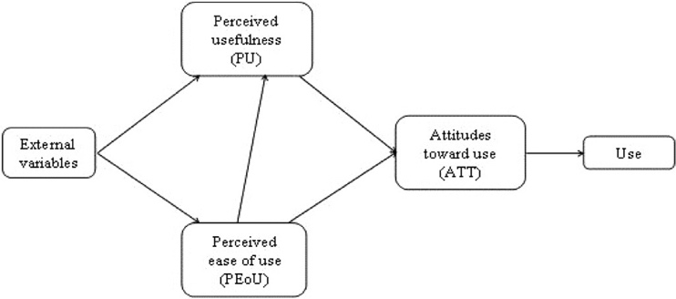

Fig1. Technology Acceptance Model (TAM) Structure[8].

References:

1. Lai, M.-C., M.V. Lombardo, and S. Baron-Cohen, Autism. The Lancet, 2014. 383(9920): p. 896-910.
2. Brugha, T., et al., Estimating the Prevalence of Autism Spectrum Conditions in Adults: Data quality and methodology. 2012.
3. Norton, K., M. Longley, and M. Ponton, The best configuration of hospital services for wales: a review of the evidence. Welsh Institute for Health and Social Care, University of Glamorgan.[online], 2012.
4. Pickard, K.E., et al., A mixed-method evaluation of the feasibility and acceptability of a telehealth-based parent-mediated intervention for children with autism spectrum disorder. Autism: The International Journal Of Research And Practice, 2016. 20(7): p. 845-855.
5. Simacek, J., A.F. Dimian, and J.J. McComas, Communication Intervention for Young Children with Severe Neurodevelopmental Disabilities Via Telehealth. Journal Of Autism And Developmental Disorders, 2017. 47(3): p. 744-767.
6. Boisvert, M., et al., Telepractice in the assessment and treatment of individuals with autism spectrum disorders: A systematic review. Developmental neurorehabilitation, 2010. 13(6): p. 423-432.
7. Greene, J.C., V.J. Caracelli, and W.F. Graham, Toward a conceptual framework for mixed-method evaluation designs. Educational evaluation and policy analysis, 1989. 11(3): p. 255-274.
8. Davis, F.D., R.P. Bagozzi, and P.R. Warshaw, User acceptance of computer technology: a comparison of two theoretical models. Management science, 1989. 35(8): p. 982-1003.
9. Welsh Government. Informed health and care – A digital health and social care strategy for Wales. 2015; Available from: http://gov.wales/docs/dhss/publications/151215reporten.pdf.

Biography: Manahil Alfuraydan has been gradated form King Faisal University with subject Health Information Management and Technology, Bachelor degree, and from King Saud bin Abdulaziz University for Health Sciences with Health Informatics, Master degree. She has worked as a lecturer at King Saud bin Abdulaziz University for Health Sciences then, at King Faisal University as a lecture in the Health Information Management and Technology Department. Presently she is a PhD student in the UK, Swansea, Swansea University Medical School (Patient and Population Health and Informatics). The research area of interest is related to the Telehealth and Autism.
Email: 842703@swansea.ac.uk
Keywords: Telehealth, Autism Spectrum Disorders, needs, Parents of children with autism, Services accessibility.

Desired Presentation : _ Oral /_ Poster /_ either

Topic : Healthcare and Technology

Corresponding Author Details: Manahil Alfuraydan
Swansea University
Swansea, Wales, UK
00447490463019

