Tracking of surgical sponges in the operating room: design and validation of an innovative medical device
Sergio Sbrenni⁽¹⁾, Eng, MSc(ICT), Alessandra Lazzaro⁽²⁾, MD, PhD, Silvia Quaresima⁽²⁾, MD, Luca Armisi⁽²⁾, Eng, PhD, Carlo Maria Medaglia⁽³⁾, Eng, Nicola Rosato⁽²⁾, FP, Nicola Di Lorenzo⁽²⁾, MD, PhD
⁽¹⁾Istituto Superiore di Sanità, Rome
⁽²⁾University of Tor Vergata, Rome, Italy
⁽³⁾Sapienza University, Rome, Italy

Abstract
During surgical procedures in operating room about 300 surgical tools (including needles, sponges, and instruments) are used. Previous studies stated that a retained surgical item in patients (gossypiboma) is one of a most critical adverse events. For the possible negative effects on patients, doctors and healthcare facilities, this event is classified as "Sentinel Event" by the Italian Ministry of Health.
In hospital facilities, there are rigorous procedures and protocols for the management of instrumentation and surgical sponges during surgery. For the surgical sponges, these protocols require the recording of the initial number and the cross-counting of the sponges used and those removed by the patient at the end of surgery, in order to ensure traceability of the devices at any times.
In order to provide a valuable support to this activity, a study was developed to design, implementation and testing of an automatic surgical sponges management system during surgery.
The system is based on Radio Frequency Identification Technology (RFId). It’s a complex hardware and software architecture that, for its intended use, is classified as a Medical Device, according to Council Directive 93/42/EEC as amended by Directive 2007/47/EC.
Results obtained after in vitro and in vivo testing, has demonstrate that the system developed allows a significant reduction of the clinical risk in surgical practice. Hundred percent retained sponges were detected correctly, even when they were overlapped. No false positive or false negative was recorded. It was demonstrate also a reduction of the surgery times into the operating room.

Image
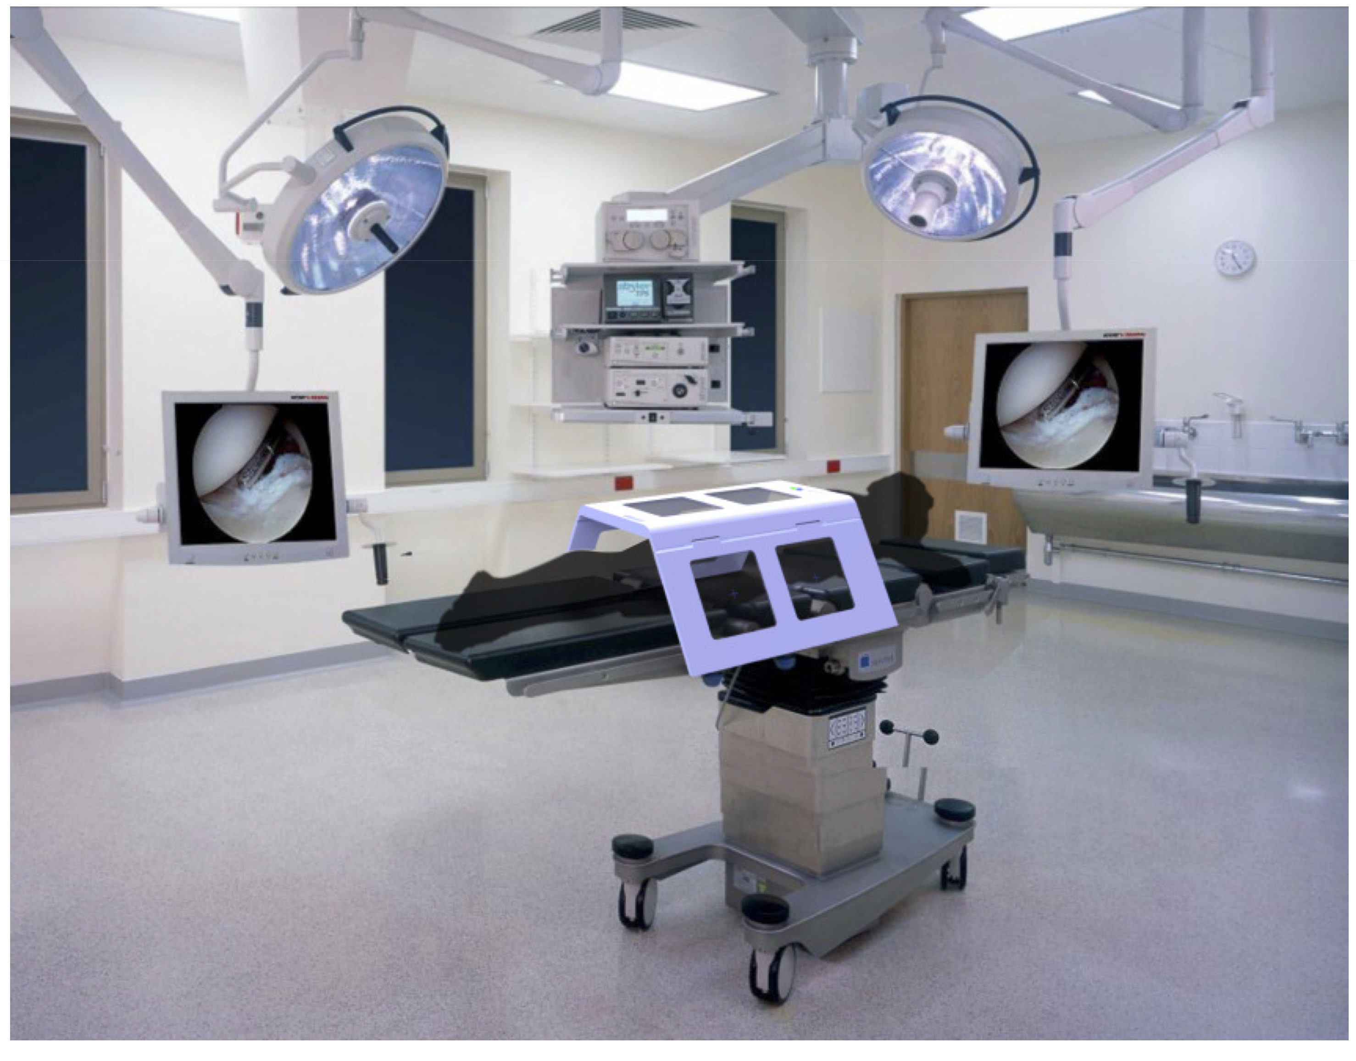
Recent Publications
- Lazzaro A, Corona A, Iezzi L, Quaresima S, Armisi L, Piccolo I, Medaglia CM, Sbrenni S, Sileri P, Rosato N, Gaspari AL and Di Lorenzo N. Radiofrequency-Based Identification Medical Device: An Evaluable Solution for Surgical Sponge Retrieval? Surgical Innovation 2017, Vol. 24(3) 268–275.
- Sbrenni S, Chiapparelli A. Quality of service, safety and protection of privacy in hospital: a method for impact assessment of RFId technology in healthcare. Working paper of public health 2014;(14):1-23.
- Armisi L, Corona A, Colangelo S, Rosato N, Lazzaro A, Iezzi L, Di Lorenzo N, Gaspari A, Piccolo I, Medaglia CM, Sbrenni S, Croci S Improving safety in operating room: design and experimentation of a RFId-based medical device for surgical sponges management. In: 2012 Fourth International EURASIP Workshop on RFID Technology. Proceedings; September 27-28, 2012; Torino. 2012. p.89-91.
- Corona A, Armisi L, Colangelo S, Lazzaro A, Iezzi L, Piccolo I, Medaglia CM, Sbrenni S, Croci S, Gaspari A, Rosato N, Di Lorenzo N. ENDOTRACK: tracking and monitoring surgical sponges using RFId technology. In: 24. International Conference of the Society for Medical Innovation and Technology (SMIT2012). Abstracts; September 20-22, 2012; Barcelona. 2012.
5. Sbrenni S, Piazza T, Macellari V. Use of RFId technology and CCOW standard for patient traceability. In: 2010 International Conference on Software, Telecommunications and Computer Networks (SoftCOM). Proceedings; September 23-25, 2010; Split. 2010. p.17-20.

Biography
Sergio Sbrenni, Graduated in Engineering, MSc in Electronics, MSc in ICT is a Researcher at the Italian National Institute of Health (ISS). He is a specialist in Health Technology Assessment, Food Safety and Medical Devices. He is presently working as a researcher at the ISS and also as Assessor at the Italian National Accreditation Body (ACCREDIA). He is currently investigating in the field of Medical Device Technology applied to humans and animals.
Email: sergio.sbrenni@iss.it

Notes/Comments:

