mHealth as a viable solution for the prevention and management of Cholera Epidemic in the Greater Accra Region of Ghana - Perspectives of Stakeholders
Ebo Hammond, BSc. MBA, PhD Candidate, University of Ghana Business School

Abstract (300 word limit)
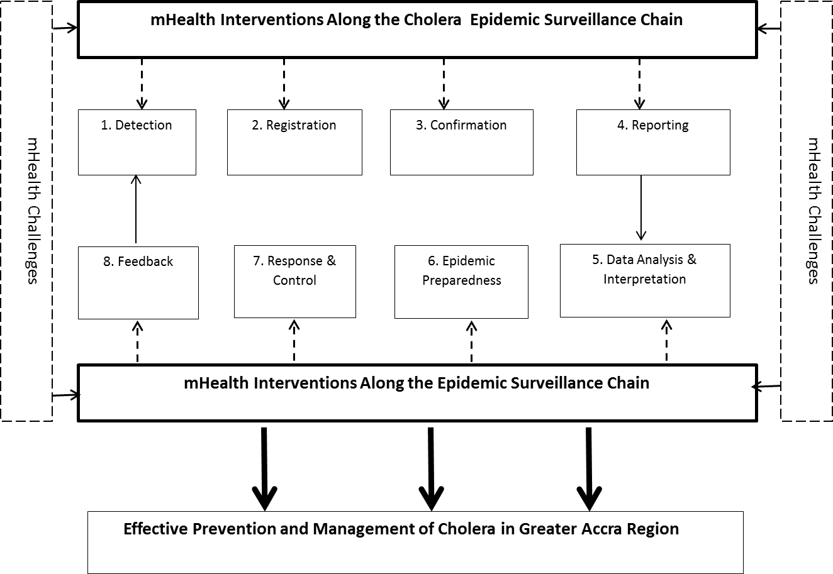
Statement of the Problem: The ubiquity of mobile phones has presented great opportunities for the health sector to explore its application as a tool for health care. This is due in part to the successful use of the mobile phone in other sectors particularly commerce, banking and financial services. The use of mobile phones in health care delivery is termed mobile health (mhealth); and has been applied in various health fields such as maternal health, behaviour change communication, treatment adherence, telemedicine, among others. Current research has aimed at determining the impact of mhealth on health access, quality and affordability and possibility of scaling-up the technology and integrating it into general health delivery system for which there seems to be no unanimity. Empirical research seems to reveal that mhealth application for the prevention and management of epidemics in Ghana is scarce, more especially for the cholera epidemic. This research is therefore aimed at determining the public health services that can be delivered through the mobile phone, the likely challenges to be faced and facilitating or enabling factors for the viability of mhealth in the management of cholera epidemic in the Greater Accra Region (GAR) of Ghana, which is a perennial source of outbreaks over the past 40 years.
Methodology & Theoretical Orientation: The study adopts an exploratory qualitative research approach and utilizes purposive and snowball sampling methods, with in-depth interviews and focus group discussions as key data collection strategies. The target population includes all people living in the GAR but eighteen years and above. Key participants include public health specialists, health policy advisors, telecom and communication experts, traders, fishermen and public servants, among others. Textual data is expected to be collected and analysed with the aid of software packages such as INVIVO.
Findings: The research benefits apply in the areas of theory, practice and policy. It will contribute to the knowledge of the viability of using mobile phones as a new health intervention strategy for effective management of the cholera epidemic. Health policy makers and managers will better appreciate the factors that may challenge or enhance the mobile health. It will finally inform practicing health managers of the potentials of mHealth as an alternative health care tool for effective cholera epidemic management.
Image

Recent Publications (minimum 5)
- Akter, S., & Ray, P. (2010). mHealth - an Ultimate Platform to Serve the Unserved. IMIA.
- Etzo, S., & Collender, G. (2010). Briefing: The Mobile phone revolution in Africa: Rhetoric or Reality? Oxford Journal: African Affairs 109(437), pp. 659-668.
- Currie, W., & Seddon, J. (2014). Social Innovation in Public Health: Can Mobile Technology Make a Difference? Special Issue: Social Innovation in the Public Sector, 31(3), pp. 187-199.
- Adokiya , M., Awoonor-Williams, J., Beiersmann, C., & Müller, O. (2015). The integrated disease surveillance and response system in northern Ghana: challenges to the core and support functions. BMC Health Services Research, 15(288).
- African Strategies for Health, Management Sciences for Health. (2016). mHealth Compendium: Special Edition 2016- Reaching Scale. Arlington, VA: United States Agency for international Development.


Mr. Ebo Hammond has over 20 years of experience in the public sector of Ghana, as applied in health. He is a high profile speaker both at the local and international levels with key lectures delivered in Colombo (Sri Lanka), Nagoya (Japan), San Jose (USA), Nairobi (Kenya), Accra (Ghana), Dubai (UAE), among others. He has core competencies in health transport policy development, fleet operations, logistics management, and strategy, among others. Mr. Hammond is a PhD candidate of the University of Ghana Business School. He is currently the President of The Chartered Institute of Logistics and Transport, Ghana and a Deputy Director in Charge of Transportation Management at the Ghana Health Service.
Email:
ebohammond@gmail.com

Notes/Comments:

Results of the research are not yet ready as data are being currently collected as part of my PhD thesis work to be submitted in 2018.

The abstract is therefore to share my thesis proposal for discussion and further critique by participants.

