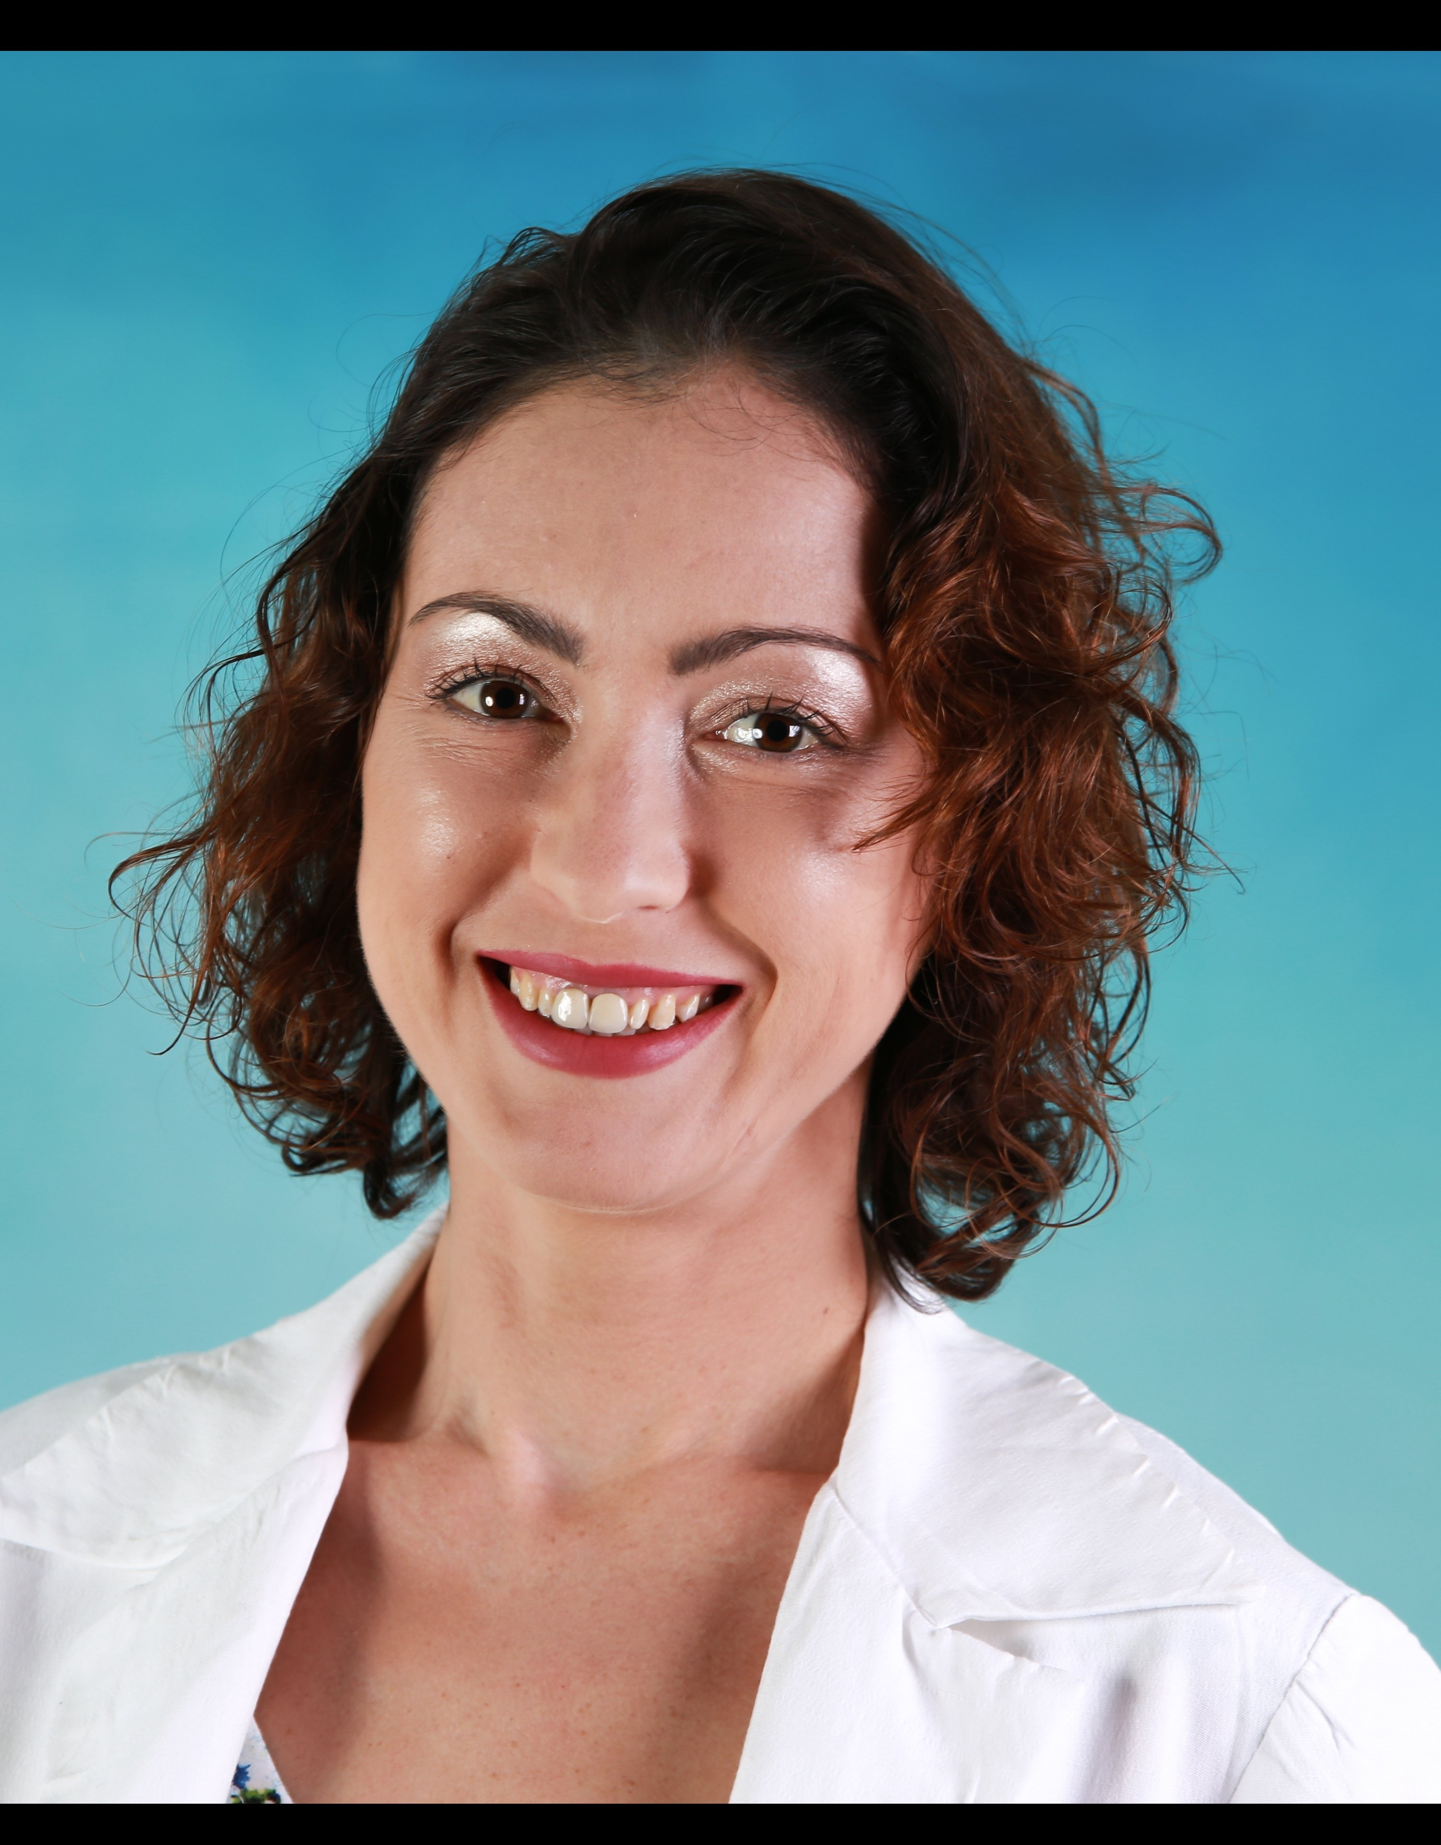

Title: Feasibility, Safety, and Effectiveness of a Novel Mobile Application in Cardiac Rehabilitation

Irene Nabutovsky PhD Candidate ^{1,2}, Saar Ashri², Amira Nschshon², Riki Tesler PhD ,¹ Yair Shapira¹, Evan Wright MD Candidate, ³ BSc Brain Vadasz MD Candidate^{, 3} Amir Offer MD FACC, ⁴ Liza Grosman-Rimon PhD ⁴, Robert Klempfner MD ^{2,5}

¹ The Department of Health Systems Management, Faculty of Health Sciences, Ariel University, Israel

² Cardiac Prevention and Rehabilitation Institute, Leviev Heart Center, Sheba Medical Center,
Tel HaShomer, Israel

³ Technion American Medical School, The Ruth and Bruce Rappaport Faculty of Medicine Efron St. Bat Galim, Haifa, Israel
⁴ Division of Cardiovascular Medicine, Baruch Padeh Medical Center, Poriya, the Azrieli Faculty of Medicine in the Galilee, Bar-Ilan University, Safed, Israel

⁵ Sackler Faculty of Medicine, Tel Aviv University, Israel

Introduction: In a pilot study, we assessed the feasibility, safety, and effectiveness of a cardiac rehabilitation program, using a combination of mobile application and multidisciplinary caregiver control center. We also evaluated clinical and physiological outcomes as well as adherence to the exercise program in patients with low cardiovascular risk. Methods: A total of 22 patients with established coronary artery disease participated in a 6-month tele-cardiac rehabilitation (tele-CR) program. Datos Health, a novel digital health application and care-team dashboard, was used for remote monitoring, communication and management of the patient. Results: Following the 6-month tele-CR intervention, there was a significant improvement in exercise capacity, assessed by estimated Metabolic Equivalents (METS). High-density lipoproteins (HDL) levels significantly improved, whereas low-density lipoproteins (LDL), triglyceride (TG) glycosylated hemoglobin (HbA1c), systolic (SBP) and diastolic (DBP) blood pressures levels were not significantly changed. Exercise adherence was consistent among patients, with more than 63% of patents who participated in a program of moderately intense exercise for 150 minutes per week. Conclusion:
Patients who participated in tele-CR adhere well to the exercise program and attained good functional improvement. Tele-CR program is a viable option for populations that cannot, or elect not to participate in center based tele-CR programs.

Biography

Irene is a research leader at the Cardiac Prevention and Rehabilitation Institute in middle east’s biggest medical center, Tel HaShomer, Israel.
She is leading remote cardio rehabilitation study which heavily uses wearable devices, web and mobile applications.
Irene works closely and advising various Health-Tech startups.
She is in the middle of her Ph.D. study at Ariel University.
Irene published several papers and presented her research in conferences.

Presenting author details
Full name: Irene Nabutovsky
Contact number: +972546411261
Twitter account:
Linked In account: https://www.linkedin.com/in/irene-nabutovsky-7aa3b6136/

Session name/ number: Healthcare IT. Theme: Technology and medical science hand in hand for better healthcare

Category: (Poster presentation)

