ESTABLISHMENT OF MOUSE FERTILIZED TETRAPLOID EMBRYOS
AND CHARACTERISTICS OF PREIMPLANTATION DEVELOPMENT
Le Sao Mai Phamª (BSc Student - phlsaomai96@gmail.com)
ªSchool of Biotechnology, International University, Vietnam National University in HCM

ABSTRACT

Tetraploid embryos are commonly used to avoid embryonic lethality due to the tetraploid complementation assay by introducing ES cells into tetraploid embryos which can develop to conceptuses. Numerous effective methods were performed to produce tetraploid embryos in vitro. However, electrofusion is one of the most accurate, measurable, repeatable, less toxic and well defined procedure which can be performed with the embryos having the zona pellucida. Efficiency of electrofusion depends on numerous factors, such as fusion medium, electrical parameters, characteristics of the cells, pulse number, alignment of embryos between electrodes, and exposure time. Attention in this study has been focused on choosing the optimal parameters of electric field with the aim of improving efficiency of cell fusion after electrofusion of 2-cell stage. The results showed that the compaction of 4-cell tetraploid embryos and 8-cell diploid embryos after 88 hr hCG injection occurred concurrently. Therefore, the timing of tetraploid embryo development and the first change in embryo morphology were dependent on the timing of fertilization, not on the number of completed cell cycles. Beside that, the immunofluorescence staining with CDX2 clarified that tetraploid embryos contributed only to trophectoderm due to lower numbers of TE cells and ICM cells in tetraploid blastocysts compared with diploid blastocysts.
Key words: tetraploid embryos, preimplantation development, cdx2

- INTRODUCTION:

In vitro, tetraploid embryos have been extensively applied in various research studies of animal biotechnology since last few years. The tetraploid embryos, having double complement of chromosomes instead of the usual diploid one, are useful model for generating valuable information on embryonic development. The application of tetraploid embryos are commonly used to generate mice directly from embryonic stem cells and to avoid embryonic lethality which may arise due to defective extra embryonic phenotypes (Nagy et al., 1990).

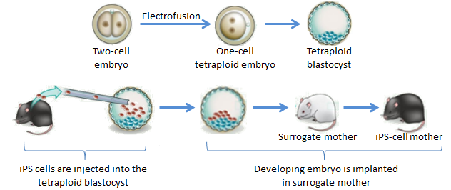
Figure 1: Application of tetraploid embryos in making an iPS-cell mouse

There are three fundamental techniques to induce tetraploidy in vitro. First technique is that a nucleus (2n) is fused to a fertilized ovum surgically. The repeatably uniform tetraploid embryos were produced by this method but only 9–15% of the injected blastocysts survived due to surgical trauma (Modlinski, 1981). The second technique was to inhibit the cleavage with the help of chemicals such as cytochalasin B (CB), a microtubule destabilizer. The third technique was the most common technique to produce tetraploid embryos to induce fusion of two cell stage embryos by electric current. Initially inactivated Sendaivirus was used as the fusion agent (Graham, 1971) but main drawback of this method was that 2-cell stage embryos have to be treated individually as a result causing the slow rate of embryo production. Along with this, due to removal of the zona pellucida (before fusion) and culture of the embryos for two days in vitro, the survivability of embryos was lowered.

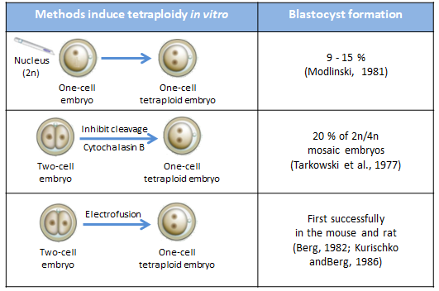
Table 1: Three fundamental techniques to induce tetraploidy in vitro

In contrast to previous methods, using electric current to induce fusion of two cell stage embryos is one of the most accurate, measurable, repeatable, less toxic and well defined procedure which can be performed with the embryos (2-cell stage) having zona pellucida. During this procedure, these embryos are placed between two electrodes in fusion buffer, electrical stimulus is provided for very short duration (Darabi et al., 2008). During electrofusion due to applied alternating current (AC) electric field for alignment of embryos, the important factor for successful fusion of the two cell stage embryos, the embryos are oriented with the interface between the two blastomeres perpendicular to the electrodes, then the membranes are polarized and in-stabilized, results in attraction of other membrane and formation of unstable flat membrane diaphragm, through reversible pore formation followed by reversible breakdown of the membrane (Darabi et al., 2008).
There are numerous factors that affect the efficiency of electrofusion, such as electrical parameters, fusion medium, alignment of embryos between electrodes, pulse number, exposure time and characteristics of the cells. Attention in this study has been focused on choosing the optimal parameters of electric field with the aim of improving efficiency of cell fusion after electrofusion of 2-cell stage, which requires more investigations to achieve high amount of blastocyst.

- METHODS:
  - Animals:
ICR male and female were used to produce in vivo fertilized embryo. These animals were cared and maintained in Mouse Room directly under Cellular Reprograming Laboratory in Vietnam National University – HCMC International University. Each male/female/pregnant/mother and babies/ used cage was labeled and placed into separated areas. They were fed artificial food with full of water bottle once a day. Their cages which kept about 8-10 mice per one, were cleaned up everyday.

  - Mouse 2-Cell Fertilized Embryo Collection:
Mature 8-10 weeks female ICR mice were induced to superovulate by PMSG and hCG, then mated with male of the same strain.
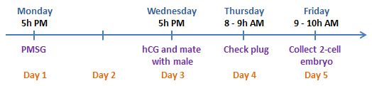
Table 2: Schedule of hormone injection for collection of fertilized embryos
About 40h after the hCG injection, 2-cell embryos were collected by using mouth pipette in fresh HEPES-mZCB medium. Embryos were transferred to a 35-mm petri dish containing mCZB-BSA medium. These embryos were recovered and kept at 37°C under 5% CO₂ in an incubator.
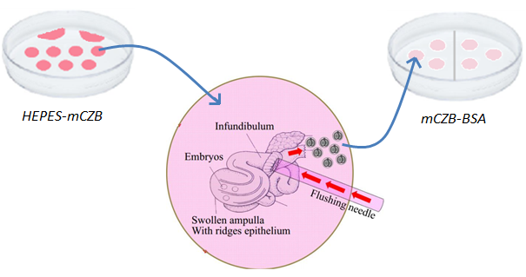
Figure 2: Collection of embryos by flushing excised oviduct

  - Electrofusion of Diploid Embryos:
An electro cell fusion system (Model LF201; NEPAGENE Co, LTD, Chiba, Japan) was used to electrofuse the two-cell stage embryos prepared by in vitro culture to generate tetraploid embryos. The electrofusion solution is composed of 0.3 M mannitol, 0.1 mM MgSO₄, and 0.05 mM CaCl₂ supplemented with 1% PVA (w/v). The embryos (generally 10-15 embryos at a time) were lined up in 20 µl of the electrofusion solution in single file between two parallel stainless-steel electrodes in a chamber. Embryos are oriented with the interface between the two blastomeres perpendicular to the electrodes using an A/C orientation field, then the aligned embryos are pulsed with D/C current to initiate blastomere fusion. Electrofused embryos are washed three times and incubated for development in mCZB-BSA medium. After 30-45 minutes, they were examined and separated embryos having fusion of 2 blastomeres to new drops.

Experimental Group | Alternating Current (A/C) | Direct Current (D/C)
Group 1 | 80 V | 100 V
Group 2 | 75 V | 100 V
Group 3 | 70 V | 100 V

  - Evaluation Characteristics of Pre-Implantation Development of Tetraploid Embryos:
    - Assessment of DAPI And CDX2 Expression
In order to clarify evidence that tetraploid embryos contribute only to the placenta, the expanded blastocysts at 112 hr after hCG injection (72 hr from the time of electrofusion) were fixed with 150 µl paraformaldehyde for 30 mins at room temperature. The fixed blastocysts were washed twice with 150 µl PBS-BSA-PVA and then stored overnight with 100 µl Triton X-100 at 4ºC. These samples were incubated for 120 min at room temperature in mouse anti-CDX2 IgG, a TE marker. After the samples were washed twice in PBS-BSA-PVA, they were incubated for 60 min with Alexa-Fluor-488 labeled goat anti-mouse IgG. After two washes in PBS-BSA-PVA for 15 min each, the DNA was stained for 30 min with 2 mg/ml 4’, 6-diamidino-2-phenylindole dihydrochloride (DAPI). After the samples were washed thoroughly, they were mounted on slides using Glycerol and observed with an epifluorescence microscope. The processes of fixation and staining of samples were performed in 96-well culture dishes (STEMCELL Technology), and the samples were transferred to subsequent treatments by mouth pipette.

    - Assessment Chromosome of One-Cell Tetraploid Embryos
16 hours after electrofusion, chromosomes of tetraploid embryos were examined by orcein staining. The addition of the hypotonic solution, distilled water, will result in water rushing into the cells due to the concentration gradient caused by the less-than physiological concentration outside of the cells. The cells will swell and cytoplasmic membranes will stretch. Fetal Bovine Serum (FBS) was then used as isotonic solution to preserve in its swollen shape. After these steps, fixative solution (acetic acid:ethanol 1:3 v/v) was passed twice via introduction from one side of the cover slip and removal from the other by absorbing it with a piece of filter paper. Staining solution (1% aceto-orcein in acetic acid:ethanol 1:3) was then passed once, albeit in a similar manner. After 5-7 min of orcein staining, destaining solution (acetic acid:distilled water:glycerol: 1:3:1) was passed thoroughly to remove excess stain, making sure that these embryos were not washed away. The cover slip was sealed and stained embryos were examined under a light microscope to determine the stages of chromosome morphology.

- RESULTS:
  - Electrofusion of 2-Cells Fertilized Embryos
Two-cell fertilized embryos were collected from female ICR mouse and then electrofused with different AC and DC values in the same volume of fusion medium, and the result are shown in Table 3. The percentage of two-cell embryos undergoing fusion was significantly higher in the groups with AC values of 75 and 80 volts and a DC value of 100 volts, compared with the remained groups. Furthermore, the survival rate of fused embryos in second group was higher compared with third group. Based on these results, the optimal electrofusion voltages for mouse embryos at the two-cell stage are AC (75V) and DC (100V).

Table 3: Optimal Electrofusion Protocol for Two-Cell Embryonic Fusion
Experimental Group | No. of 2-cell  embryos examined | No. of 2-cell  embryos fused | Non-degenerated | Degenerated
AC = 70V,  DC = 100V | 85 | 71 (83.5%) | 65 (76.5%) | 20 (23.5%)
AC = 75V,  DC = 100V | 85 | 83 (98.0%) | 78 (91.2%) | 7 (0.08%)
AC = 80V,  DC = 100V | 85 | 80 (94.0%) | 75 (88.2%) | 10 (1.18%)
*All experimental groups of embryos were electrofused in the same volume of fusion medium 20 µL.
**Degenerated embryos died immediately after electrofusion.

At 64 hr after hCG injection, most of the tetraploid embryos (88.24%) were at two-cell stage, whereas 94.34% of diploid embryos had developed into the four-cell stage (Table 4, 64 hr). At 76 hr after hCG injection, 58.97% of the tetraploid embryos were still at four-cell stage, whereas most of diploid embryos had reached the eight-cell stage (67.92%) (Table 4, 76 hr). Interestingly, at 88 hr after hCG injection, the percentage of tetraploid embryos developing into the morula stage were similar to diploid embryos (Table 4, 88 hr). Similar to morula stage, at 112 hr after hCG injection, both tetraploid and diploid embryos had reached the blastocyst stage with no significant differences between two groups (Table 4, 112 hr).

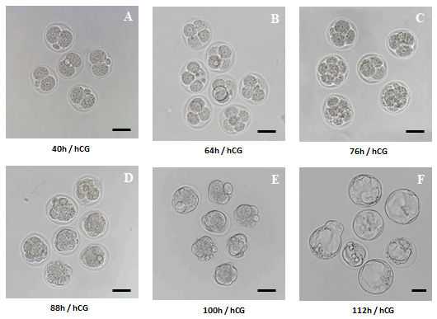
Figure 3: In vitro development of in vivo fertilized mouse embryo after hCG injection (HI) and mating. A. 2-cell embryos (40 hrs after HI). B. 4-cell embryos (64 hrs after HI). C. 8-cell embryos (76 hrs after HI). D. Morula stage (88 hrs after HI). E. Early blastocyst stage (100 hrs after HI). F. Late blastocyst stage (112 hrs after HI). The scale bar is 50 µm

Table 4: Preimplantation Development of Diploid and Tetraploid Embryos
 |  |  | AC = 75V and DC = 100V
After hCG injection | Type of Embryo | No. of Embryos | 1-cell | 2-cell | 4-cell | 8-cell | Morula | Early BL | Late BL
64 hr | Diploid | 53 |  | 3  (5.66%) | 50 (94.34%)
64 hr | Tetra |  | 8  (9.41%) | 75 (88.24%)
76 hr | Diploid |  |  |  | 17 (32.08%) | 36 (67.92%)
76 hr | Tetra |  |  |  | 32 (41.03%) | 46 (58.97%)
88 hr | Diploid |  |  |  |  | 1  (1.89%) | 50 (94.34%)
88 hr | Tetra |  |  |  |  |  | 4  (5.13%) | 71  (91.03%)
100 hr | Diploid |  |  |  |  |  | 35 (66.04%) | 16  (30.19%)
100 hr | Tetra |  |  |  |  |  |  | 50  (64.1%) | 19  (24.36%)
112 hr | Diploid |  |  |  |  |  |  |  | 44  (83.02%)
112 hr | Tetra |  |  |  |  |  |  |  | 57  (73.08%)
Tetra, tetraploid; BL, blastocyst
**2-cell embryos were collected after 40 hr of hCG injection
**2-cell embryos were collected after 40 hr of hCG injection and electrofused with 75 volts, AC, 100 volts, DC in in the volume of fusion medium, 20 µL

These results showed that the timing of tetraploid embryo development and the first change in embryo morphology were dependent on the timing of fertilization, not on the number of completed cell cycles (Table 5).
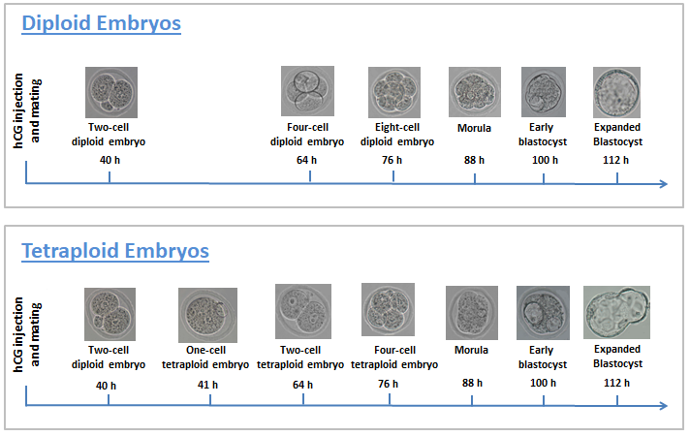
Table 5: Comparison of each cell stages between tetraploid embryos and diploid embryo
  - Assessment of DAPI and CDX2 Expression
In this experiment, ten expanded diploid blastocysts and ten expanded tetraploid blastocysts at 112 hr after electrofusion with the optimal parameters of electric field 75 volts, AC, and 100 volts, DC were fixed and stained immunofluorescence. The results of DAPI staining showed that the compaction of tetraploid embryos and diploid embryos occurred concurrently at 4-cell stage and 8-cell stage, respectively.
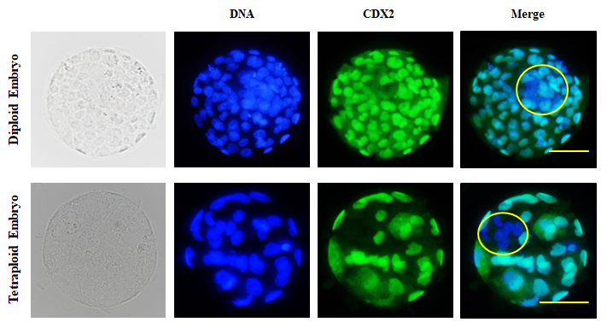
Figure 4: CDX2 expression of expanded tetraploid and diploid blastocyst at 112 hr after hCG injection with optimal AC = 75V and DC = 100V. DNA is blue, CDX2 is green. Scale bar = 50 µm
The total number of cells in tetraploid and diploid blastocysts were shown in Table 6. The numbers of cells in the tetraploid expanded blastocysts (30.1 ± 5.7) were significantly lower than in the diploid expanded blastocysts (60.3 ± 6.2) due to the compaction of 4-cell tetraploid embryos and 8-cell diploid embryos at the same time. Figure 10 showed the difference in cell numbers of diploid expanded blastocysts was caused by a higher number of TE cells (48.0 ± 5.9) and ICM cells (12.3 ± 1.0) when compared with tetraploid expanded blastocysts (25.8 ± 4.7) and (4.4 ± 1.3). The results of TE cell numbers and ICM cell numbers indicated that the tetraploid embryo contributes only to placenta.

Table 6: Number of cells in tetraploid- and diploid-derived expanded blastocysts
Type of Embryos | No. of Blastocysts* | Mean No. of Cells in Total | Mean No. of Cells in TE* | Mean No. of Cells in ICM*
Diploid | 10 | 60.3 ± 6.2ª | 48.0 ± 5.9ª | 12.3 ± 1.0ª
Tetraploid | 10 | 30.1 ± 5.7^{b} | 25.8 ± 4.7^{b} | 4.4 ± 1.3^{b}
*TE (Trophectoderm) and ICM (Inner Cell Mass)
*Blastocyst (diploid and tetraploid) were fixed 112 hr from human chorionic gonadotropin injection (at 72 hr from the time of electrofusion).
^{a,b}Values with different superscripts within a column are significantly different (P<0.05)

  - Assessment Chromosome of One-Cell Tetraploid Embryos
16 hr after electrofusion 1-cell tetraploid embryos (56 hr after hCG injection) with optimal parameter AC, 75V and DC, 100V were used to identify the chromosome morphology of tetraploid embryos. In this case of aceto-orcein staining, hypotonic solution (water) and Fetal Bovine Serum (FBS) were used to observe chromosome spreading easily. The figure indicated that two blastomere chromosome sets were combined together and reached metaphase at 16 hr after electrofusion (56 hr after hCG injection).

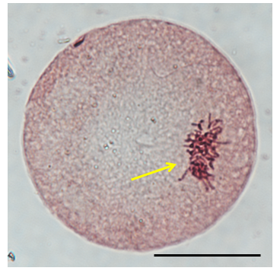
Figure 5: Chromosome of 1-cell tetraploid embryo after 16 hr of electrofusion

- CONCLUSION:
In conclusion, the optimal electrofusion voltage for mouse embryos at the two-cell stage is 75 volts (AC) and 100 volts (DC). Both tetraploid embryos and diploid embryos had reached morula and blastocyst stage at equivalent times, eventhough they had different cell numbers. The timing of compaction and blastocyst formation depends on the absolute age after fertilization. The numbers of cells in the tetraploid blastocysts were significantly smaller than in the diploid blastocysts. The higher numbers of TE cells and ICM cells in diploid blastocyst compared with tetraploid blastocyst. Around 16 hr after electrofusion, the two chromosome sets had combined together and had reached the second mitotic metaphase. These finding will support for the research of the tetraploid complementation assay to avoid embryonic lethality.

- REFERENCE:
- Eakin, G. S. & A. K. Hadjantonakis. (2006). Production of chimeras by aggregation of embryonic stem cells with diploid or tetraploid mouse embryos. Nature Protocols 1:1145-1153.
- Agrawal JK, Kharche SD, Saxena A, Patel A, Pathak J, Sikarwar AKS (2016). Tetraploidy induced by electrofusion- A review. Adv. Anim. Vet. Sci. 4(5): 266-270.
- Wakayama, S., Cibelli, J.B., Wakayama, T., 2003. Effect of timing of the removal of oocytes chromosomes before or after injection of somatic nucleus on development of NT embryos, Cloning Stem Cells 5 (3), 181-189.
- Modlinski JA. 1978. Transfer of embryonic nuclei to fertilised mouse eggs and development of tetraploid blastocysts. Nature 273:466–467.
- Modlinski JA. 1981. The fate of inner cell mass and trophectoderm nuclei transplanted to fertilized mouse eggs. Nature 292:342–343.
- Nagy A, Gocza E, Diaz EM, Prideaux VR, Ivanyi E, Markkula M, Rossant J. 1990. Embryonic stem cells alone are able to support fetal development in the mouse. Development 110:815–821
- Agrawal JK , Kharche SD , Saxena A , Patel A , Pathak J , Sikarwar AKS (2016) Tetraploidy induced by electrofusion - a review , Advances in Animal and Veterinary Sciences, Vol.4 ; pp.266-270

