LASER DENTISTRY – UNFOLD THE MYSTERY
Dr. Niladri Maiti BDS¹ , MDS(Conservative Dentistry & Endodontics) , M.Sc (Laser Dentistry) , Laser Diplomate of University of Genova, Italy, Fellowship in Aesthetic Medicine
¹(Senior Lecturer, Department of Conservative Dentistry & Endodontics, Guru Nanak Institute of Dental Science and Research, Kolkata , India)

Abstract (300 word limit)

Laser is used in medical field from a very long time specially in the field of ophthalmology and dermatology. Recently it has gained its pace in dentistry. There is a wide range of hard-tissue and soft-tissue lasers that are used currently used in dentistry. Ever since laser has gained its popularity there has been a war of wave length which are continuously introduced claiming best results. Lasers are used in bacterial decontamination(Fig. 1) , periodontal pocket theraphy , gingivoplasty, laser assisted bleaching etc. Beside these there are other uses like photo-active disinfection , photobiomodulation etc.

This presentation deals with the the application of laser in dentistry with special emphasis on laser in endodontics, laser tip initiation protocols, choice of wavelength for the most effective application of the device in particular cases. The presentation also points out the most recent literature and changing protocols in laser in endodontics .

Image

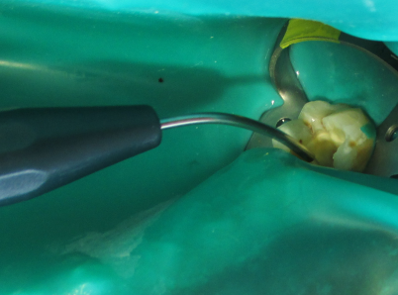

Fig 1.- Root Canal Decontamination

Recent Publications (minimum 5)

Comparative evaluation of the dimensional accuracy of three different irreversible hydrocolloid impression materials at different storage periods - An invitro study

International Journal of Current Research Vol. 9, Issue, 04, pp.48733-48739, April, 2017

Flexing in Canal with EDM : Healtalk , A Journal of Clinical Dentistry Volume 09/Issue 06/July-August- 2017

THE ADORABLE ADORO–A CASE REPORT ; European Scientific Journal June 2014 edition vol.10, No.18 ISSN: 1857 – 7881 (Print) e - ISSN 1857- 7431 .

NATURE’S OWN ALTERNATIVE – RESTORATION WITH BIOLOGICAL CROWNS; International Journal of Medical Dentistry; volume 3 • issue 2 April / June 2013 • pp. 144-149

Lasers In Facial Aesthetics - An Emerging Trend In Clinical Cosmetology;

Heal Talk; Volume 08 / Issue 04 / March-April 2016.

6. Ferrule Effect and Length of Posts in Anterior Teeth – A 3D Stress Analysis; Journal of Clinical Research in Dentistry

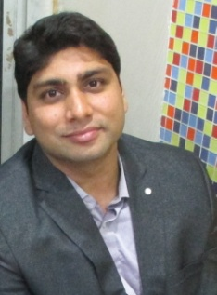
Biography (150 word limit)
Dr. Niladri Maiti has completed his BDS and MDS in Conservative Dentistry & Endodontics. He did his basic laser training from Society Of Oral Laser Application, SOLA, Vienna (Module I & II) followed by Basic Laser Certification from WLFD (World Federation of Laser Dentistry). He has completed his one year post graduate Diploma in Laser Dentistry from university of Genova, Italy followed by M.Sc in Laser Dentistry from University of Genova, Italy. He has received numerous training in Laser in Oncology , Photo active disinfection etc. In the quest of using multiple wavelength and exploring laser he got his Fellowship In Aesthetic Medicine from University of Greifswald , where he got his training of laser in various cosmetologic & dermatological applications . He also did his Masters in Bioscience and Certification in Oral Implantology from Biohorizons. He is also a Speaker & Key Opinion Leader of Coltene, Whaledent . He has numerous national & international publications. He is also a invited speaker in state and national conferences. He is the youngest dental professional from India to hold a M.Sc in Laser Dentistry. He is also the first to achieve combined effect of bioglass and laser in desensitization of tooth in his M.Sc thesis in University of Genoa, Italy.

Designation:
He is presently Senior Lecturer, Department of Conservative Dentistry & Endodontics, GuruNanak Institute Of Dental Science & Research, Kolkata, India
Key Opinion Leader: Coltene, Whaledent

Asst. Editor : Updent Dental Journal
Editorial Board Member: Open Acess Journal Of Dental Sciences
Invited Peer Reviewer: JCDR (Pubmed Indexed Journal)
Peer Reviewer: British Journal of Medicine & Medical Research

Email: drniladrimaiti@gmail.com

Notes/Comments:

