Effectiveness of ultrafast MRI scans in children
TANG Phua Hwee, MBBS MMED, FRCR, FAMS
KK Women’s and Children’s Hospital, SINGAPORE

Abstract (300 word limit)
Statement of the Problem:
MRI scan frequently exceeds half an hour and young children have difficulty keeping still for such long periods. Images are non-diagnostic and marred by motion artifact when children or adults move during the scan.
Vendors have created ultrafast sequences which propose to be able to scan the brain in a very short imaging time of 5 minutes compared to our standard MRI brain protocol which has an imaging time of 14 mins.
Methodology :
In this prospective study children scheduled for MRI brain underwent both the ultrafast MRI as well as standard MRI protocol. The presence of artifacts on each set of scans for the children were compared across the T1, T2, FLAIR, DWI and SWI sequences in both protocols and statistical significant differences were calculated using chi square test.
Findings:
In the 30 children who had MRI brain scan, 13 (43%) of the ultrafast scans were non-diagnostic due to artefact. For the rest of the 17 scans, the diagnoses made on ultrafast scans were similar to the diagnosis made on the standard MRI scans.
Artifacts seen on the ultrafast T2 and FLAIR images were statistically significantly more than those present on standard MRI.
Time taken to carry out 30 standard MRI brains is 30 x 14 mins =420 minutes. Time to carry out 30 ultrafast MRI brains is 30 x 5= 150 minutes.
Even after factoring time required to carry out supplementary standard brain MRI to supplement the 43% of ultrafast imaging with non-diagnostic MRI= 150 minutes + (13 x 14 minutes) = 332 minutes, ultrafast MRI provides time saving compared to standard protocol for all (which is 420 minutes).
Conclusion & Significance:
Ultrafast MRI is effective and saves time even with some scans having artifacts and requiring supplementation with standard MRI brain.

Image
Ultrafast T1, T2, FLAIR, DWI and DWI sequences from right to left
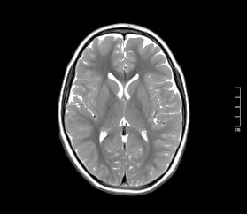
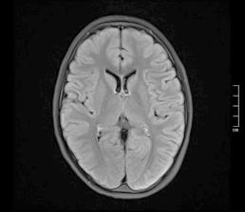
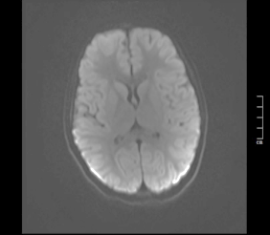
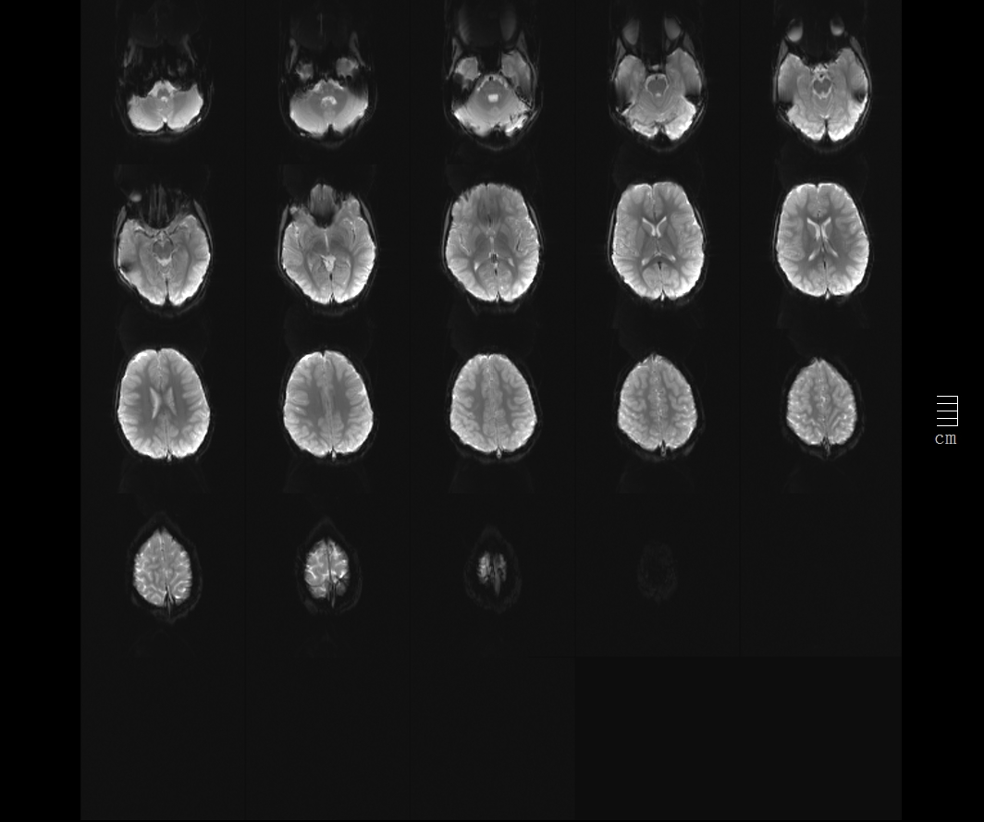
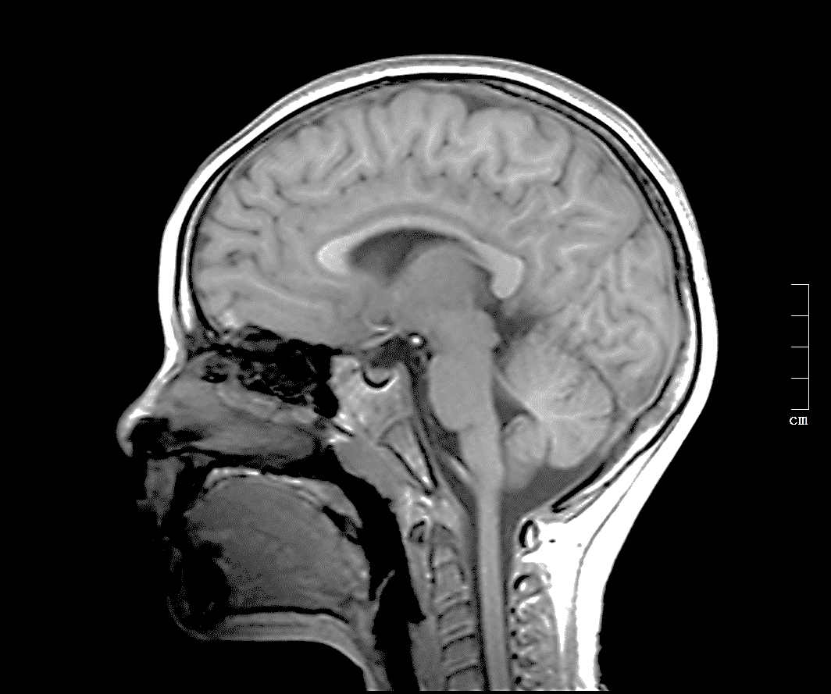

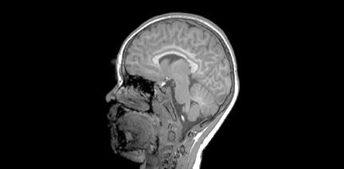
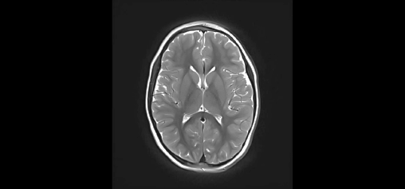
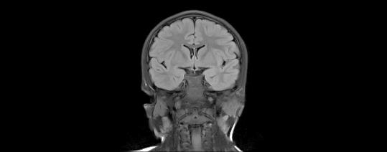
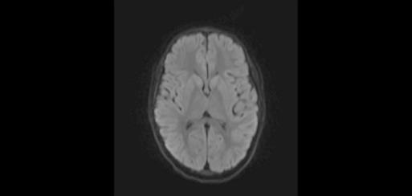
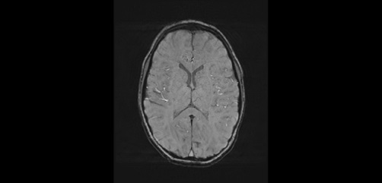
Standard T1, T2, FLAIR, DWI and DWI sequences from right to left

Artifacts on ultrafast T2 (left image) compared with standard T2
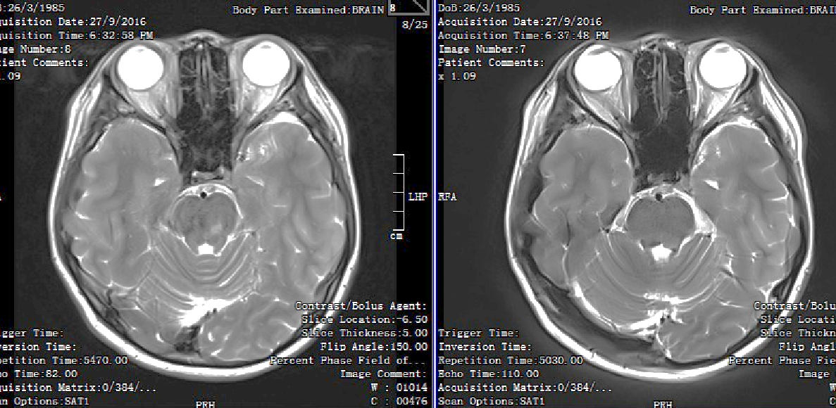

Recent Publications (minimum 5)
- Prakkamakul S, Witzel T, Huang S, et al (2016) Ultrafast Brain MRI: Clinical Deployment and Comparison to Conventional MRI at 3T. J Neuroimaging 26:503-510.
- Kralik SF, Yasrebi M, Supakul N, et al. (2017) Diagnostic Performance of Ultrafast Brain MRI for Evaluation of Abusive Head Trauma. AJNR Am J Neuroradiol 38:807-813.
- Woodfield J, Kealey S (2015) Magnetic resonance imaging acquisition techniques intended to decrease movement artefact in paediatric brain imageing: a systematic review. Pediatr Radiol 45:1271-1281.
- Sharma A, Reis M, Parsons MS, et al (2013) Two-Tiered Approach to MRI for Headache: A Cost-Effective Way to Use an Expensive Technology. AJR Am J Roentgenol 201:W75-W80.
5. Medina LS, Kuntz K, Pomeroy S (2001) Children With Headache Suspected of Having a Brain Tumor: A Cost-Effectiveness Analysis of Diagnostic Strategies.

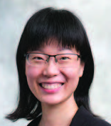Biography (150 word limit)
Dr Tang is a paediatric radiologist with interest in neuroimaging. She is a graduate of the National University of Singapore and did her basic and advanced radiology training in various hospitals in Singapore. After obtaining her FRCR and Masters in Diagnostic Radiology, she spent 6 months in University of California San Francisco learning the finer points of paediatric imaging, including paediatric neuroimaging and foetal imaging. She has also done a mini-fellowship in neuroradiology at Cincinnati Children’s Hospital Medical Centre and a visiting fellowship at Athinoula A. Martinos Center for Biomedical Imaging. She completed the Khoo Clinical Scholar’s Program and is currently conducting research on non-invasive methods of tissue assessment as well as optimising MR imaging for children with her collaborators from ASTAR and Duke-NUS. Dr Tang is actively involved in education and mentors medical students and junior staff in carrying out their research activities.
Email: tang.phua.hwee@singhealth.com.sg

