Daily Nutrition of Foreign Students in South Korea
Aratrika De,
U Design_MastersProgram
Professor : Eui Tay Jung
Inje University, South Korea

Abstract
Statement of the Problem: Living in a foreign country has its challenges for an individual. Food is an essential requirement, becomes a regular struggle to balance out their nutrition intake. Diverse opportunities in education have become global. This encourages youngsters and adults to get more exposure in their careers. But sometimes their nutrition get compromised.
Methodology & Theoretical Orientation: Being a foreign student in Korea, I have experienced similar challenges. My research will cover personal statements of foreign students from different ethnicities and their hurdles when it comes to meeting their nutrition needs. These statements will be broken down into groups and visually represent this data.
Conclusion & Significance: The change in food and lifestyle can affect the health of a person. As each country has different preferences, it can be hard to adapt to the new lifestyle and food habits in a new place. A student will also have limited finance range, this could lead to the compromise of the health behavior when it comes to food. Teens to adulthood is a prime time to keep a check on the nutrition. Lack of any nutrition leads to health problems. Why is nutrition so important? In a country like South Korea, their local taste palette and food preference are different. For example, it can be difficult for a vegetarian to survive for long on a limited budget of money, as they can’t consume meat. Hence, subjects like these should get more light in a global academic space. This should be more relevant to university nutritionists in the cafeteria.

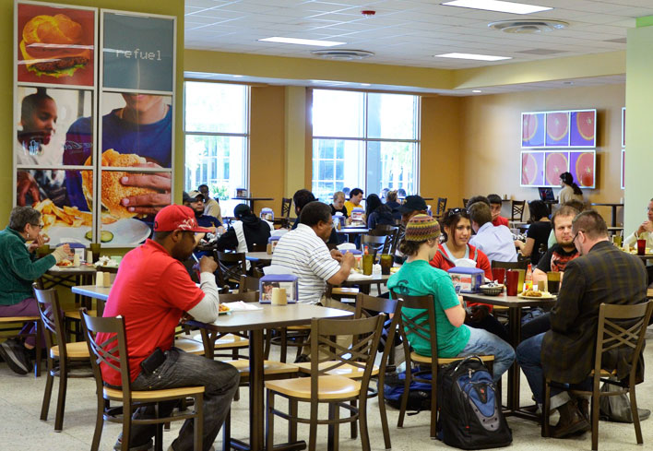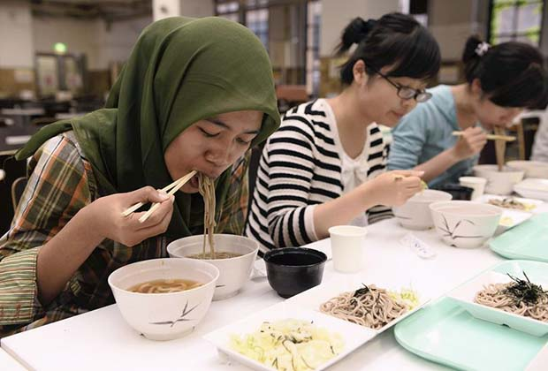

------------------------------------------------------------------------
Bio
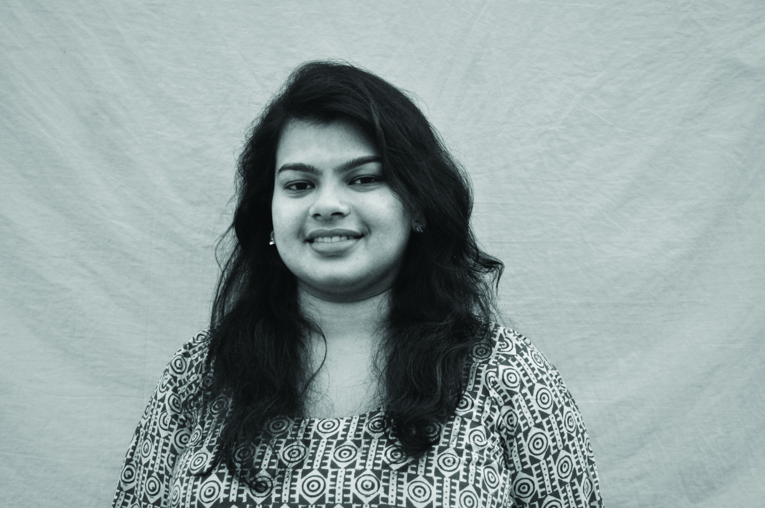
Aratrika De from India is pursuing her masters degree in visual design at Inje University, South Korea. Art & Design has been her background for some years now. Innovation is a significant part of Design, combining its values with Healthcare is something she would be very interested to explore and learn from.
DOB: 25.08.90
aratrika.de@gmail.com

