Medicine Package Design For Senior In Korea
Ku Ji Hyun,
DOB : 17.02.1974
U Design_Phd Student
Professor : Park Su Jin
Inje University, South Korea

Abstract
In the modern society, it is a challenge to live alone compared to living with family. We as individuals try to fulfill the best health conditions for our close ones, But some challenges still exist. The elderly in Korea are competent in terms of self-care. They have access to healthcare information and are aware of their needs.
The elderly who face visual difficulty in their daily lives without help from others, medical aids are sometimes limited to them. One of the main challenge that is considered, understanding packaging of the medicines. Our country has health care standard, such as the development of improved living standards and basic nutrition certification to improve on chronic infections and public health. This has increased the average life expectancy of the people. In the meantime, old man's life extension was decreasing; bring about an increase in chronic diseases.
Hospital and Institute care for the elderly is a necessity. Pharmacy as a source is a very important asset to healthcare. The research will aim to collect data and evidence of the elderly's experience with medicine packaging and to simplify the visual communication design for them. This study, therefore, visual constraints the elderly face and modular process occurring in medicine and a hard time understanding of information. The study will be based on the characteristic analysis of the subjects' behavior that will provide material and information guide for the package design.
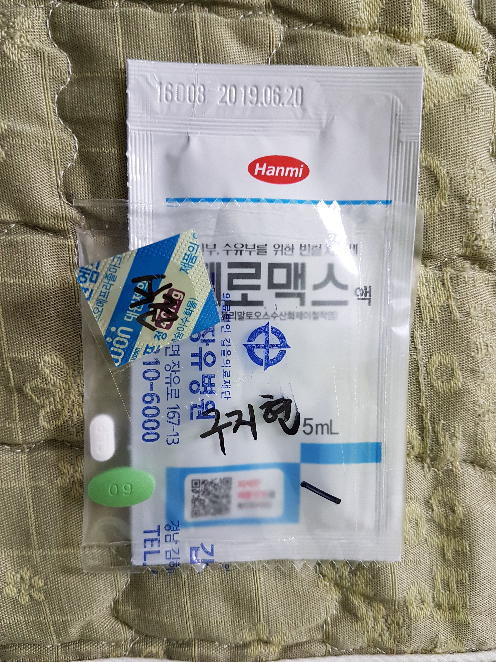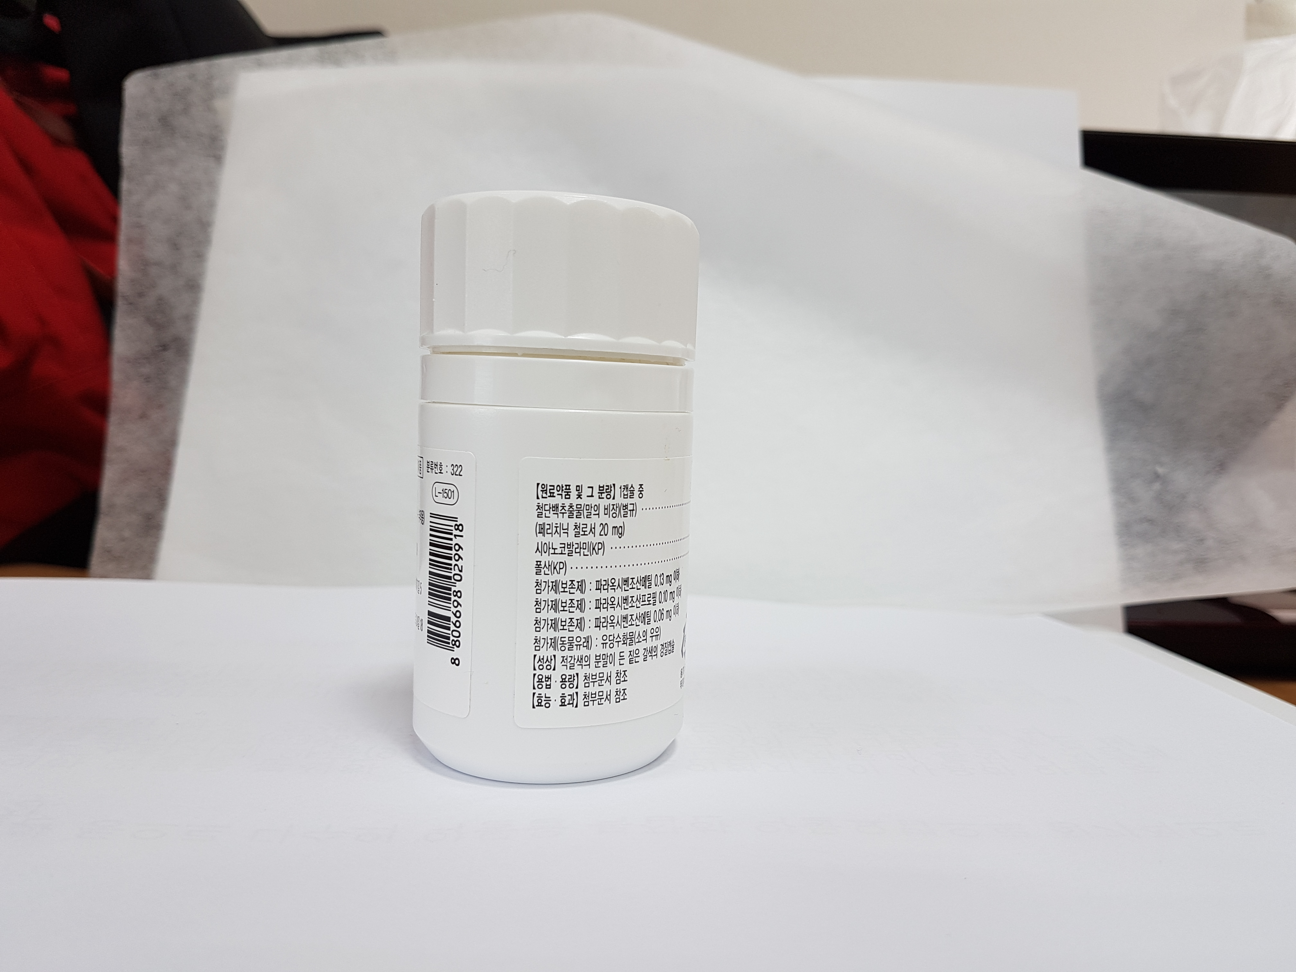

------------------------------------------------------------------------
Bio
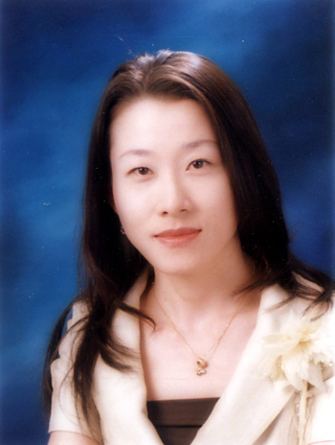
Ku Ji Hyun from South Korea is pursuing her Phd in visual design at Inje University, South Korea. Visual Design has been her background.

