Healthcare Applications for Senior Citizens in India
Aratrika De,
U Design_MastersProgram
Professor : Eui Tay Jung
Inje University, South Korea

Abstract
Statement of the Problem: Poor availability of healthcare services for the urban dwelling senior citizens in India is a serious concern. With opportunities outside of family trading, Indians are opting to leave their parents behind to pursue their career and lives. This change from living in joint families to nuclear independent families affects toddlers and aging parents. Quality of communication and services for aging parents are neglected. Lack of awareness of healthcare services therefore needs more attention.
Methodology & Theoretical Orientation: Being a citizen of India, it will be a familiar ground for my research in terms of access and communication. To understand if there is a scope among the target user group and collect relevant data regarding their lifestyles and culture. From the initial study of data, will segregate focus groups to conduct further narratives and scenarios of potential users, and their challenges.
Conclusion & Significance: The Healthcare situation for any citizen in India is questionable. There is a huge difference in the Public and the Private sectors as far as services and their awareness is concerned. Public is affordable but not a commendable access. Wheras private is accessible but not affordable to the average income groups. Financially senior citizens from the privileged income groups own assets or policies of pension through which they sustain their living. Higher income groups own more property and have enough funds to leave behind for generations of their offsprings. Why are Applications needed? At this point our earlier generations have had a progress in adapting to technology in their own ways. Focussing on urban groups of users, as majority smartphone users can be found there. My initiative is to understand if there is scope to make their health requirements met through mobile devices. There are many healthcare applications which are popular and known, it is not accessible or known to the senior citizens as much.
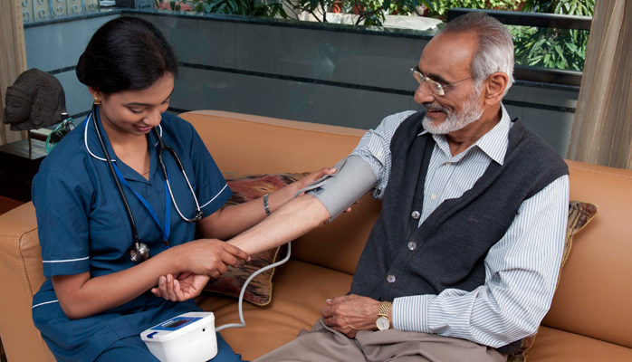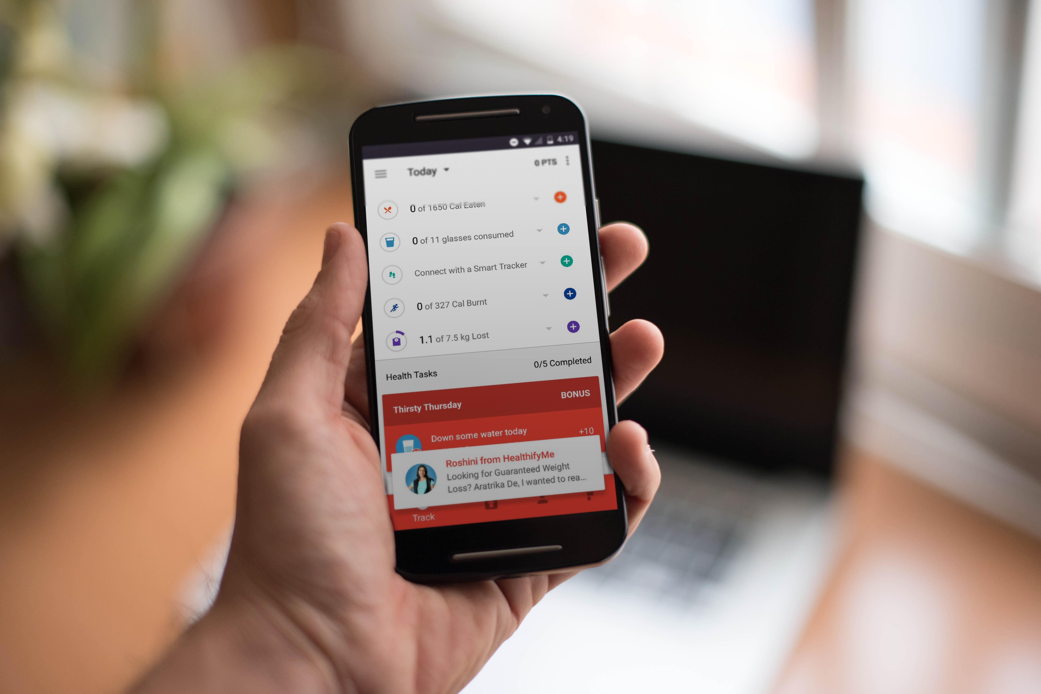

------------------------------------------------------------------------
Bio
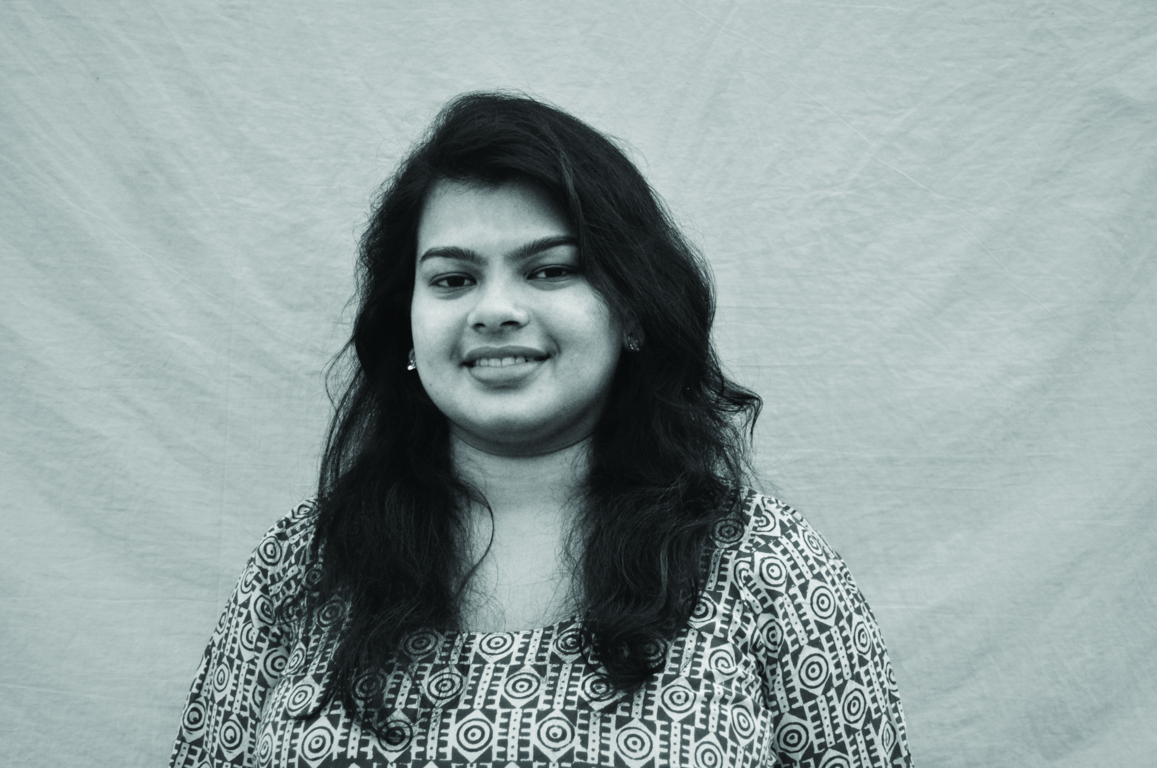
Aratrika De from India is pursuing her masters degree in visual design at Inje University, South Korea. Art & Design has been her background for some years now. Innovation is a significant part of Design, combining its values with Healthcare is something she would be very interested to explore and learn from.
aratrika.de@gmail.com

